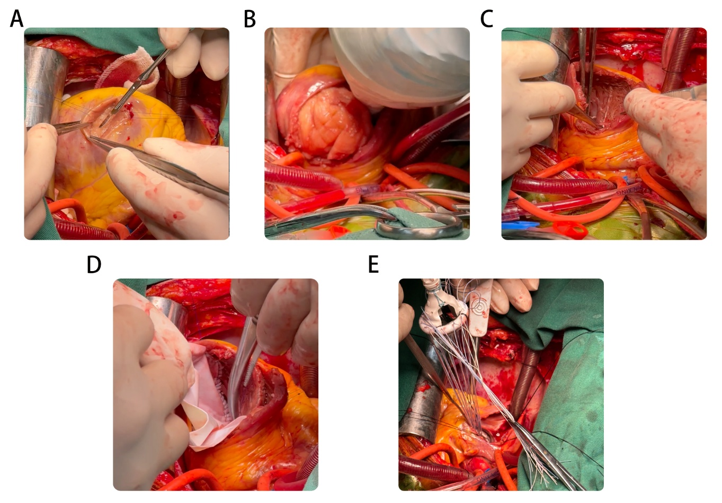
Fig S1. A. Intraoperative apical incision of the left ventricular wall. B. Stripping of tumor tissue. C. Left ventricle after stripping of tumor tissue. D. Reconstructed left ventricle. E. Insert a mechanical mitral valve
Fig S2. A. Immunohistochemical staining: expression of CD68, CDK4 and Vimentin. B. Immunohistochemical staining: expression of CD31, CD34 and Desmin. C. Immunohistochemical staining: expression of Ki-67

