PubMed (n=747) | (Transradial OR radial artery access OR TRA OR Transfemoral OR femoral artery access OR TFA) AND ("Rotational atherectomy" OR "RA" OR "Rotablation")
Google Scholar (n=2750) | (Radial approach OR Femoral approach) AND ("Rotational atherectomy")
Cochrane Library (n=93) | (Transradial OR radial artery access OR TRA OR Transfemoral OR femoral artery access OR TFA) AND ("Rotational atherectomy" OR "RA" OR "Rotablation")

Table S1. Detailed search strategy used in each database.
Study | Hypertension, n (%) |  | Diabetes mellitus, n (%) |  | Current smokers, n (%) |  | BMI (kg/m²), mean (SD) |  | Hyperlipidemia, n (%) |  | Prior myocardial infarction, n (%)
 | RA | FA | RA | FA | RA | FA | RA | FA | RA | FA | RA | FA
Dall’ara 2023 | 99 (86.8) *  32(86.5) ** | 62 (86.1) | 52 (45.6) *  13 (35.1) ** | 32 (44.4) | 37 (32.5) *  15 (40.5) ** | 28 (38.9) | - | - | 88 (77.8) *  26 (70.3) ** | 52 (72.2) | - | -
Desta 2022 | 540 (83.2) | 633 (82) | 216 (33.5) | 287 (36.9) | 67 (10.7) | 68 (9.4) | 27.8 (8.2) | 27.5 (7.6) | 526 (81.1) | 648 (83.7) | 273 (42.9) | 387 (52.2)
Ferstl 2022 | 156 (91.2) | 255 (95.7) | 50 (29.2) | 100 (39.2) | - | - | 27.4 (5) | 27.8 (4) | 158 (92.3) | 273 (92.5) | - | -
Giustino 2023 | - | - | - | - | - | - | - | - | - | - | - | -
Januszek 2020 | 628 (74.3) | 620 (14.9) | 272 (32.2) | 269 (31.8) | 144 (17) | 133 (15.7) | - | - | - | - | 436 (51.6) | 439 (52)
Kassimis 2014 | 48 (80) | 66 (88) | 17 (28) | 24 (32) | 6 (10) | 8 (11) | 27 (5) | 30 (10) | 42 (70) | 49 (66) | - | -
Kotowycz 2015 | 41 (79) | 58 (87) | 15 (29) | 33 (49) | - | - | - | - | 44 (85) | 58 (87) | 12 (23) | 25 (37)
Kubler 2018 | 103 (84) | 44 (81) | 52 (42) | 26 (48) | 12 (10) | 2 (4) | - | - | 59 (48) | 22 (41) | 77 (63) | 34 (63)
Solomonica 2020 | 108 (57) | 134 (78) | 61 (32) | 71 (41) | - | - | - | - | 88 (46) | 124 (72) | 50 (26) | 59 (34)
Watt 2009 | 50 (66.7) | 49 (64.5) | 17 (22.7) | 21 (27.6) | 43 (57.3) | 47 (61.8) | 27.9 (4.3) | 26.8 (4.1) | 51 (68) | 55 (72.4) | 36 (48) | 36 (47.4)
Watt 2017 *** | 2129 (72.5) | 3917 (74.9) | 911 (30.4) | 1604 (30.2) | - | - | - | - | 2010 (68.6) | 3698 (70.8) | 1072 (37.6) | 2125 (42.3)
Yin 2015 | 43 (73) | 56 (84) | 30 (50) | 38 (57) | 6 (10) | 8 (12) | 25.6 (6.5) | 25.1 (4.8) | 35 (59) | 41 (61) | 6 (10) | 11 (16)
CONTINUED ON THE NEXT PAGE

Study | Prior PCI, n (%) |  | Prior CABG, n (%) |  | Ejection fraction (%), mean (SD), or Median (IQR) |  | Prior CVA, n (%) |  | Atrial fibrillation, n (%) |  | PAD, n (%) |  | Previous kidney disease, n (%)
 | RA | FA | RA | FA | RA | FA | RA | FA | RA | FA | RA | FA | RA | FA
Dall’Ara 2023 | - | - | - | - | 50 (45-55) *  50 (40-60) ** | 50 (42-55) | - | - | - | - | 35 (30.7) *  13 (35.1) ** | 30 (41.7) | 6 (5.3) * | 7 (9.7)
Desta 2022 | 319 (49.2) | 449 (57.5) | 118 (18.2) | 198 (25.3) | - | - | - | - | - | - | - | - | - | -
Ferstl 2022 | 73 (42.7) | 135 (52.9) | 17 (9.9) | 80 (31.3) | 51 (11) | 48 (14) | 14 (8.2) | 21 (8.3) | 39 (22.80) | 77 (29.90) | 26 (15.20) | 40 (15.70) | - | -
Giustino 2023 | - | - | - | - | 57.1 (8.3) | 55.8 (9.2) | - | - | - | - | - | - | - | -
Januszek 2020 | 486 (57.5) | 485 (57.4) | 124 (14.7) | 129 (15.3) | - | - | 40 (4.7) | 33 (3.9) | - | - | - | - | 115 (13.6) | 126 (14.9)
Kassimis 2014 | - | - | - | - | 47 (10) | 48.5 (9.5) | - | - | - | - | - | - | 9 (8) | 13 (18)
Kotowycz 2015 | 21 (40) | 27 (40) | 9 (17) | 11 (16) | - | - | 3 (6) | 3 (4) | - | - | - | - | - | -
Kubler 2018 | 93 (76) | 38 (70) | 14 (11) | 11 (20) | 55 (40-60) | 55 (40-60) | 14 (11) | 7 (13) | 21 (17) | 14 (26) | 39 (32) | 15 (28) | - | -
Solomonica 2020 | 32 (17) | 49 (28) | 25 (13) | 54 (31) | 52.7 (10.2) | 49.3 (12.1) | 16 (8.3) | 27 (16) | - | - | 21 (11) | 17 (9.9) | 18 (22) | 34 (21)
Watt 2009 | 12 (16) | 15 (19.7) | 12 (16) | 16 (21.1) | - | - | 8 (10.7) | 11 (14.5) | - | - | - | - | - | -
Watt 2017*** | - | - | 349 (11.6) | 964 (17.8) | - | - | 245 (8.4) | 373 (7.1) | - | - | 369 (12.6) | 603 (11.6) | 139 (4.8) | 418 (8.0)
Yin 2015 | - | - | - | - | - | - | 4 (7) | 9 (13) | - | - | - | - | 14 (24) | 19 (29)

BMI, body mass index; CABG, coronary artery bypass grafting; CVA, cerebrovascular accident; FA, femoral access; IQR, interquartile range; MI, myocardial infarction; PAD, peripheral artery disease; PCI, percutaneous coronary intervention; RA, radial access; SD, standard deviation
*radial standard access, **radial sheathless guiding catheter access, ***Patient totals are delineated individually for each characteristic due to incomplete data retrieval
Table S2. Baseline characteristics of patients

Previous studies
Identification of new studies via databases and registers

Studies included in previous version of review (n = 5)

Reports of studies included in previous version of review (n = 5)
Records identified from databases* (n=3590)
PubMed (n = 747)
Google Scholar (n = 2750)
Cochrane Library (n=93)
Records removed before screening (n=2743)
Duplicate records removed.
(n = 2743)

Identification

Total studies included in review.
(n = 12)
Reports of total included studies
(n = 12)
Reports assessed for eligibility.
(n = 20)
Reports sought for retrieval.
(n =49)
Records screened.
(n =847)
Records excluded.
(n =798)

Reports not retrieved.
(n =29)
Screening

Reports excluded (n=13)

No outcome of interest (n=8)
Non-comparative groups (n =5)

New studies included in review.
(n = 7)
Reports of new included studies
(n =7)

Included

Figure S1. PRISMA flowchart

Figure S2. AMSTAR 2 checklist
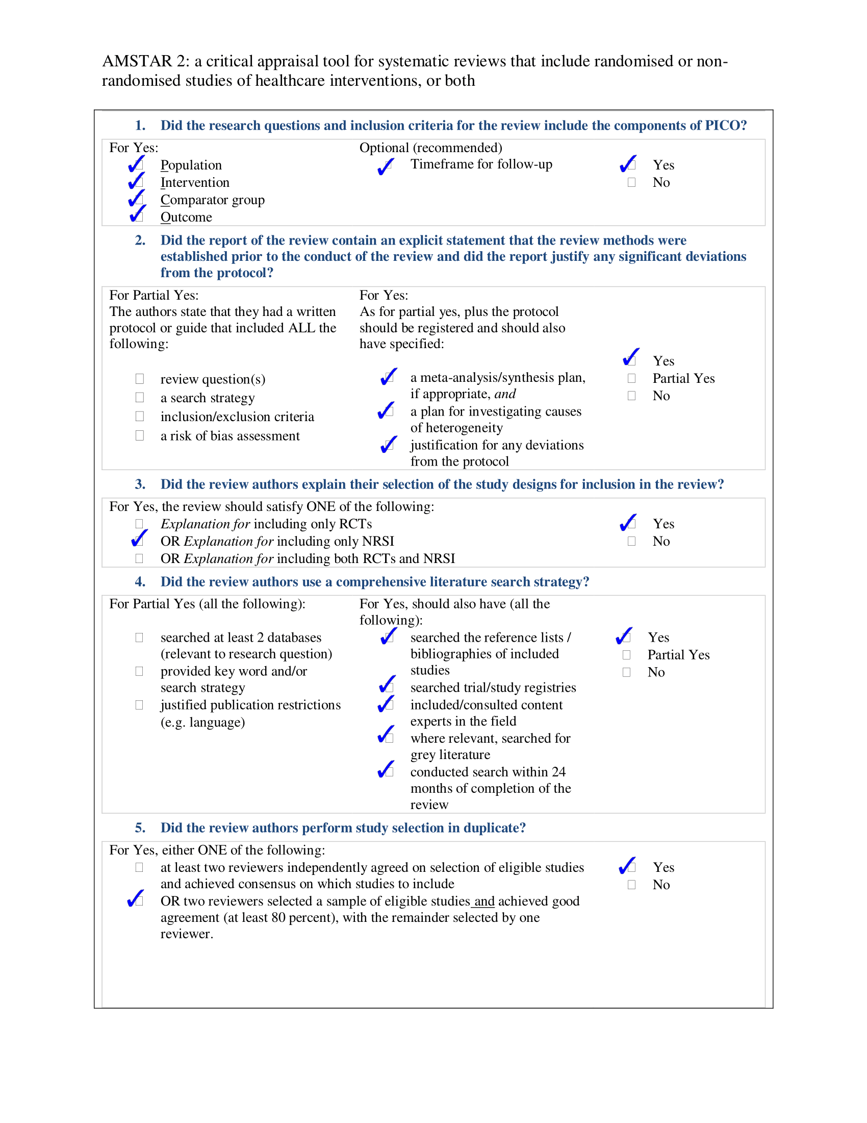
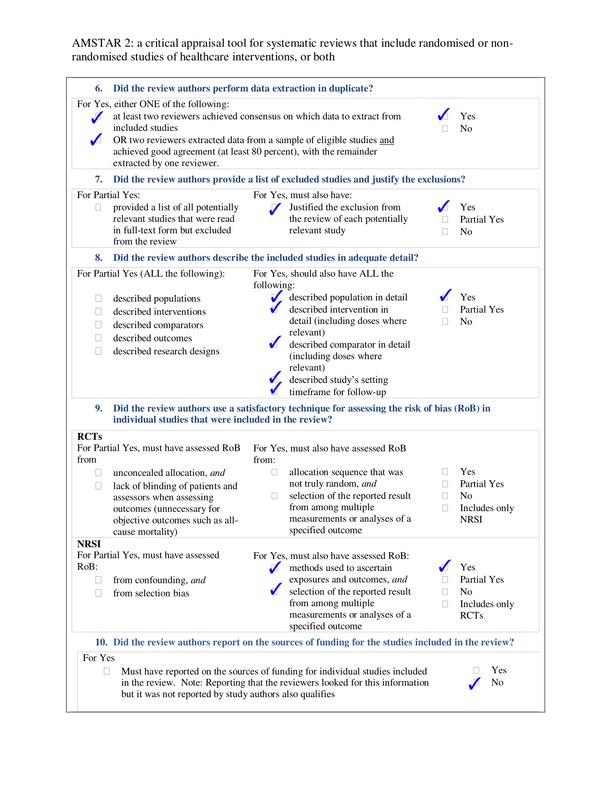
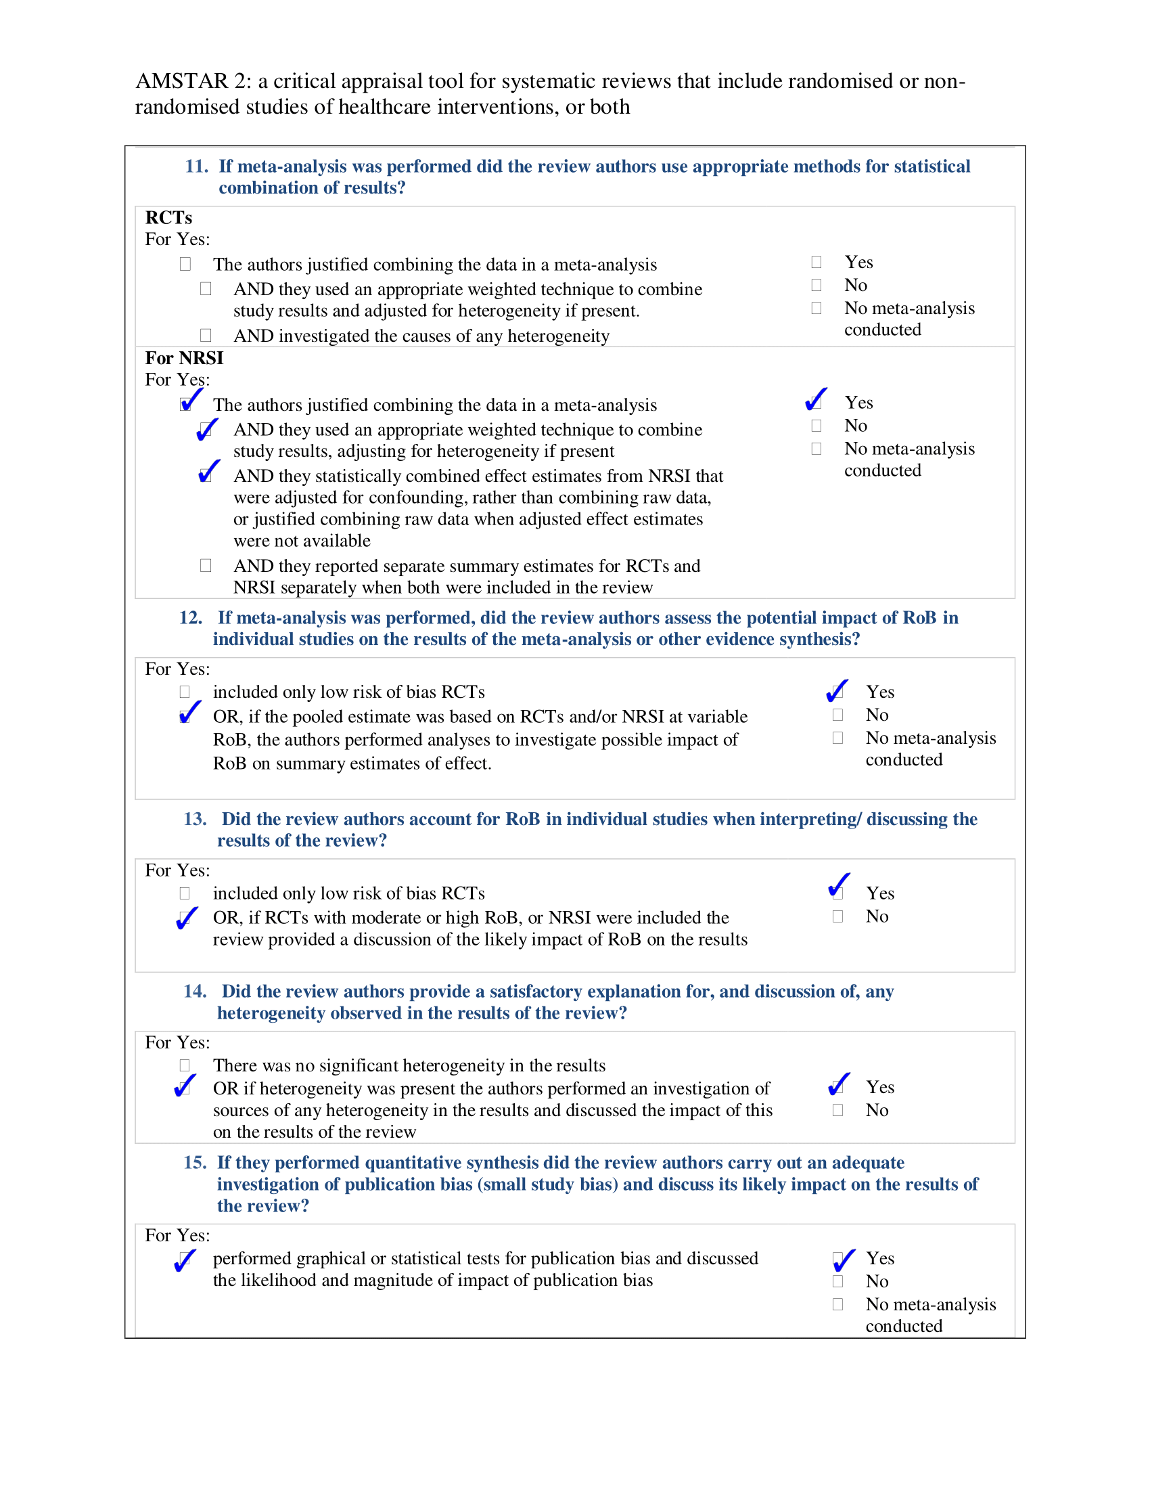
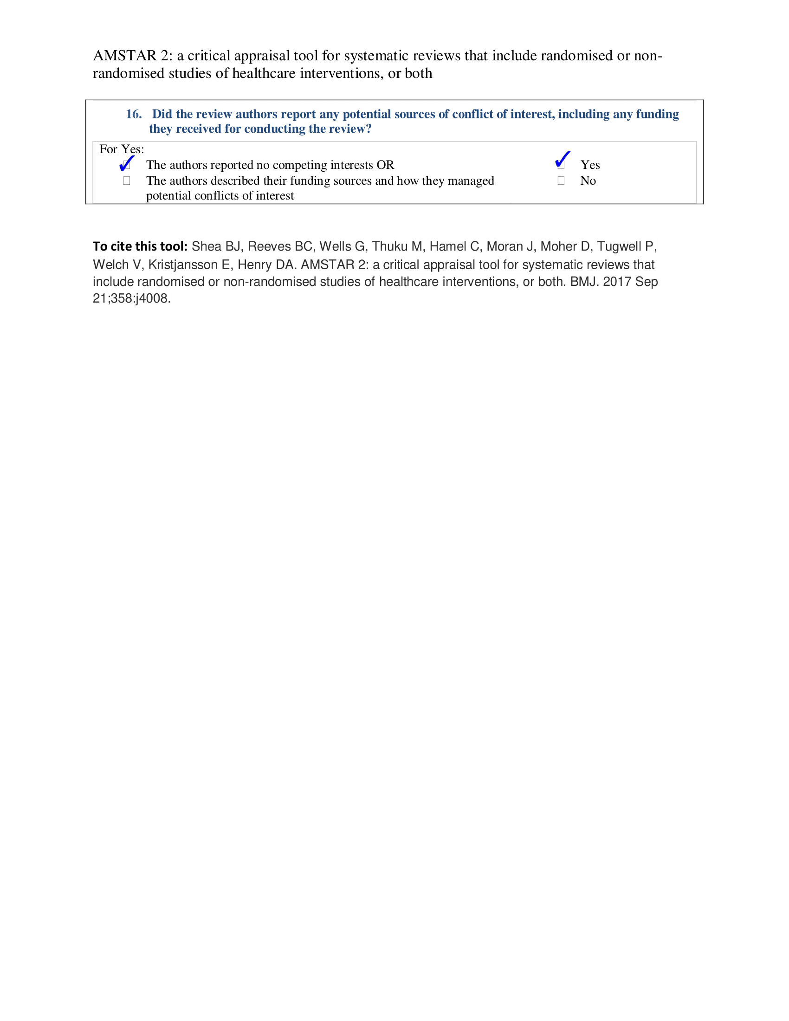
Study and Year | Fluoroscopy time (minutes), mean (SD) or Median (IQR) |  | Contrast dye (mL), mean (SD) or Median (IQR) |  | Total stent length (mm), mean (SD) or Median (IQR) |  | Vessel diameter (mm), mean (SD) or Median (IQR)
 | RA | FA | RA | FA | RA | FA | RA | FA
Dall’Ara 2023 | 26 (20-35) *  25 (19-30) ** | 26 (19-33) | 162 (130-210) *  167 (127-190) ** | 160 (129-226) | 48 (30-58) *  31 (18-43) ** | 31 (18-49) | 3.3 (0.5) *  3.3 (0.5) ** | 3.6 (0.6)
Desta 2022 | 30 (21-44) | 28 (21-40) | - | - | - | - | - | -
Ferstl 2022 | 24 (14) | 30 (19) | 217 (91) | 217 (98) | 59 (34) | 62 (34) | - | -
Giustino 2023 | - | - | - | - | - | - | - | -
Januszek 2020 | - | - | 201.9 (80.7) | 223.5 (105.2) | - | - | - | -
Kassimis 2014 | - | - | - | - | 38 (18) | 36 (19) | - | -
Kotowycz 2015 | 43.8 (18.1) | 40.5 (21.2) | 384 (189) | 429 (182) | 34.2 (27.3) | 40.3 (27.9) | - | -
Kubler 2018 | 20 (14-27) | 22 (17-32) | 250 (200-300) | 280 (200-350) | - | - | - | -
Solomonica 2020 | 31 (16) | 29 (14) | 205 (77) | 220 (92) | - | - | - | -
Watt 2009 | - | - | - | - | 38.1 (19.4) | 35.2 (21.3) | - | -
Watt 2017 | - | - | - | - | - | - | - | -
Yin 2015 | - | - | - | - | 24 (19) | 26 (21) | 3.0 (0.5) | 3.1 (0.3)
FA, femoral access; IQR, interquartile range; mL, milliliter; mm, millimeter; RA, radial access; SD, standard deviation
*radial standard access
**radial sheath less guiding catheter access

Table S3. Angiographic data of the patients in the included studies

Study | Radial Access | Femoral Access
Frestl et al. 2022 | 6F (39.5%), 7F (60.5%) | 6F (16.1%), 7F (76.7%), 8F (7.2%)
Solomonica et al. 2020 | 6F (100%) | >6F (79%)
Dall’Ara et al. 2023 | 6F (27.4%), 7F (55.2%), 7.5F (16.6%), 8F (0.9%) | 6F (27.4%), 7F (55.2%), 7.5F (16.6%), 8F (0.9%)
Kassimis et al. 2014 | 7.5F (Sheathless) | 8F
Kotowycz et al. 2015 | 6F (69%), 7F (31%), 8F (0%) | 6F (30%), 7F (62%), 8F (9%)
Kübler et al. 2018 | 6F (default) | 6F (default), 7F (for burrs >1.75mm)
Watt et al. 2009 | 6F (70.7%), 7F (29.3%) | 6F (28.9%), 7F (34.2%), 8F (36.8%)
Watt et al. 2017 | Not Reported | Not Reported
Yin et al. 2015 | 6F (59%), 7F (31%), 8F (10%) | 6F (10%), 7F (78%), 8F (12%)
Desta et al. 2022 | Not Reported | Not Reported
Giustino et al. 2023 | Not Reported | Not Reported
Januszek et al. 2020 | Not Reported | Not Reported

Table S4. Sheath sizes used in radial and femoral access across included studies.

Study | Anticoagulant Used | ACT Target | Use of Bivalirudin (Angiomax) | Antiplatelet Therapy | Glycoprotein IIb/IIIa Inhibitors | Meets Criteria (Heparin alone, ACT 250-300s)?
Kassimis et al. | Unfractionated Heparin (70-100 U/kg) | >300 sec (unless abciximab is used) | Operator discretion | DAPT | Abciximab or Bivalirudin used at the discretion | No (ACT >300s, GPIIb/IIIa allowed)
Desta et al. | Heparin (91.2%), Bivalirudin (9.2%) | Not specified | Used in 9.2% | Aspirin + Clopidogrel/Ticlopidine (62.9%) or Ticagrelor/Prasugrel (34.2%) | Used in 22.0% | No (Bivalirudin and GPIIb/IIIa inhibitors used)
Kubler et al. | Heparin (infusion via burr sheath) | >250 sec | Not reported | Aspirin + Clopidogrel (except 3 on Ticagrelor, 1 on Prasugrel) | Not reported | Yes (Heparin alone, ACT >250s)
Solomonica et al. | Bivalirudin (3.2% Radial, 29% Femoral) | Not reported | Used in 29% (Femoral) | DAPT (96% Radial, 84% Femoral) | Not reported | No (Bivalirudin used)
Giustino et al. | Not reported | Not reported | Not reported | Not reported | Not reported | No (No anticoagulation details)
Arra et al. | Not reported | Not reported | Not reported | DAPT pretreatment (30.5%) | Not reported | No (Lacks anticoagulant details)
Yin et al. | Unfractionated Heparin (70 U/kg IV) | 250 sec (for procedures >1 hr) | Not mentioned | Preloaded with DAPT (Aspirin + Clopidogrel) | Use at the operator’s discretion | Partially (Heparin used, but GPIIb/IIIa inhibitors allowed)
Watt et al. 2017 | Not explicitly mentioned | Not specified | Not mentioned | Likely DAPT (based on high DES use) | Used in 13.7% (Radial) and 14.9% (Femoral) | No (Lacks Heparin details, ACT, and GPIIb/IIIa inhibitor specifics)
Watt et al. 2009 | Unfractionated Heparin (70 U/kg IV) | 250 sec (for procedures >1 hr) | Not mentioned | Preloaded with DAPT | Used in 49.3% (Radial) and 42.1% (Femoral) | Partially (Heparin used, but GPIIb/IIIa inhibitors allowed)
Kotowycz et al. 2015 | Intravenous Heparin | Not specified | Not mentioned | DAPT (Aspirin + Clopidogrel) | Used in 52% (Femoral) and 54% (Radial) | No (Lacks ACT details, Heparin alone not specified)
Frestl et al. 2022 | Not mentioned | Not specified | Not mentioned | DAPT (No specific agents detailed) | Not mentioned | No (Lacks anticoagulant, ACT, and GPIIb/IIIa inhibitor details)
Januszek et al. 2020 | Not mentioned | Not specified | Not mentioned | No details provided (DAPT likely used) | Not mentioned | No (Lacks all anticoagulant details)

ACT, activated clotting time; DAPT, dual antiplatelet therapy; DES, drug-eluting stent; GPIIb/IIIa, glycoprotein IIb/IIIa inhibitors; IV, intravenous; UFH, unfractionated heparin
Table S5: Anticoagulant and antiplatelet strategies used across included studies.

Study and Year | Selection |  |  |  | Comparability | Outcome |  |  | NOS score
Dall’ Ara 2023 | * | * | * | * | * | * | * | * | 8
Desta 2022 | * | * | * | * | ** | * | * | * | 9
Ferstl 2022 | * | * | * | * | * | * | * | * | 8
Giustino 2023 | * | * | * | * | * | * | * | * | 8
Januszek 2020 | * | * | * | * | ** | * | * | * | 9
Kassimis 2014 | * | * | * | - | * | * | * | * | 7
Kotowycz 2015 | * | * | - | * | ** | * | * | * | 8
Kubler 2018 | * | - | * | * | * | * | * | * | 7
Solomonica 2020 | * | * | - | * | * | * | * | * | 7
Watt 2009 | * | * | - | * | * | * | * | * | 7
Watt 2017 | * | * | * | * | ** | * | * | * | 9
Yin 2015 | * | * | * | - | * | * | * | * | 7

Table S6. Newcastle-Ottawa Quality Assessment for cohort studies.

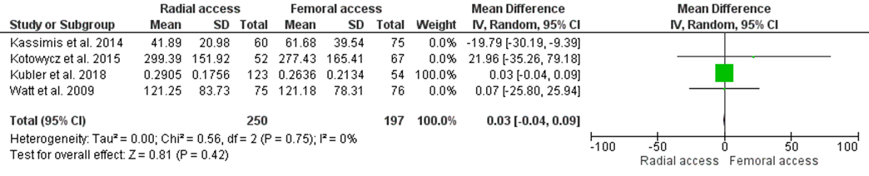
Figure S3. Leave-one-out analysis to test the heterogeneity of radiation exposure

Figure S4. Funnel plots: A) major vascular site bleeding, B) procedural success

 | Major vascular site bleeding | Procedural success
Egger p value | 0.00231 | 0.06156
Begg’s p value | 0.27576 | 0.04910
Table S7. Begg’s and Egger test p values

Figure S5. Scatter plots: A) age, B) hypertension, C) diabetes mellitus
Figure S6. Scatter plots: A) current smoker, B) BMI, C) hyperlipidemia
Figure S7. Scatter plots: A) previous MI, B) previous CABG, C) ejection fraction

Figure S8. Scatter plots: A) previous PAD, B) previous Kidney disease, C) male sex %

