Supplementary tables
Supplementary table 1. Missing data for variables reported in Table 1 and Table 2.
 | Missing data
Age (years) | 0 (0)
Female sex | 0 (0)
BMI (kg/m²) | 69 (3.7)
Hypertension | 8 (0.43)
Diabetes | 14 (0.76)
Hyperlipidaemia | 60 (3.2)
CKD | 16 (0.86)
LVEF ≤35% | 53 (2.9)
Preoperative angiography | 1 (0.05)
Left main stenosis | 0 (0)
NYHA 4 | 0 (0)
CCS 4 | 0 (0)
EuroSCORE II | 26 (1.4)
Haemoglobin (g/L) | 13 (0.70)
Platelet count (10⁹/L) | 29 (1.57)
Clopidogrel | 9 (0.49)
Aspirin | 10 (0.54)
Heparins | 9 (0.49)
Warfarin | 9 (0.49)
Beta-blockers | 26 (1.41)
Calcium channel blockers | 190 (10.3)
Statins | 68 (3.7)
Emergency operation | 0 (0)
CPB time (min) | 0 (0)
Cross-clamp time (min) | 272 (14.7)
Skin-to-skin time (min) | 179 (9.7)
CPB time categories* | 0 (0)
Chest drain output (mL within 24h) | 33 (1.8)
Re-exploration for bleeding | 0 (0)
30-day mortality | 0 (0)
Abbreviations: BMI, body mass index; CKD, chronic kidney disease; LVEF, left ventricular ejection fraction; NYHA, New York Heart Association; CCS, Canadian Cardiovascular Society; EuroSCORE, European System for Cardiac Operative Risk Evaluation; CPB, cardiopulmonary bypass.
*Categorical variable with values OPCAB, 0-120min and >120min.

Supplementary Table 2. Transfusion and fibrinogen proportions per year.
Year | Transfusion proportions, % | Fibrinogen proportions, %
2005 | 65.4 | 1.5
2006 | 79.3 | 3.7
2007 | 67.3 | 0.65
2008 | 76.2 | 4.9
2009 | 78.1 | 2.2
2010 | 84.4 | 3.9
2011 | 77.8 | 1.7
2012 | 62.3 | 3.6
2013 | 51.1 | 6.0
2014 | 58.3 | 15.0
2015 | 45.5 | 8.9
2016 | 45.8 | 12.0
2017 | 57.8 | 20.3
2018 | 59.3 | 18.5
2019 | 47.4 | 28.1
2020 | 40.9 | 37.9
2021 | 32.6 | 30.4
2022 | 47.8 | 37.0

Supplementary Table 3. Variance inflation factor calculations
 | GVIF
Interval | 1.11
Age (years) | 1.07
Sex | 1.04
BMI categories | 1.01
CKD | 1.06
3VD and/or left main stenosis | 1.02
LVEF ≤35% | 1.02
Haemoglobin (g/L) | 1.06
Clopidogrel | 1.04
Aspirin | 1.14
Heparins | 1.02
Emergency operation | 1.04
CPB time categories* | 1.04
Abbreviations: BMI, body mass index; CKD, chronic kidney disease; VD, vessel disease; LVEF, left ventricular ejection fraction.
*Categorical variable with values OPCAB, 0-120min and >120min.

Supplementary Table 4. Multivariable logistic regression analysis with interaction terms.
 | OR (95% CI) | p-value
Interval
2005-2010 | 1 (Reference)
2011-2016 | 0.31 (0.23–0.41) | <0.001
2017-2022 | 0.16 (0.11–0.23) | <0.001
Age (per year) | 1.03 (1.02–1.04) | <0.001
Female sex | 3.89 (2.56–6.04) | <0.001
BMI categories |  | 0.007
Underweight | 3.39 (1.25-10.95) | 0.025
Normal weight | 1 (Reference)
Overweight | 0.71 (0.51-0.98) | 0.039
Obesity class I | 0.55 (0.38-0.78) | 0.001
Obesity class II | 0.50 (0.30-0.82) | 0.006
Obesity class III | 0.36 (0.16-0.82) | 0.014
CKD | 1.66 (1.21–2.31) | 0.002
3VD and/or left main stenosis | 2.22 (1.56–3.16) | <0.001
LVEF ≤35% | 1.81 (1.15–2.88) | 0.011
Haemoglobin (per g/L) | 0.96 (0.95–0.97) | <0.001
Clopidogrel within five days before surgery | 1.62 (0.89–2.99) | 0.114
Aspirin until surgery | 1.02 (0.78–1.32) | 0.908
Heparins until surgery | 1.17 (0.94–1.47) | 0.165
Emergency operation | 2.29 (1.13–4.94) | 0.027
CPB time categories
CPB 0 min (OPCAB) | 0.81 (0.58–1.14) | 0.230
CPB ≤120 min | 1 (Reference)
CPB >120 min | 3.13 (2.21–4.49) | <0.001
Abbreviations: OR, odds ratio; CI, confidence interval; BMI, body mass index; CKD, chronic kidney disease; VD, vessel disease; LVEF, left ventricular ejection fraction; CPB, cardiopulmonary bypass; OPCAB, off-pump coronary artery bypass. Bold p-values indicate statistically significant differences.

Supplementary Table 5. Comparison across intervals.
 | 2005-2010  (n=853) | 2011-2016  (n=664) | 2017-2022  (n=333) | p-value
Age (years) | 67 [60, 73] | 67 [61, 73] | 68 [63, 74] | 0.005
Female sex | 139 (16.3) | 108 (16.3) | 51 (15.3) | 0.910
BMI categories |  |  |  | 0.037
Underweight | 4 (0.5) | 4 (0.6) | 1 (0.3)
Normal weight | 173 (20.7) | 116 (18.6) | 45 (14.1)
Overweight | 413 (49.4) | 307 (49.1) | 146 (45.6)
Obesity class I | 188 (22.5) | 137 (21.9) | 90 (28.1)
Obesity class II | 46 (5.5) | 48 (7.7) | 27 (8.4)
Obesity class III | 12 (1.4) | 13 (2.1) | 11 (3.4)
CKD | 133 (15.9) | 141 (21.3) | 101 (30.3) | <0.001
3VD and/or left main stenosis | 771 (90.4) | 562 (84.6) | 303 (91.0) | 0.001
LVEF ≤35% | 40 (4.9) | 58 (9.0) | 38 (11.6) | <0.001
Haemoglobin (g/L) | 143 [131, 151] | 142 [133, 151] | 142 [131, 151] | 0.787
Aspirin | 324 (38.4) | 539 (81.3) | 270 (81.1) | <0.001
Clopidogrel | 24 (2.8) | 45 (6.8) | 38 (11.4) | <0.001
Emergency operation | 41 (4.8) | 51 (7.7) | 18 (5.4) | 0.057
CPB time categories |  |  |  | <0.001
CPB 0 min (OPCAB) | 170 (19.9) | 55 (8.3) | 19 (5.7)
CPB >120 min | 105 (12.3) | 119 (17.9) | 60 (18.0)
Chest drain output (mL within 24h) | 790 [570, 1,070] | 715 [540, 965] | 470 [327, 685] | <0.001
Re-exploration for bleeding | 51 (6.0) | 30 (4.5) | 11 (3.3) | 0.130
30 day mortality | 22 (2.6) | 7 (1.1) | 8 (2.4) | 0.092
Abbreviations: BMI, body mass index; CKD, chronic kidney disease; LVEF, left ventricular ejection fraction; CPB, cardiopulmonary bypass; OPCAB, off-pump coronary artery bypass.
Note: Numerical variables are presented as median [IQR]. Categorical variables are presented as counts and percentages, n (%). Bold p-values indicate statistically significant differences.

Supplementary figures

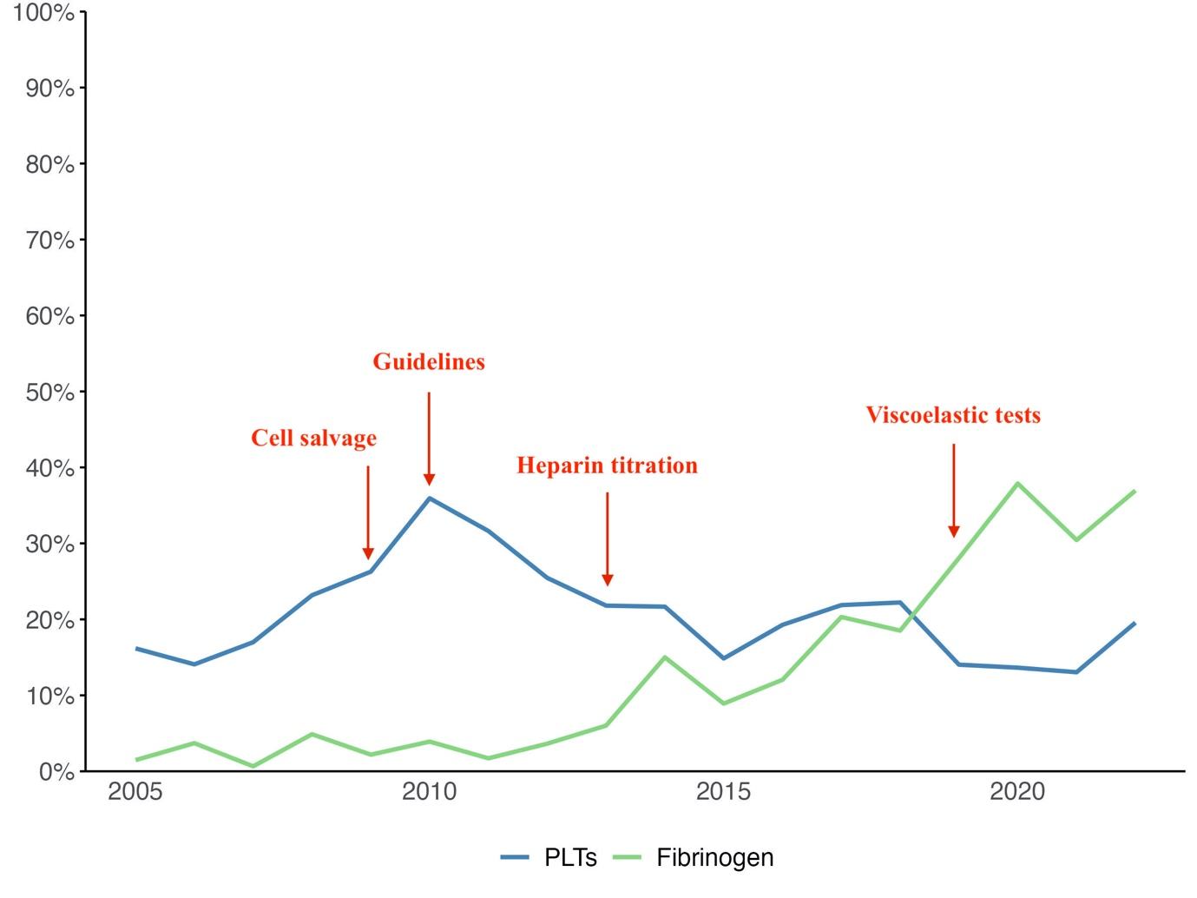
Supplementary Fig. 1. Perioperative platelet transfusion proportions and proportions of CABG patients administered fibrinogen from 2005-2022. Arrows indicate the introduction of various transfusion-sparing methods: cell salvage (2009), transfusion guidelines (2010), routine use of heparin titration (2013) and viscoelastic tests (2019).

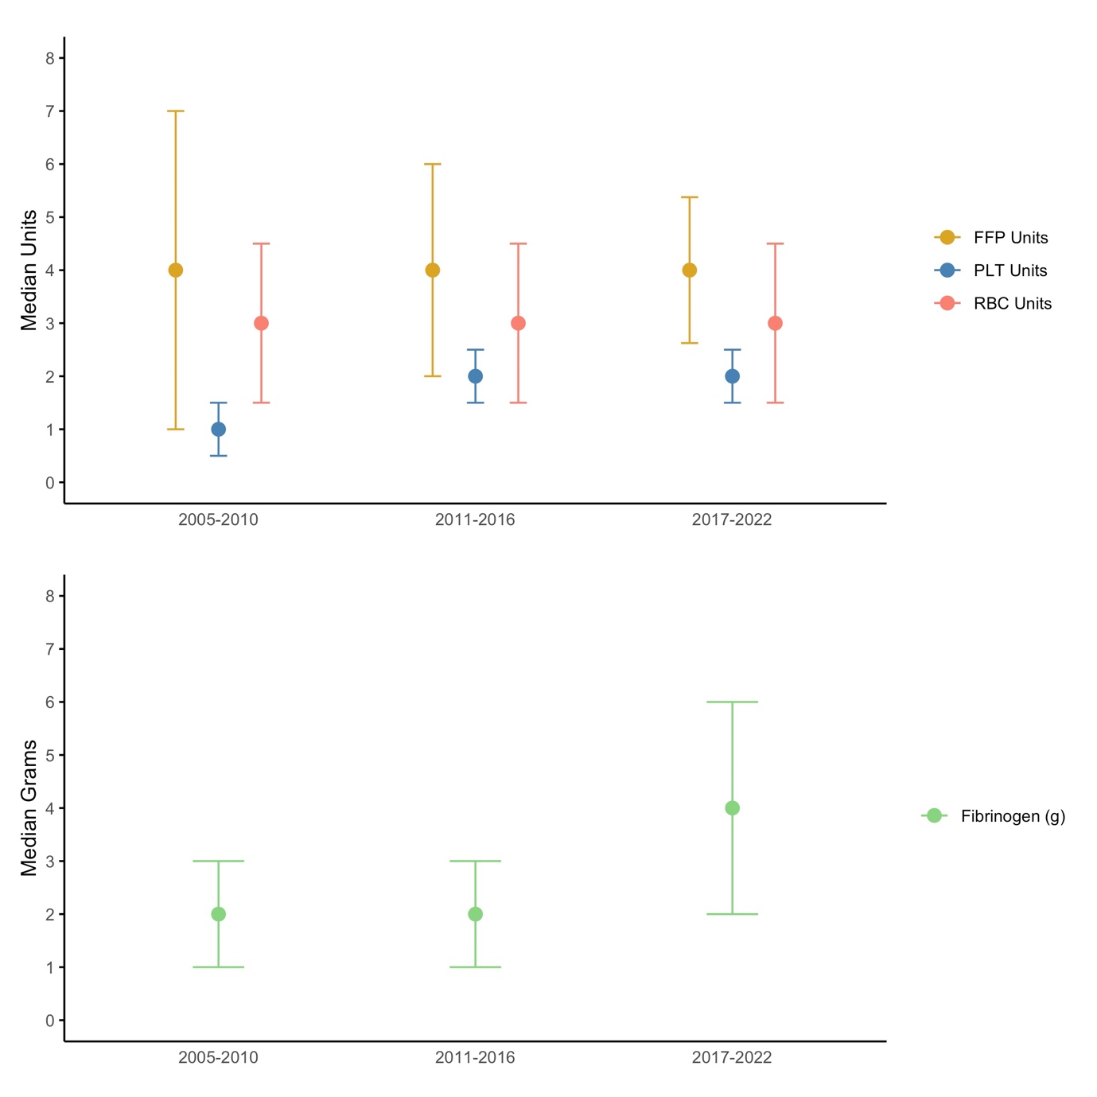
Supplementary Fig. 2. Median units of RBCs, FFP and PLTs transfused across three 6-year intervals. Median grams of administered fibrinogen are also shown for the same intervals. Note: Median units of RBCs are calculated exclusively among RBC-transfused patients. The same applies for median units of FFP and PLTs and median fibrinogen grams. Error bars represent interquartile ranges.

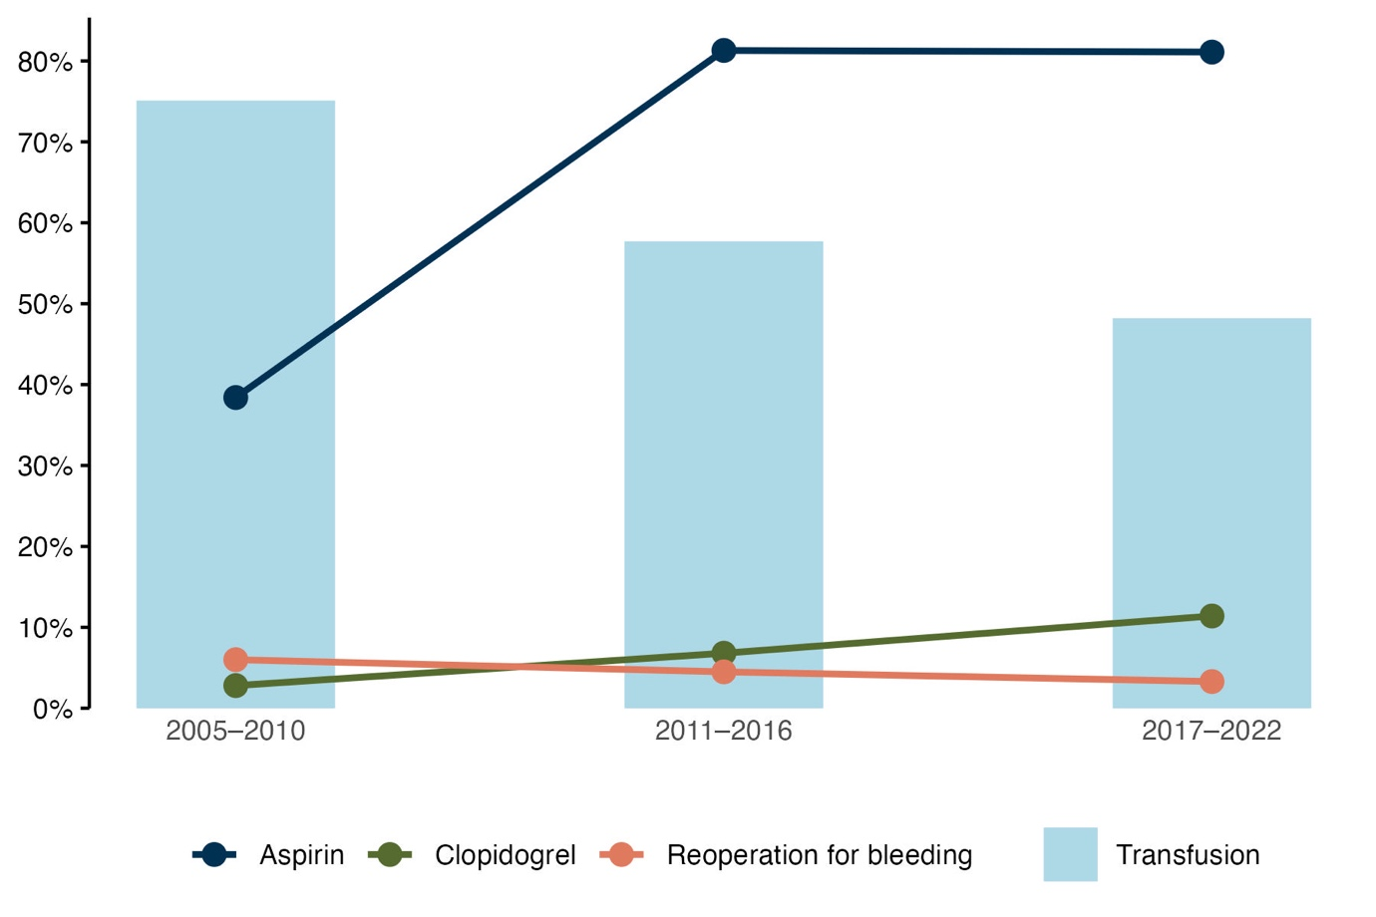
Supplementary Fig. 3. Perioperative transfusion proportions across three 6-year intervals. Proportions of patients treated with aspirin until surgery and clopidogrel within five days before surgery is also shown, along with proportions of patients undergoing reoperation for bleeding.

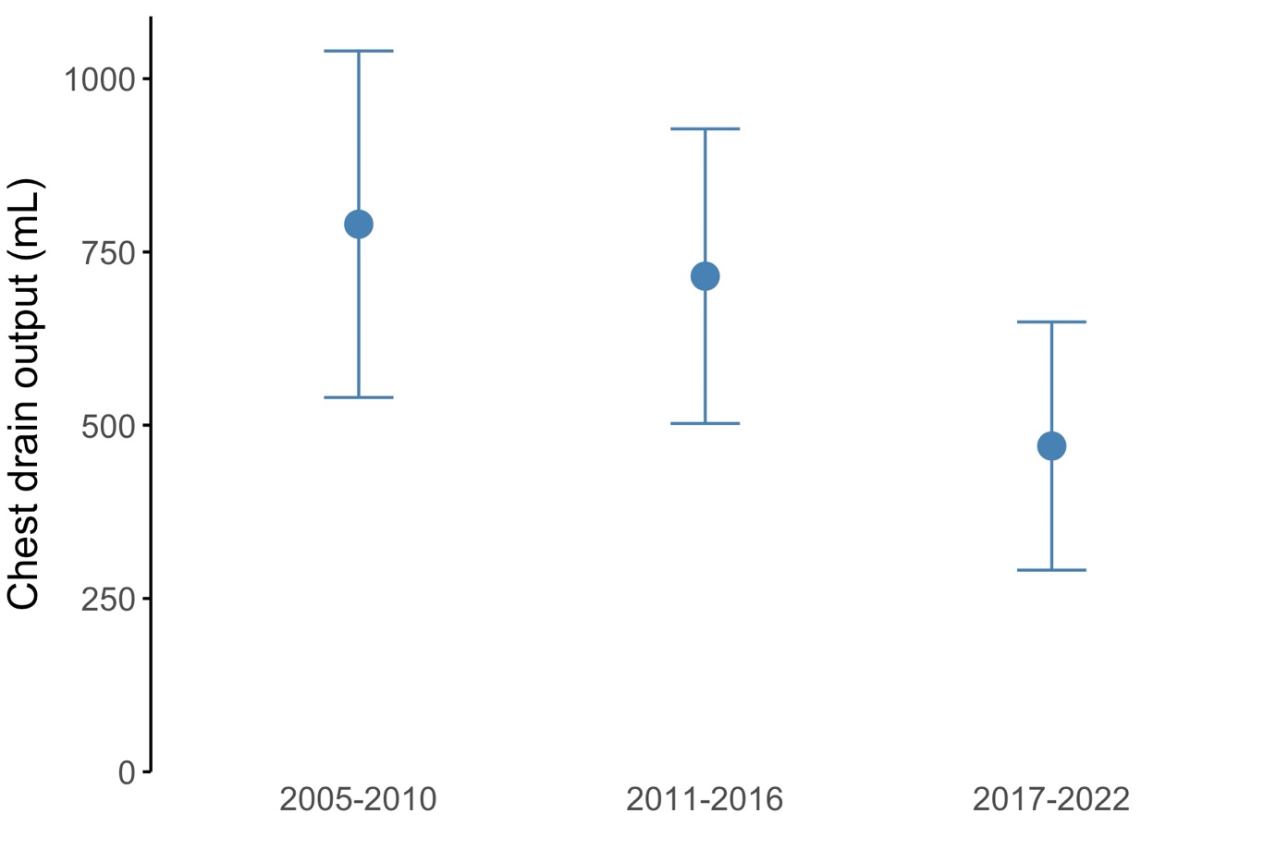
Supplementary Fig. 4. Median chest drain output 24 hours postoperatively across three 6-year intervals. Error bars represent interquartile ranges.

