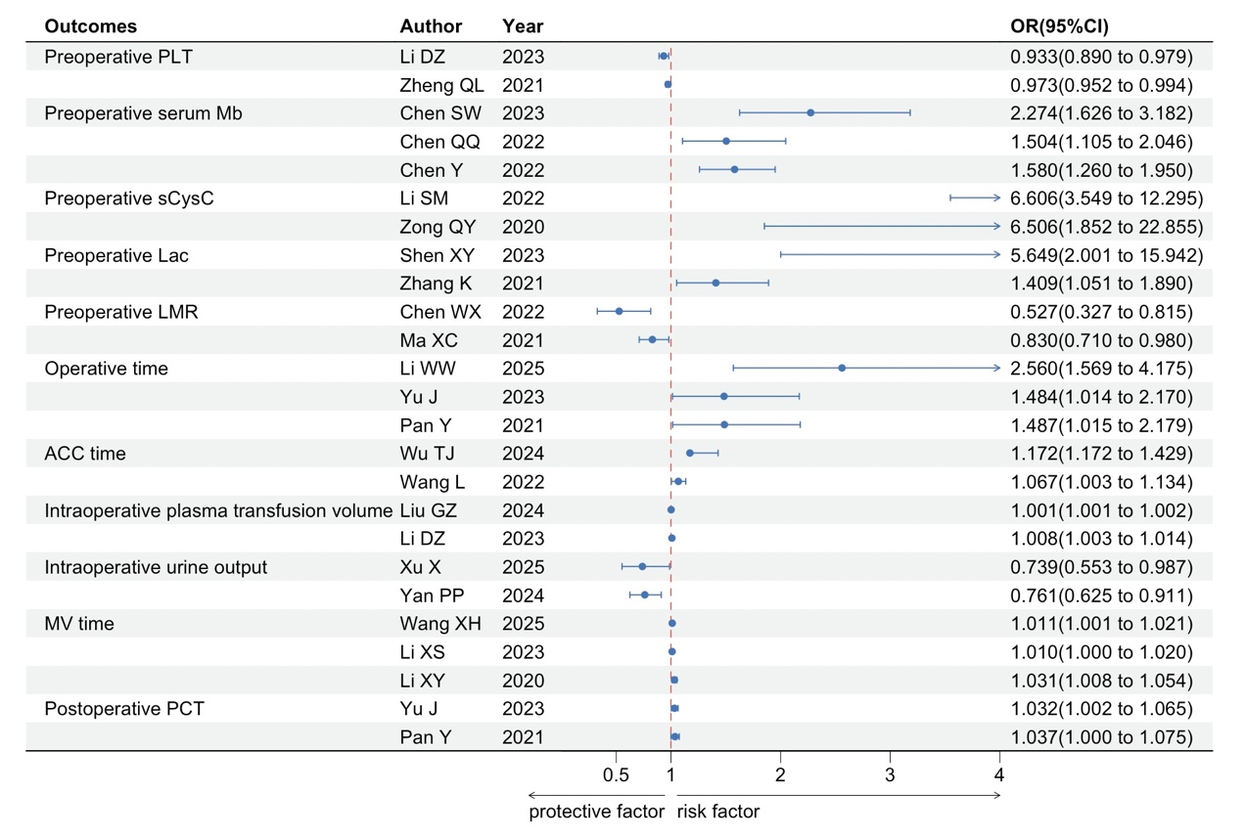
Figure 1. Forest plot of preoperative PLT, preoperative serum Mb, preoperative sCysC, preoperative Lac, preoperative LMR, operative time, ACC time, intraoperative plasma transfusion volume, intraoperative urine output, MV time, and postoperative PCT.
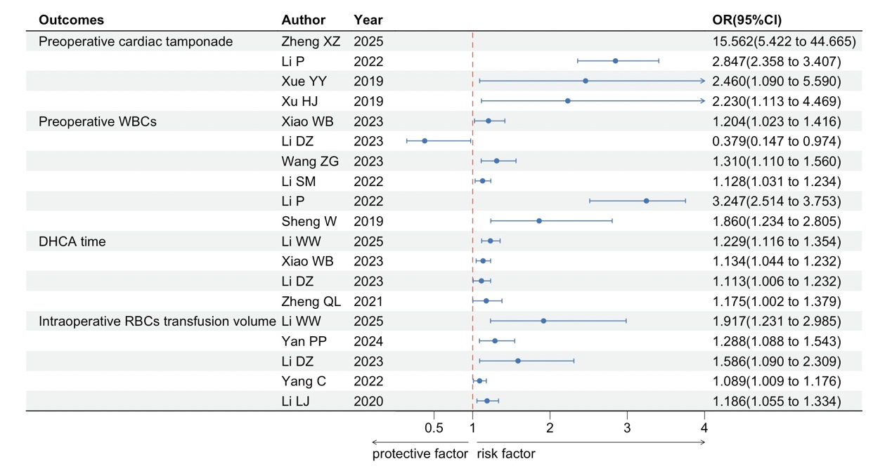
Figure 2. Forest plot of preoperative cardiac tamponade, preoperative WBCs, DHCA time, and intraoperative RBCs transfusion volume.
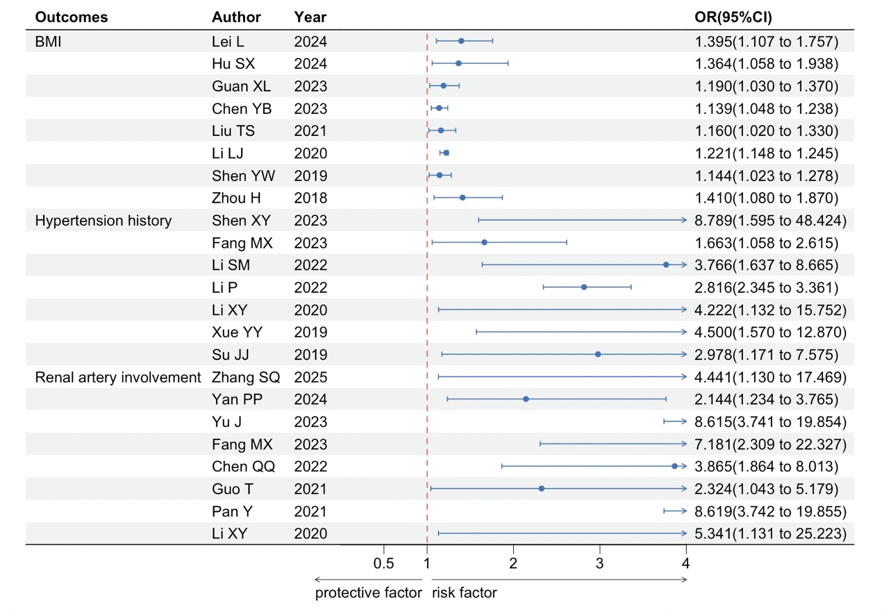
Figure 3. Forest plot of BMI, hypertension history, and renal artery involvement.
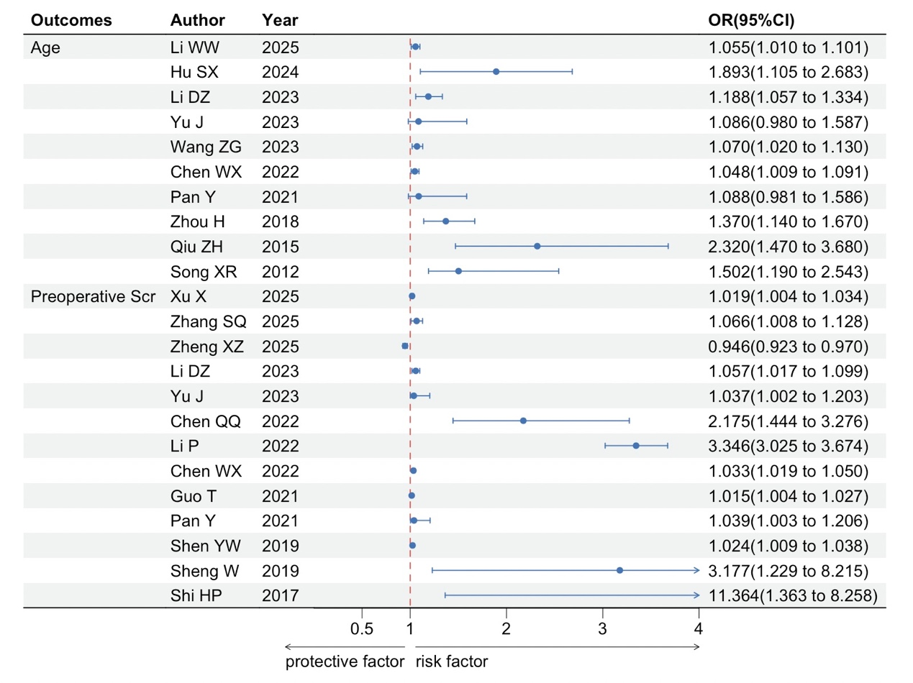
Figure 4. Forest plot of age and preoperative Scr.
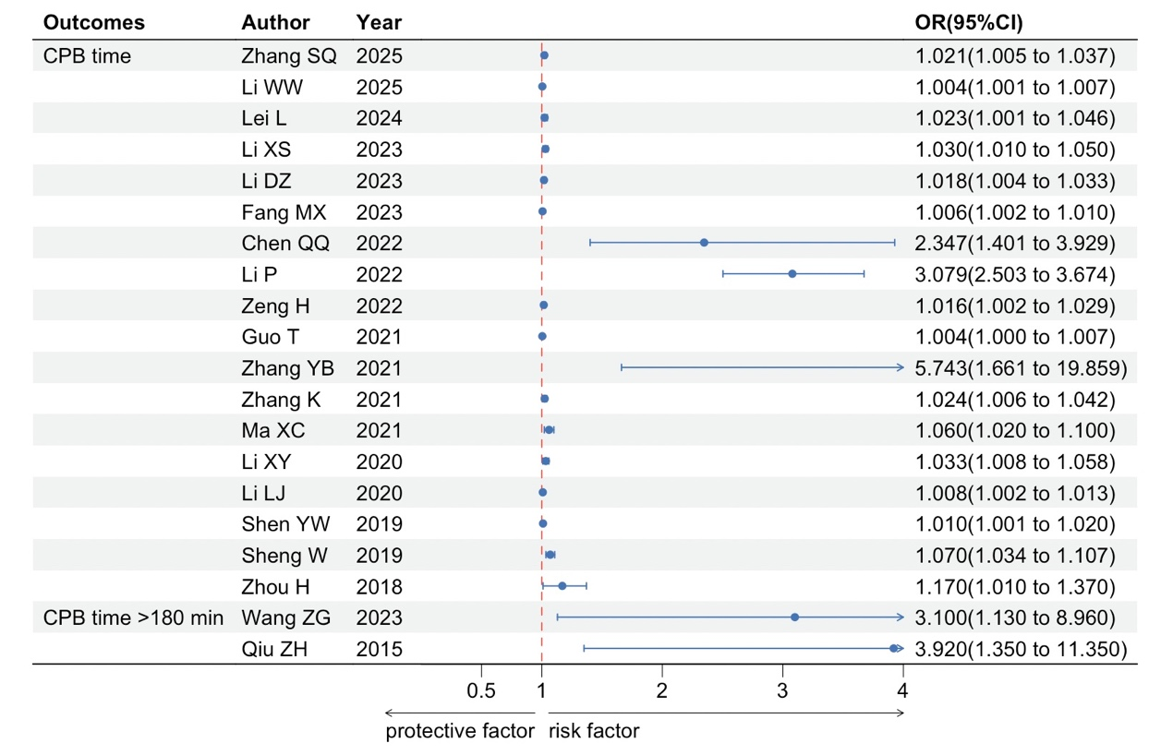
Figure 5. Forest plot of CPB time and CPB time >180min.

