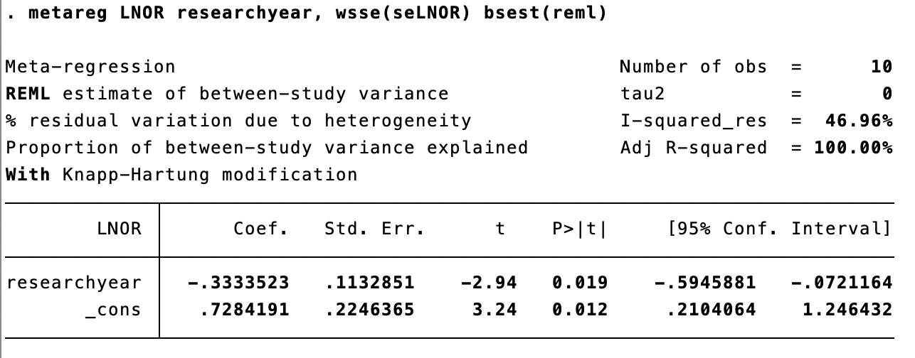
Figure 1. Meta-regression of the research year of age.
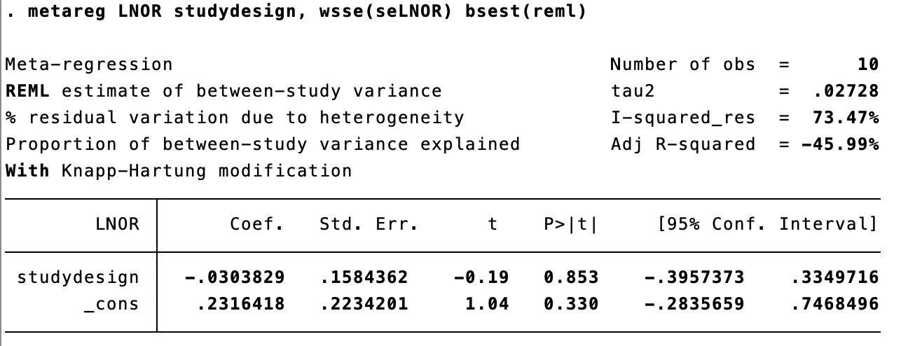
Figure 2. Meta-regression of the study design of age.
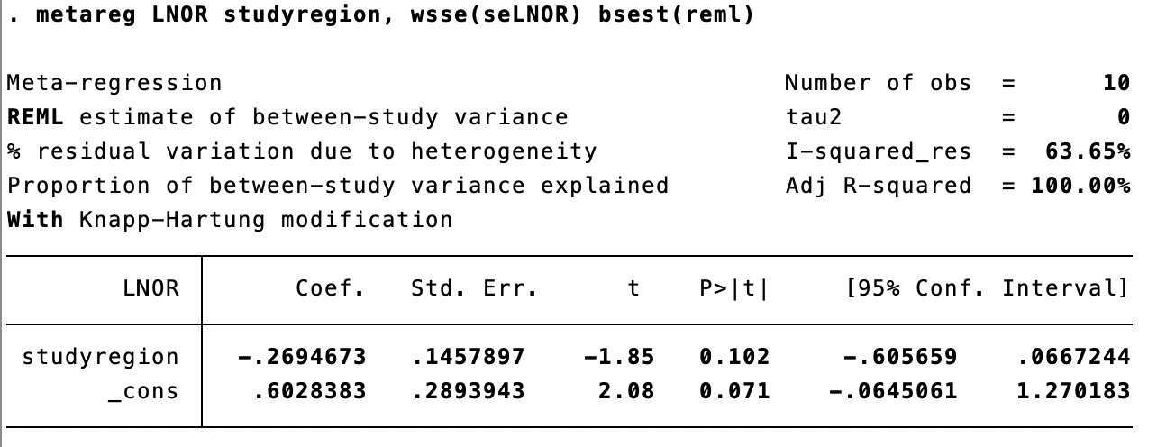
Figure 3. Meta-regression of the study region of age.
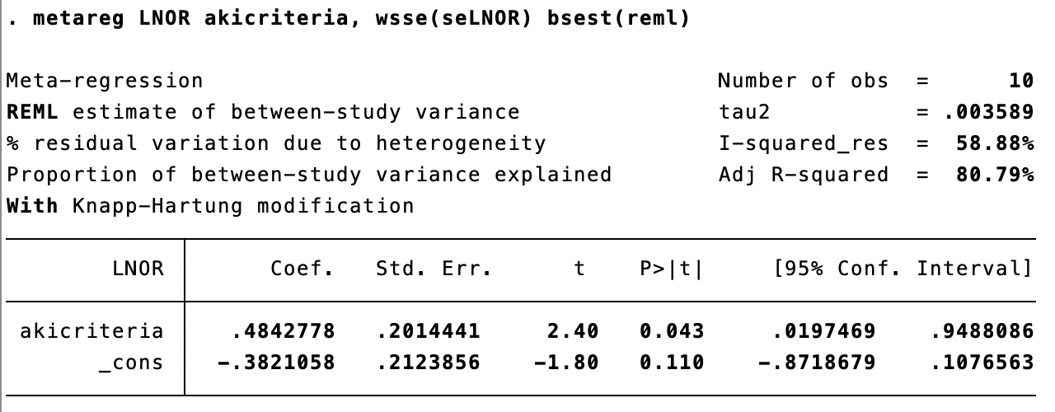
Figure 4. Meta-regression of the AKI criteria of age.
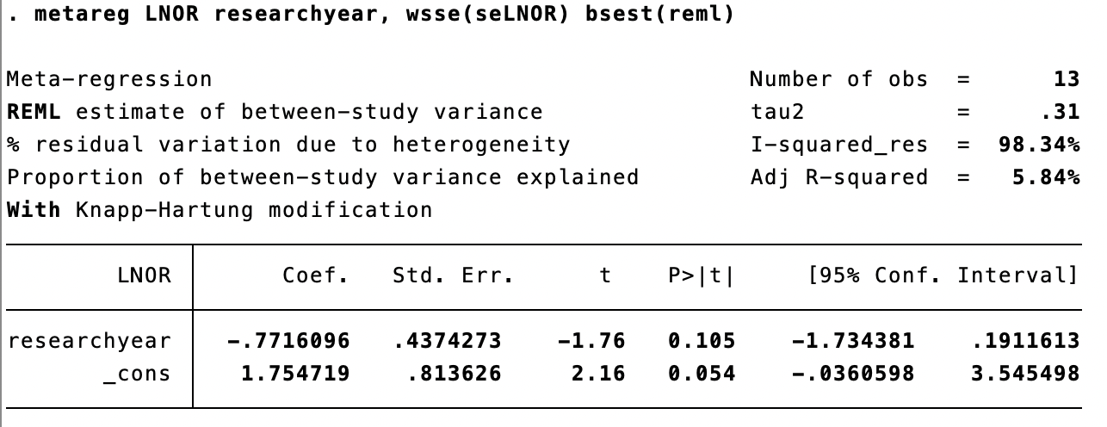
Figure 5. Meta-regression of the research year of preoperative Scr.
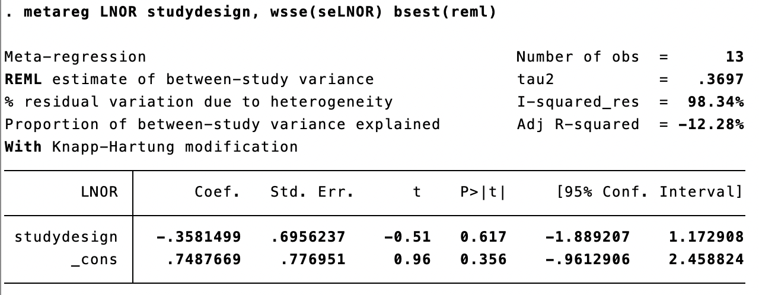
Figure 6. Meta-regression of the study design of preoperative Scr.
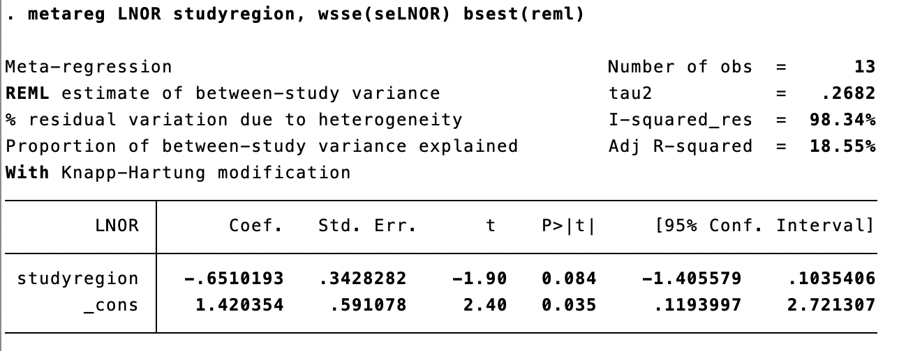
Figure 7. Meta-regression of the study region of preoperative Scr.
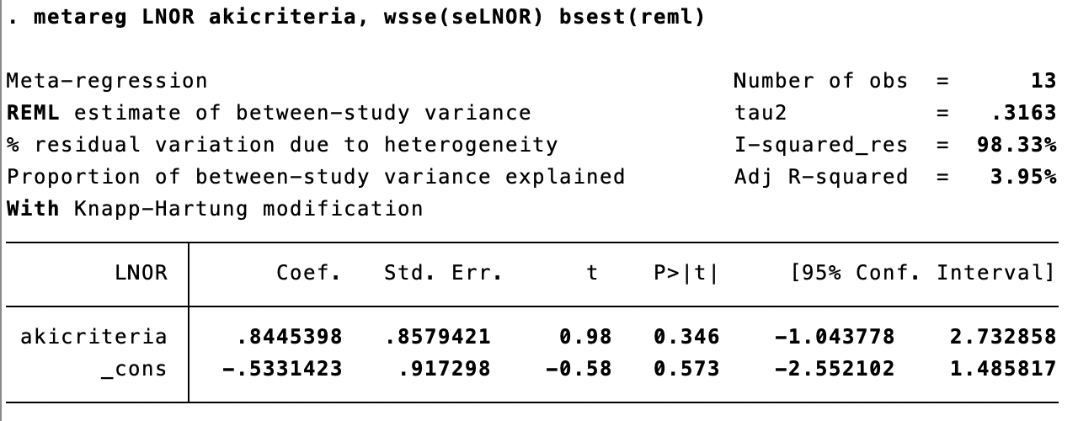
Figure 8. Meta-regression of the AKI criteria of preoperative Scr.
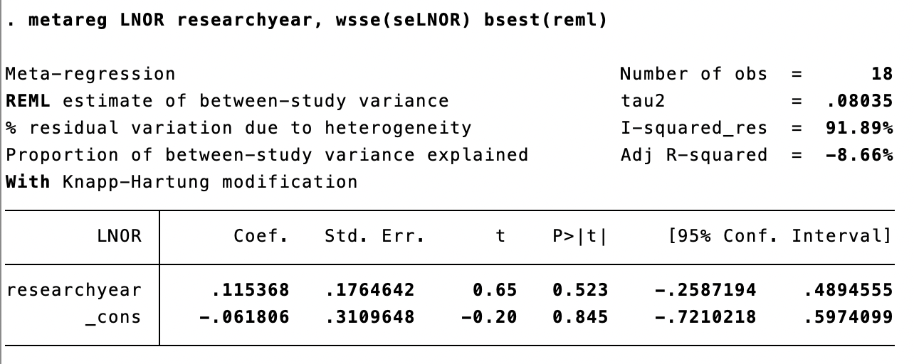
Figure 9. Meta-regression of the research year of CPB time.
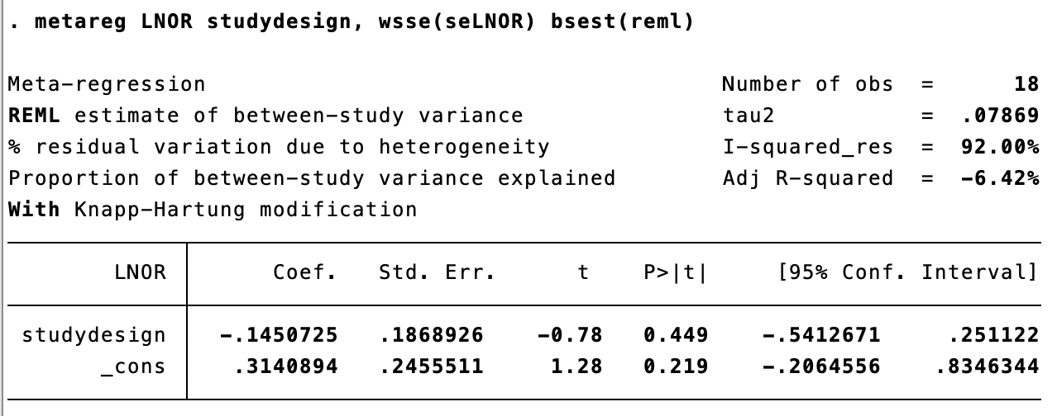
Figure 10. Meta-regression of the study design of CPB time.
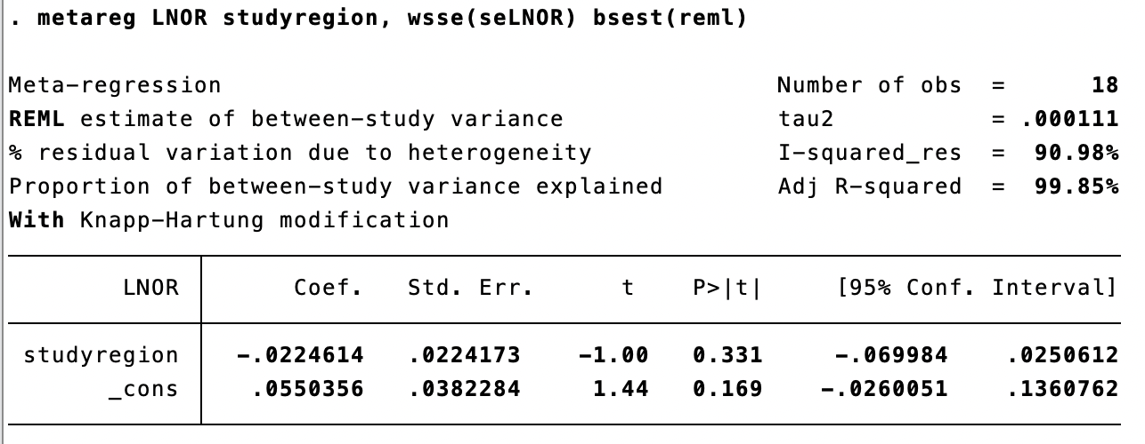
Figure 11. Meta-regression of the study region of CPB time.
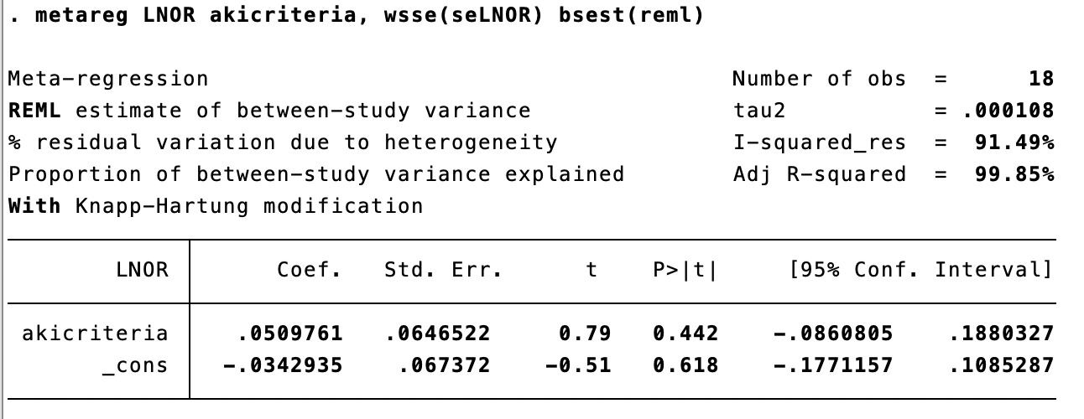
Figure 12. Meta-regression of the AKI criteria of CPB time.

