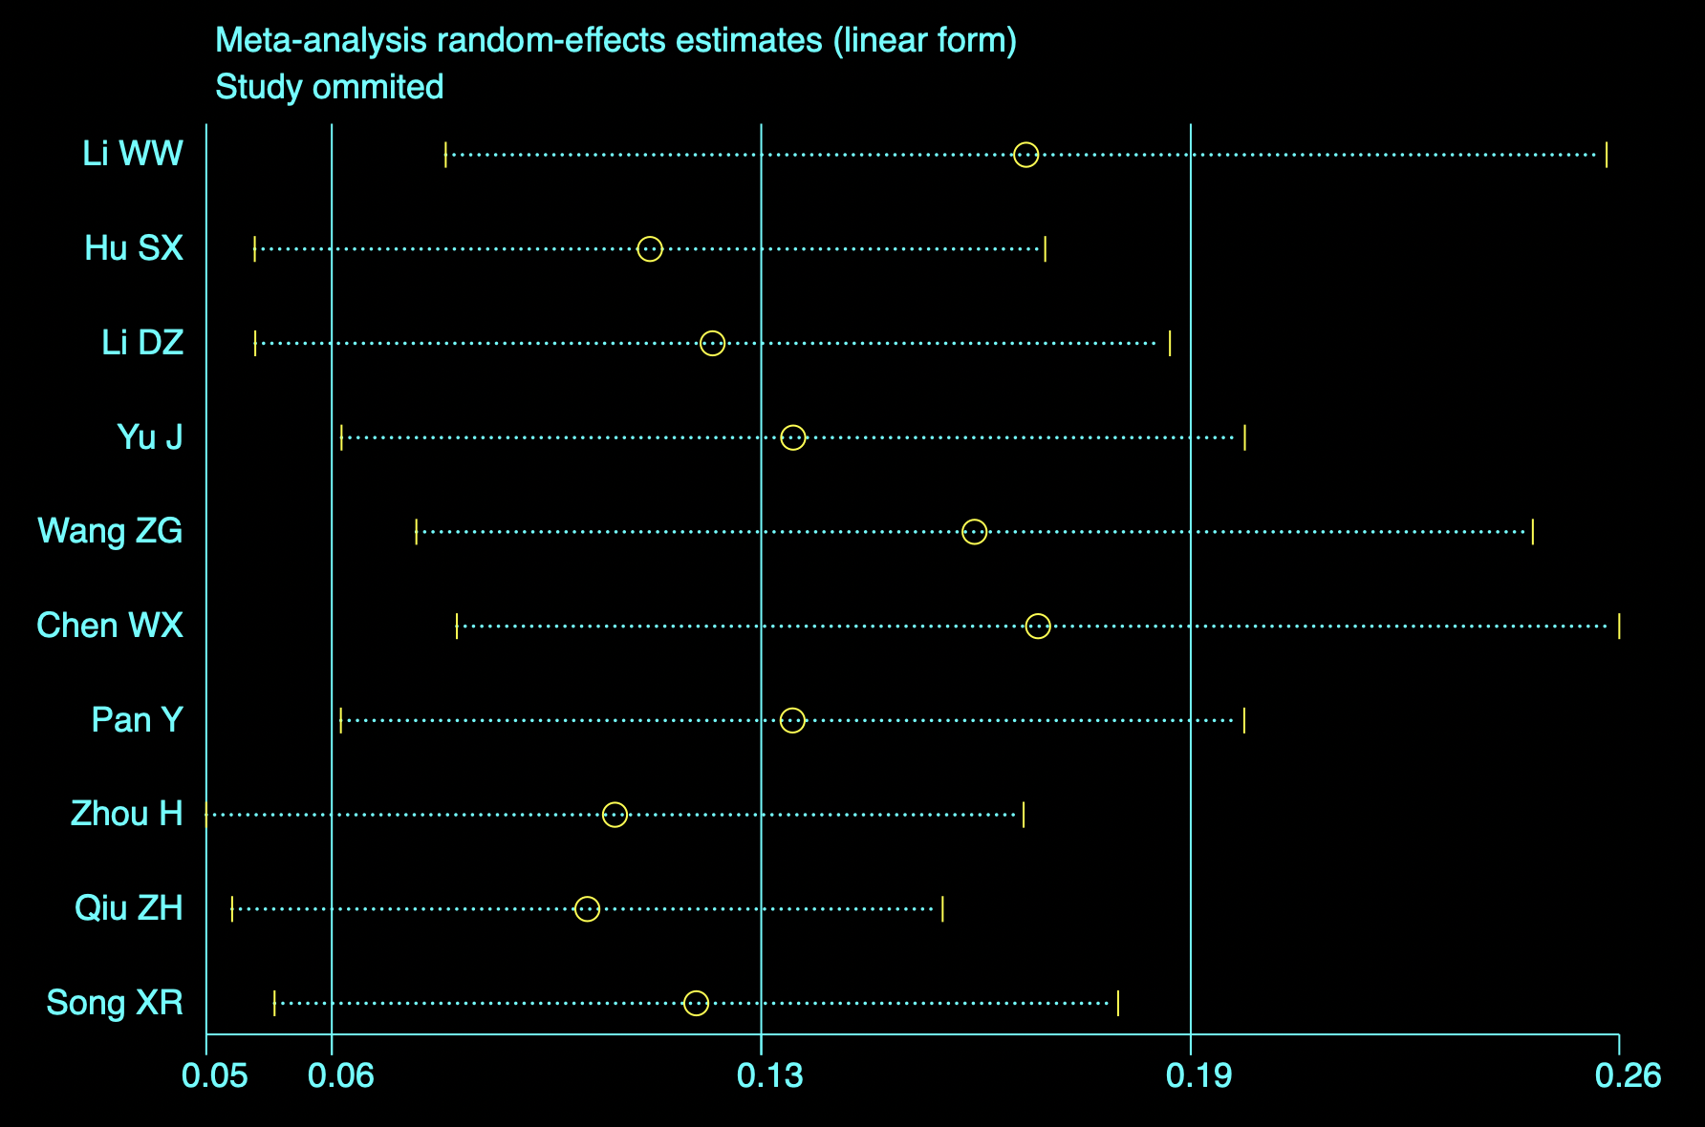
Figure 1. Sensitivity analysis of age.
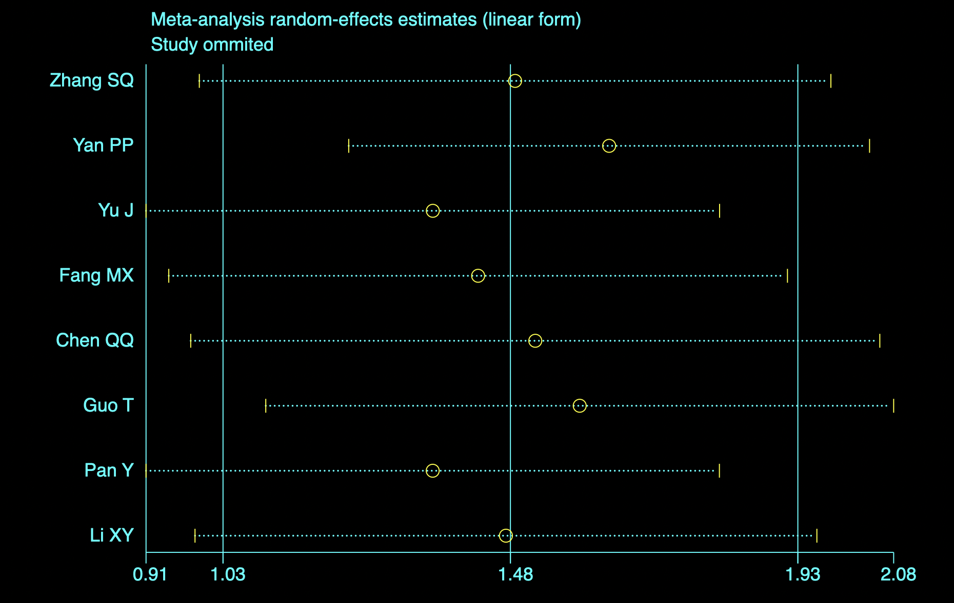
Figure 2. Sensitivity analysis of renal artery involvement.
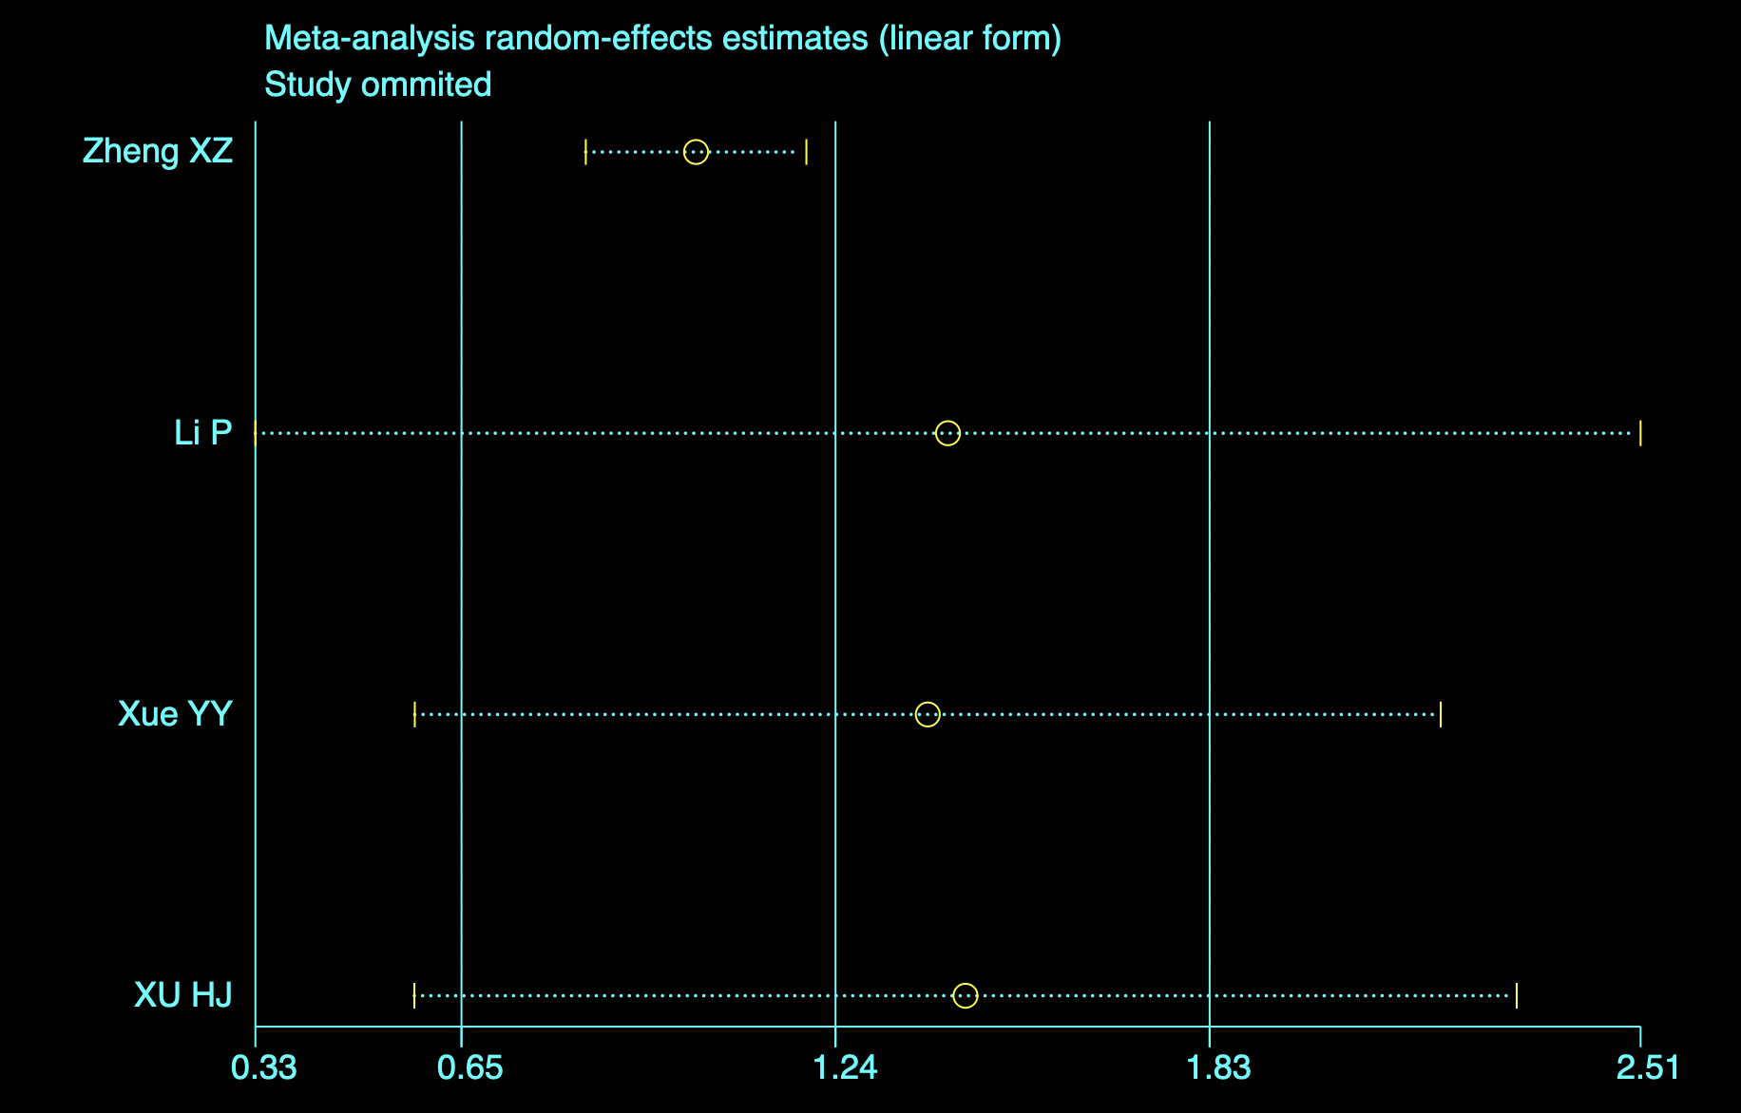
Figure 3. Sensitivity analysis of preoperative cardiac tamponade.
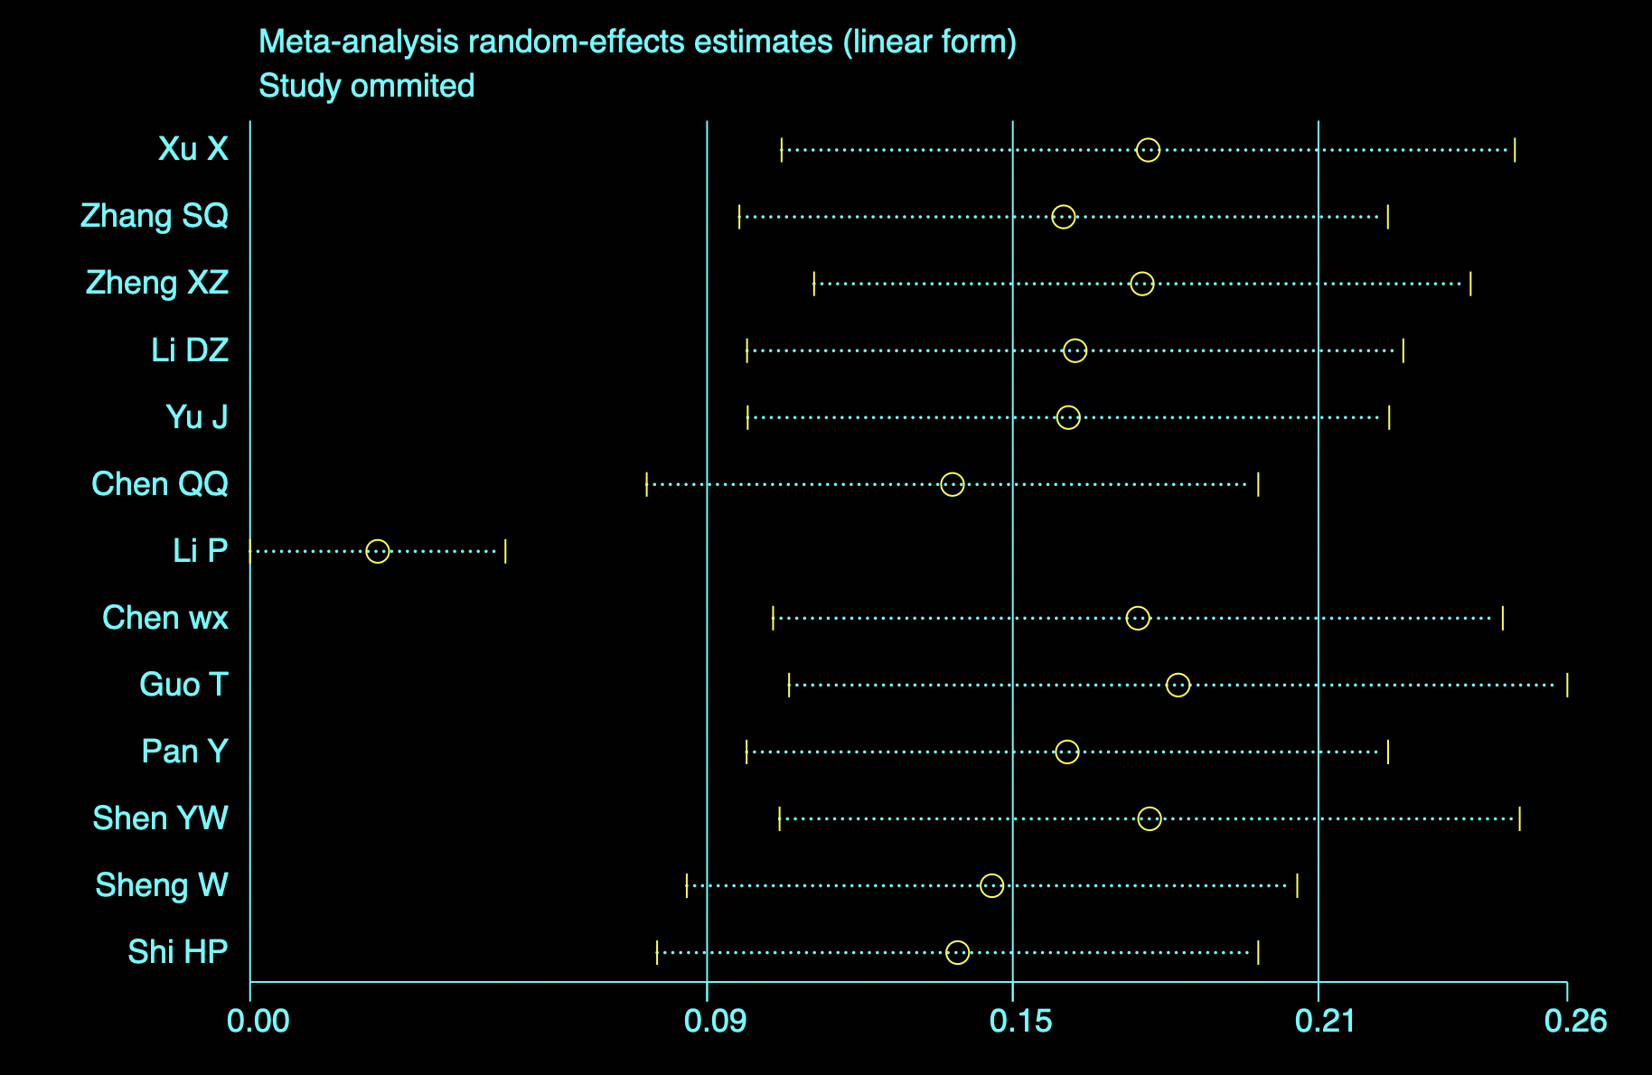
Figure 4. Sensitivity analysis of preoperative Scr.
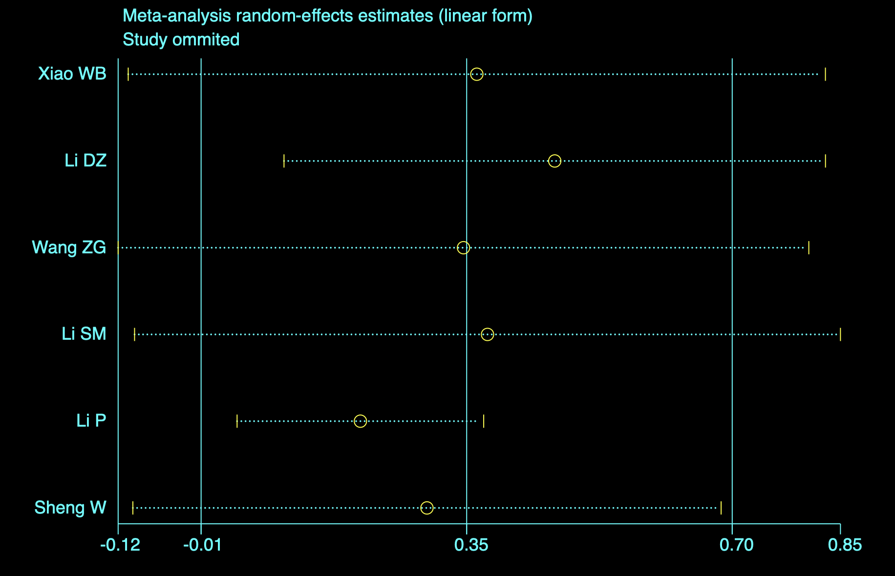
Figure 5. Sensitivity analysis of preoperative WBCs.
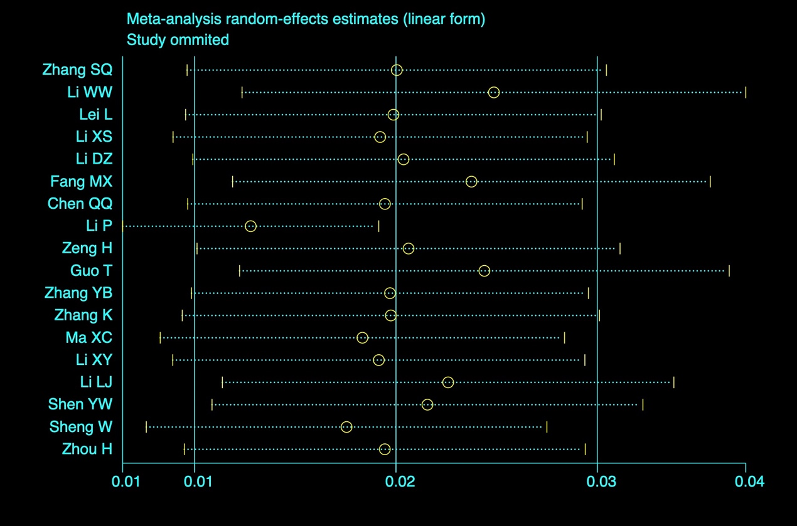
Figure 6. Sensitivity analysis of CPB time.
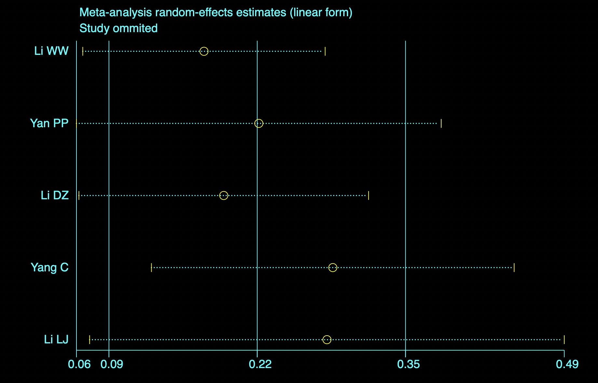
Figure 7. Sensitivity analysis of intraoperative RBCs transfusion volume.

