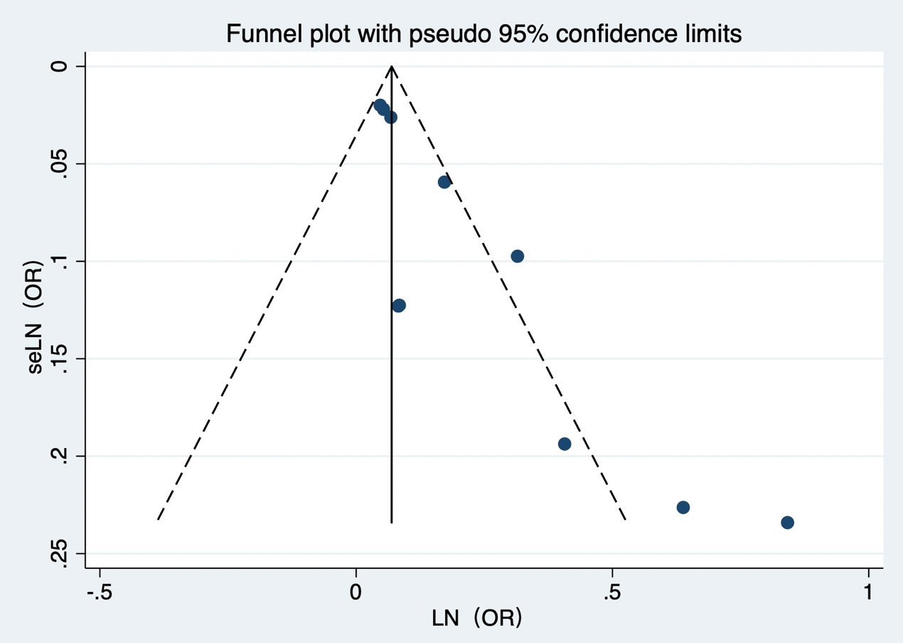
Figure 1. Funnel Graph of age.
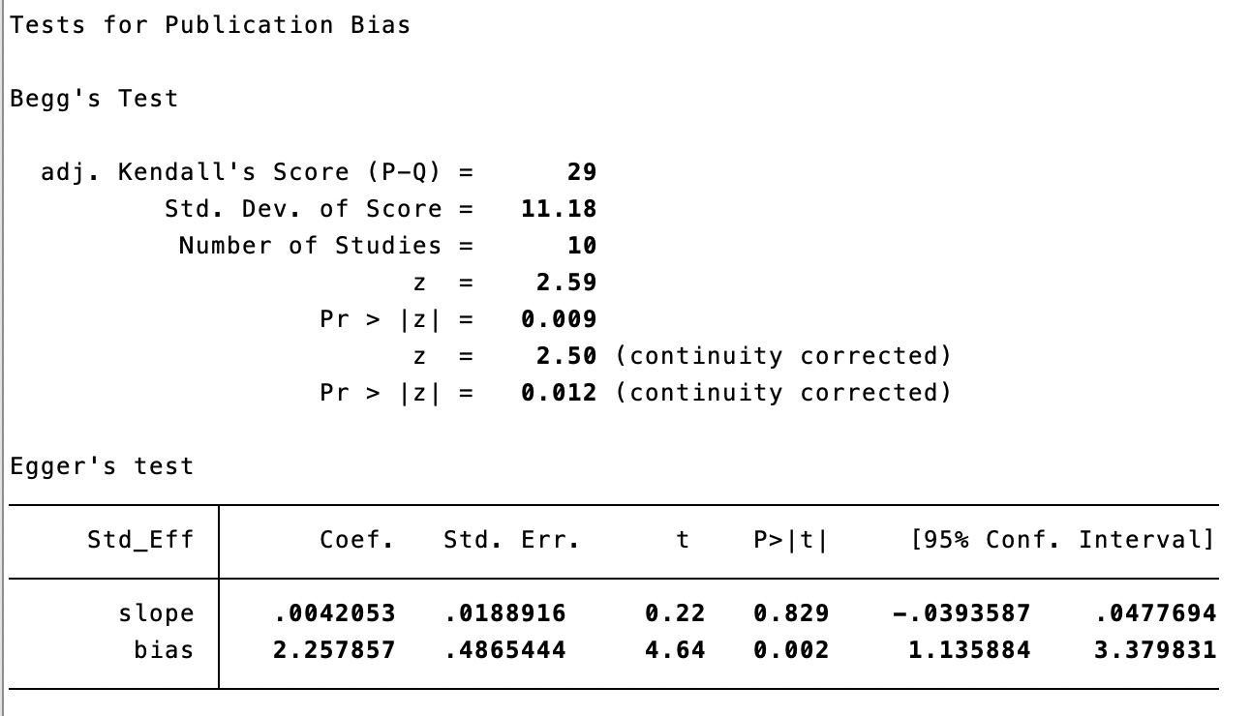
Figure 2. Publication Bias of age.
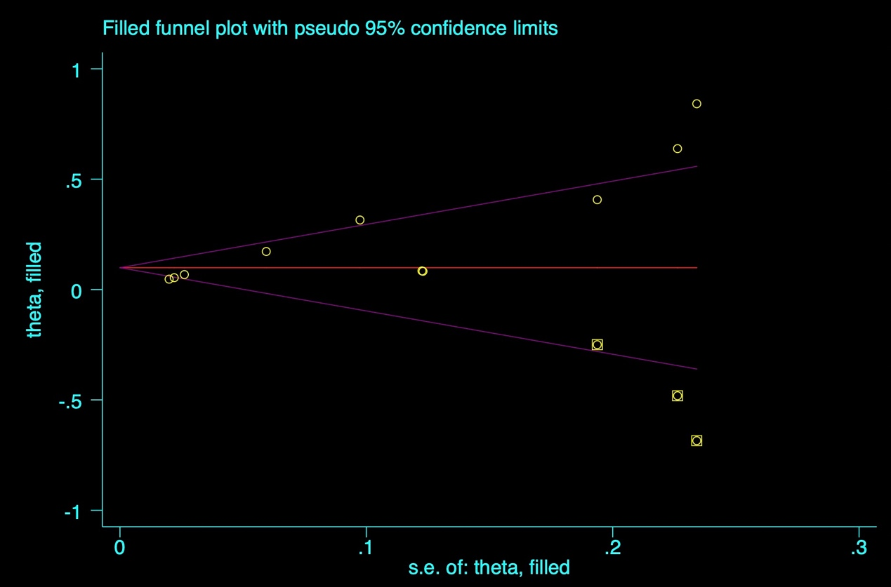
Figure 3. Trim and fill analysis of age.
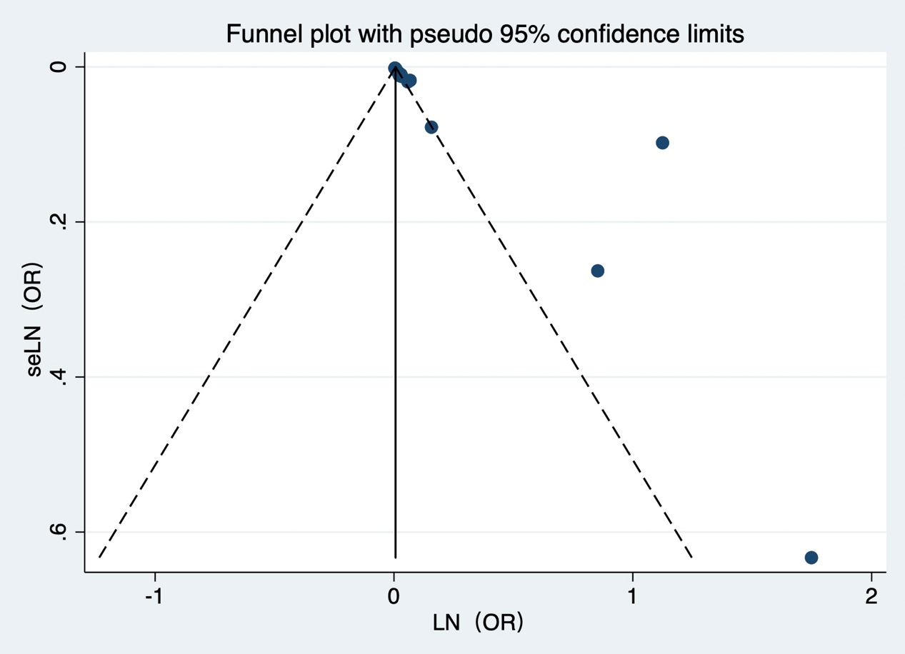
Figure 4. Funnel Graph of CPB time.
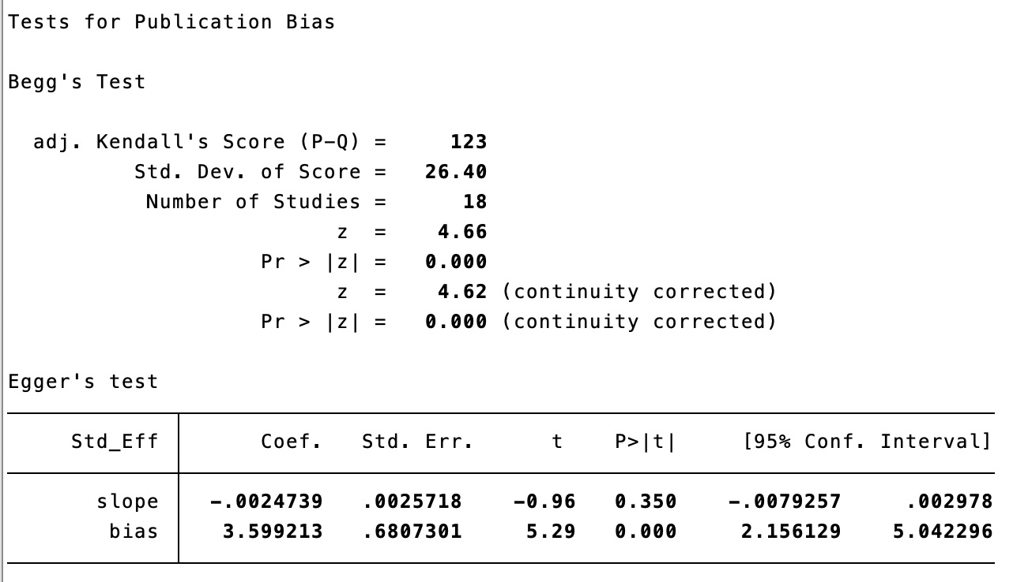
Figure 5. Publication Bias of CPB time.
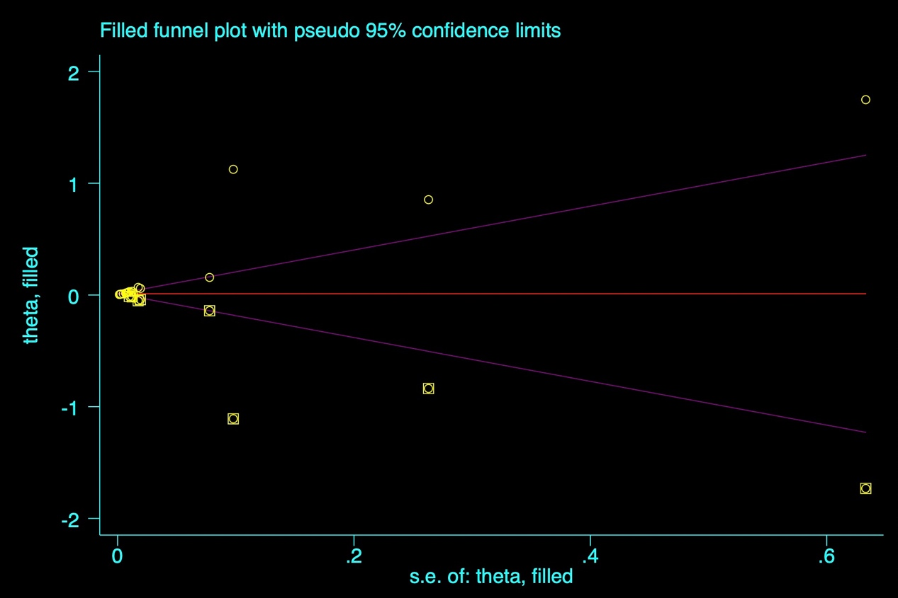
Figure 6. Trim and fill analysis of CPB time.
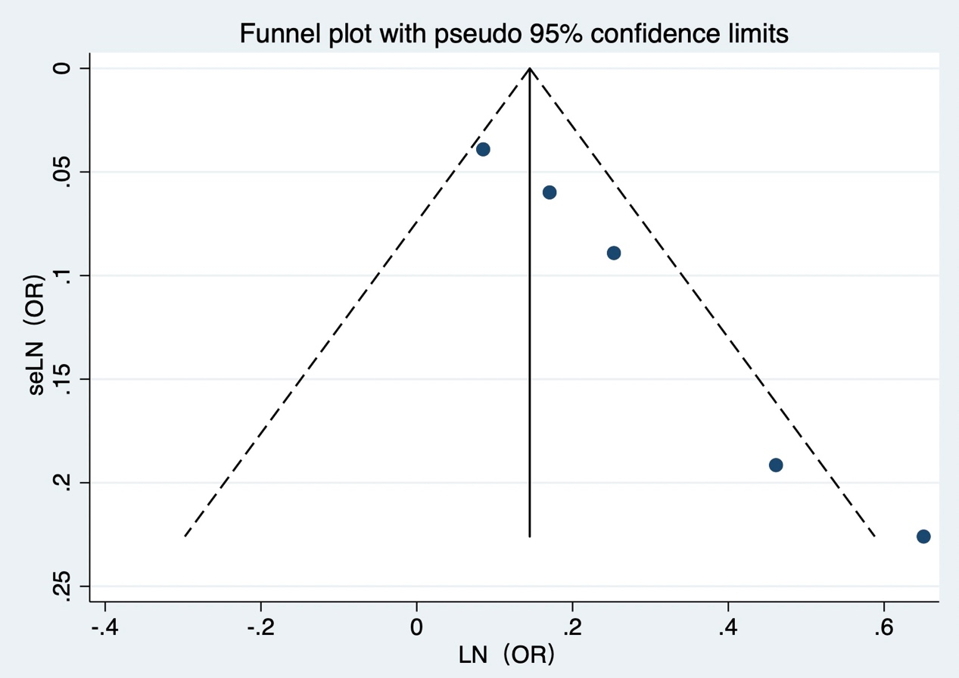
Figure 7. Funnel Graph of intraoperative RBCs transfusion volume.
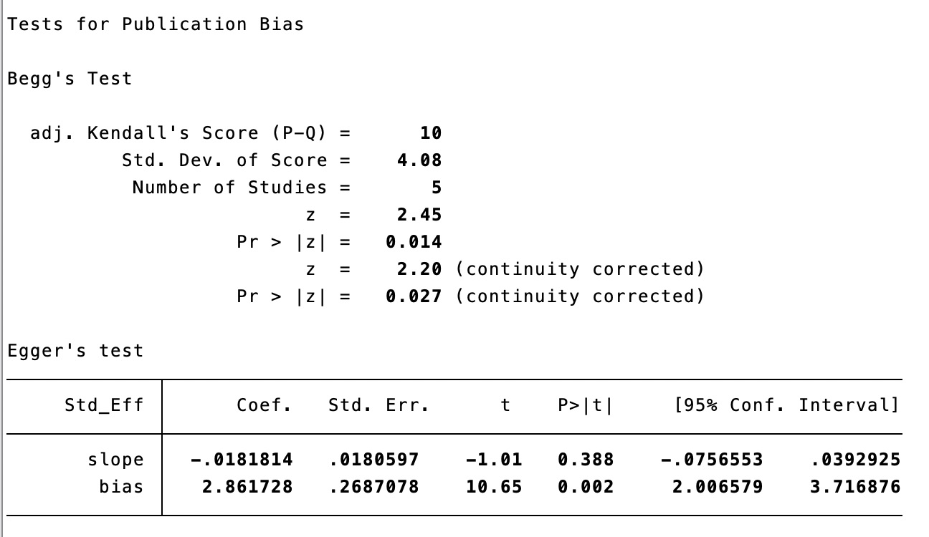
Figure 8. Publication Bias of intraoperative RBCs transfusion volume.
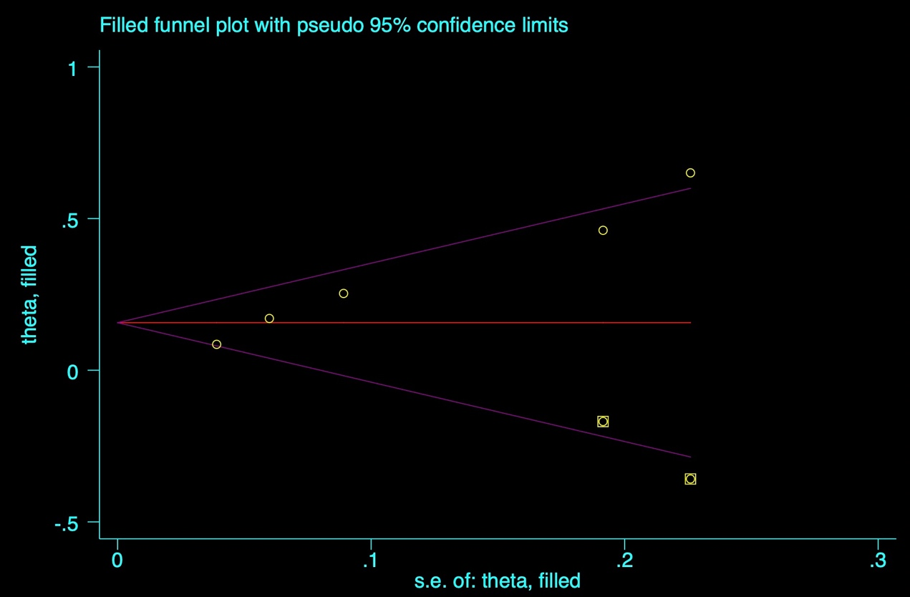
Figure 9. Trim and fill analysis of intraoperative RBCs transfusion volume.

