Outcomes of Mechanical and Bioprosthetic Surgical Valve Replacements in Egypt: Evidence from a Literature Review and Experts’ Survey

Appendix 5: Expert survey responses

Section 1: Experts’ demographics (Q1-Q3)

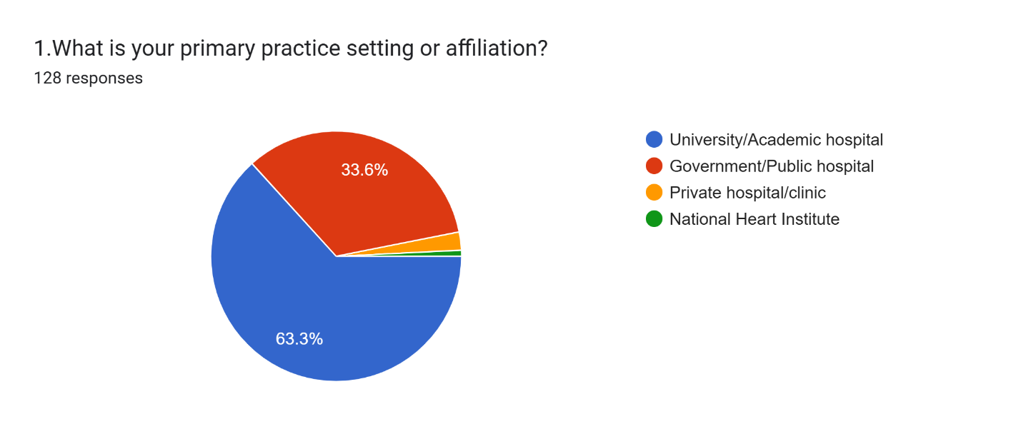
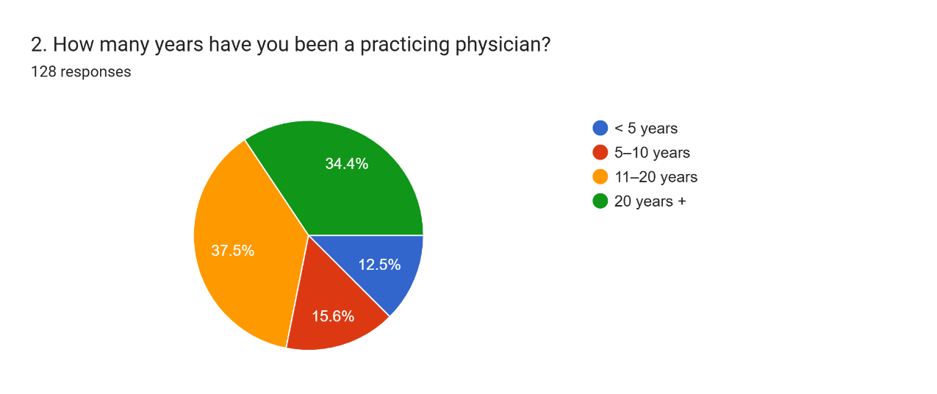
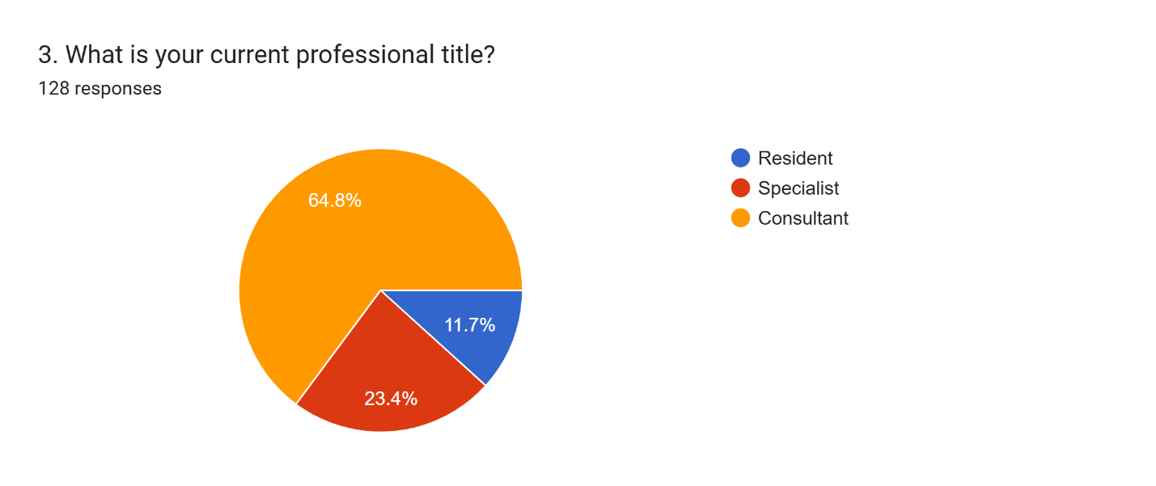

Section 2: Valve Selection Criteria and Preferences (Q4-Q8)
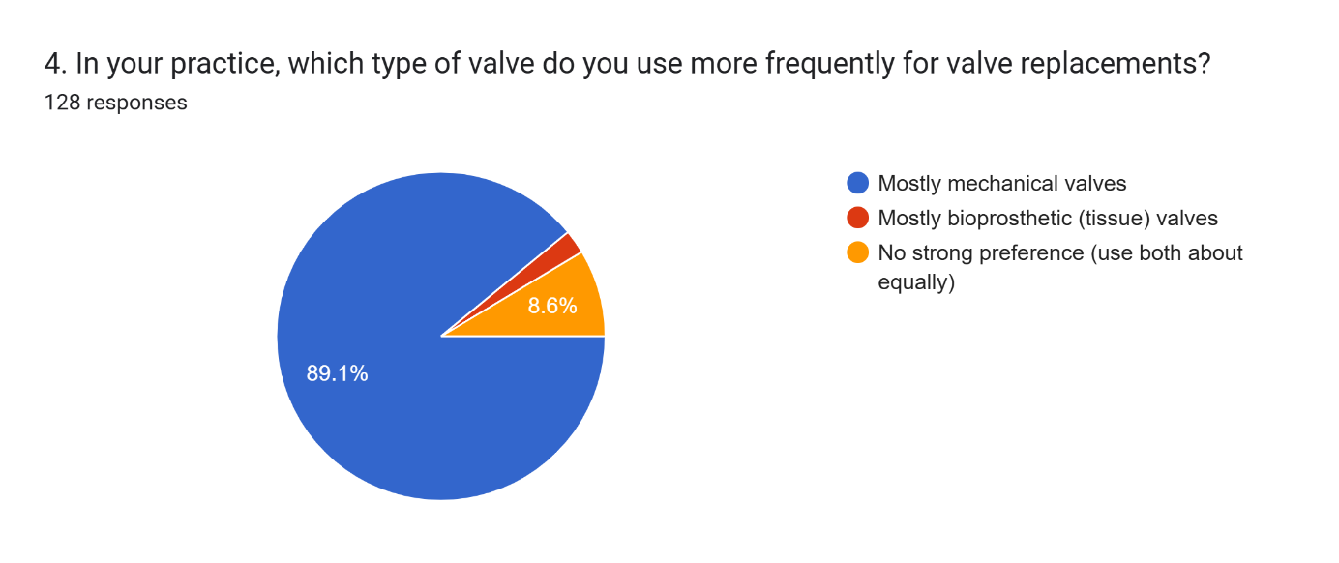
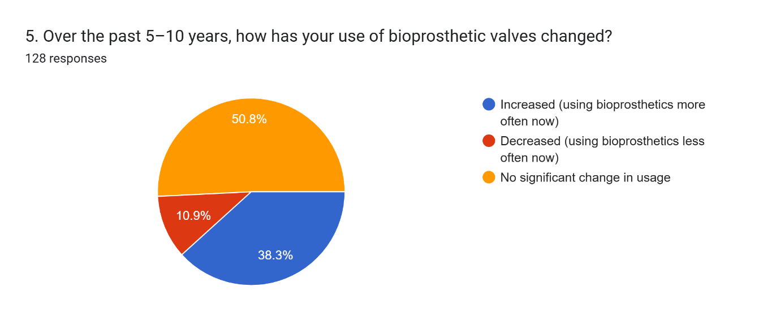
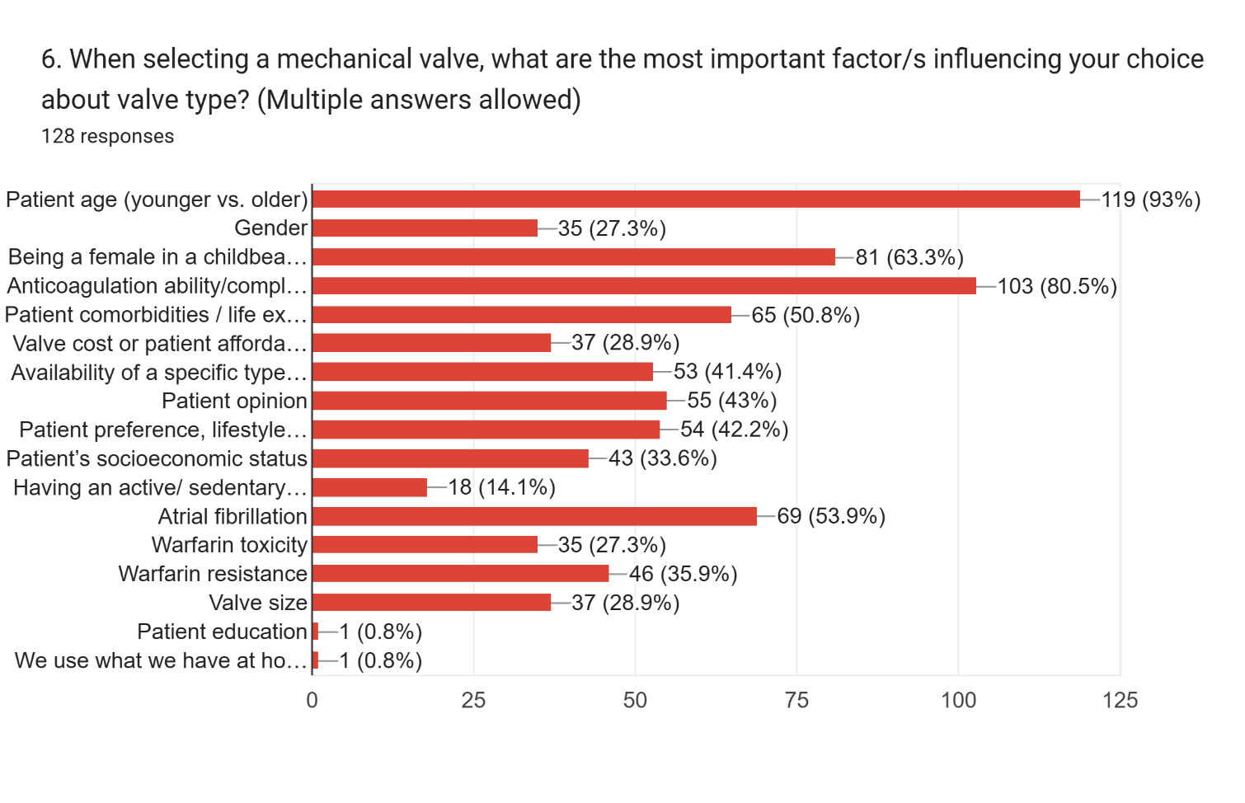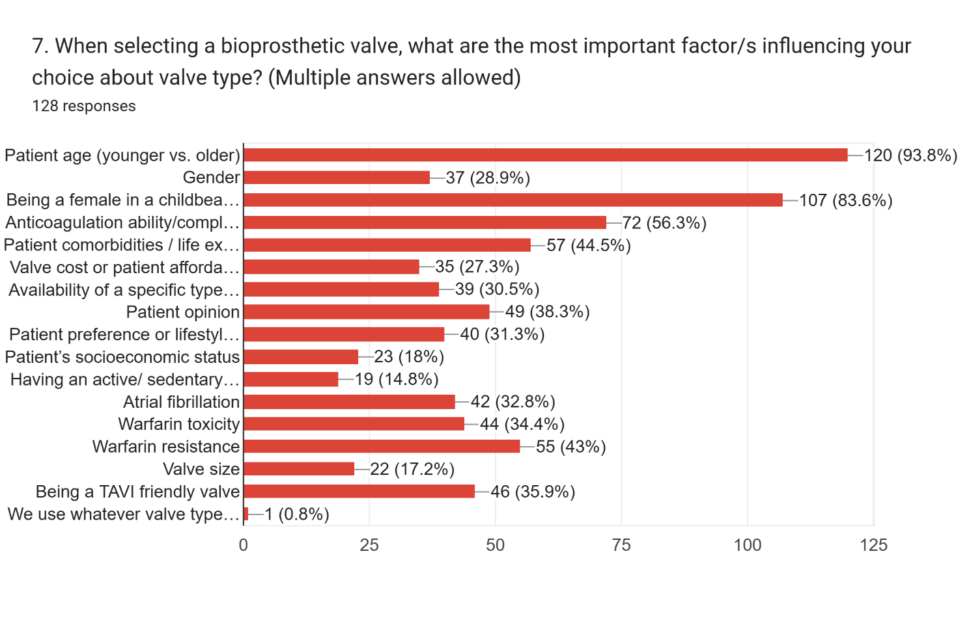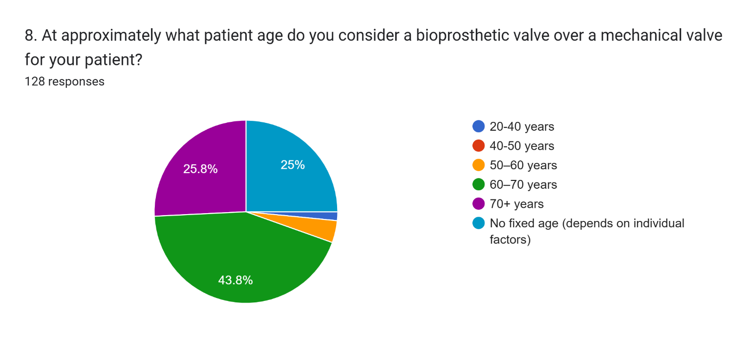

Section 3: Clinical Outcomes and Complications (Q9-Q21)

9. From real life practice in Egypt, approximately how many years does a bioprosthetic valve typically last in a middle-aged patient before needing replacement (reoperation)?
10. From real life practice in Egypt, approximately how many years does a mechanical valve typically last in a middle-aged patient before needing replacement (reoperation)?

Mechanical valves demonstrate significantly longer durability, lasting a mean of 20.8 ± 8.2 years, compared to bioprosthetic valves, which last a mean of 9.0 ± 2.9 years.

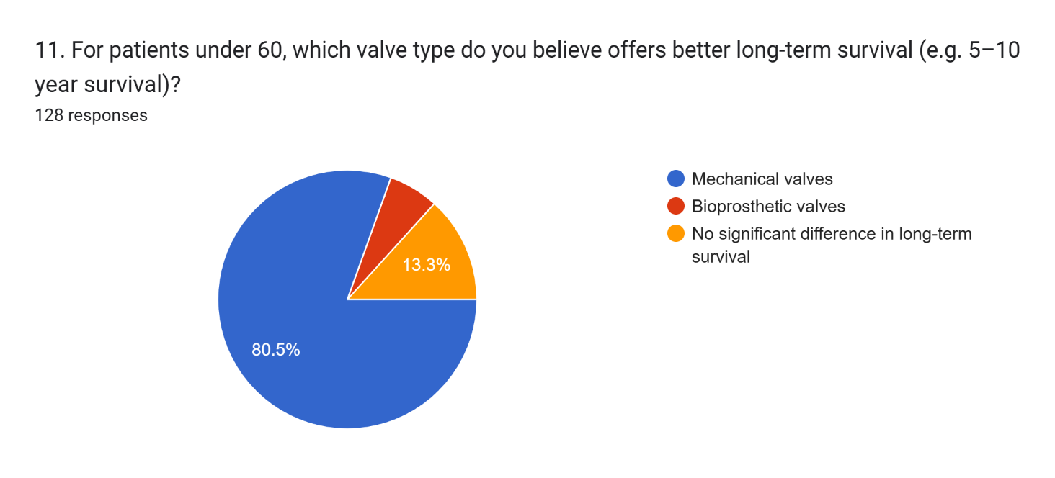
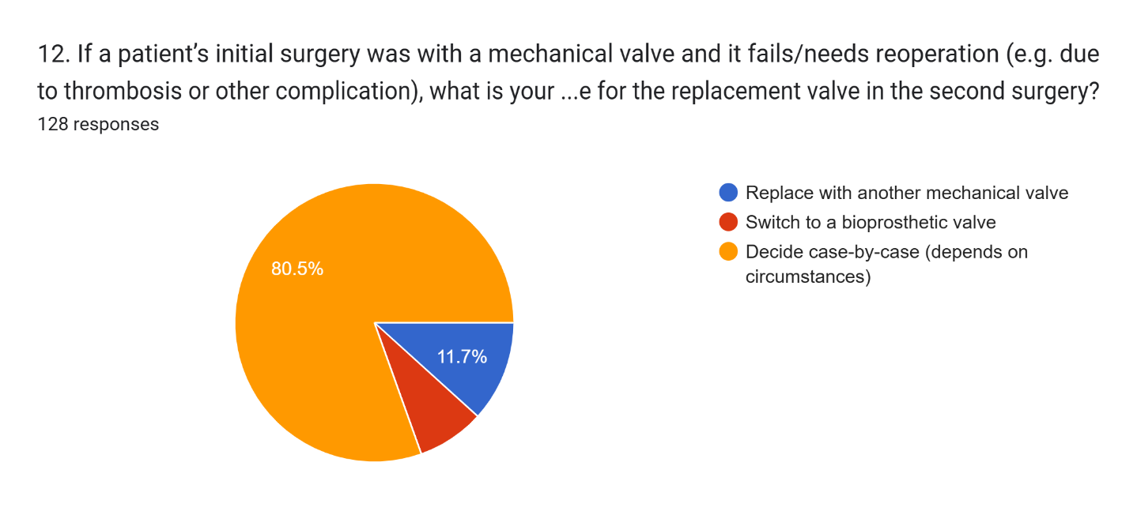

13. What proportion of your patients with mechanical valves are compliant with anticoagulation (e.g. Warfarin)?
72.7% ± 26.2% of patients with mechanical valves were compliant with anticoagulation therapy.
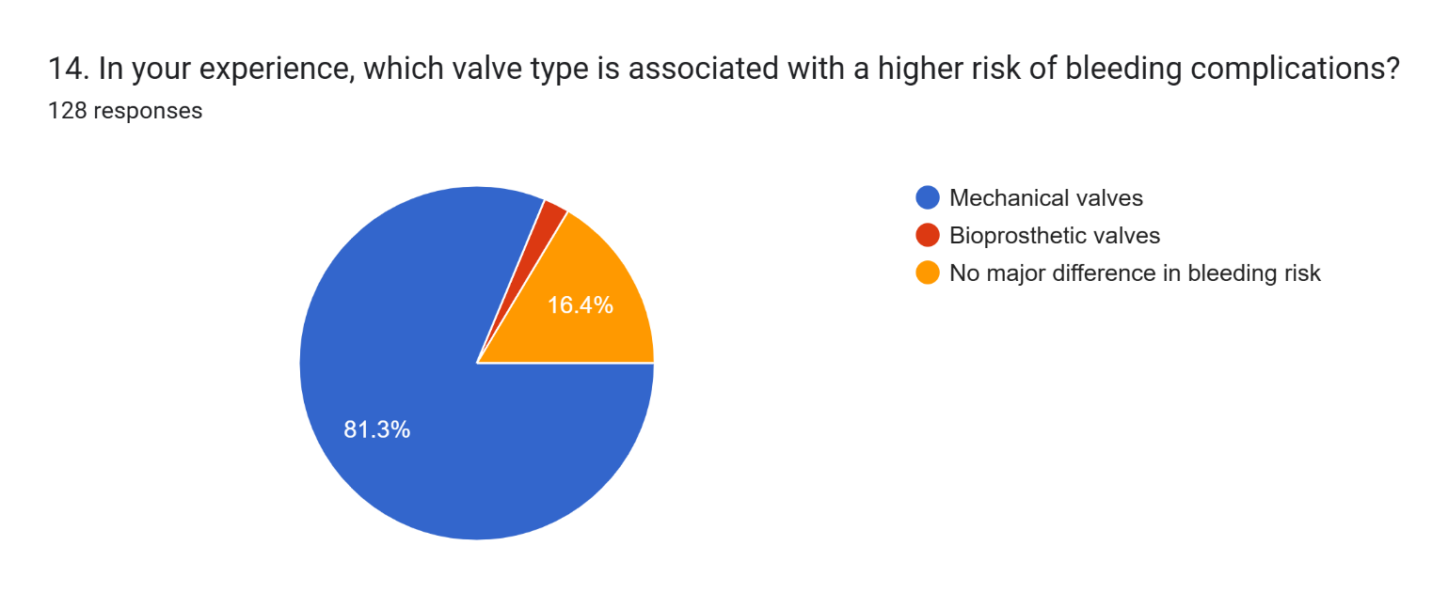
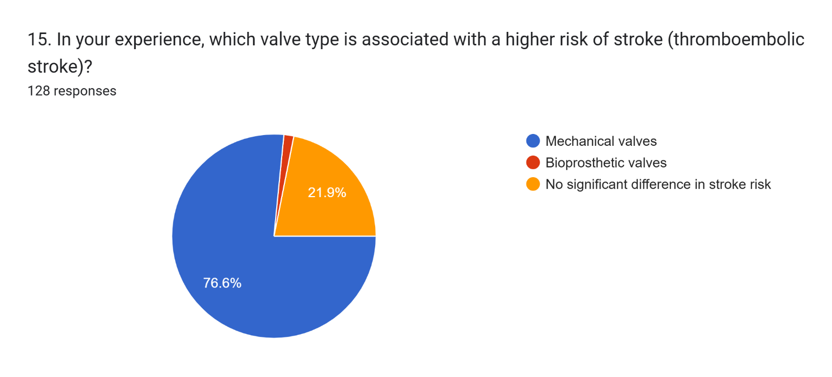
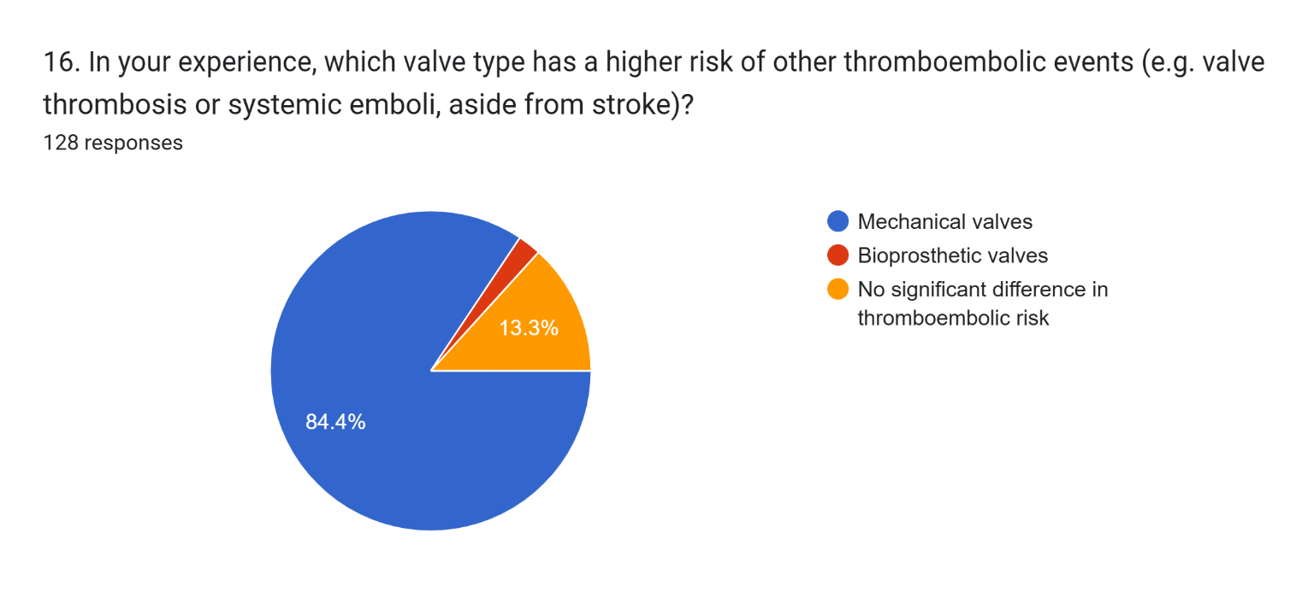
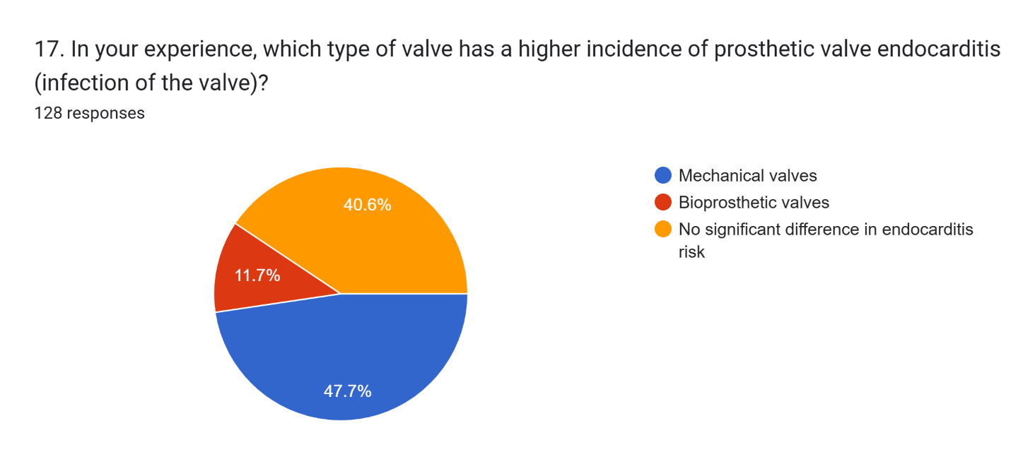
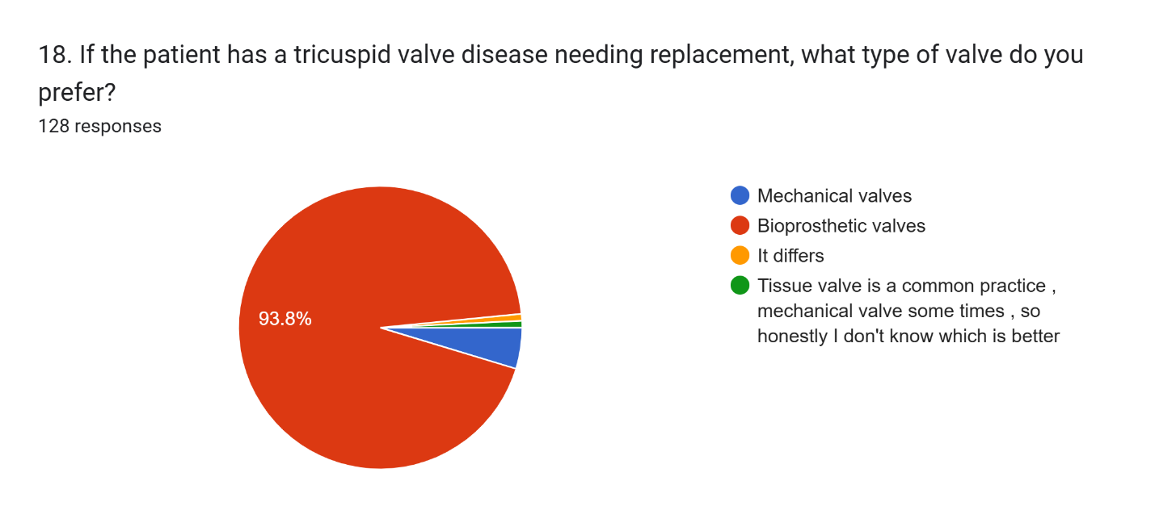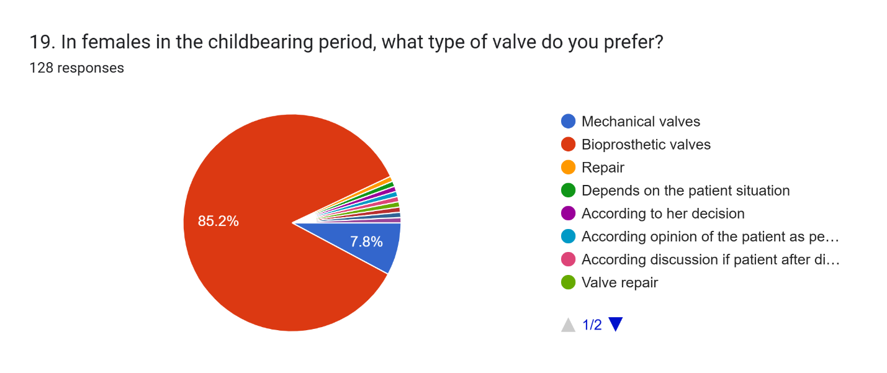
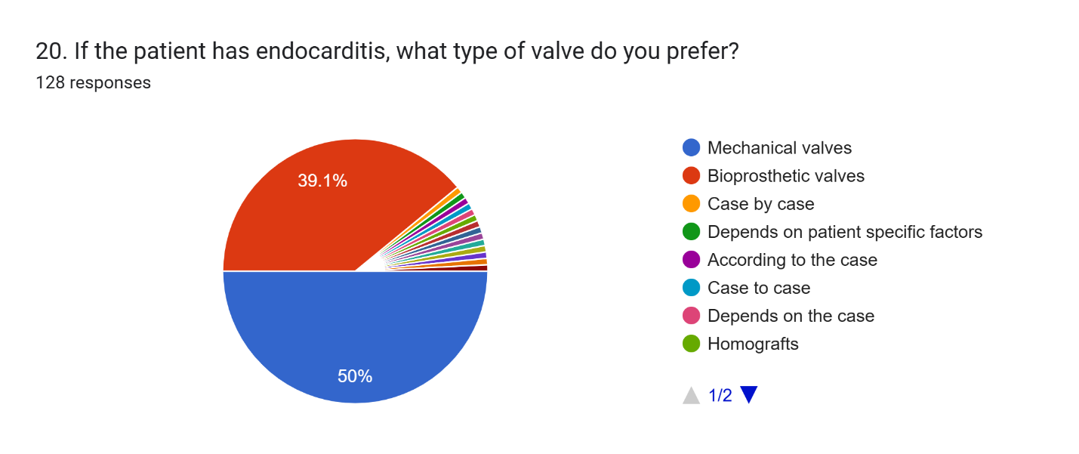
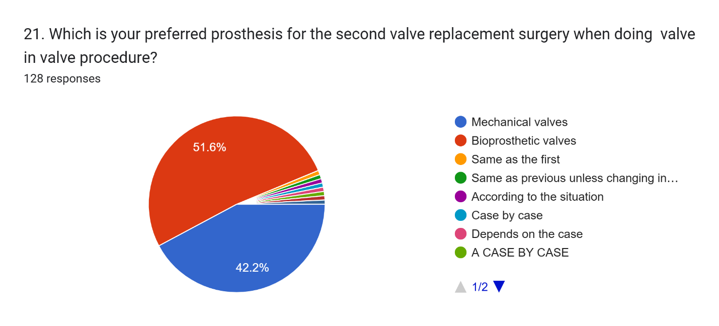

Section 4: Expert Insights (Q22-Q23)
22.What do you consider the biggest drawbacks of mechanical valves in Egypt?
Theme | n | % | Examples of drawbacks mentioned
Anticoagulation-related issues | 64 | 50.0 | Lifelong anticoagulation needs, INR monitoring difficulties, warfarin toxicity, bleeding risk, socioeconomic barriers
Thrombosis & thromboembolic complications | 24 | 18.8 | Valve thrombosis, stuck valve, thromboembolic events, pannus formation
Compliance & patient-related issues | 20 | 15.6 | Poor compliance, low literacy, lack of follow-up, young women concern
Bleeding complications | 12 | 9.4 | General bleeding, bleeding with noncompliance, mitral bleeding
Availability & cost issues | 5 | 3.9 | Limited availability, high cost, price fluctuations
Other issues | 3 | 2.3 | Valve noise, prosthetic dysfunction, limited options

23. What do you consider the biggest drawbacks of bioprosthetic valves in Egypt? ?
Theme | N | % | Examples of drawbacks mentioned
Limited durability and structural degeneration | 70 | 54.7 | Early degeneration, SVD, short life span, frequent reoperation, dysfunction
High cost and economic issues | 30 | 23.4 | High price, financial burden, affordability challenges
Availability and accessibility issues | 20 | 15.6 | Limited availability, poor storage, lack of types
Risk of infection and complications | 5 | 3.9 | Endocarditis, thrombosis, pannus
Patient-related issues and fear of redo surgery | 3 | 2.3 | Patient fear of reoperation, poor follow-up
Other / not specific | 2 | 1.6 | "Nothing", "No specific", general comments

Section 5: Egypt vs. Global Context (Q24-Q25)
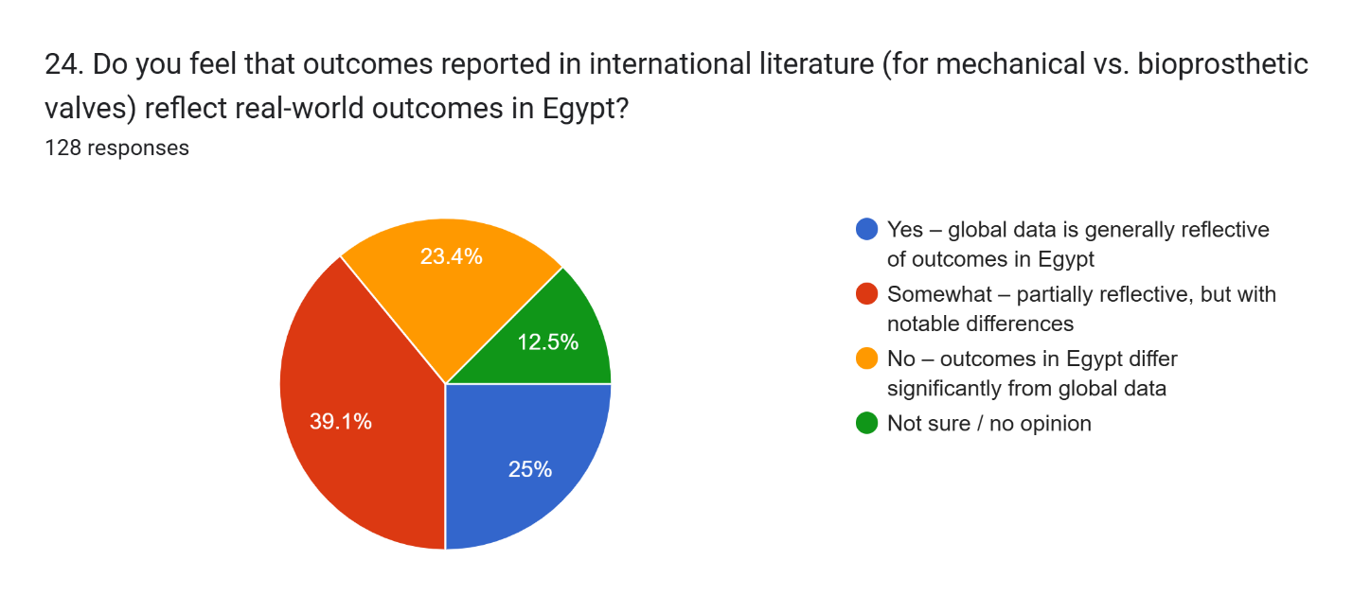
25. If you perceive differences in outcomes for Egypt, what are the key factors you believe are responsible? (one or two words, e.g. “compliance”)
Theme | n | % | Examples of factors mentioned by physicians
Compliance & patient-related | 55 | 43.0 | Compliance, follow-up, lifestyle, cultural levels, patient knowledge
Socioeconomics & cost | 11 | 8.6 | Cost, affordability, socioeconomic standards, financial issues
Anticoagulation-related | 10 | 7.8 | Anticoagulation control, warfarin monitoring, INR follow-up
Health system & data | 9 | 7.0 | Availability of valves, lack of registries, poor follow-up systems
Pathology-related | 6 | 4.7 | Rheumatic fever, different pathology, age-related factors
Education & awareness alone | 5 | 3.9 | Patient awareness, lack of education, less education
Valve type & durability | 5 | 3.9 | Type of bio prosthesis, mechanical valve, early degeneration
No difference / no opinion | 16 | 12.5 | "No difference", "no opinion", "same outcome"
Other | 11 | 8.6 | Adjustable research, surgeon experience, data bias, miscellaneous

