Supplementary Figure S1. Preoperative fibrinogen

Supplementary Figure S2. Preoperative platelet count

Supplementary Figure S3. Preoperative ALT

Supplementary Figure S4. Preoperative AST

Supplementary Figure S5. Preoperative total bilirubin

Supplementary Figure S6. Operative time.
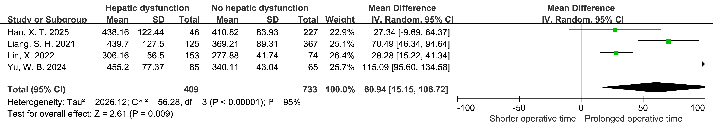

Supplementary Figure S7. Postoperative mechanical ventilation time

Supplementary Figure S8. Postoperative 24-h drainage volume.

Supplementary Figure S9. Postoperative AKI
Supplementary Figure S10. Incidence of Hepatic Dysfunction
