Supplementary TABLES and FIGURES

Supplementary Table S1- Fine–Gray competing-risk models for the primary endpoint according to treatment strategy, including unadjusted analyses and models adjusted by propensity score.
Comparison | Model | sHR | 95% CI | p value
PCI vs OMT | Unadjusted Fine–Gray model | 0.523 | 0.358–0.766 | 0.00088
PCI vs OMT | Fine–Gray model adjusted for the propensity score logit | 0.467 | 0.314–0.695 | 0.00017
PCI vs OMT | Fine–Gray model adjusted for propensity score covariates | 0.448 | 0.296–0.678 | 0.00015
CABG vs OMT | Unadjusted Fine–Gray model | 0.410 | 0.272–0.617 | 0.000019
CABG vs OMT | Fine–Gray model adjusted for the propensity score logit | 0.439 | 0.275–0.700 | 0.00055
CABG vs OMT | Fine–Gray model adjusted for propensity score covariates | 0.444 | 0.283–0.698 | 0.00042
Intervention vs OMT | Unadjusted Fine–Gray model | 0.466 | 0.339–0.640 | 0.0000024
Intervention vs OMT | Fine–Gray model adjusted for the propensity score logit | 0.488 | 0.340–0.700 | 0.000096
Intervention vs OMT | Fine–Gray model adjusted for propensity score covariates | 0.480 | 0.334–0.689 | 0.000071
Abbreviations: sHR, sub distribution hazard ratio; CI, confidence interval; PCI, percutaneous coronary intervention; CABG, coronary artery bypass grafting; OMT, optimal medical therapy. Footnote: Unadjusted Fine–Gray models are shown together with two adjusted approaches: adjustment for the propensity score logit and adjustment for the baseline covariates included in the propensity score model. For the CABG versus OMT comparison, a more parsimonious propensity score specification was used to improve covariate balance. Subdistribution hazard ratios <1 indicate a lower cumulative incidence of the primary endpoint in the revascularization group relative to OMT.

Supplementary Table S2. Covariate balance and effective sample size after propensity score adjustment across treatment comparisons.
____________________________________________________________________________
Comparison | Highest SMD Before weighting | Highest SMD After weighting | Control ESS | Treated ESS
PCI vs OMT | 0.5708 (Canadian Cardiovascular Society angina class) | 0.0313 | 494.77 | 468.09
CABG vs OMT | 0.2530 (left main coronary artery disease) / 0.2244 (Canadian Cardiovascular Society angina class) | 0.0639 | 437.07 | 515.38
Intervention vs OMT | 0.4005 (Canadian Cardiovascular Society angina class) | 0.0602 | 432.56 | 1001.65
Abbreviations: SMD, standardized mean difference; ESS, effective sample size; PCI, percutaneous coronary intervention; CABG, coronary artery bypass grafting; OMT, optimal medical therapy.
Footnote: The table summarizes the highest absolute standardized mean difference before and after propensity score adjustment for each treatment comparison, together with the effective sample size of the control and treated groups after weighting. Post-adjustment SMD values <0.10 were considered indicative of adequate covariate balance. For the CABG versus OMT comparison, a more parsimonious propensity score specification was used to improve balance.

Supplementary Figure 1S

Figure 1S. Cumulative incidence function for treated artery–related events according to treatment strategy, accounting for death as a competing risk (Fine–Gray model).

Supplementary Figure 2S

Figure 2S. Event-free survival according to coronary intervention status (Kaplan–Meier analysis).

Figure 3S. Cumulative incidence of treated-artery-related events according to coronary intervention status (Fine–Gray competing risk analysis).

Figure 4S – Event-free survival according to completeness of coronary revascularization
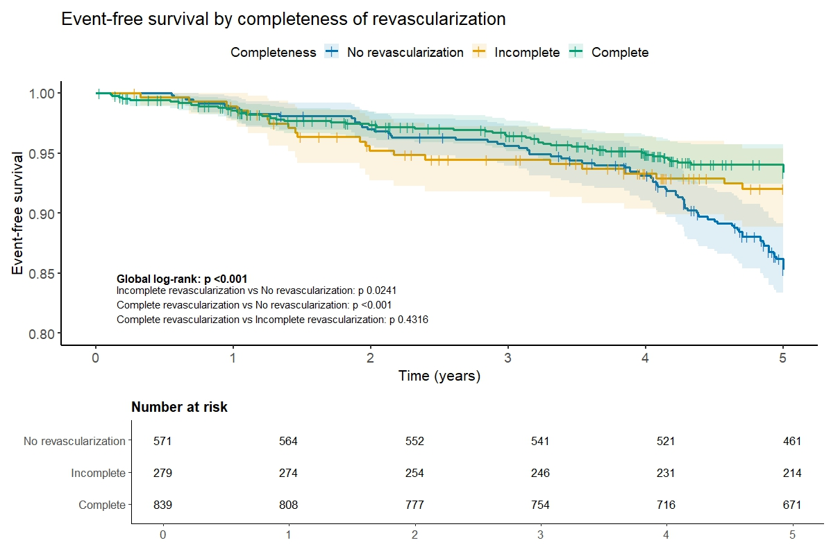

Figure 5 S- Competing risk analysis (Fine and Gray) for an event related to the treated artery.

Table 3 S – Multivariate Cox analysis for events related to the treated artery according to the completeness of revascularization.
Variable |  | HR adjusted (IC 95%) | p-Valor
Incomplete revascularization vs. no revascularization |  | 0.62 (0.38–1.03) | 0.066
Incomplete revascularization vs. no revascularization |  | 0.57 (0.39–0.84) | 0.004
Age (years) |  | 1.01 (0.99–1.03) | 0.377
Male Gender |  | 1.18 (0.81–1.72) | 0.377
Body Mass Index (BMI) |  | 1.01 (0.97–1.05) | 0.691
Diabetes Mellitus |  | 1.55 (1.07–2.24) | 0.019
Hypertension |  | 1.18 (0.74–1.87) | 0.487
Tobaco |  | 1.29 (0.91–1.84) | 0.159
Ejection Fraction (%) |  | 0.99 (0.97–1.01) | 0.324
Serum Creatinine (mg/dL) |  | 1.09 (0.68–1.75) | 0.719
LDL (mg/dL) |  | 1.00 (1.00–1.01) | 0.176
Glycated hemoglobin (%) |  | 1.00 (0.96–1.04) | 0.894
Triglycerides (mg/dL) |  | 1.00 (1.00–1.00) | 0.065
Number of diseased vessels |  | 1.44 (0.96–2.15) | 0.077
HDL (mg/dL) |  | 1.01 (0.99–1.03) | 0.208

Figure 6S – Competing risk analysis (Fine-Gray) for an event related to the treated artery according to the completeness of the revascularization.

