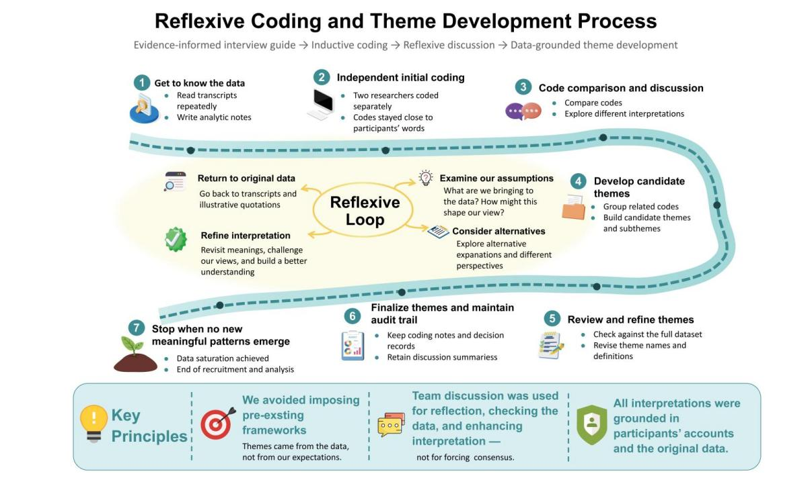
Supplementary material：
Supplementary Figure S1. Reflexive coding and theme development process
Note: This figure summarizes the iterative process used to move from verbatim transcripts to data-grounded themes. The analysis involved independent initial coding, code comparison, return to original transcripts and illustrative quotations, reflexive discussion of researcher assumptions, theme development and refinement, and maintenance of an audit trail. Team discussion was used to enhance interpretation rather than to force consensus or impose pre-existing frameworks.

