SUPPLEMENTARY MATERIAL
Robotic-Assisted versus Conventional Coronary Artery Bypass Grafting: A Systematic Review and Meta-Analysis
Supplementary Table S1. Comprehensive Search Strategy
PubMed/MEDLINE: ((robotic[tiab] OR "robot-assisted"[tiab] OR "da Vinci"[tiab] OR TECAB[tiab] OR RMIDCAB[tiab] OR telemanipulation[tiab]) AND ("coronary artery bypass"[tiab] OR CABG[tiab] OR "coronary revascularization"[tiab])) AND (comparative[tiab] OR matched[tiab] OR cohort[tiab] OR retrospective[tiab] OR prospective[tiab])
Embase: (robotic OR robot-assisted OR da:Vinci OR TECAB OR RMIDCAB) AND (coronary:artery:bypass:graft* OR CABG) AND (comparative OR matched OR cohort)
Cochrane CENTRAL: (robotic OR robot-assisted) AND (coronary artery bypass OR CABG)
Web of Science: TS=(robotic CABG OR robotic coronary artery bypass OR TECAB OR RMIDCAB)
Search date: January 31, 2026. Language: No restriction. Date limits: None.
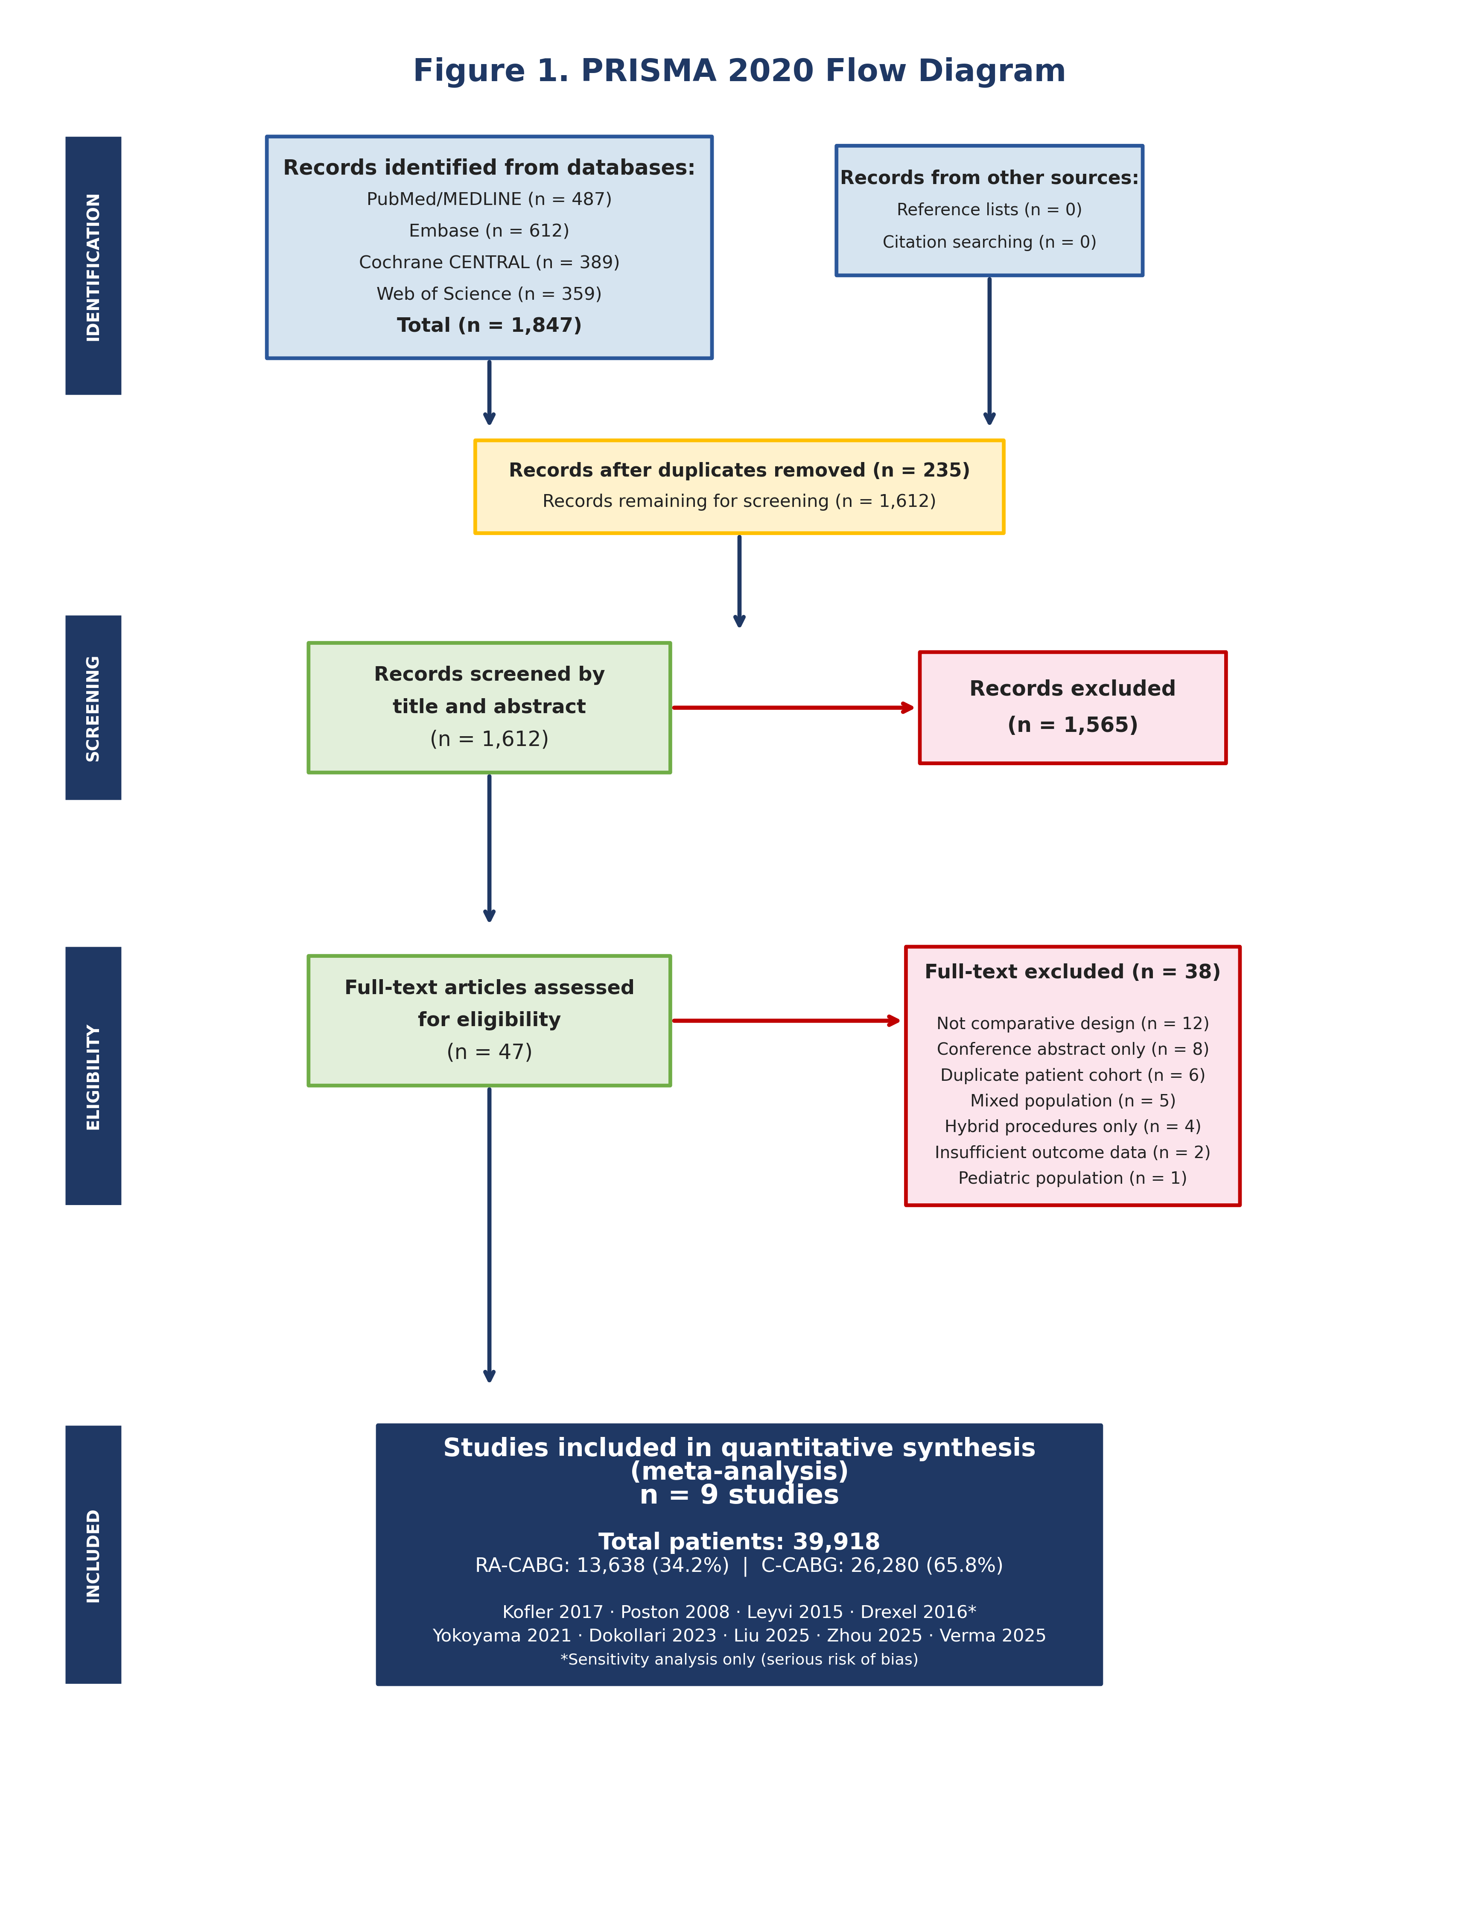
Supplementary Table S2. PRISMA 2020 Checklist
Section/Topic | Item No. | Checklist Item | Location | ✓/NA
Title | 1 | Identify the report as a systematic review. | Title page | ✓
Abstract | 2 | Structured abstract with background, methods, results, conclusions. | Abstract | ✓
Introduction – Rationale | 3 | Rationale for the review. | Section 1 | ✓
Introduction – Objectives | 4 | Explicit objectives and PICO. | Section 1 | ✓
Methods – Eligibility | 5 | Eligibility criteria specified. | Section 2.3 | ✓
Methods – Sources | 6 | Information sources and search dates. | Section 2.2 | ✓
Methods – Search | 7 | Full search strategy for one database. | Supp. Table S1 | ✓
Methods – Selection | 8 | Selection process. | Section 2.4 | ✓
Methods – Data collection | 9 | Data collection process. | Section 2.4 | ✓
Methods – Data items | 10a | All outcomes sought. | Section 2.5 | ✓
Methods – Risk of bias | 11 | Risk of bias assessment. | Section 2.6 | ✓
Methods – Statistics | 13 | Statistical synthesis methods. | Section 2.7 | ✓
Results – Selection | 16 | Study selection results with PRISMA diagram. | Section 3.1 + Fig S1 | ✓
Results – Study characteristics | 17 | Characteristics of studies. | Table 1 | ✓
Results – Risk of bias | 18 | Risk of bias assessments. | Table 3 + Figs S2–S3 | ✓
Results – Synthesis | 20a | Pooled results for all outcomes. | Table 2 + Figs 1–4 | ✓
Discussion – Limitations | 27 | Discussion of limitations. | Section 4.8 | ✓
Discussion – Conclusions | 28 | General interpretation. | Section 5 | ✓
Registration – Registration | 24a | PROSPERO registration. | Section 2.1 | ✓

Supplementary Table S3. Verified Event Counts by Outcome
All values verified line-by-line against source full-texts. NA = outcome not reported in study. † = Sensitivity analysis only (Drexel 2016, unmatched).
Study | Mortality R/N | Mortality C/N | Stroke R/N | Stroke C/N | AF R/N | AF C/N | Renal R/N | Renal C/N | Resp R/N | Resp C/N | Reop R/N | Reop C/N | LOS R (days) | LOS C (days) | ICU R (hrs) | ICU C (hrs)
Kofler 2017 | 0/134 | 2/134 | 0/134 | 1/134 | NA | NA | NA | NA | NA | NA | NA | NA | NA | NA | NA | NA
Dokollari 2023 | 1/267 | 0/267 | 2/267 | 2/267 | 47/267 | 81/267 | 1/267 | 5/267 | 4/267 | 15/267 | 2/267 | 1/267 | 5 (IQR 4–7) | 7 (IQR 5–10) | 31.2 (IQR) | 65.0 (IQR)
Yokoyama 2021 | 81/7330 | 154/7330 | 73/7330 | 95/7330 | NA | NA | 59/7330† | 59/7330† | NA | NA | NA | NA | 7.3±6.2 | 9.3±6.6 | NA | NA
Liu 2025 | 23/1796 | 32/1796 | HR 0.77‡ | — | NA | NA | NA | NA | NA | NA | NA | NA | NA | NA | NA | NA
Zhou 2025 | 3/338 | 5/338 | 4/338 | 2/338 | 64/338 | 107/338 | 1/338 | 4/338 | 8/338 | 28/338 | 8/338 | 3/338 | 5.90±3.35 | 7.24±5.11 | 51.0±52.3 | 60.4±57.6
Verma 2025 | AOR 0.35§ | — | — | — | NA | NA | NA | NA | NA | NA | NA | NA | 4 (IQR 3–5) | 5 (IQR 4–7) | NA | NA
Drexel 2016† | 0/99 | 5/300 | 0/99 | 3/300 | 18/99 | 75/300 | NA | NA | NA | NA | NA | NA | 5±3 | 7±5 | 50.1±55.6 | 63.5±86.1
Poston 2008 | 0/100 | 2/100 | 0/100 | 2/100 | 12/100 | 20/100 | 3/100 | 5/100 | 6/100 | 12/100 | 1/100 | 6/100 | 3.77±1.51 | 6.38±2.23 | 21.9±9.3 | 50.6±27.3
Leyvi 2015 | 0/141 | 2/141 | 0/141 | 2/141 | NA | NA | 1/141 | 1/141 | 2/141 | 7/141 | 2/141 | 5/141 | 6 (IQR 4–9) | 7 (IQR 5–11) | 31 (IQR) | 52 (IQR)

R = Robotic; C = Conventional; N = denominator; AF = Atrial Fibrillation; Resp = Respiratory Failure/Prolonged Ventilation; Reop = Reoperation for Bleeding; LOS = Length of Stay; ICU = ICU Stay; IQR = Interquartile Range; † Drexel 2016: unmatched comparison, sensitivity analysis only. ‡ Liu 2025 stroke: Kaplan-Meier HR 0.771 (0.600–0.991); not pooled in binary forest plot. § Verma 2025 mortality: adjusted OR via entropy balancing; not pooled as raw counts.

