Supplementary Figure S1. ROBINS-I Summary Bar Chart
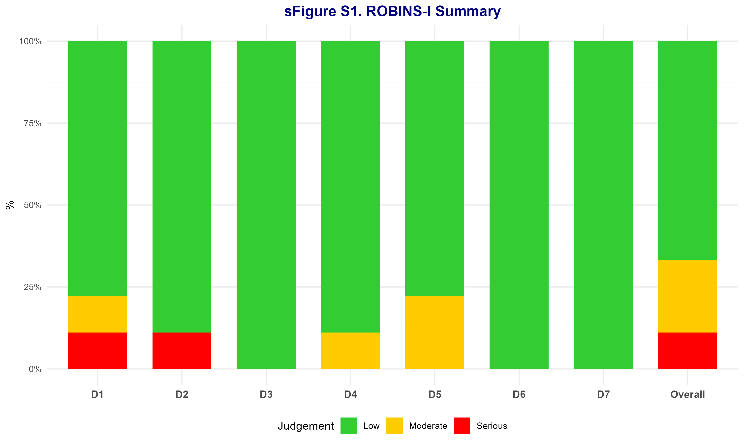

Supplementary Figure S2. Leave-One-Out — Mortality
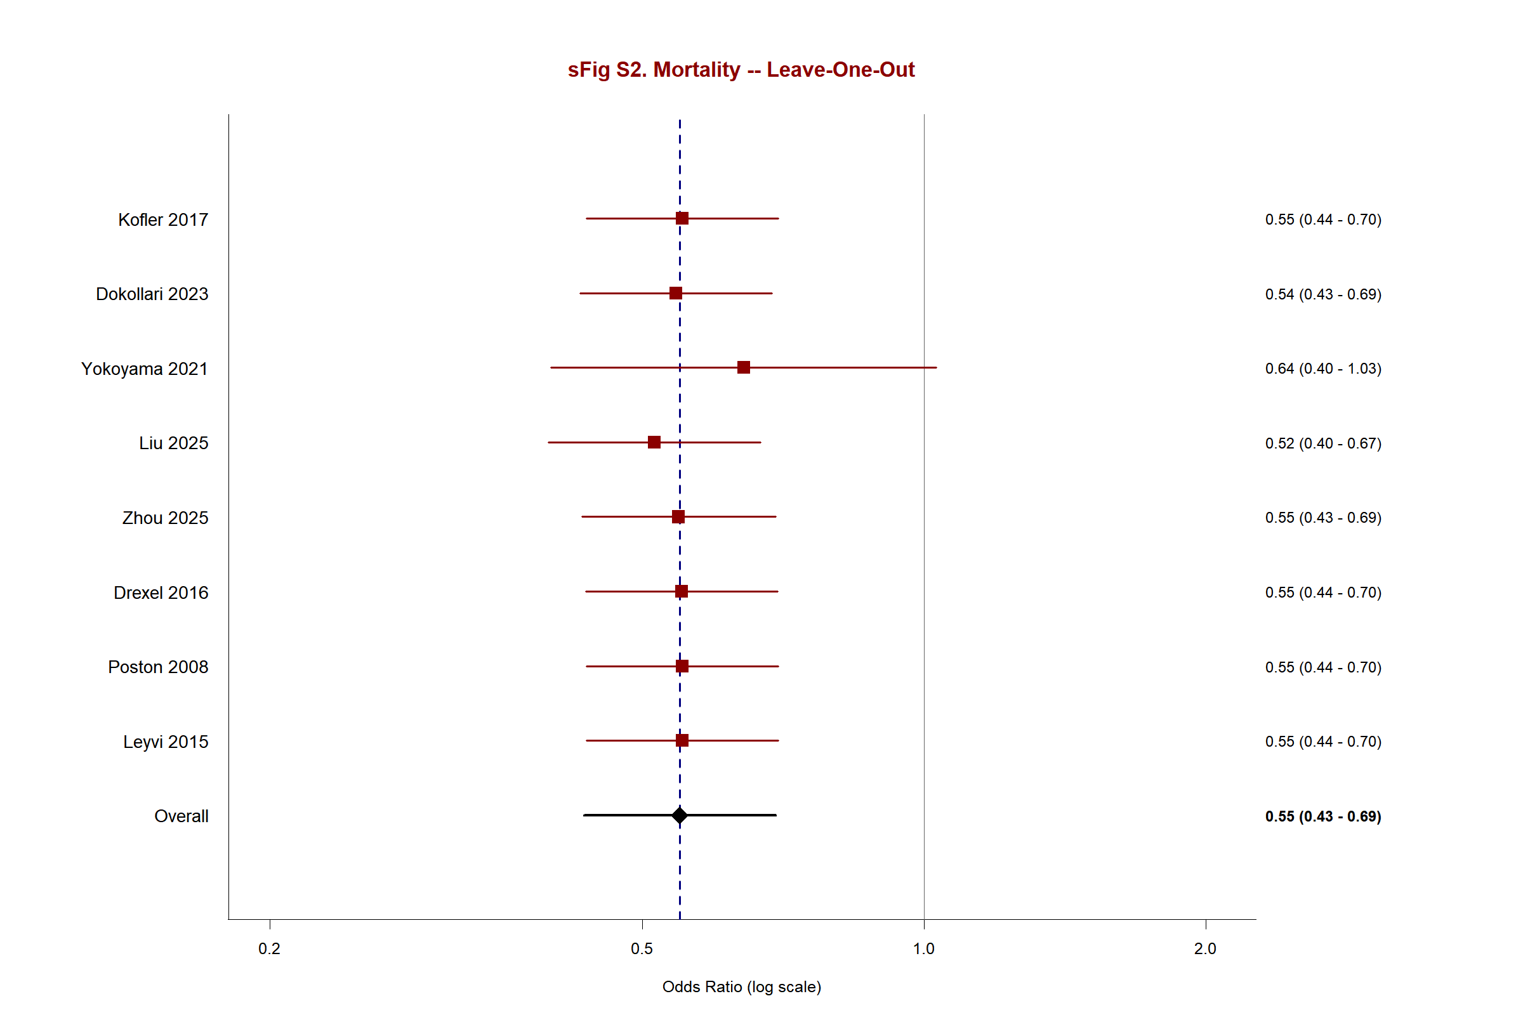

Supplementary Figure S3. Forest Plot — Renal Failure
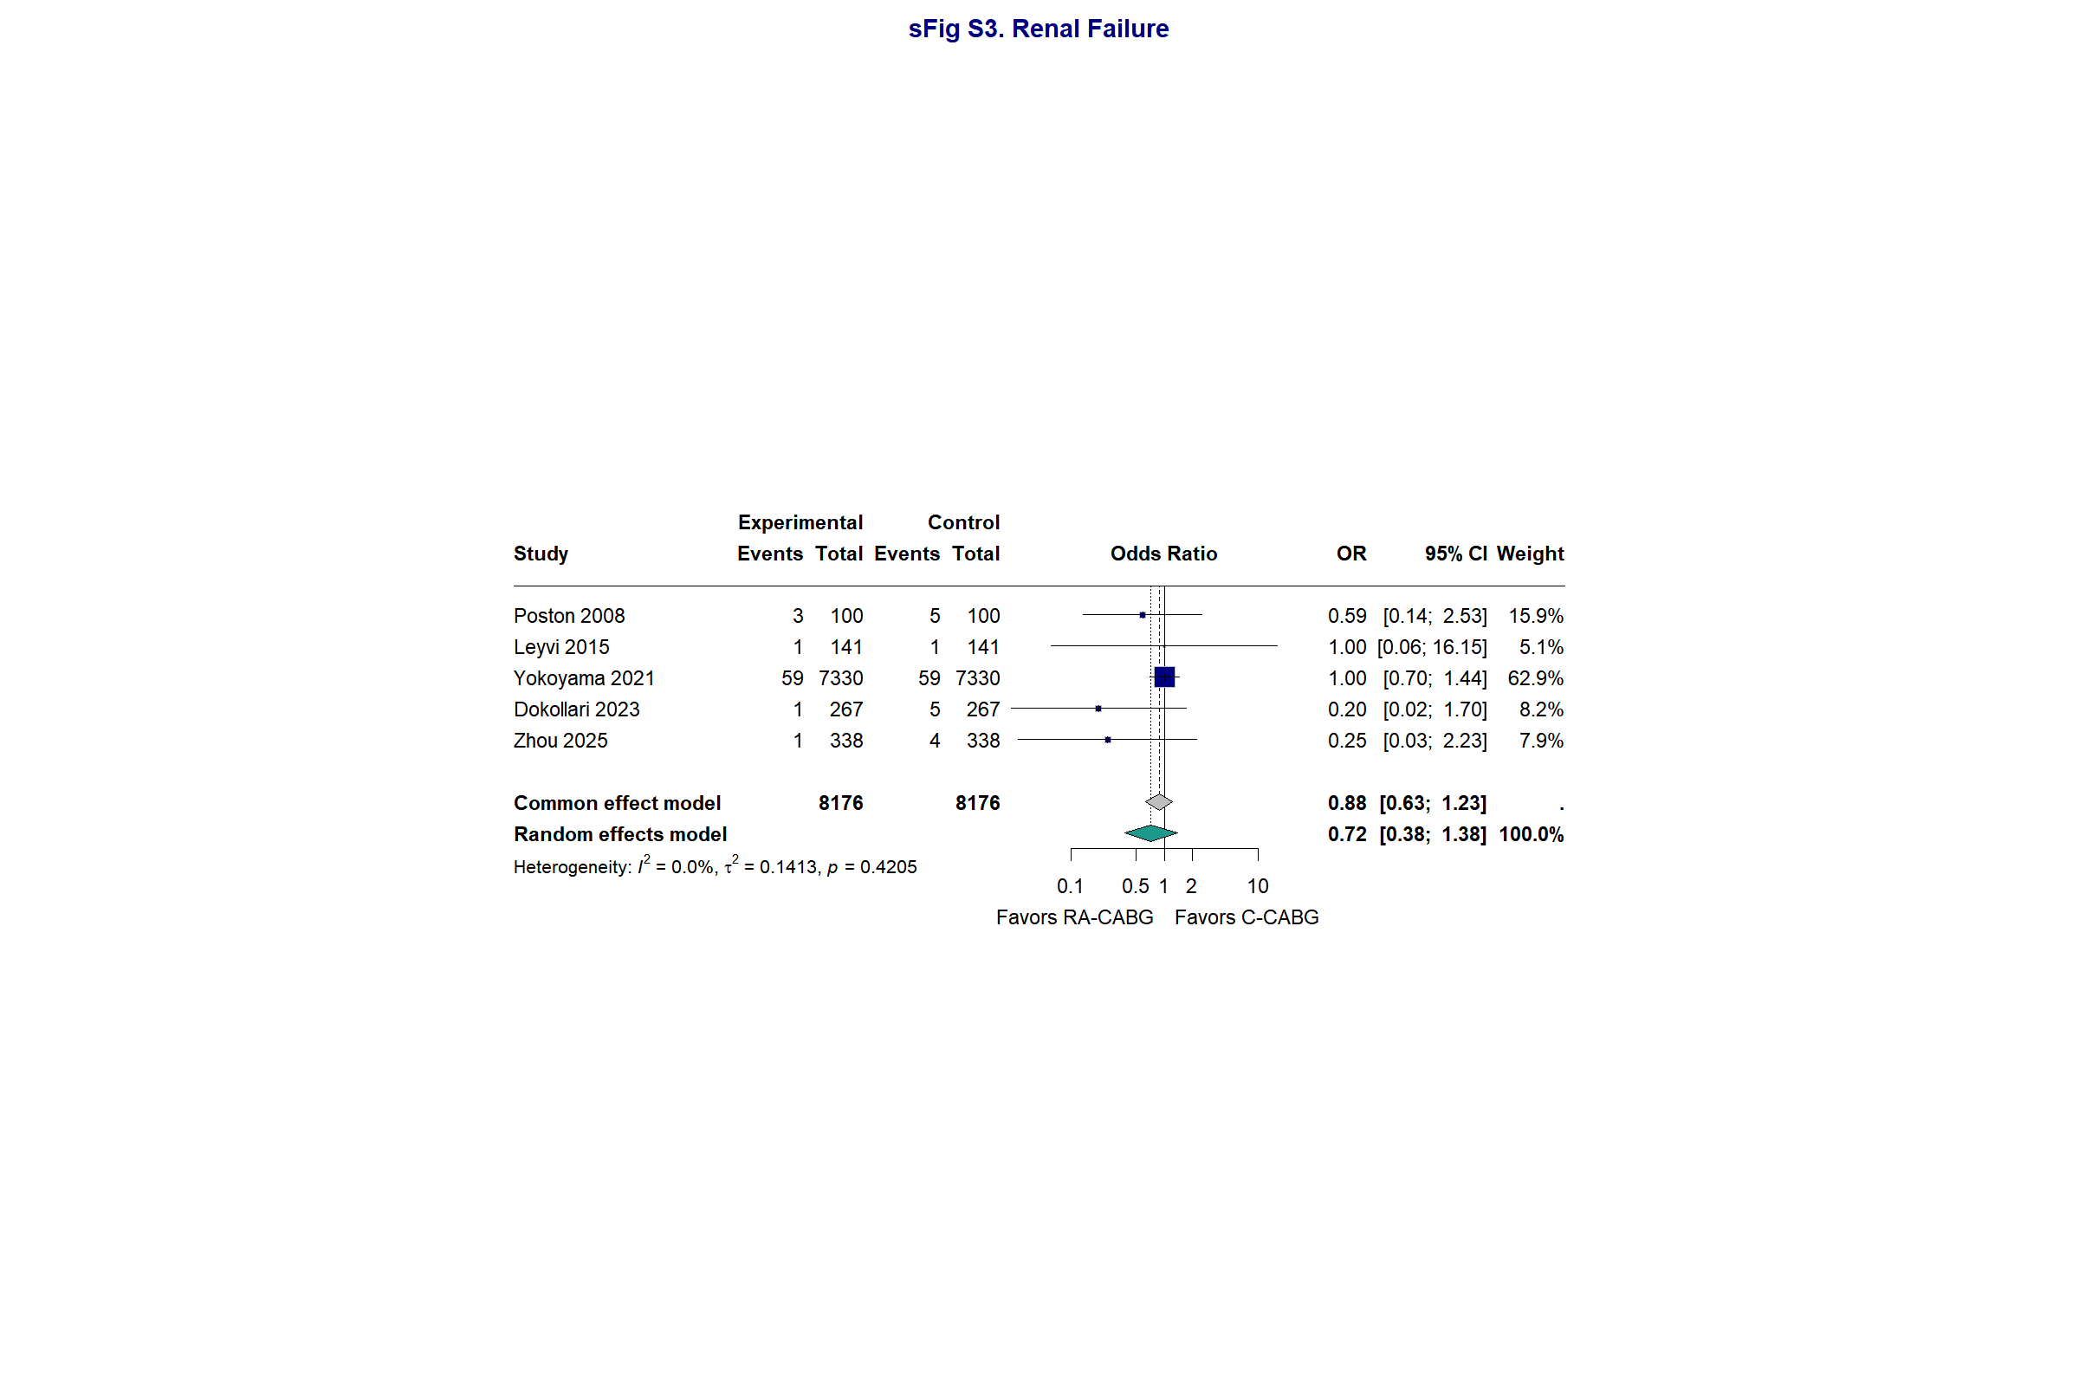

Supplementary Figure S4. Forest Plot — Reoperation for Bleeding
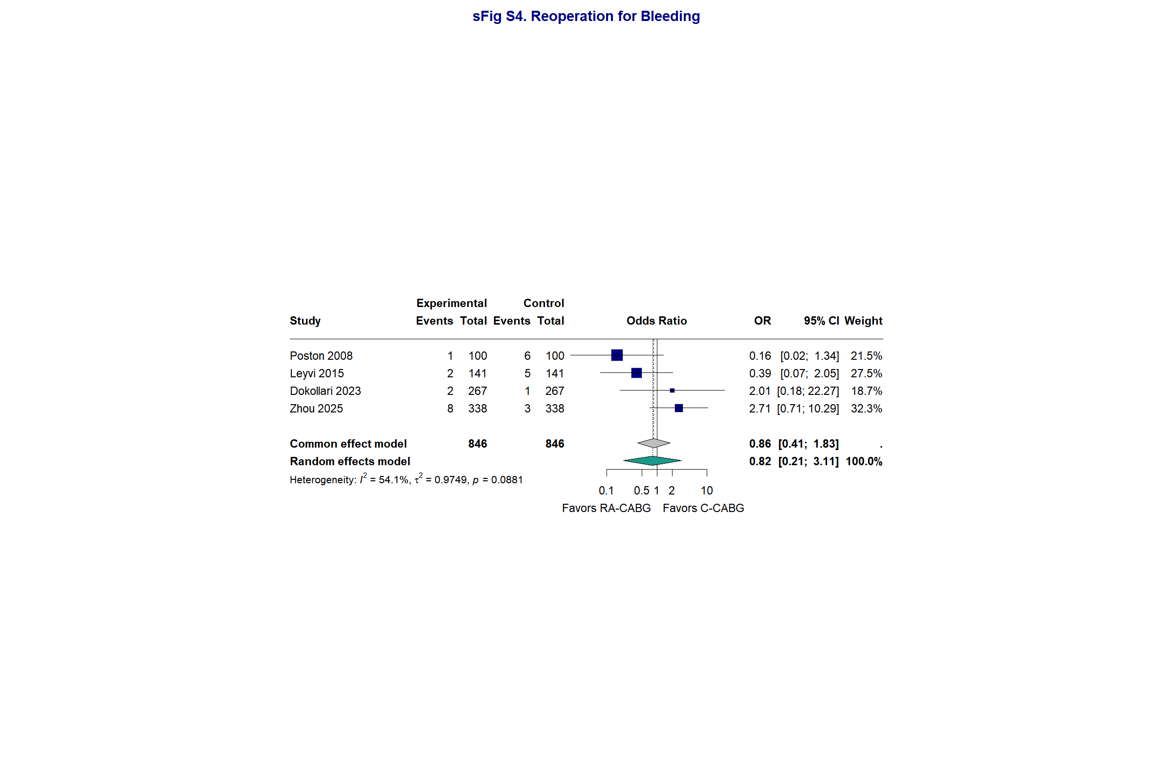

Supplementary Figure S5. Forest Plot — Sepsis
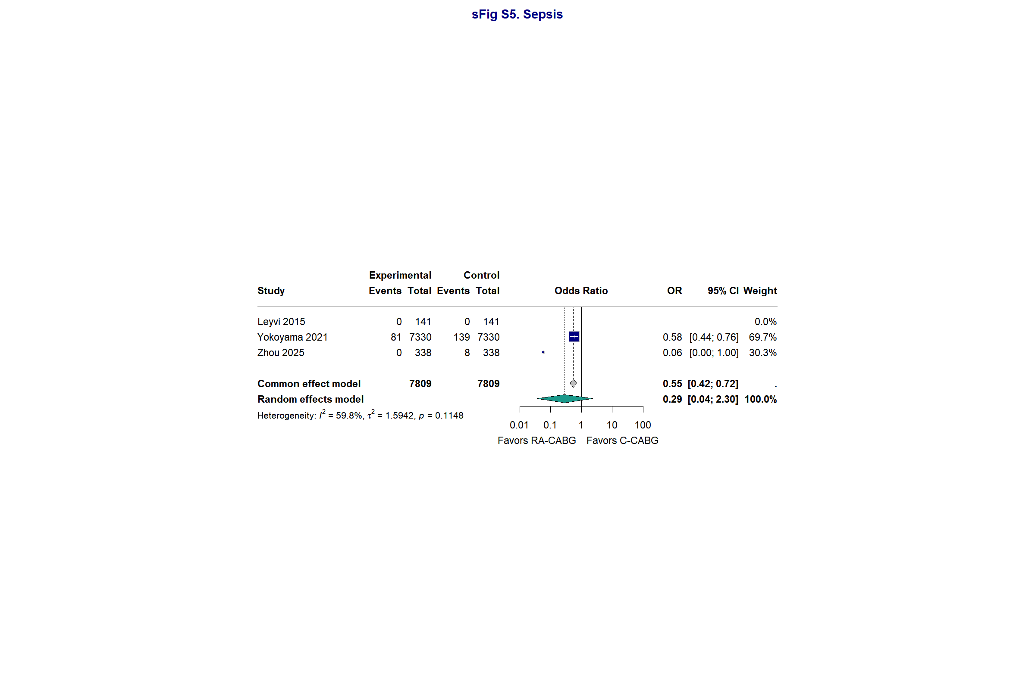

Supplementary Figure S6. Forest Plot — Deep Sternal Wound Infection
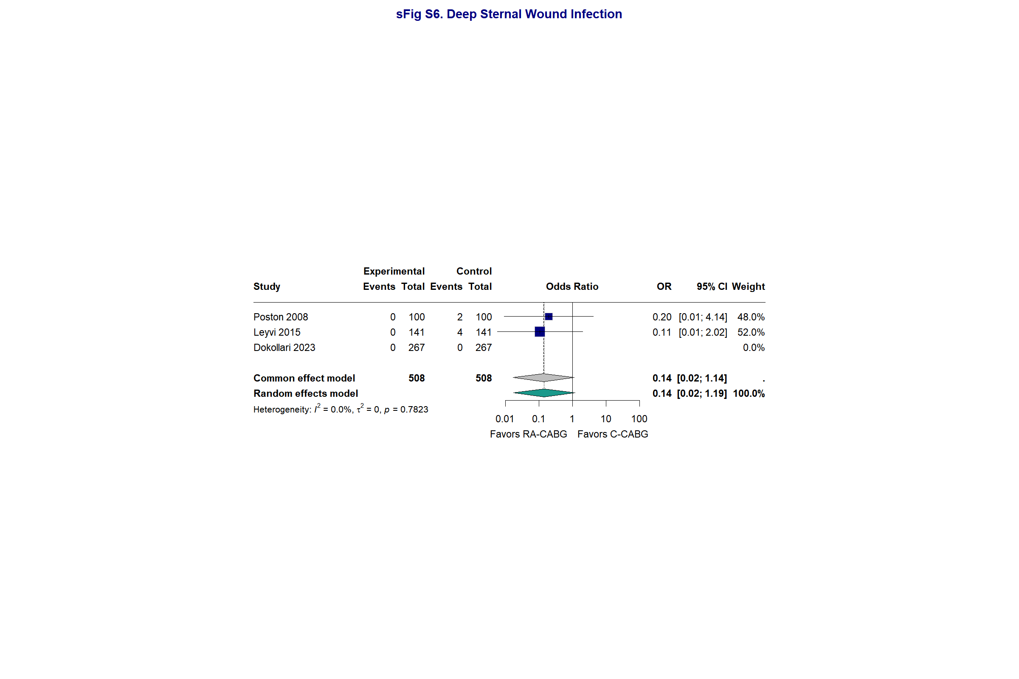

Supplementary Figure S7. Forest Plot — Myocardial Infarction
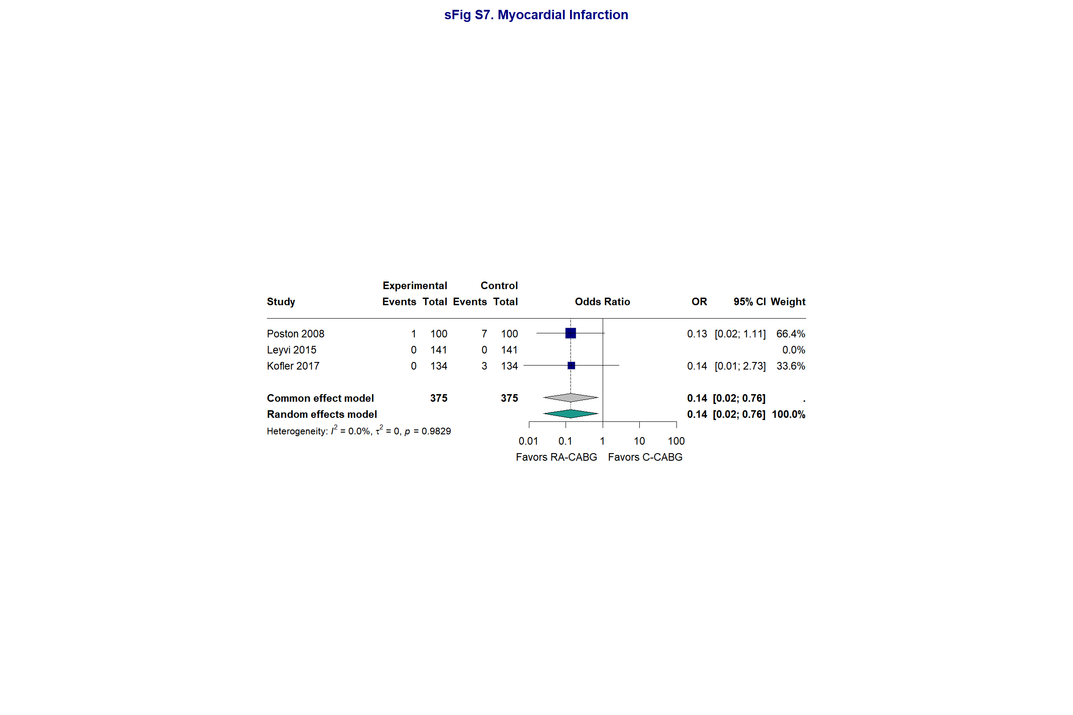

Supplementary Figure S8. Sensitivity — Mortality (Excluding Drexel 2016)
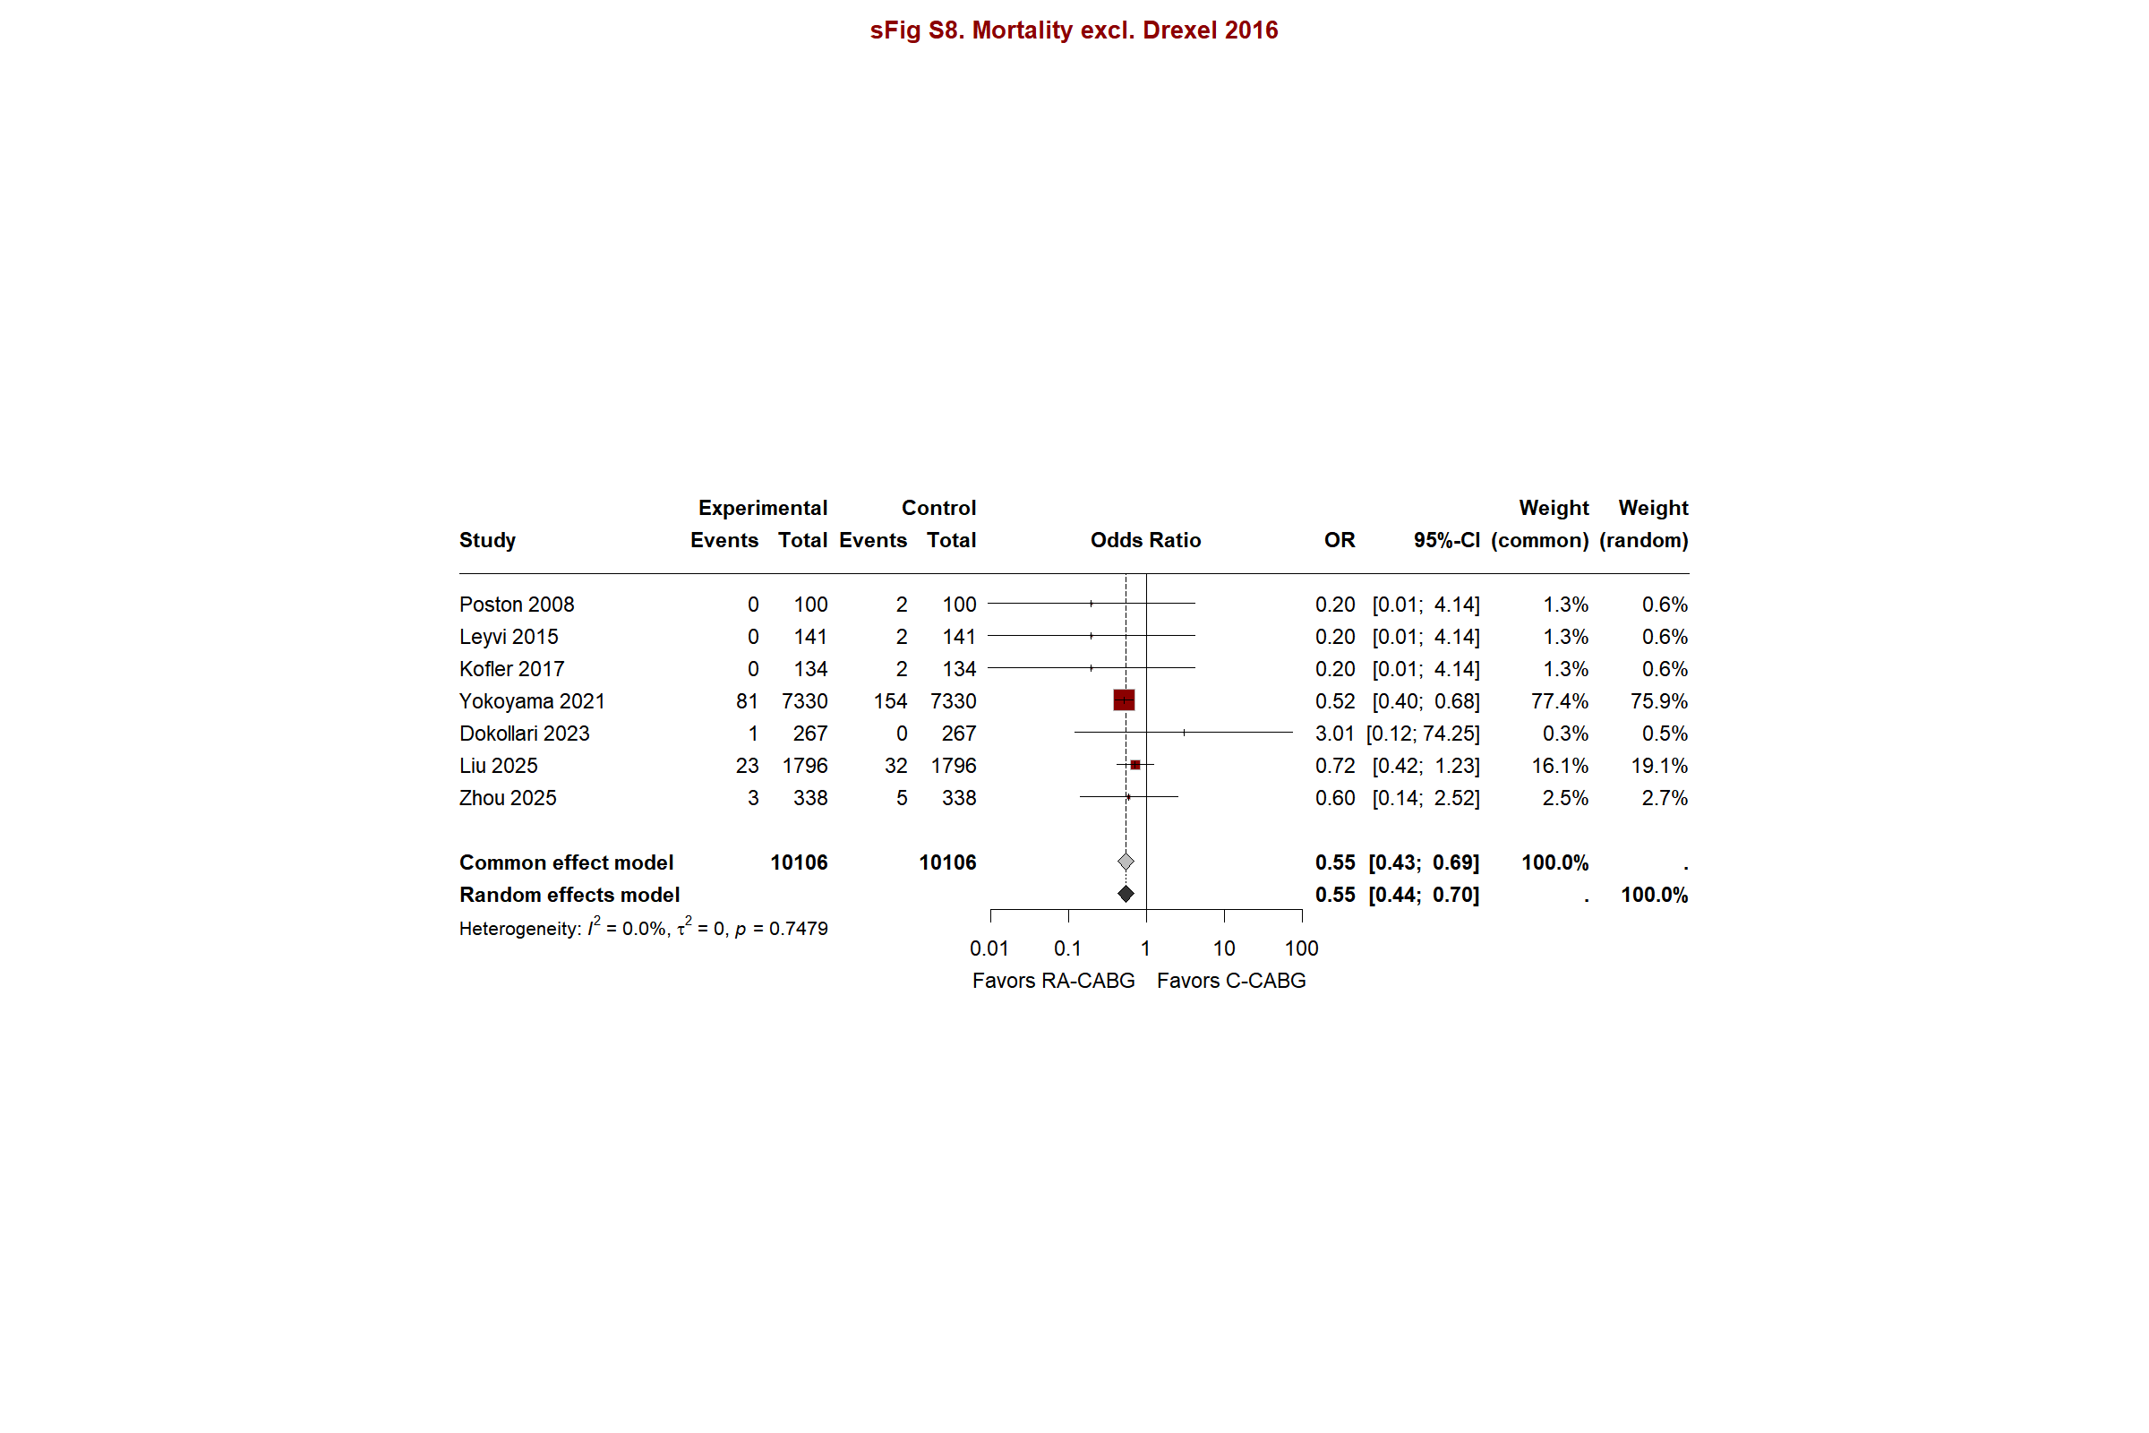

Supplementary Figure S9. Sensitivity — Stroke (Excluding Drexel 2016)
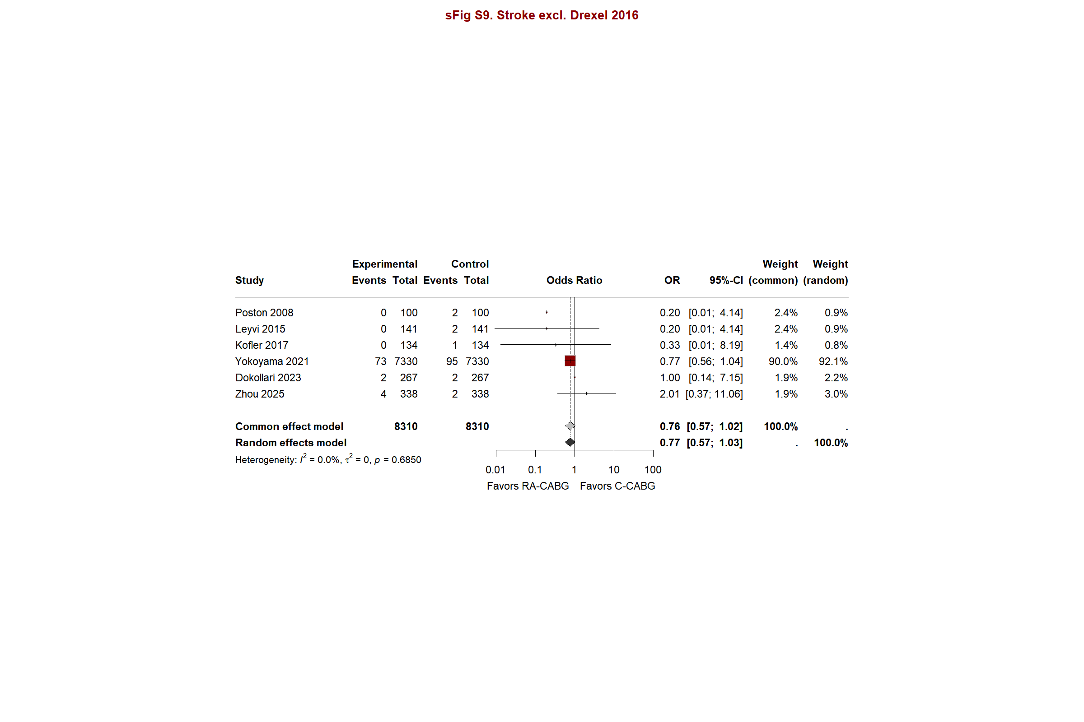

Supplementary Figure S10. Funnel Plot — Stroke
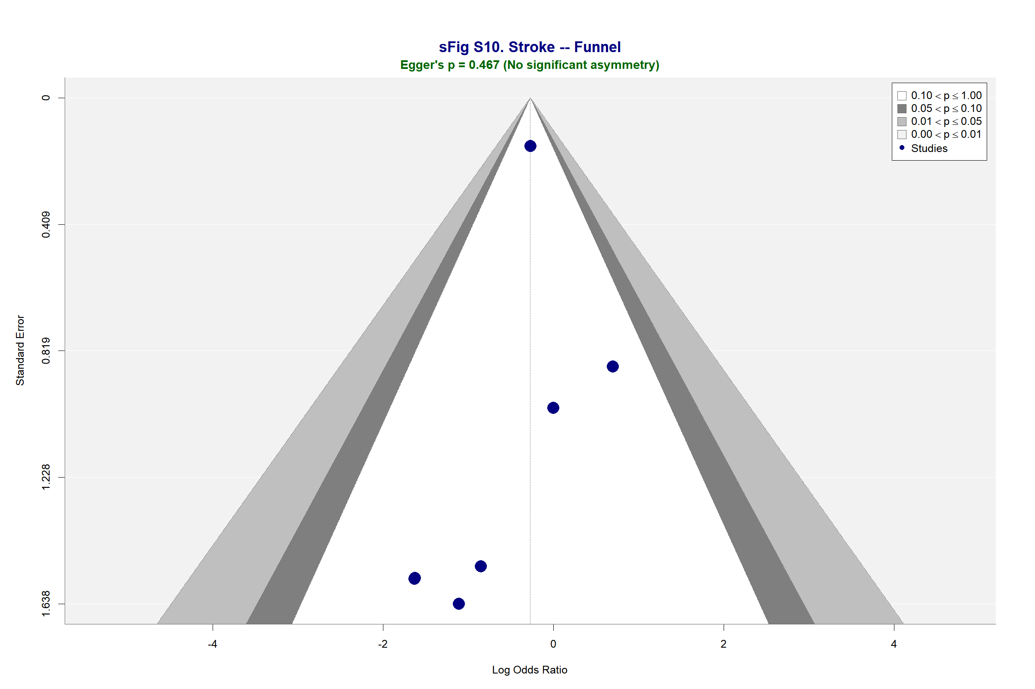

Supplementary Figure S11. Funnel Plot — Atrial Fibrillation
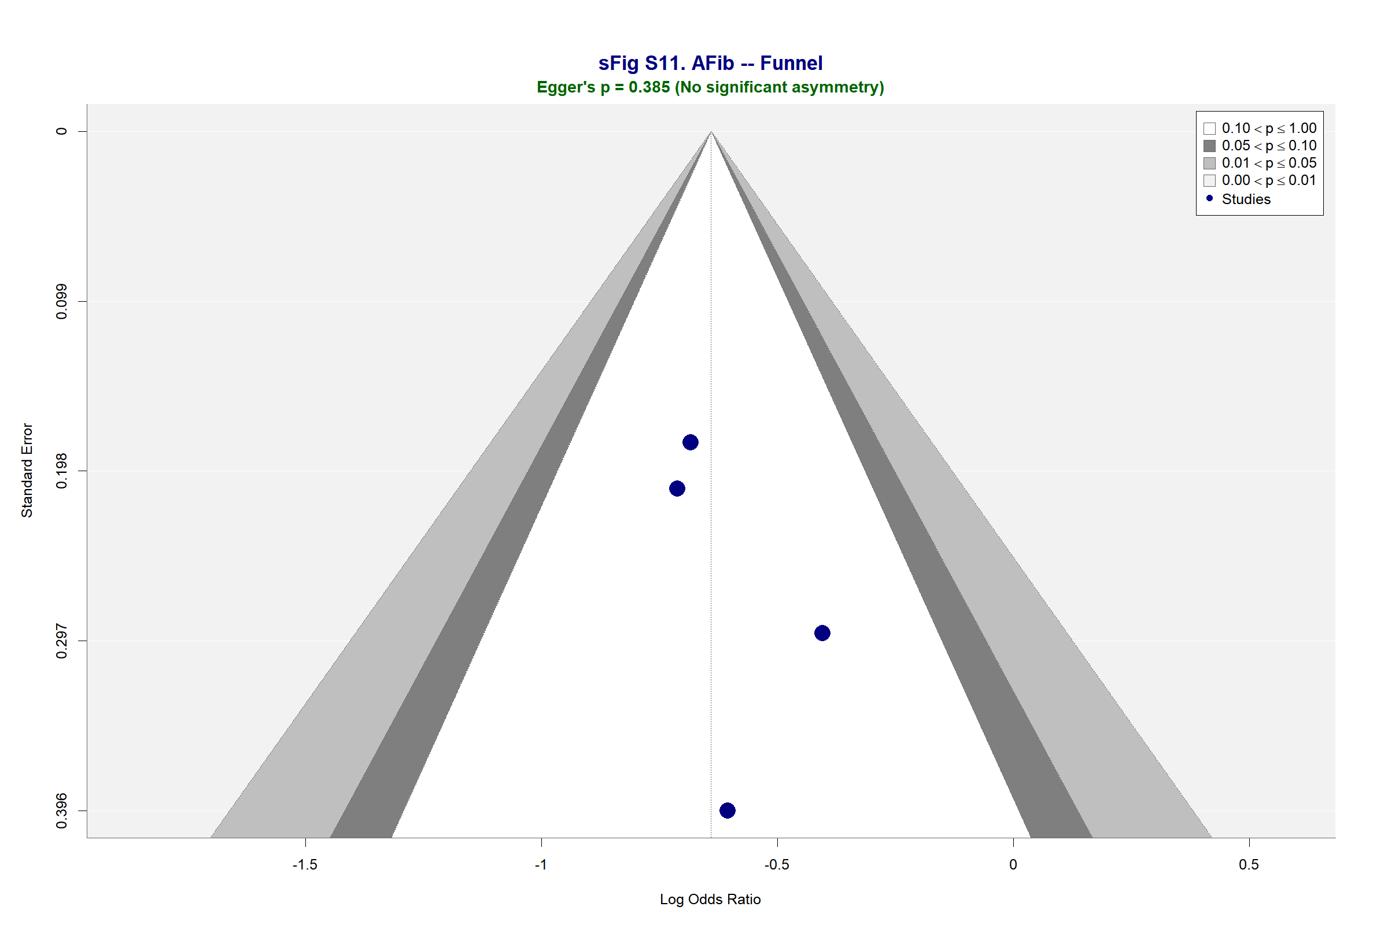

Supplementary Figure S12. Funnel Plot — Renal Failure
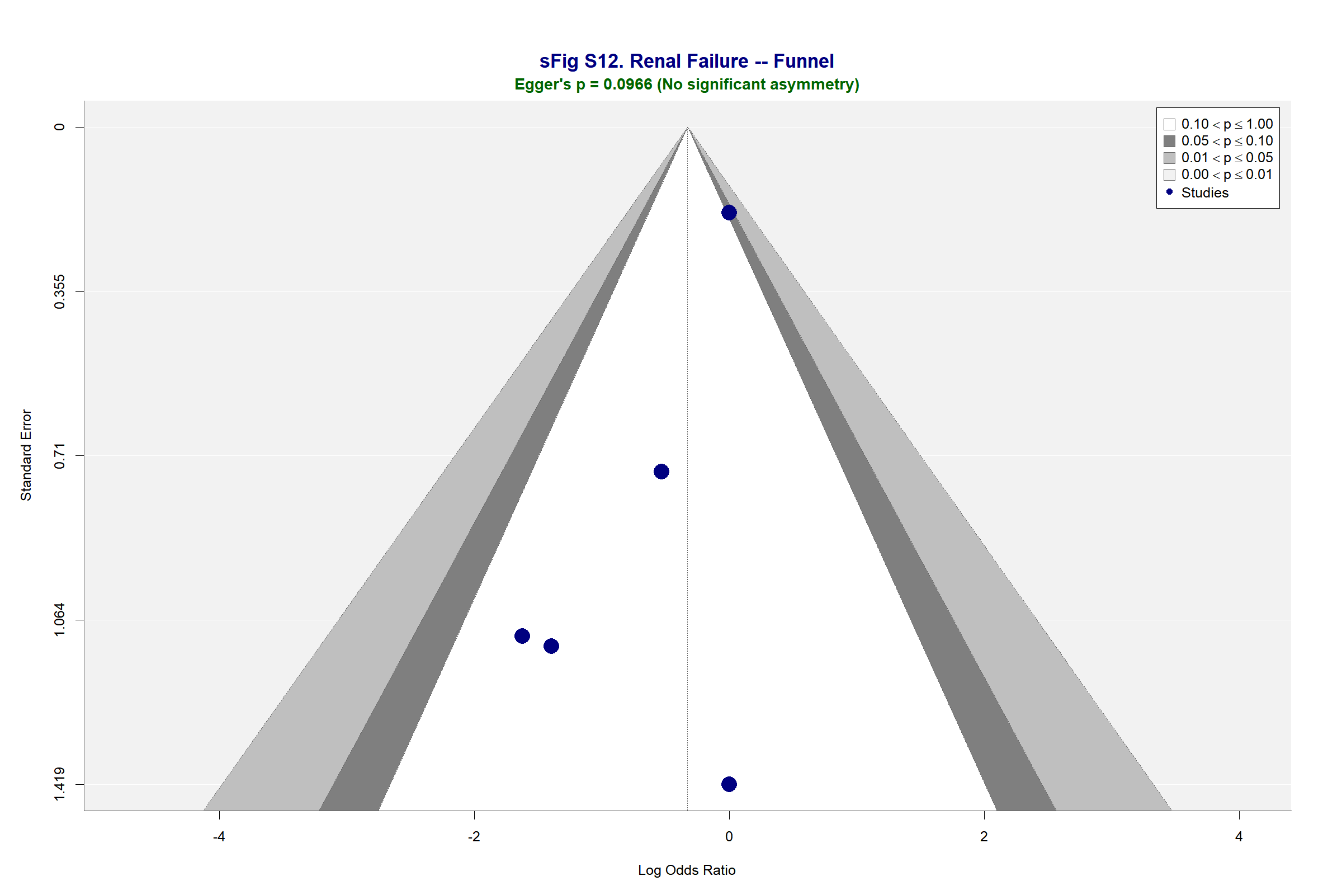

Supplementary Figure S13. Funnel Plot — Respiratory Failure
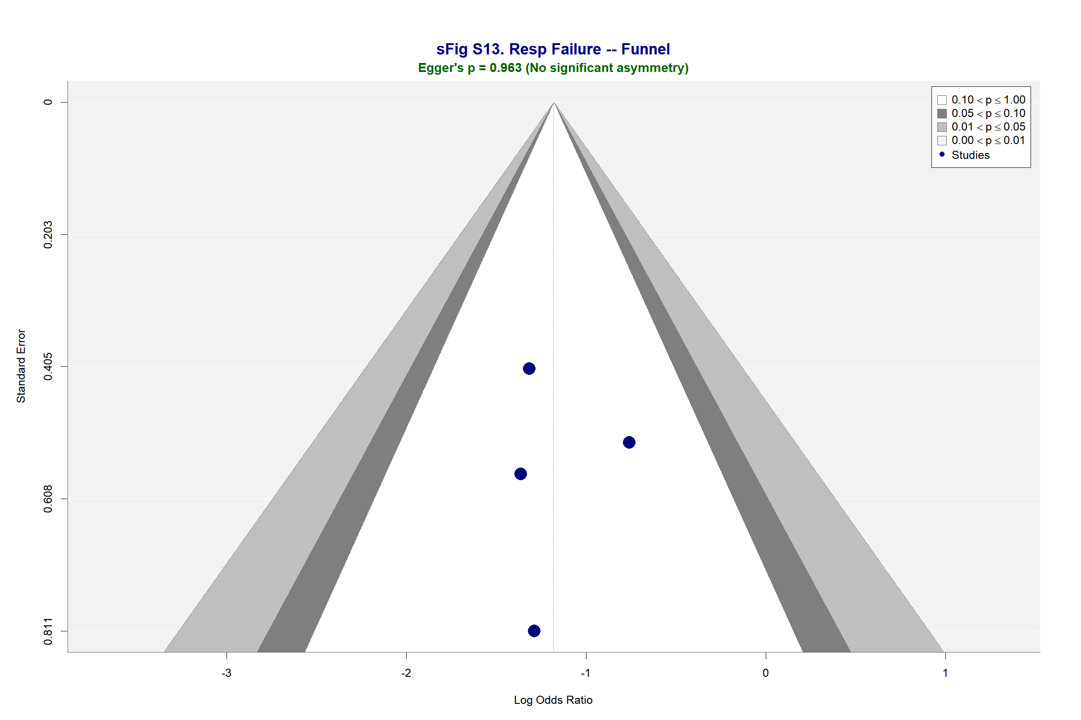

Supplementary Figure S14. Funnel Plot — Reoperation
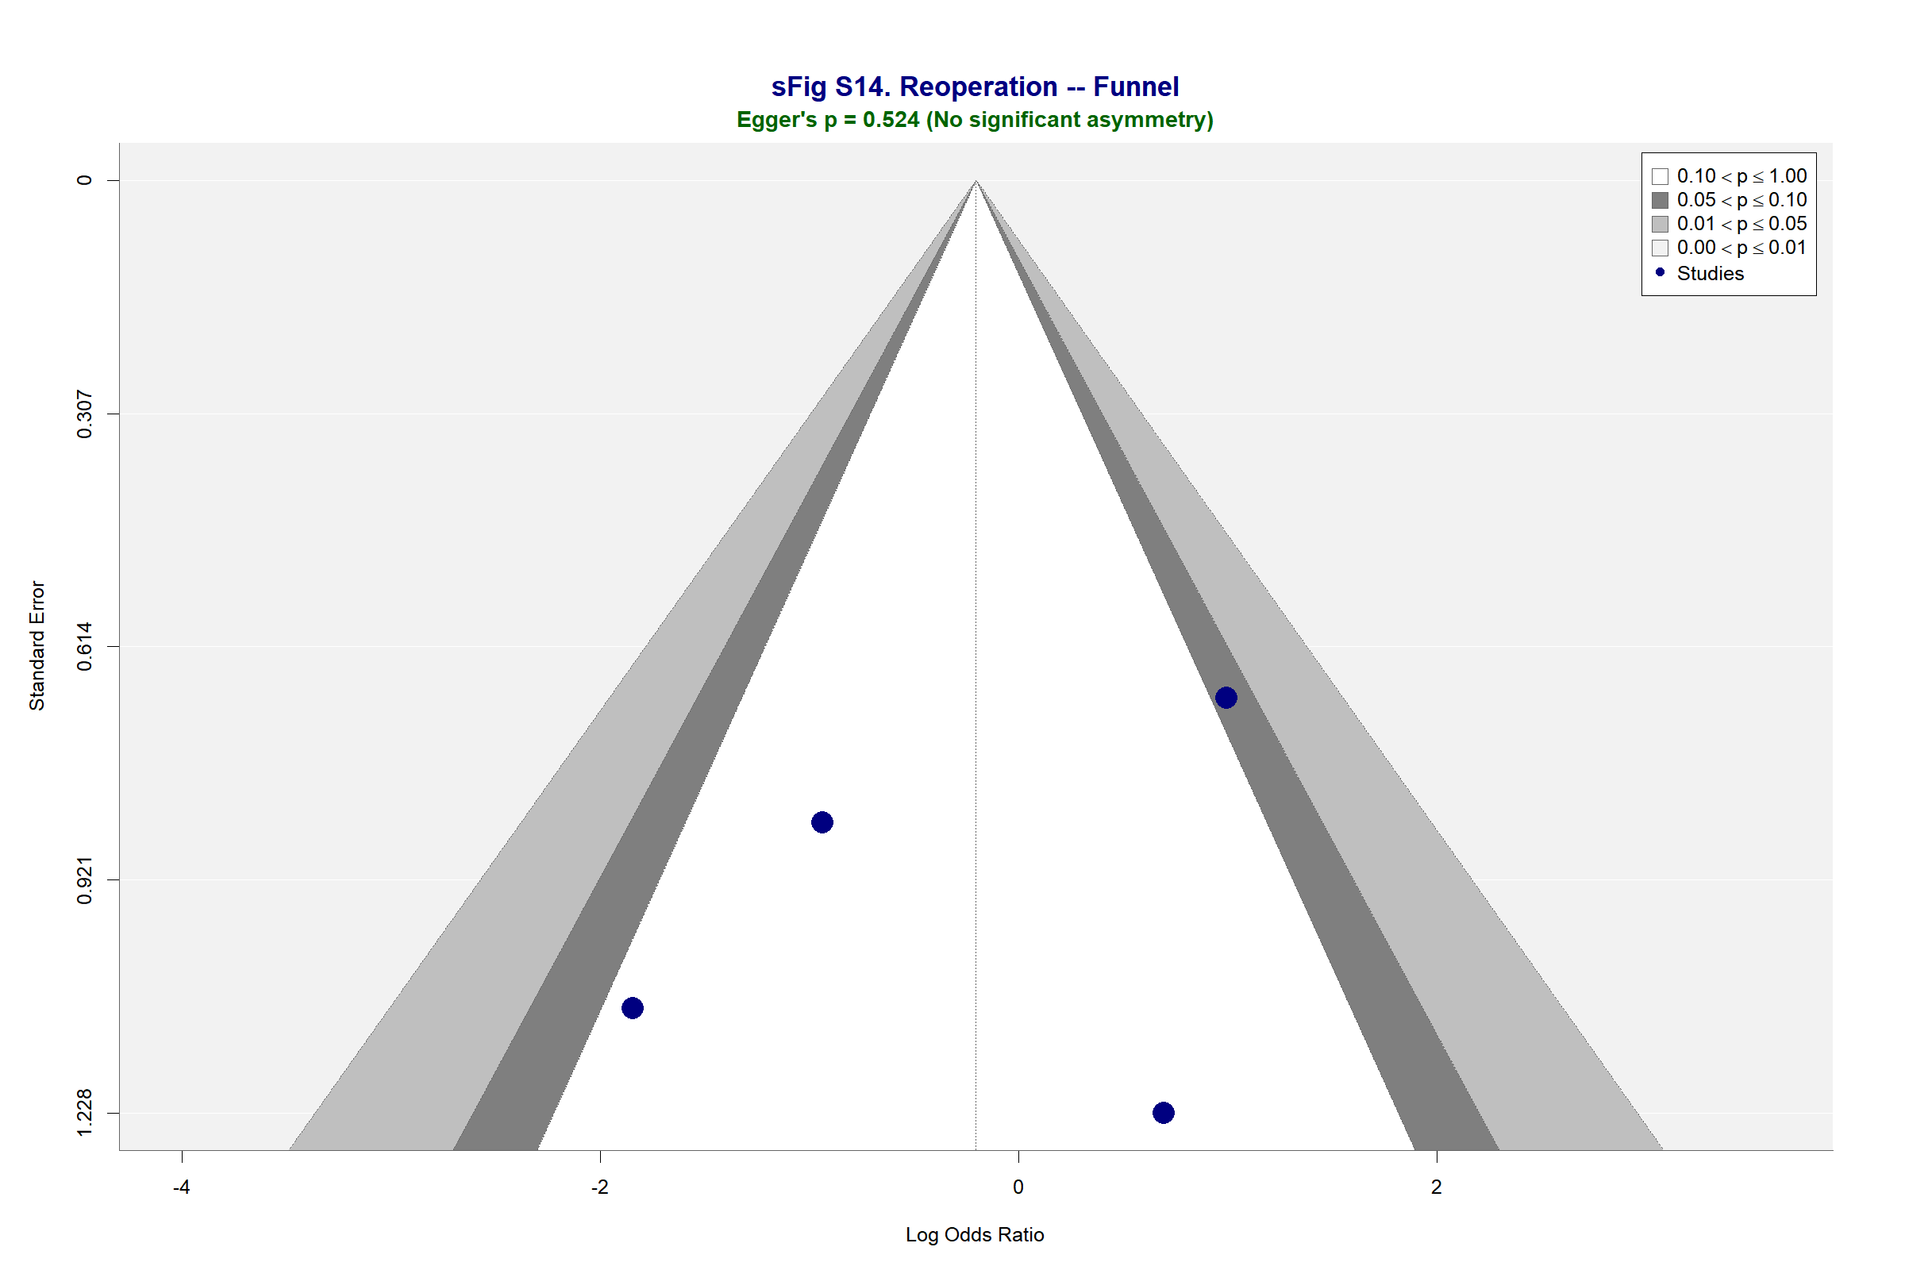

Supplementary Figure S15. Funnel Plot — Transfusion
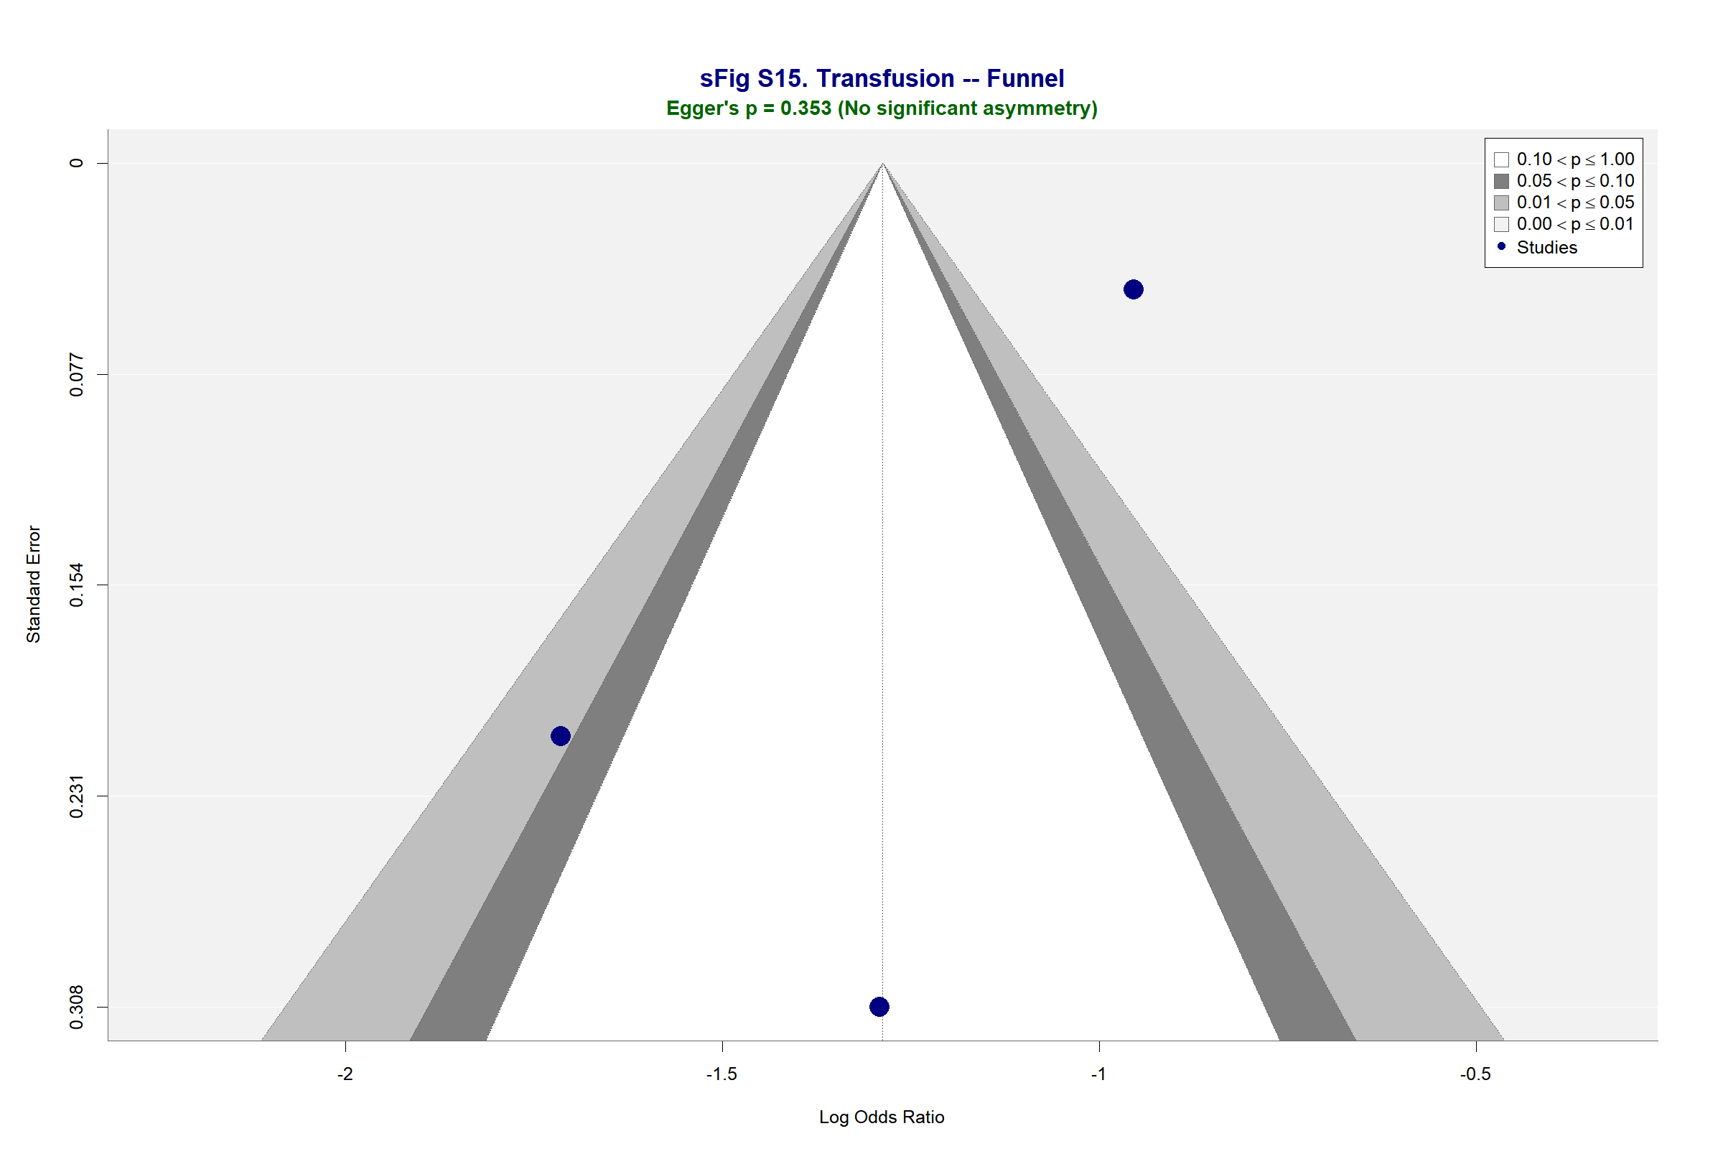

Supplementary Figure S16. Subgroup Analysis — Mortality
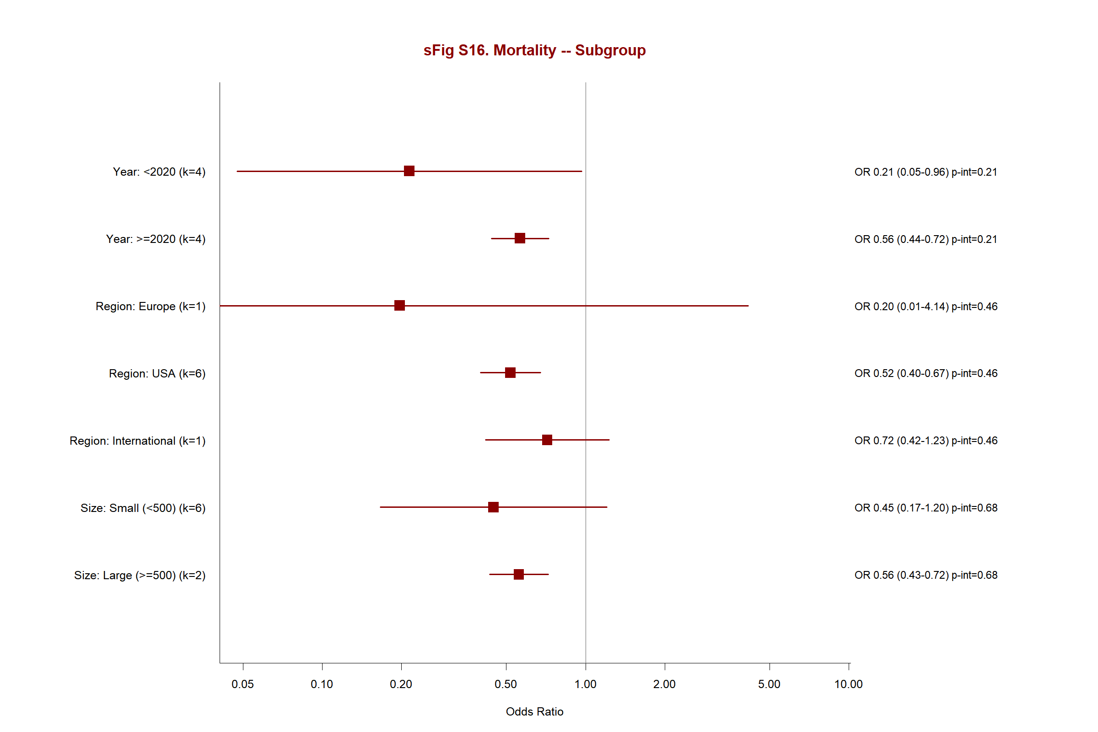

Supplementary Figure S17. Subgroup Analysis — Stroke
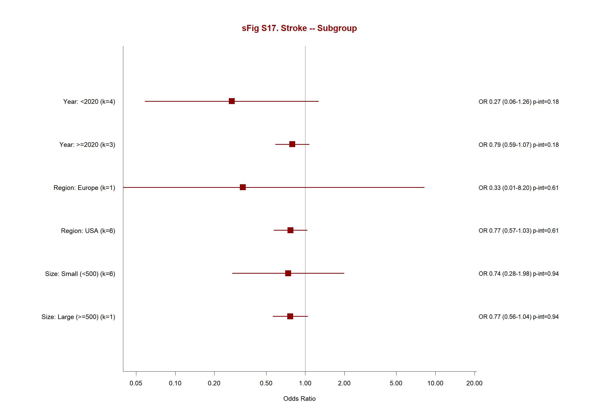

Supplementary Figure S18. Subgroup Analysis — Atrial Fibrillation
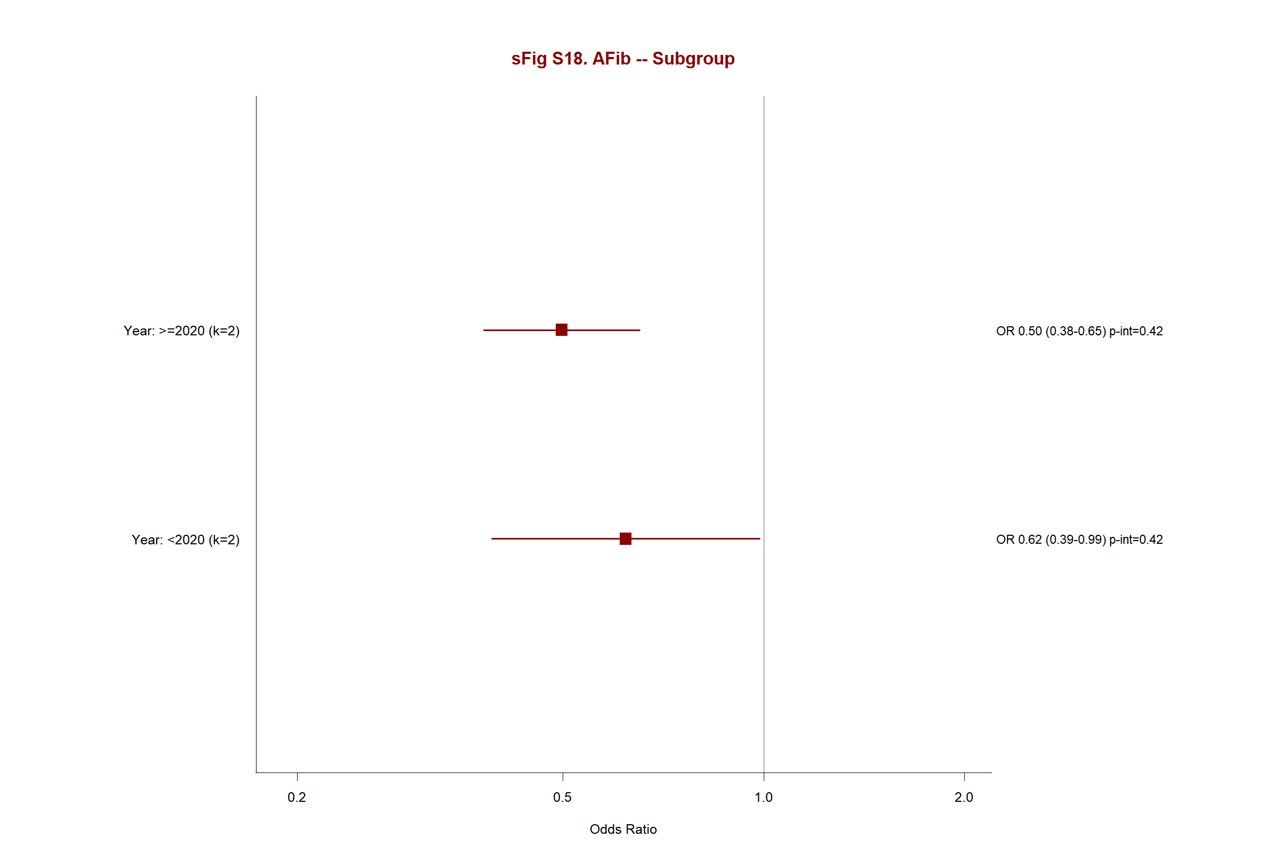

Supplementary Figure S19. Subgroup Analysis — Renal Failure
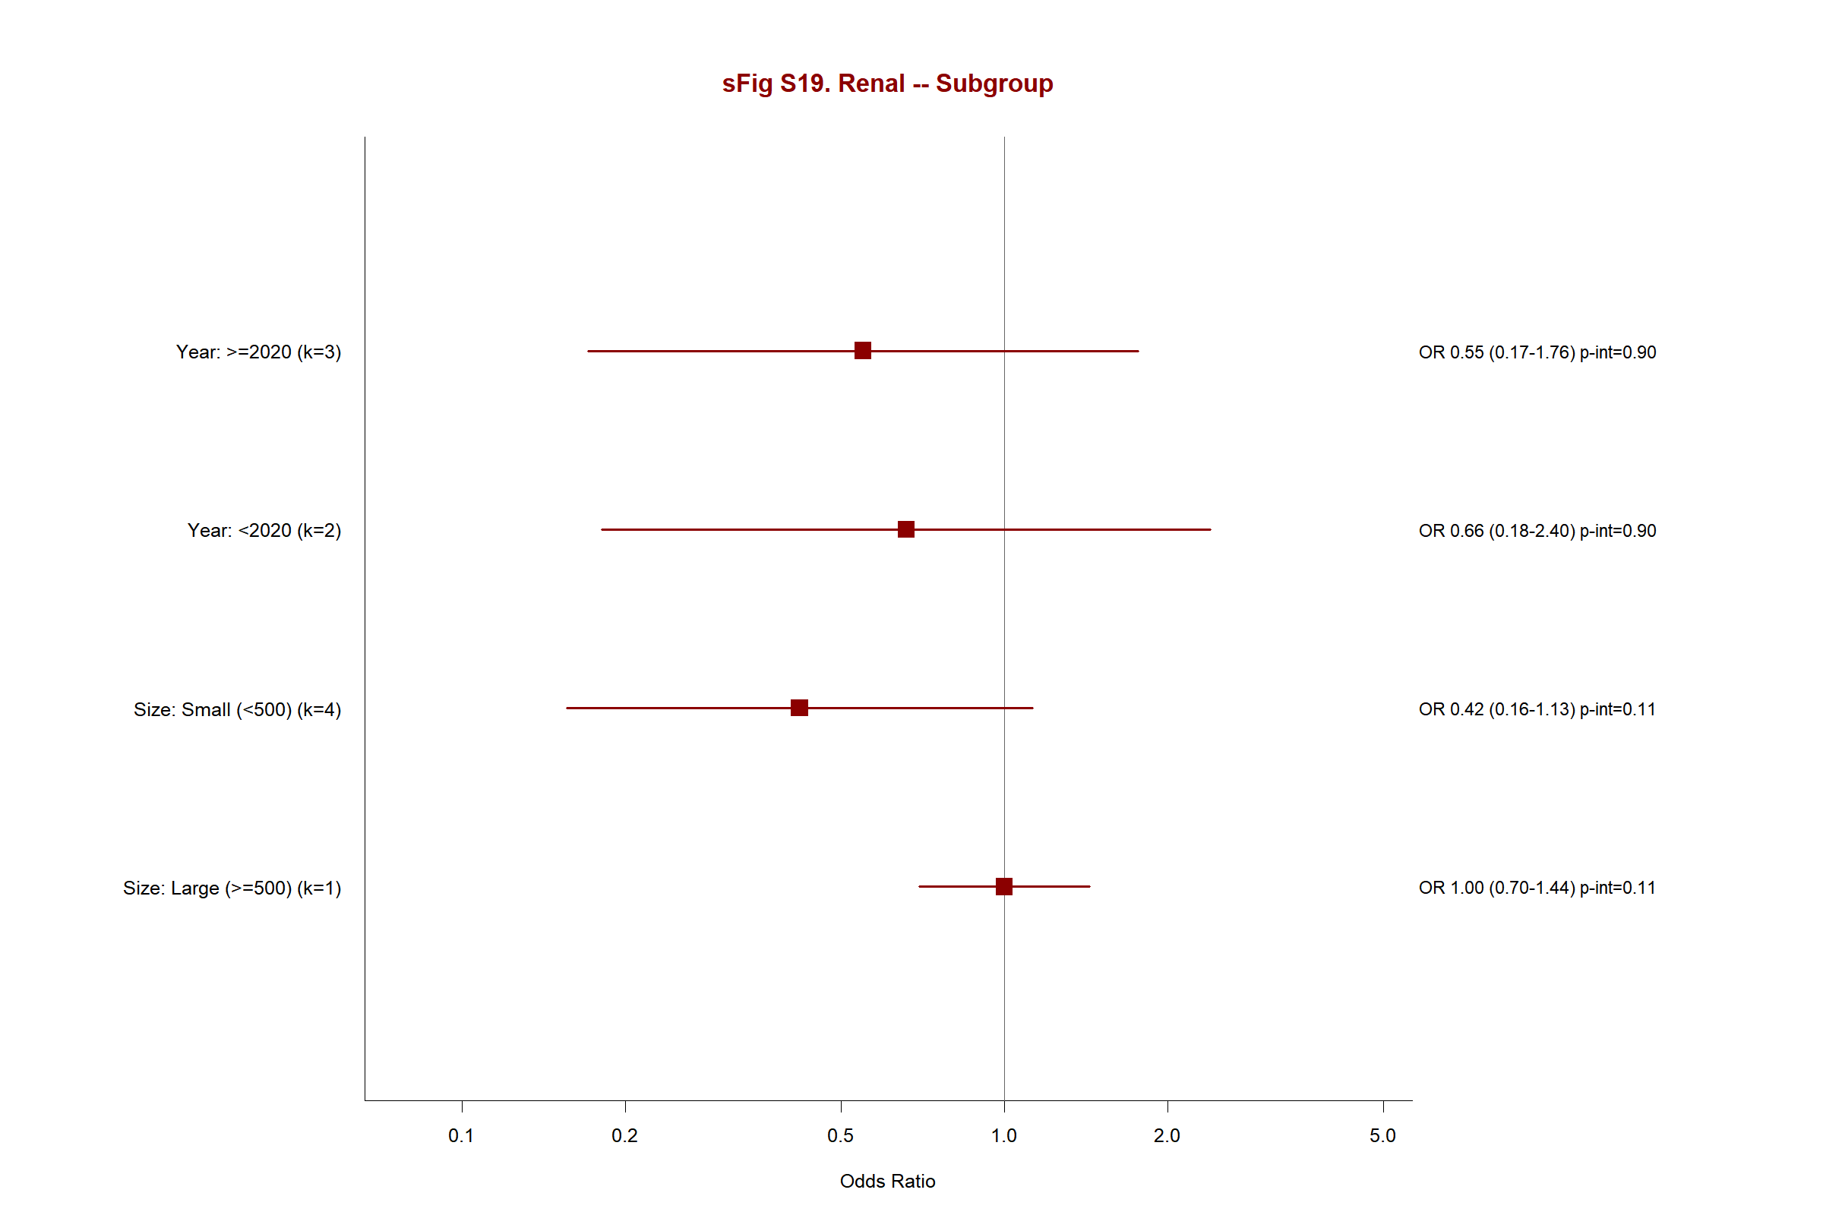

Supplementary Figure S20. Subgroup Analysis — Respiratory Failure
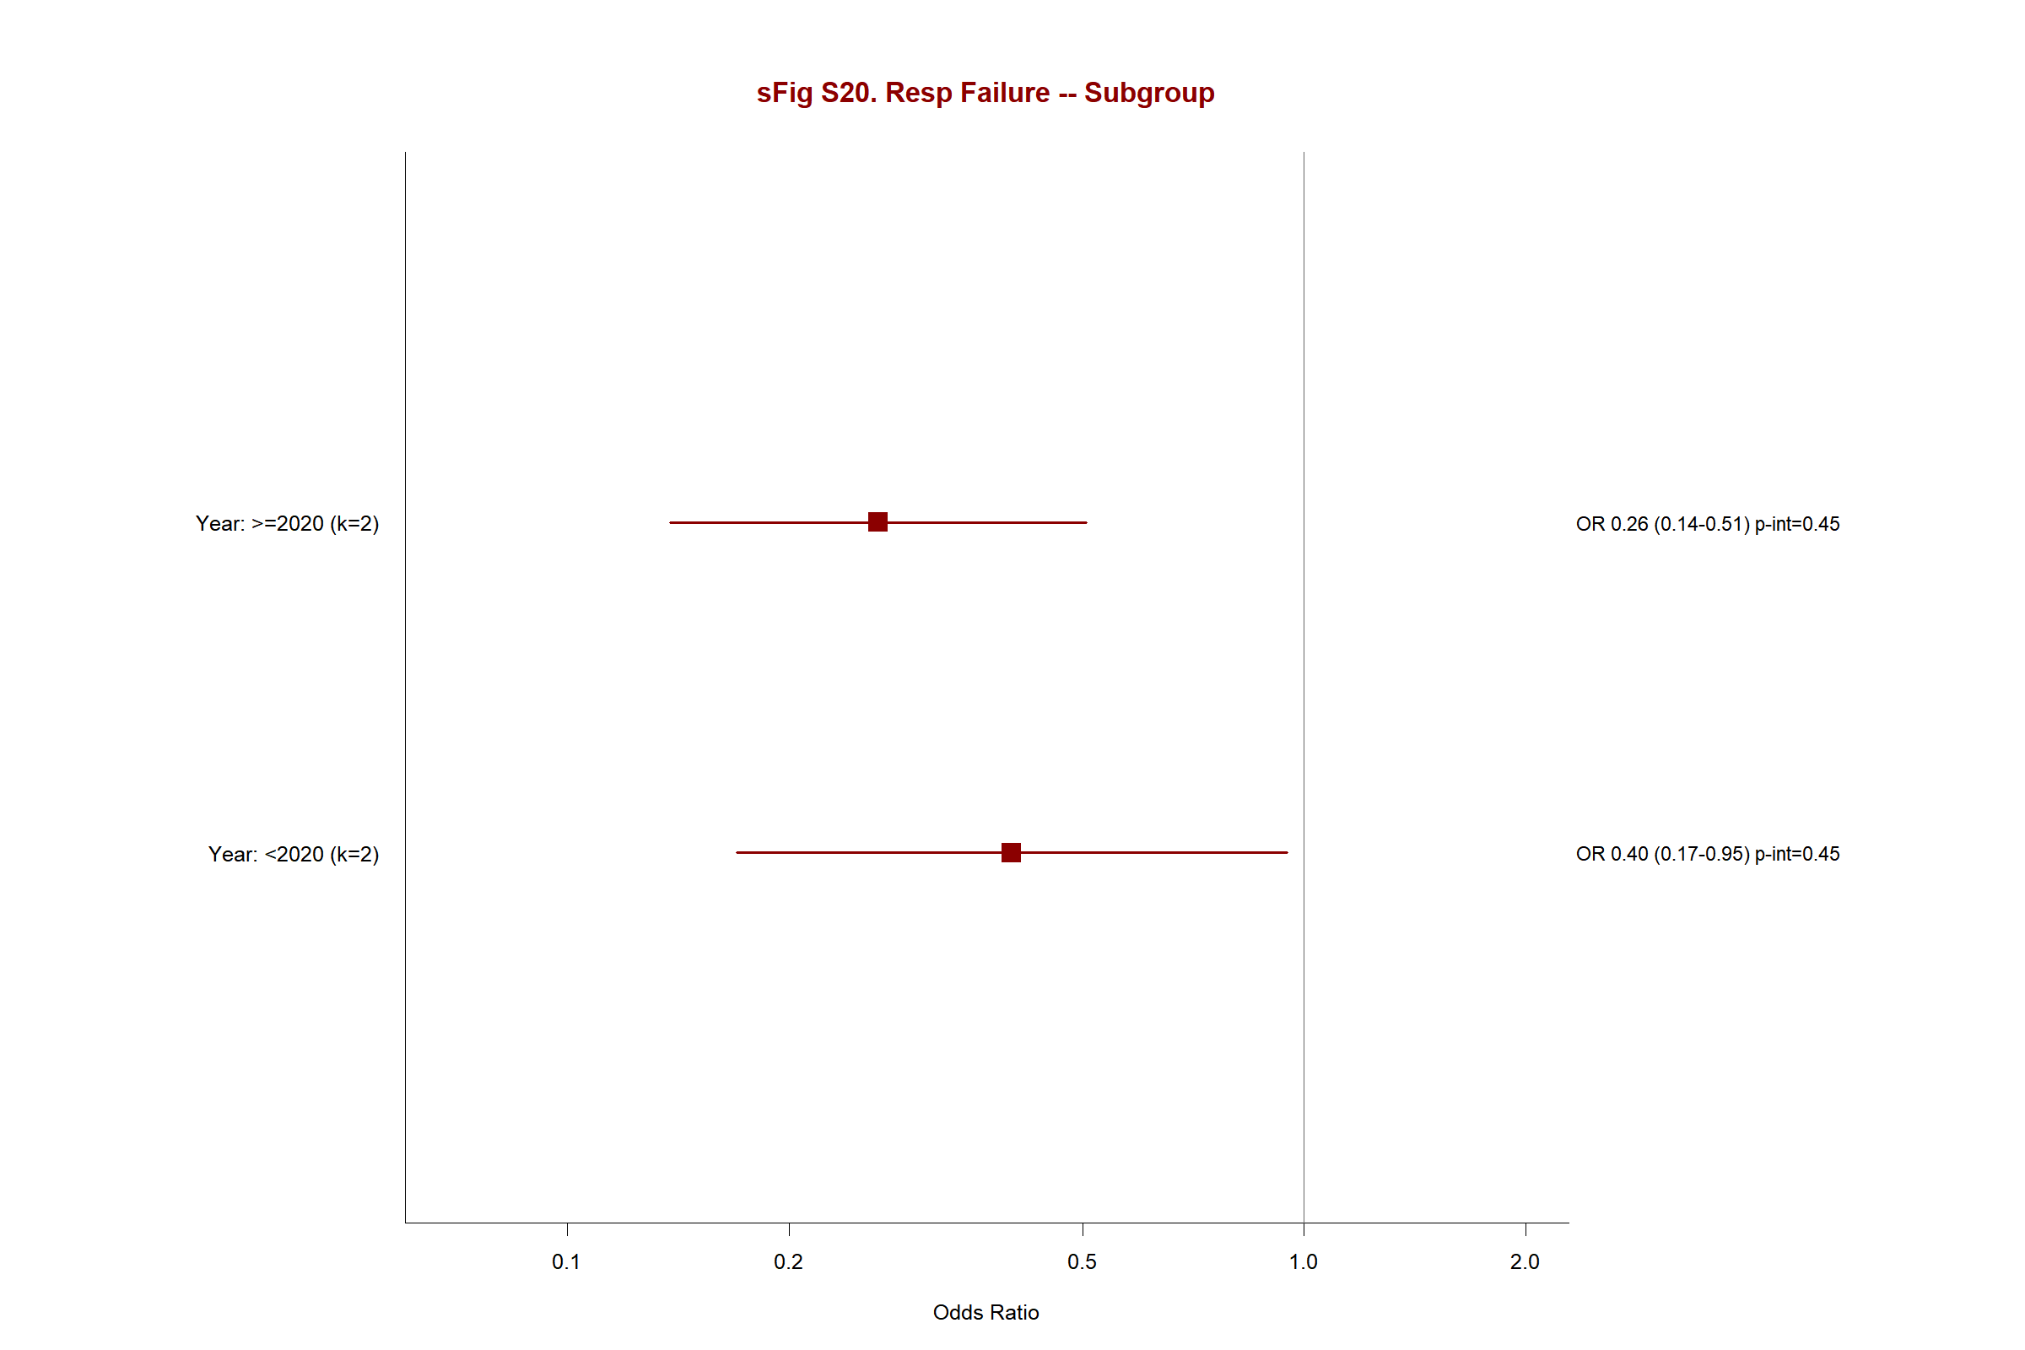

Supplementary Figure S21. Meta-Regression — Mortality by Year
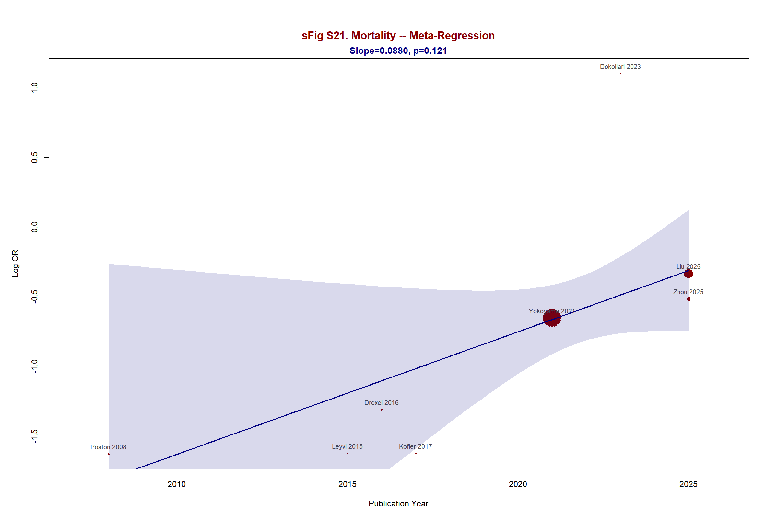

Supplementary Figure S22. Meta-Regression — Stroke by Year
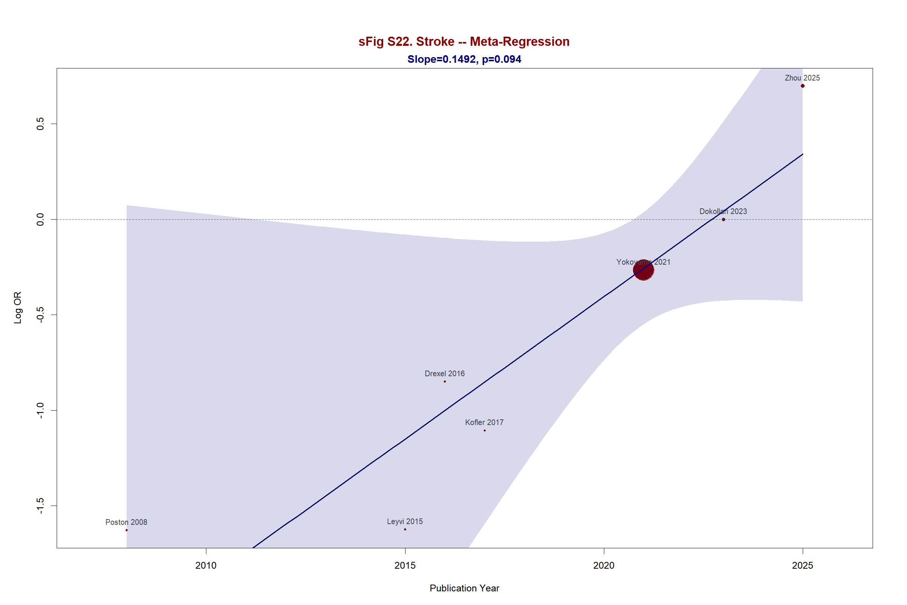

Supplementary Figure S23. Meta-Regression — Atrial Fibrillation by Year
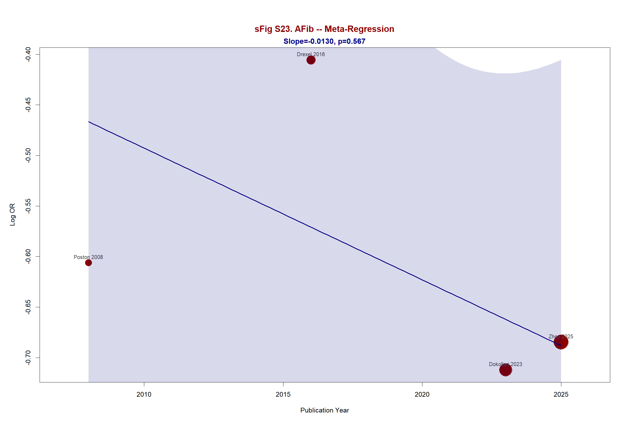

Supplementary Figure S24. Meta-Regression — Renal Failure by Year
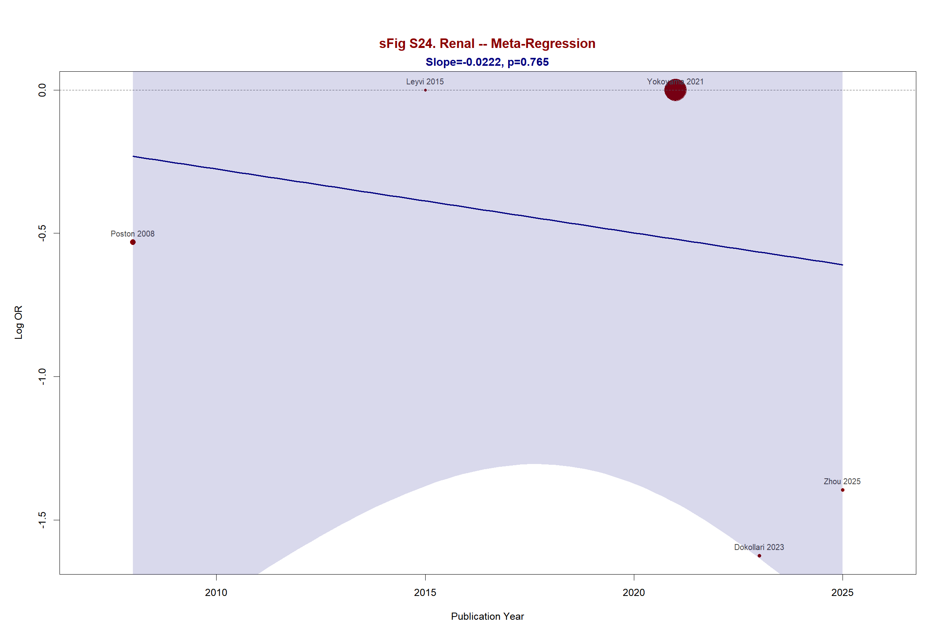

Supplementary Figure S25. Meta-Regression — Respiratory Failure by Year
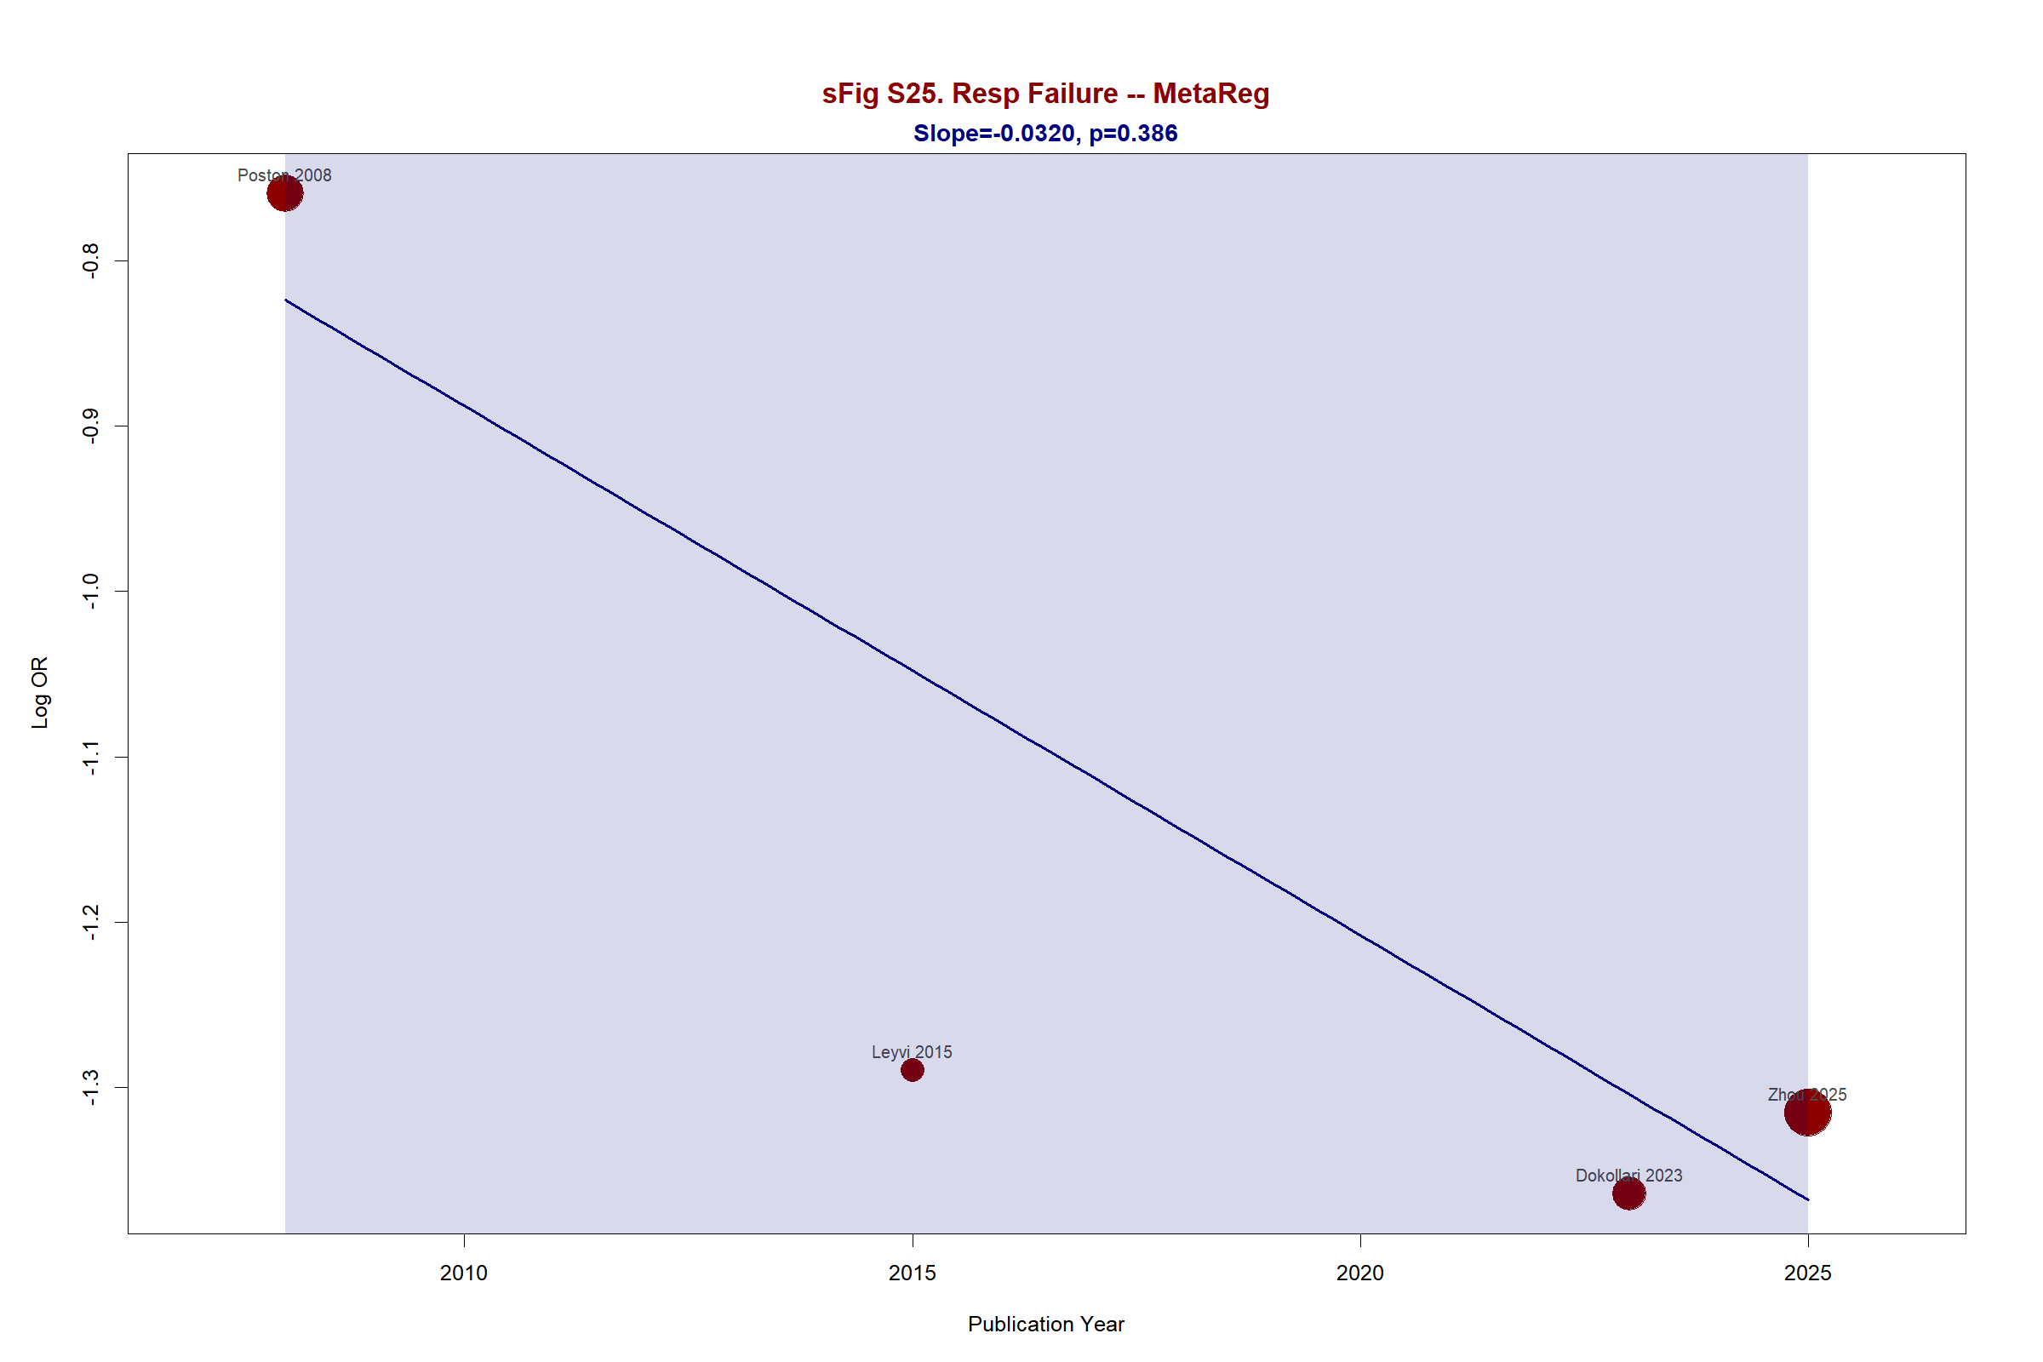

Supplementary Figure S26. Leave-One-Out — Stroke
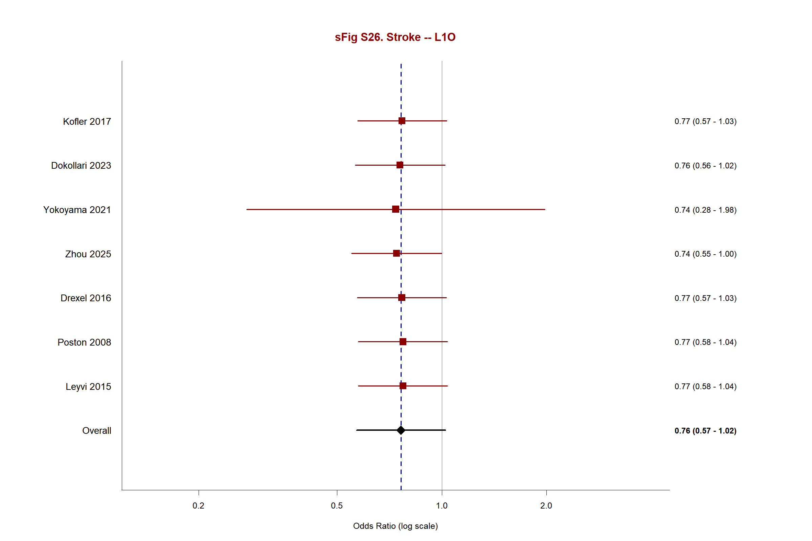

Supplementary Figure S27. Leave-One-Out — Atrial Fibrillation
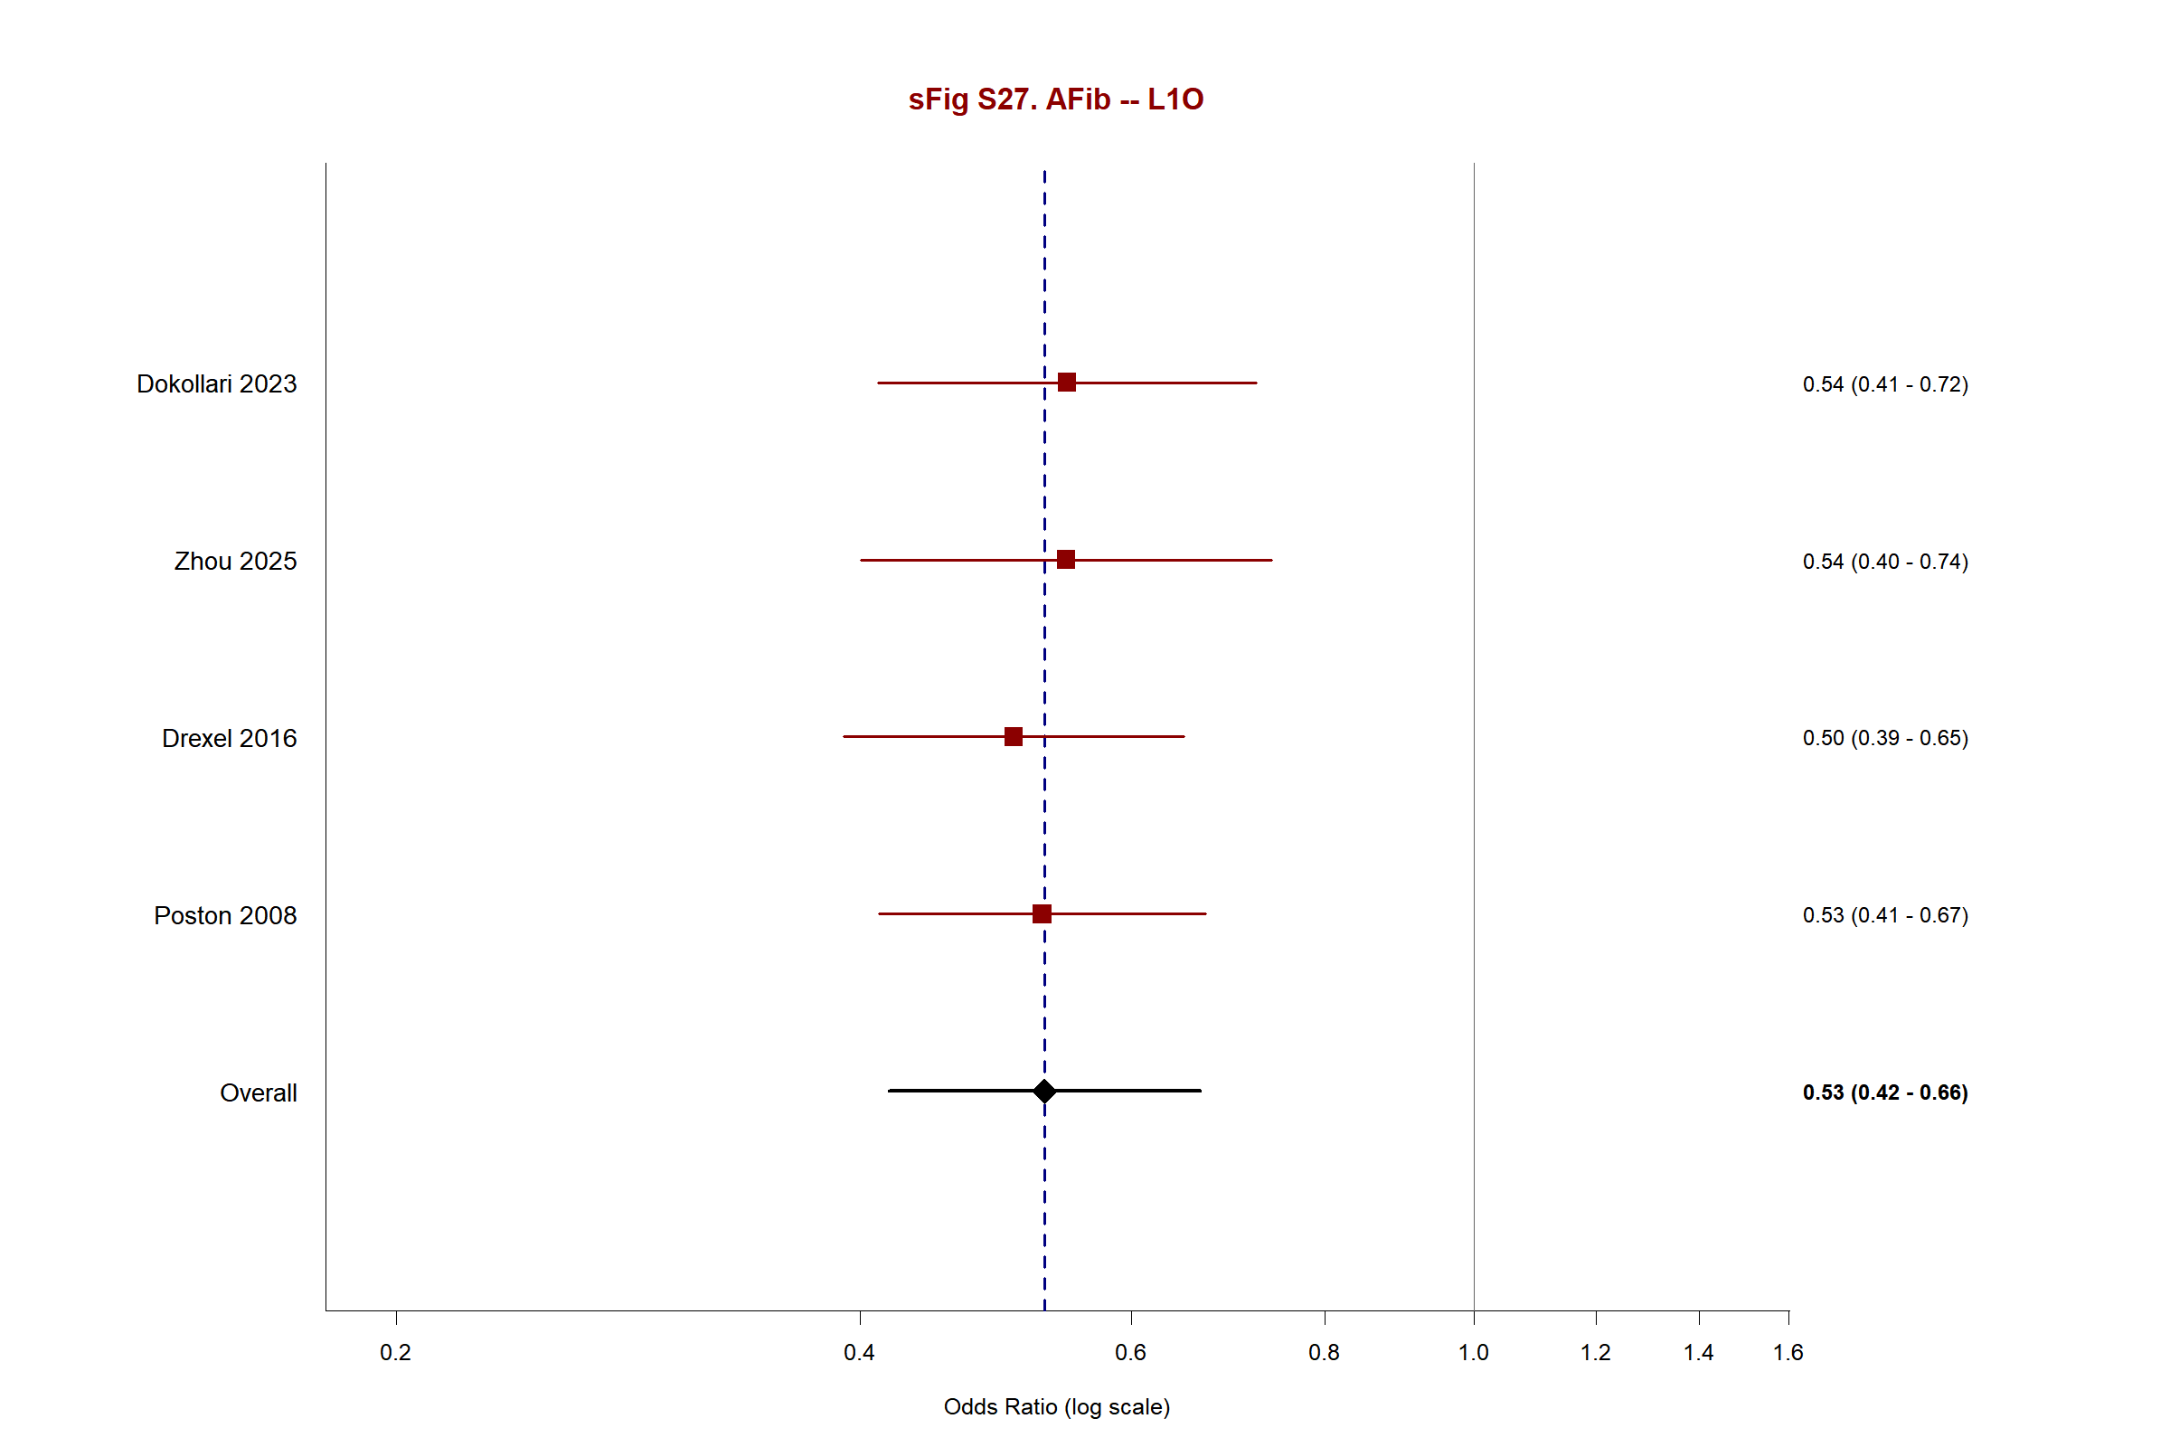

Supplementary Figure S28. Leave-One-Out — Renal Failure
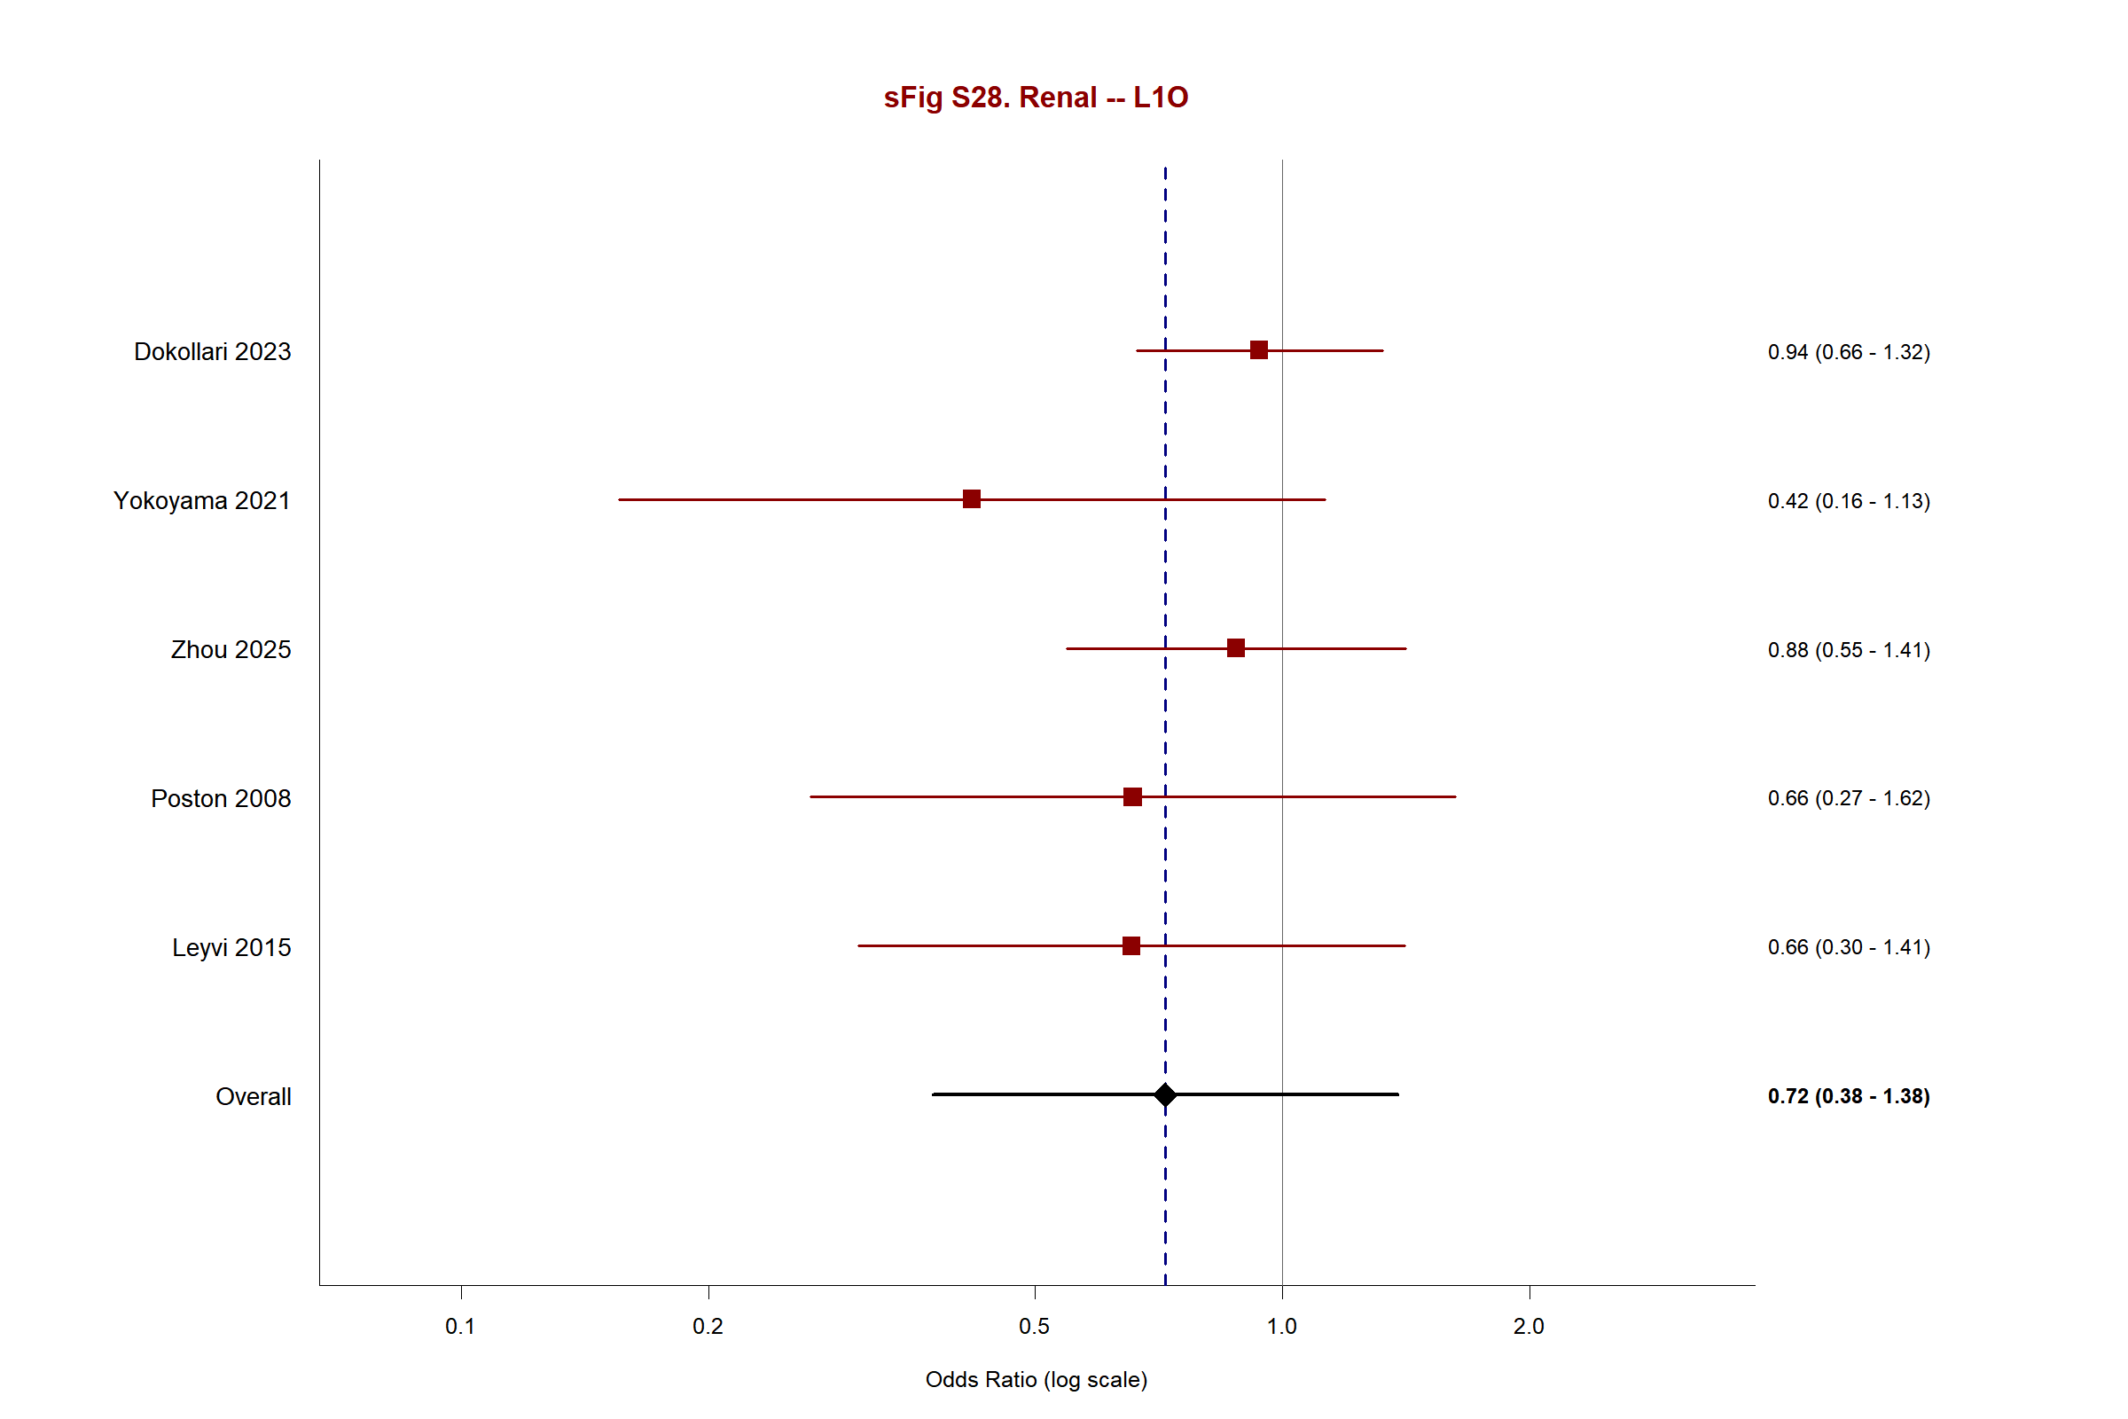

Supplementary Figure S29. Leave-One-Out — Respiratory Failure
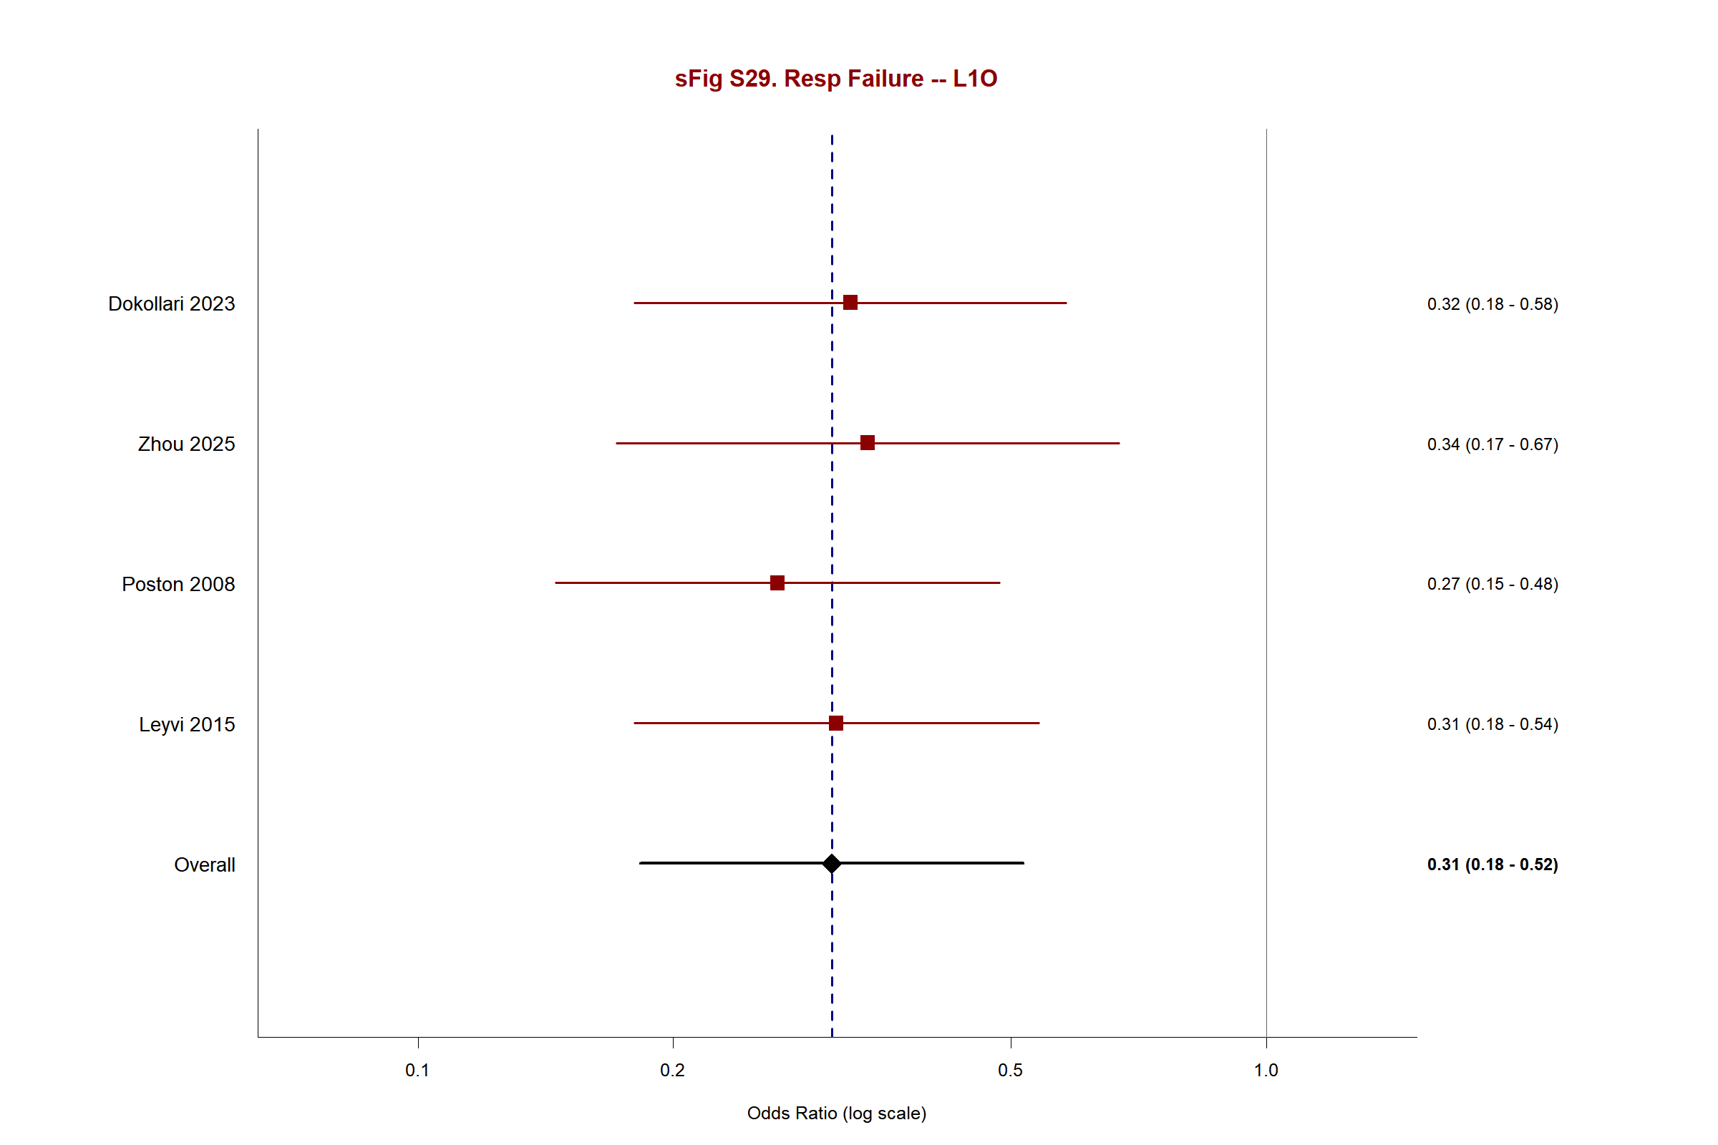

Supplementary Figure S30. Leave-One-Out — Reoperation
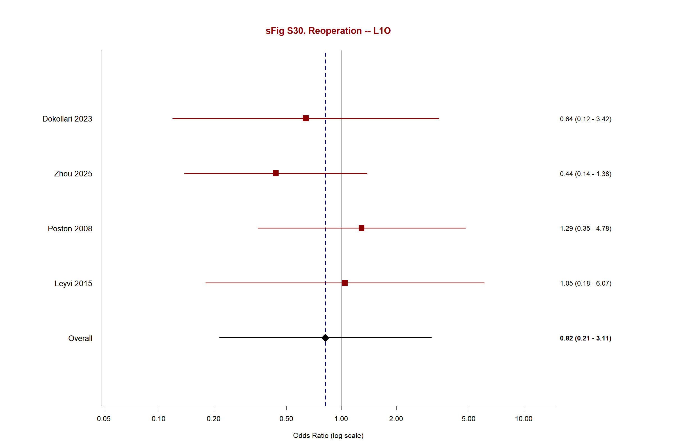

Supplementary Figure S31. Leave-One-Out — Transfusion
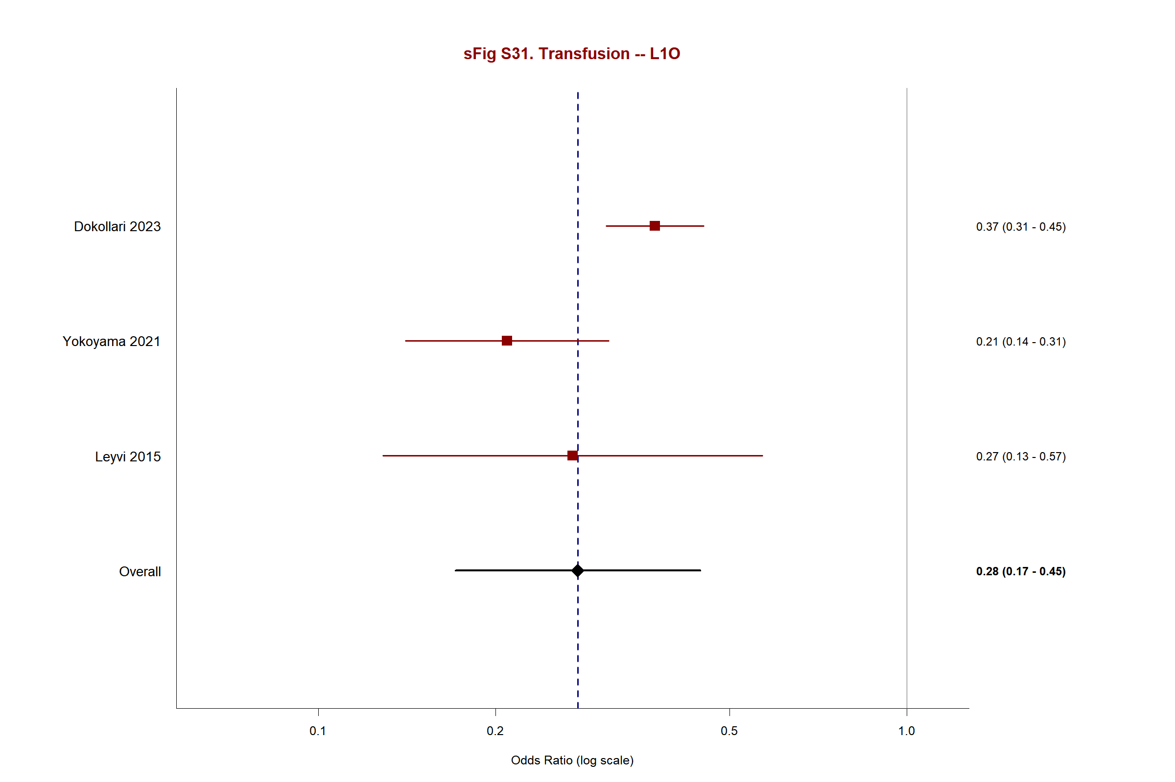

Supplementary Figure S32. Trial Sequential Analysis — Mortality (RA-CABG vs C-CABG)
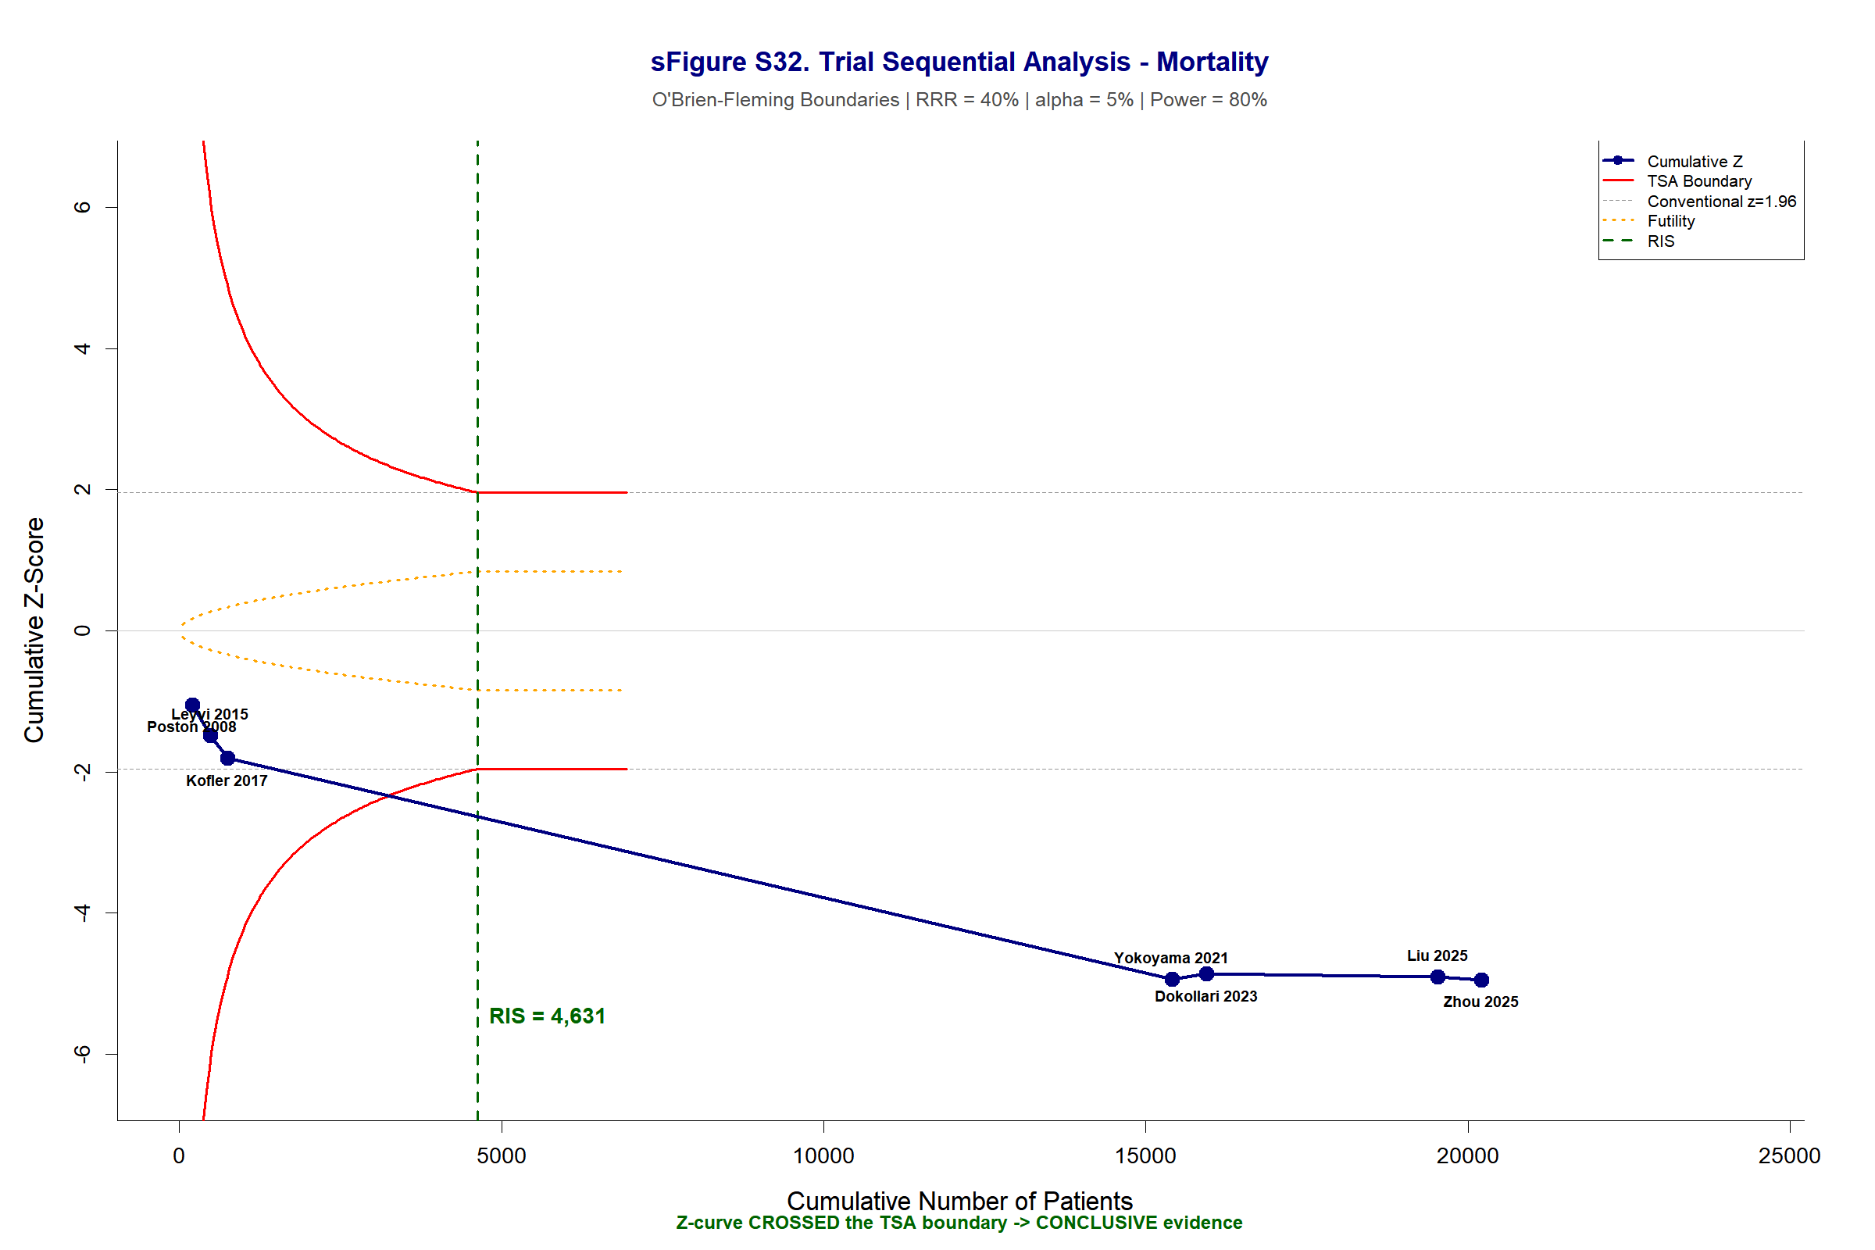

Supplementary Figure S33. Trial Sequential Analysis — Stroke (RA-CABG vs C-CABG)
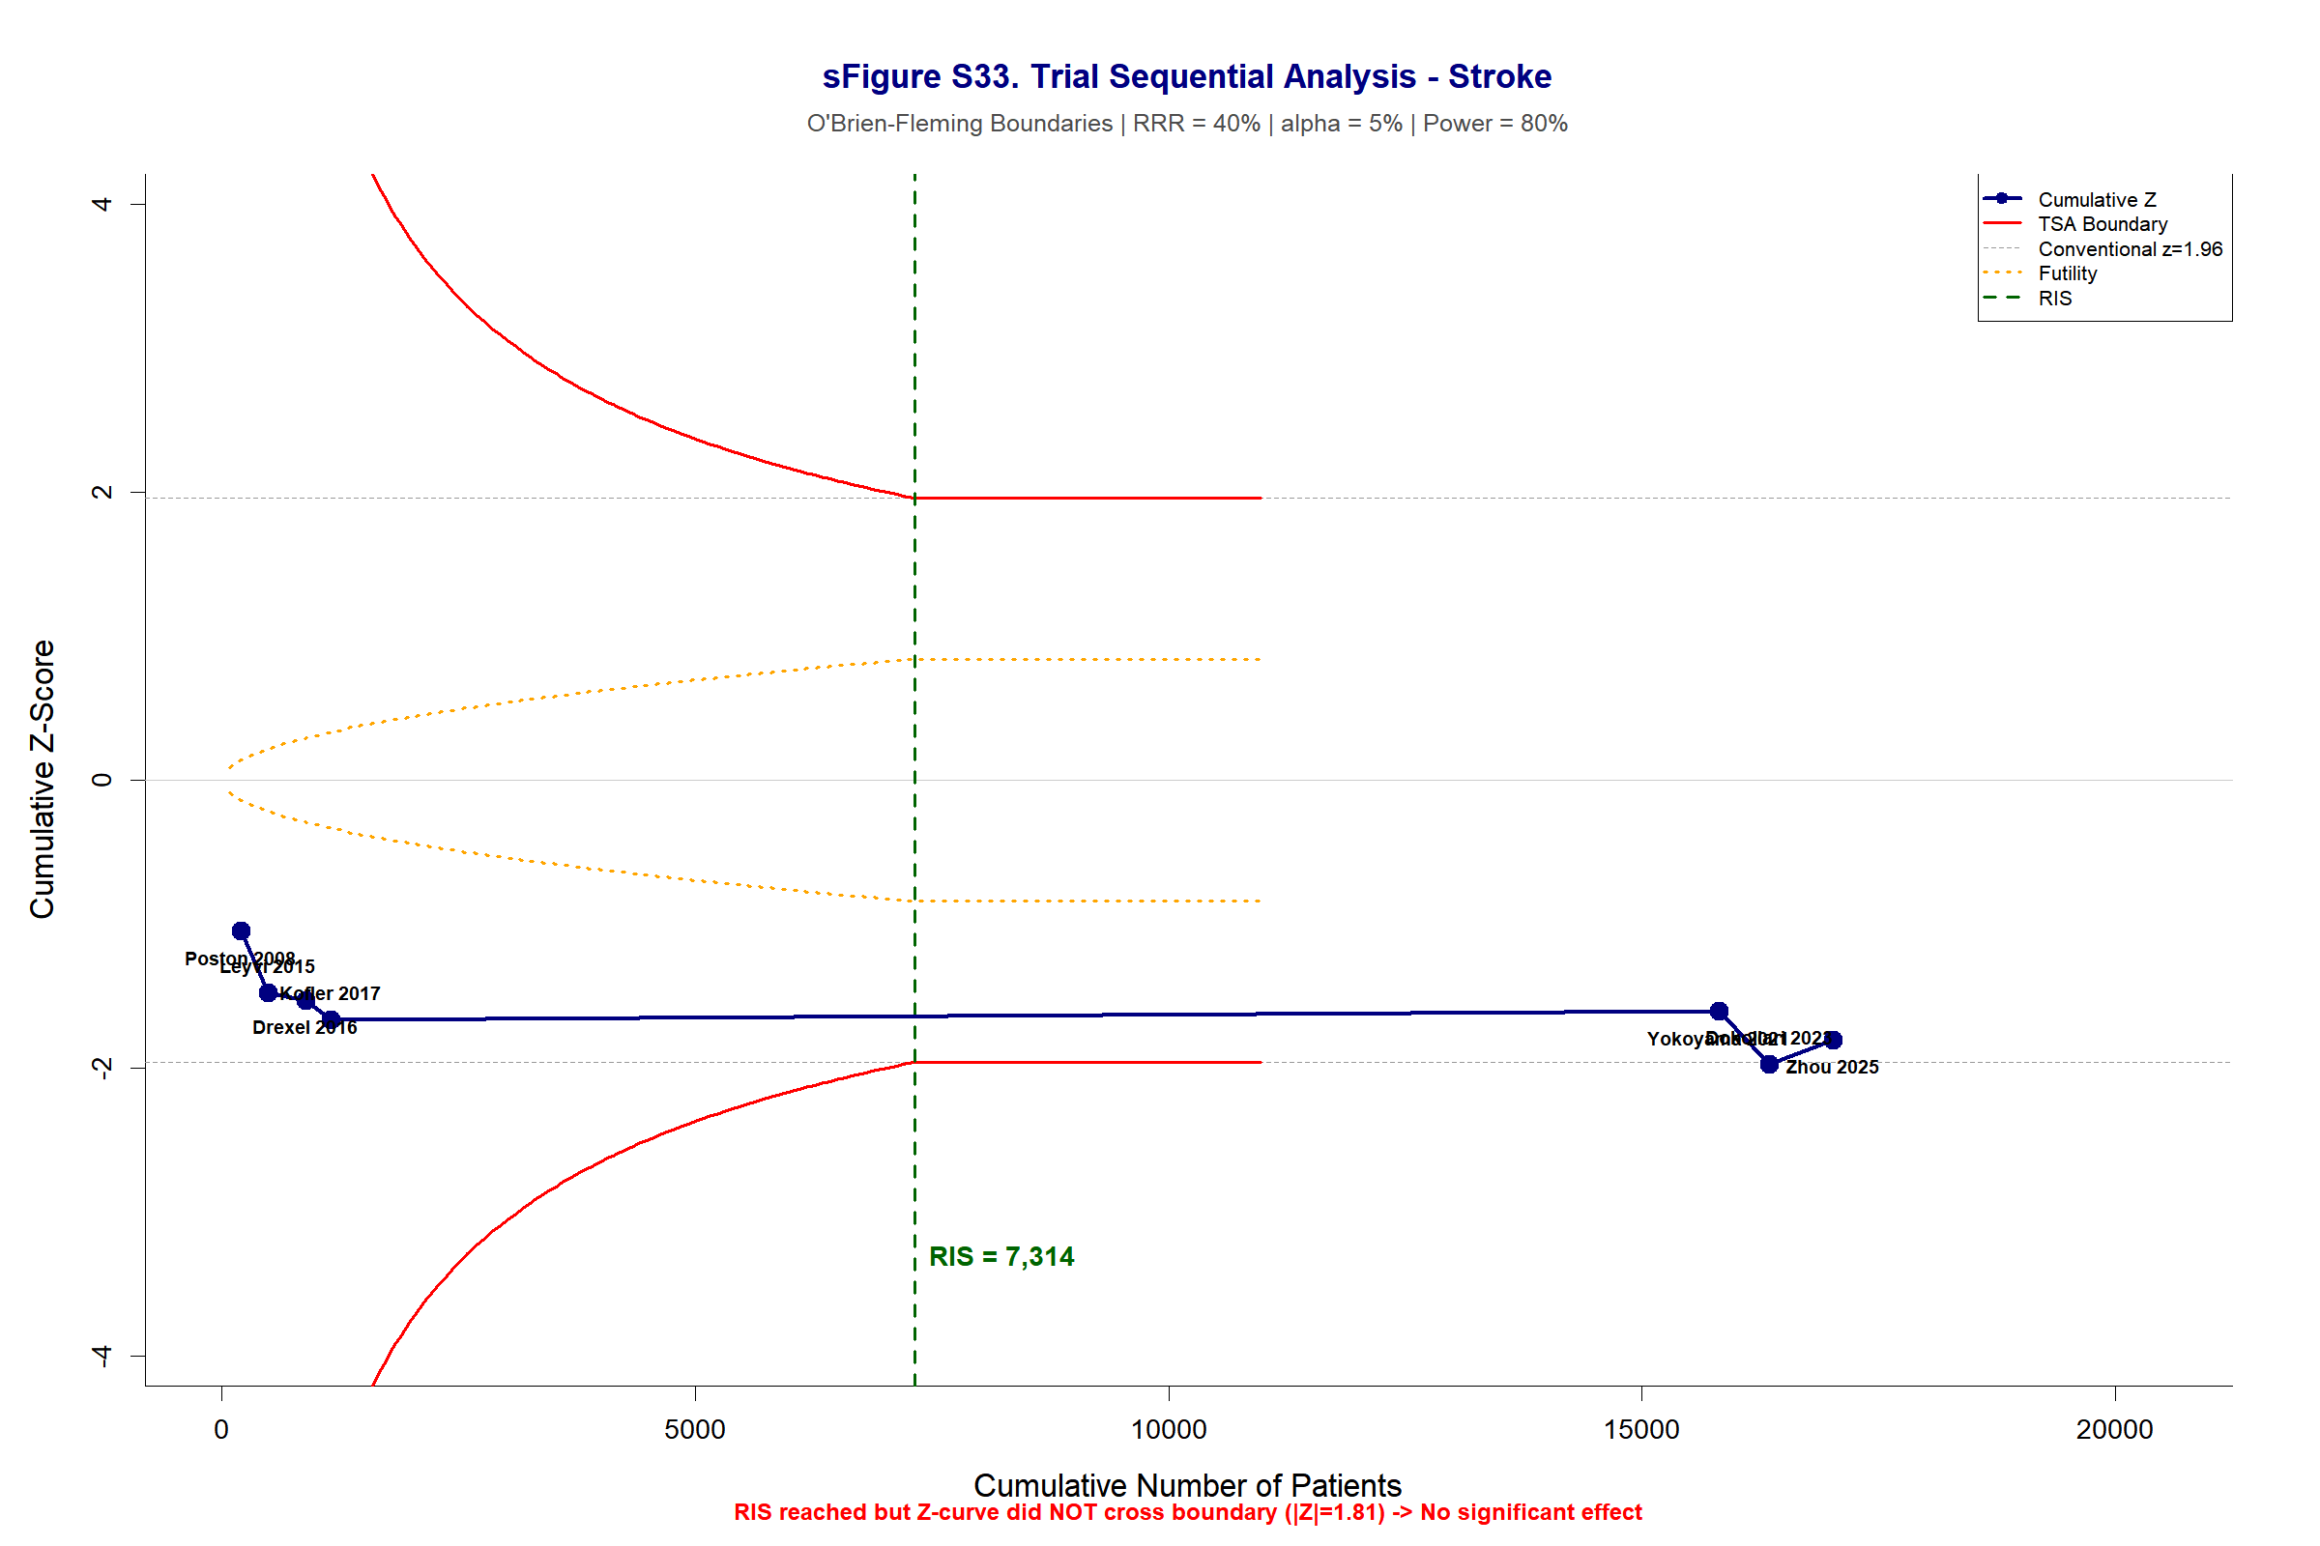

Supplementary Figure S34. Trial Sequential Analysis — Atrial Fibrillation (RA-CABG vs C-CABG)
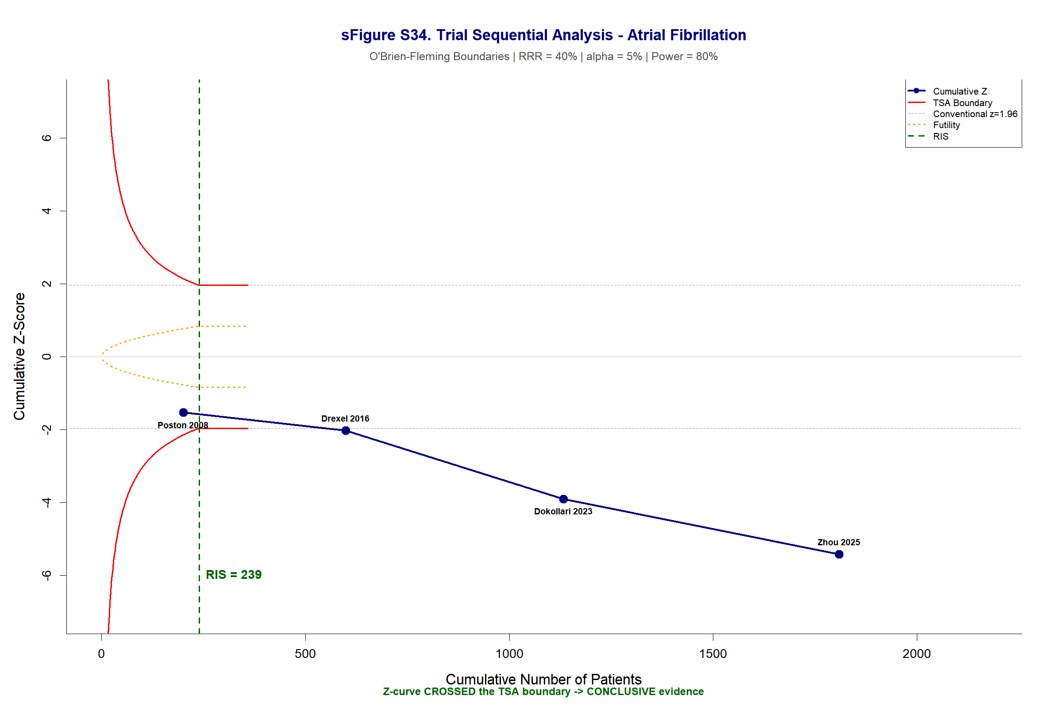

Supplementary Figure S35. Trial Sequential Analysis — Respiratory Failure (RA-CABG vs C-CABG)
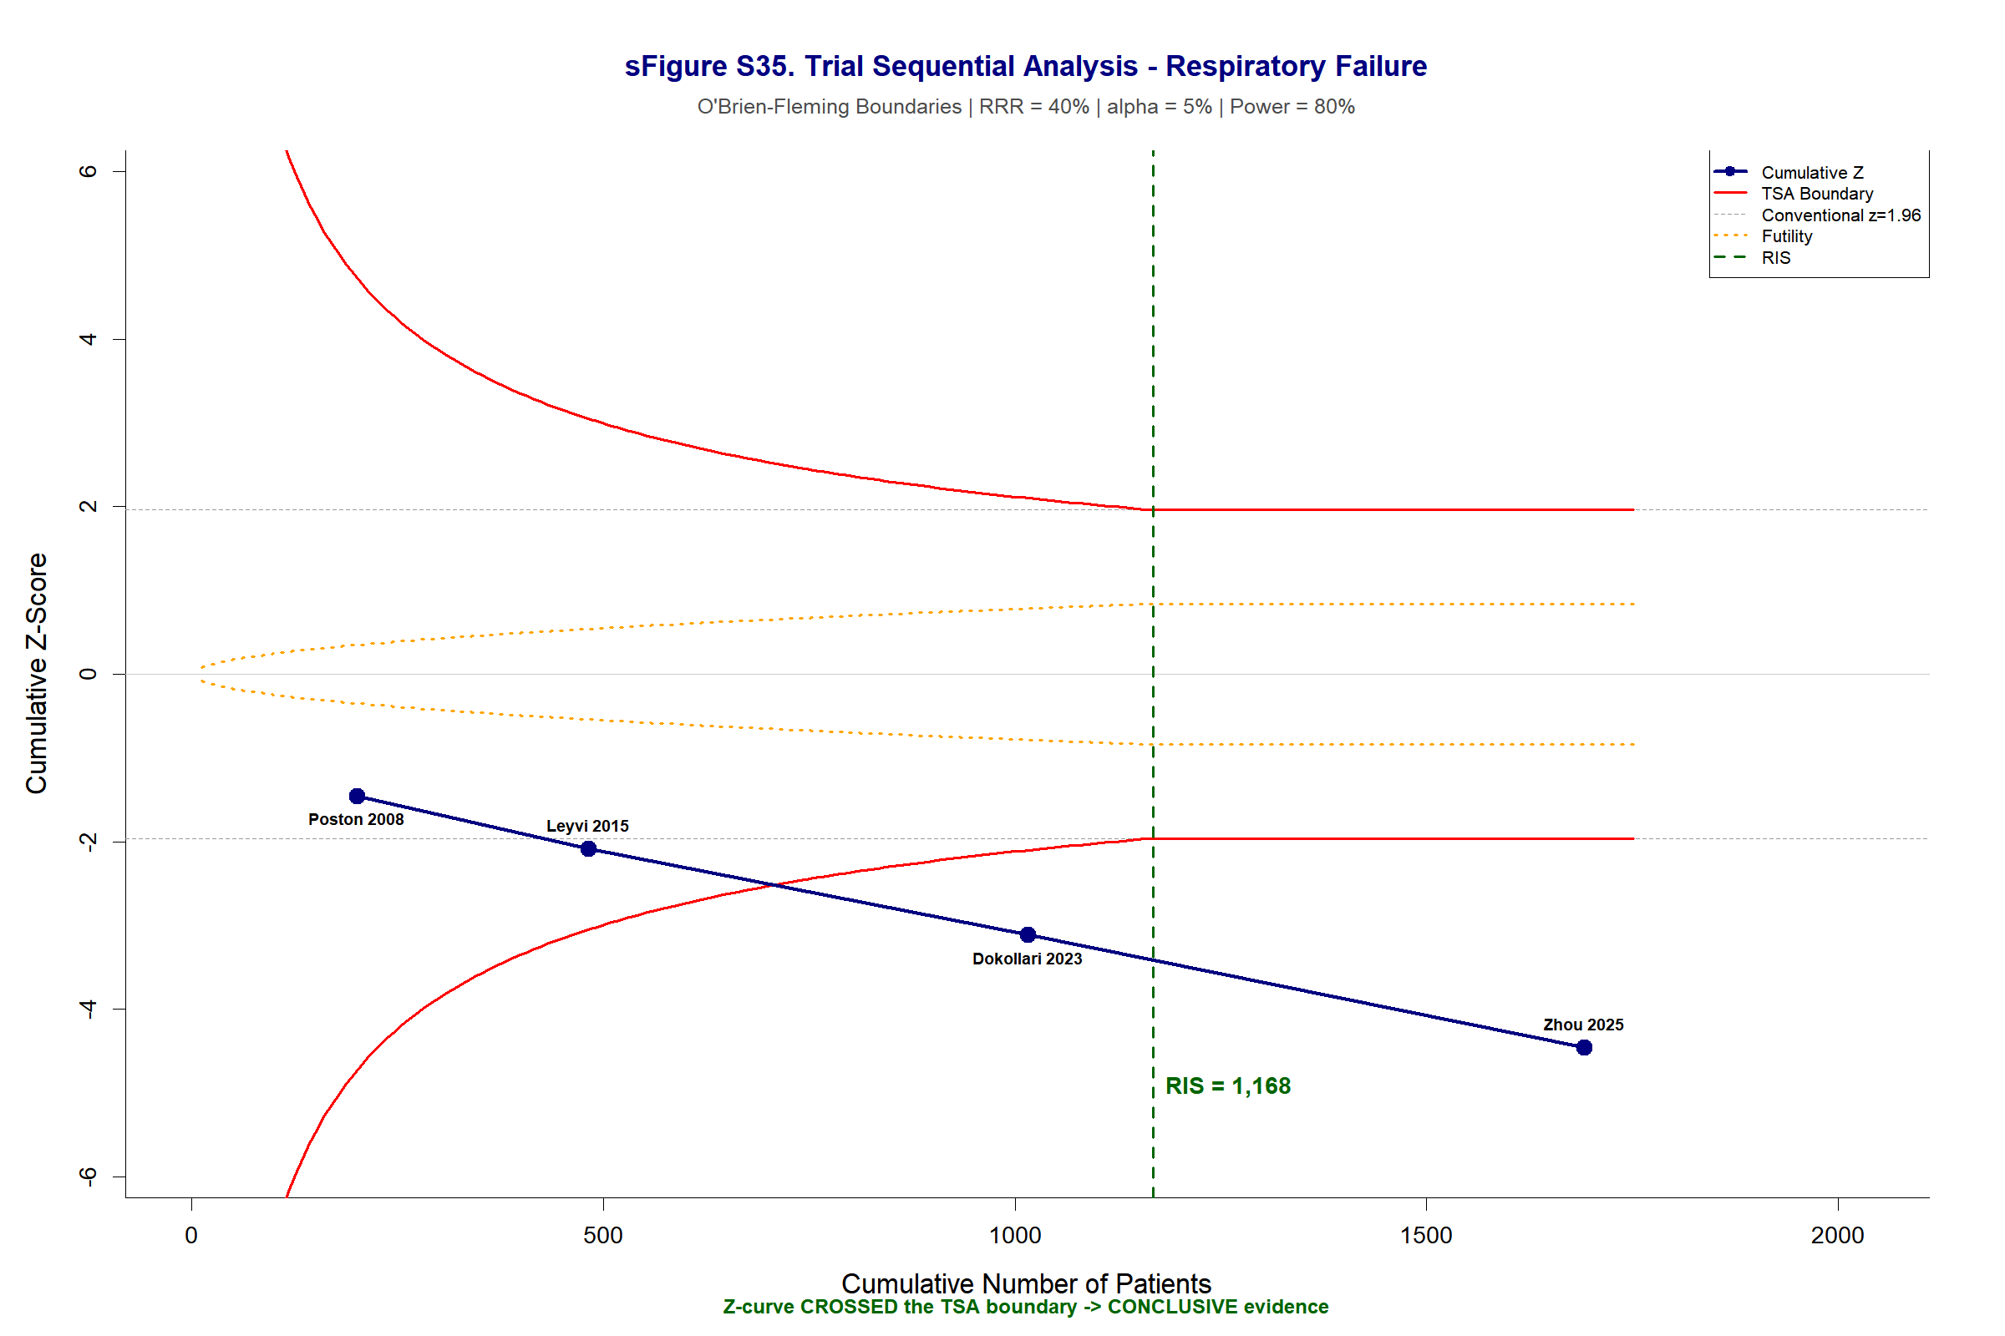

Supplementary Figure S36. Trial Sequential Analysis — Blood Transfusion (RA-CABG vs C-CABG)
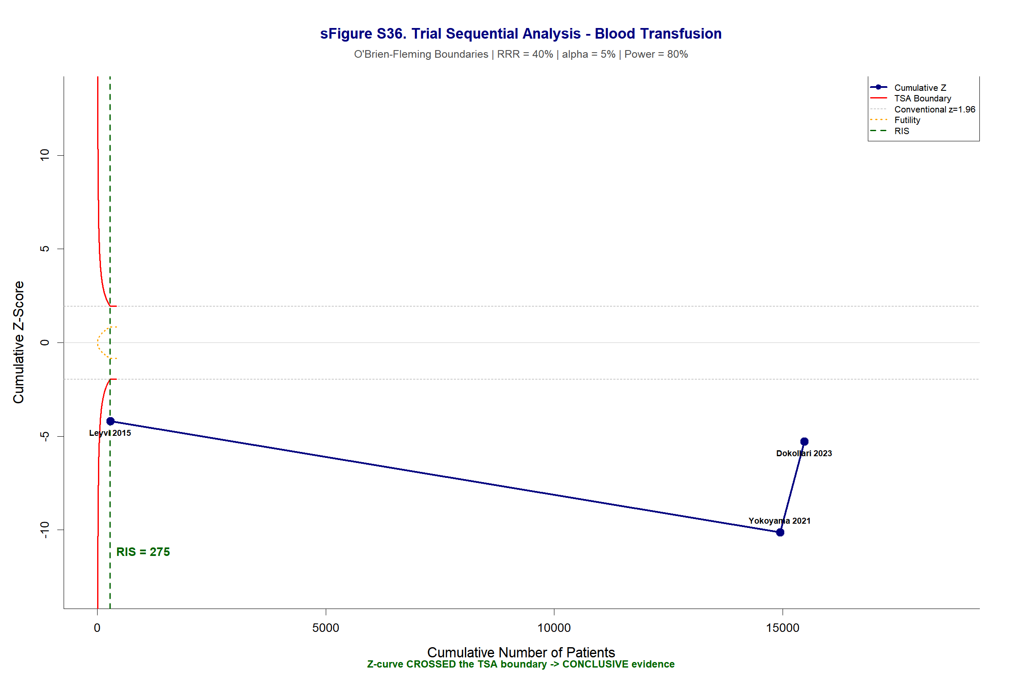

Supplementary Figure S37. Trial Sequential Analysis — Renal Failure (RA-CABG vs C-CABG)
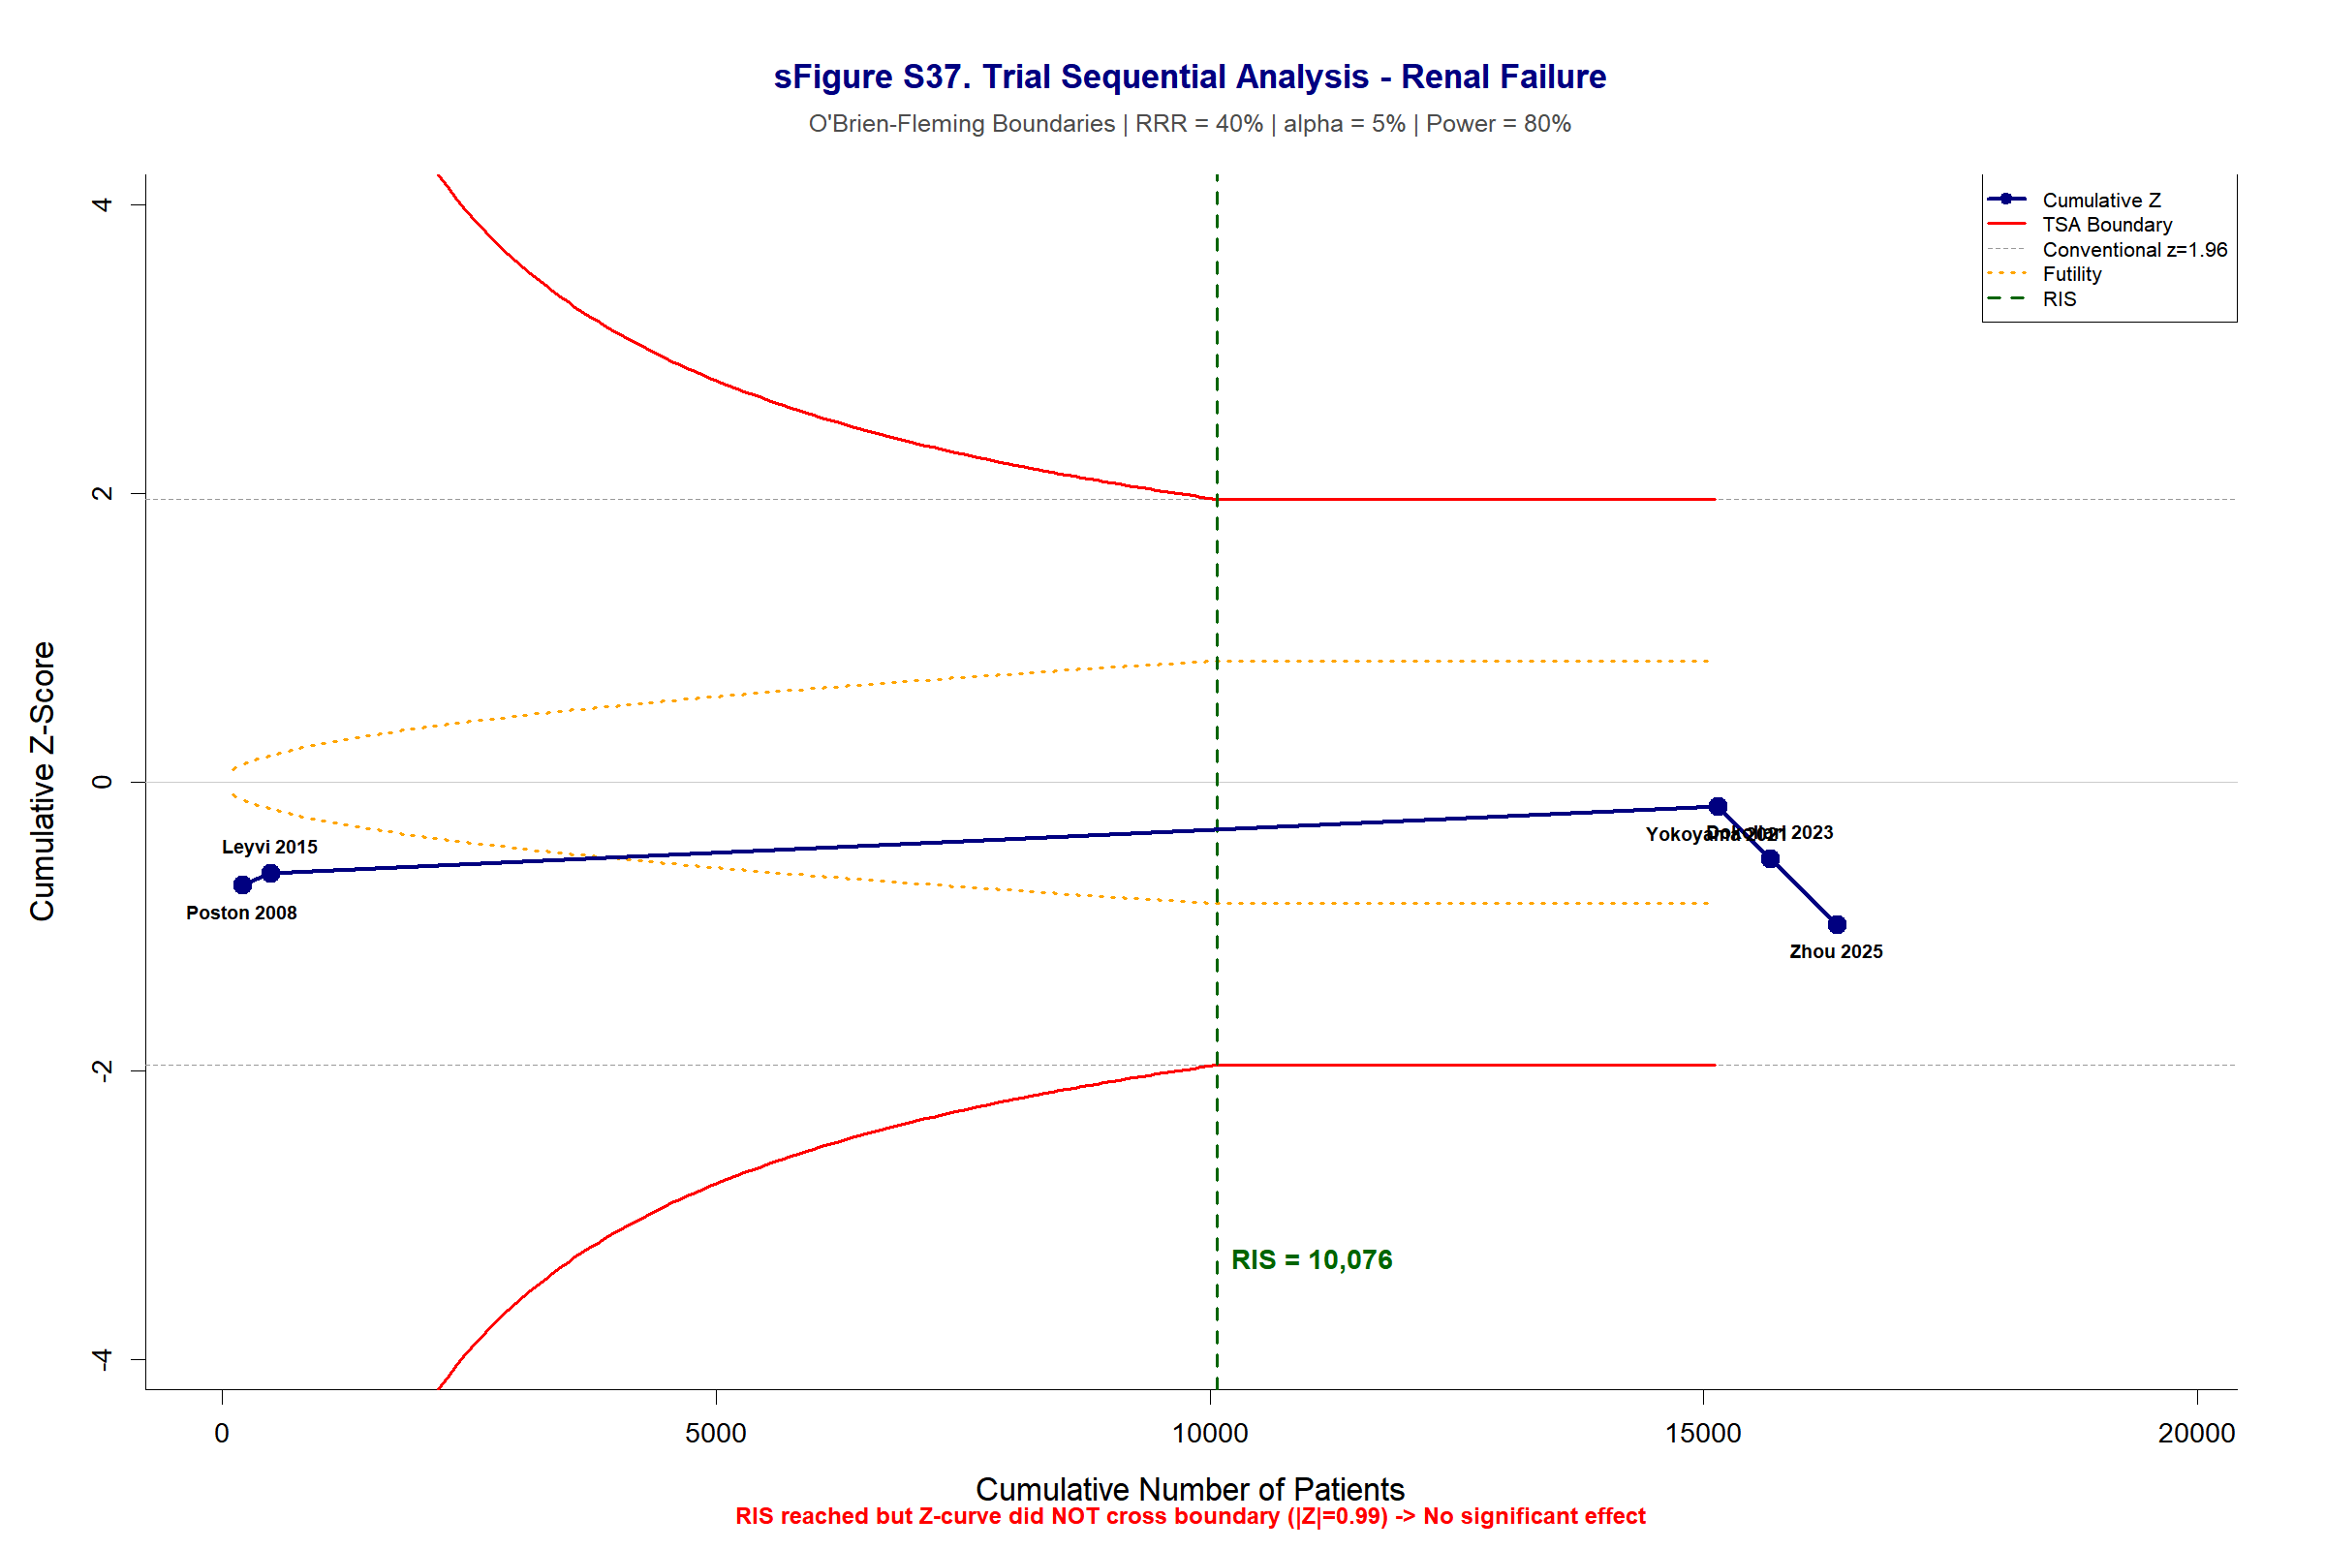

Supplementary Figure S38. Trial Sequential Analysis — Reoperation for Bleeding (RA-CABG vs C-CABG)
