The accessions containing inversion sequence:

voucher No | species | psbA-trnH | Inversion
PS1001MT01 | U. rhynchophylla_01 | KM057031 | Yes
PS1001MT02 | U. rhynchophylla_02 | KM057032 | Yes
URH-1 | U. rhynchophylla_05 | KF881177 | Yes
URH-2 | U. rhynchophylla_06 | KF881178 | Yes
PS1002MT01 | U. macrophylla_01 | KM057033 | Yes
PS1002MT02 | U. macrophylla_02 | KM057034 | Yes
PS1002MT03 | U. macrophylla_03 | KM057035 | Yes
PS1038MT03 | U. macrophylla_04 | GQ435234 | Yes
PS1038MT04 | U. macrophylla_05 | GQ435235 | Yes
UMA-1 | U. macrophylla_07 | KF881170 | Yes
UMA-2 | U. macrophylla_08 | KF881171 | Yes
UMA-3 | U. macrophylla_09 | KF881172 | Yes
UMA-4 | U. macrophylla_10 | KF881173 | Yes
UMA-6 | U. macrophylla_12 | KF881174 | Yes
UMA-8 | U. macrophylla_14 | KF881175 | Yes
PS1003MT01 | U. sessilifructus_01 | KM057036 | Yes
PS1003MT02 | U. sessilifructus_02 | KM057037 | Yes
USE-2 | U. sessilifructus_06 | KF881160 | Yes
USE-3 | U. sessilifructus_07 | KF881161 | Yes
USE-4 | U. sessilifructus_08 | KF881162 | Yes
PS1004MT01 | U. hirsuta_01 | KM057038 | Yes
PS1004MT02 | U. hirsuta_02 | KM057039 | Yes
PS1004MT03 | U. hirsuta_03 | KM057040 | Yes
PS1005MT01 | U. lancifolia_01 | KM057041 | Yes
ULA-1 | U. lancifolia_03 | KF881176 | Yes
PS1006MT01 | U. homomalla_01 | KM057042 | Yes
UHO-1 | U. homomalla_03 | KF881163 | Yes
UHO-2 | U. homomalla_04 | KF881164 | Yes
UHO-3 | U. homomalla_05 | KF881165 | Yes
UHO-4 | U. homomalla_06 | KF881166 | Yes
UHO-5 | U. homomalla_07 | KF881167 | Yes
UHO-6 | U. homomalla_08 | KF881168 | Yes
UHO-7 | U. homomalla_09 | KF881169 | Yes
PS1039MT01 | U. sinensis_01 | GQ435236 | Yes
USI-2 | U. sinensis_03 | KF881183 | Yes
USI-4 | U. sinensis_05 | KF881184 | Yes
UYU-1 | U. yunnanensis_01 | KF881191 | Yes
UYU-4 | U. yunnanensis_04 | KF881193 | Yes
UYU-5 | U. yunnanensis_05 | KF881194 | Yes
USC-1 | U. scandens_02 | KF881185 | Yes
USC-2 | U. scandens_03 | KF881186 | Yes
USC-3 | U. scandens_04 | KF881187 | Yes
USC-4 | U. scandens_05 | KF881188 | Yes
USC-6 | U. scandens_07 | KF881189 | Yes
USC-7 | U. scandens_08 | KF881190 | Yes
ULAE-1 | U. laevigata_02 | KF881179 | Yes
ULAE-4 | U. laevigata_05 | KF881180 | Yes
ULAE-5 | U. laevigata_06 | KF881181 | Yes
ULAE-7 | U. laevigata_08 | KF881182 | Yes
Total No. of sequences |  | 49

KF881172 inversion
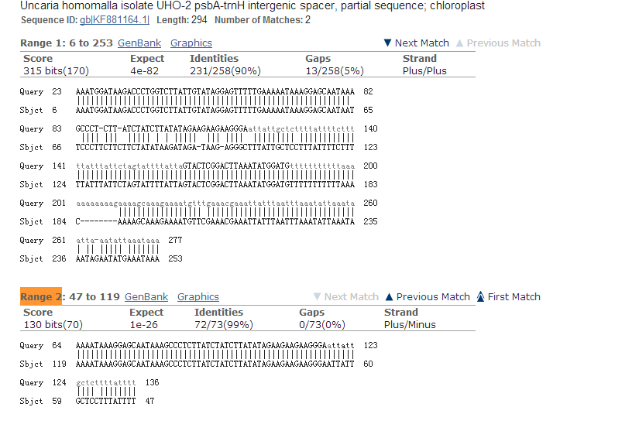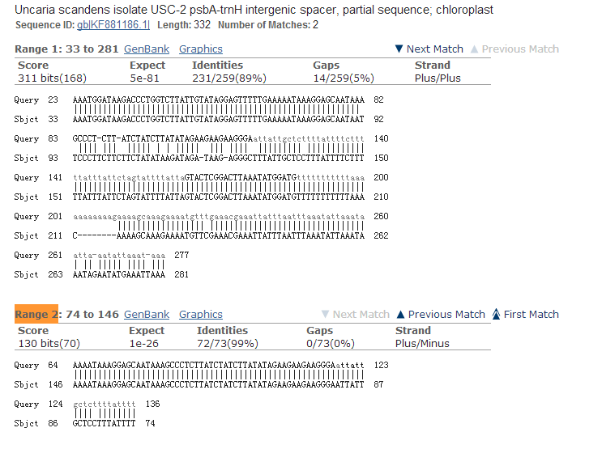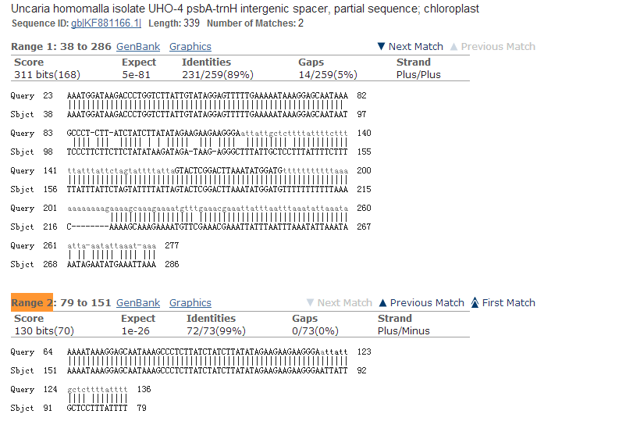
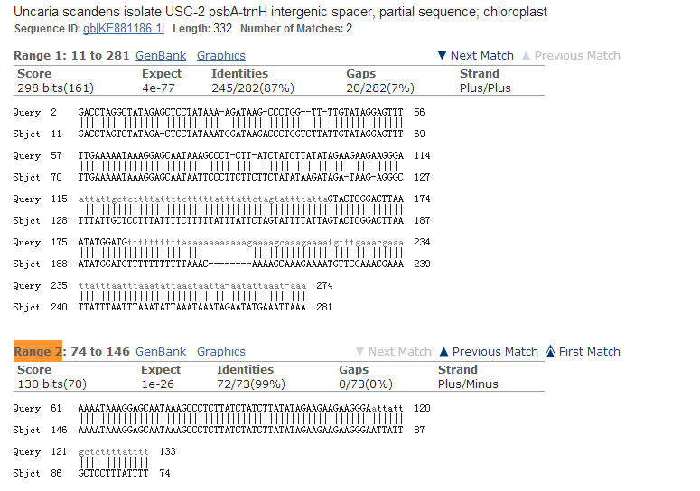

KF881174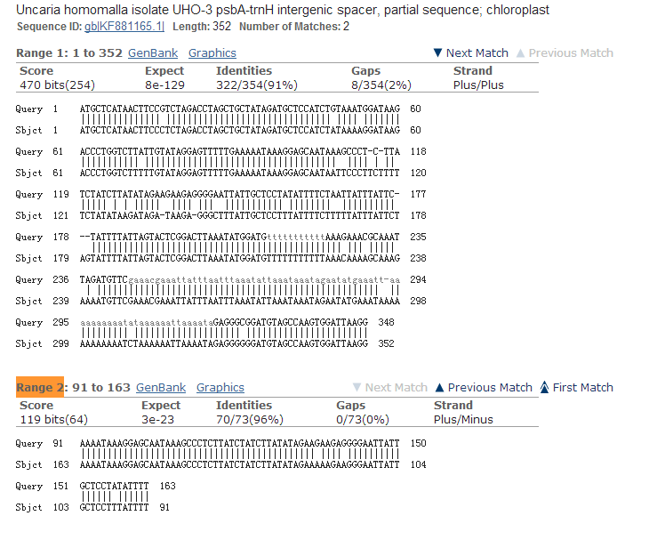

KF881160
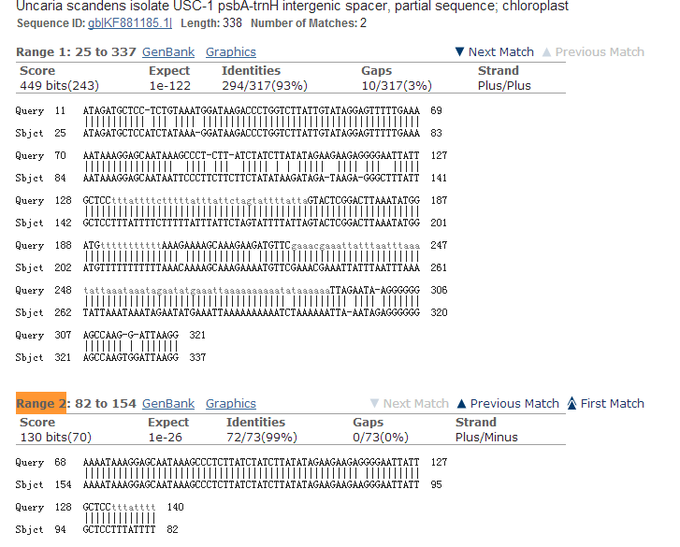
KF881161
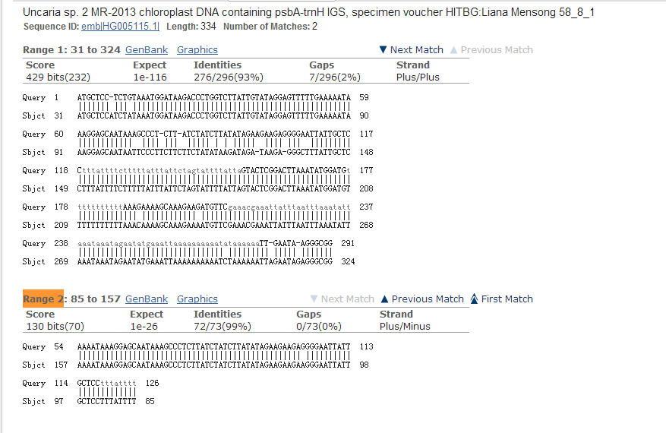
KF881162
