Additional file 1

Appendix S1: MEDLINE (OvidSP) Search Strategy
This search will be based on the following MeSH terms and keywords:
Search strategy to locate alcohol dependence:
1. alcohol related disorders.mp. or exp Alcoholism/ or exp Alcohol-Related Disorders/ (99745)
2. exp Alcohol Drinking/ or drinking behaviour.mp. or exp Drinking Behavior/ (60216)
3. exp Alcohol Withdrawal Delirium/ or exp Substance Withdrawal Syndrome/ or alcohol withdrawal.mp. (21750)
4. alcohol dependence.mp. (7160)
5. exp Substance-Related Disorders/ or alcohol dependent.mp. or exp Substance Withdrawal Syndrome/ (234093)
6. alcohol abuse.mp. (11498)
7. alcohol abstinence.mp. or exp Alcohol Abstinence/ (662)
8. alcohol addiction.mp. (803)
9. alcohol misuse.mp. or exp Alcohol-Related Disorders/ (100170)
10. alcohol abstinence.mp. or exp Alcohol Abstinence/ (662)
11. alcohol craving.mp. (504)
12. exp Alcohol Drinking/ or alcohol$ beverage$.mp. or exp Alcoholic Beverages/ (67210)
13. exp Alcoholic Intoxication/ or alcohol intoxication.mp. (12292)
14. substance related disorder.mp. or exp Substance-Related Disorders/ (233911)
- 1 or 2 or 3 or 4 or 5 or 6 or 7 or 8 or 9 or 10 or 11 or 12 or 13 or 14 (291208)
Search strategy to locate acupuncture:
16. exp Acupuncture Analgesia/ or exp Acupuncture Therapy/ or exp Acupuncture/ or exp Acupuncture Points/ or exp Acupuncture, Ear/ or acupuncture.mp. (20219)
17. auricular acupuncture.mp. (221)
18. electroacupuncture.mp. or exp Electroacupuncture/ (3318)
19. body acupuncture.mp. (107)
20. medical acupuncture.mp. (54)
21. traditional acupuncture.mp. (167)
22. traditional Chinese medicine.mp. or exp Medicine, Chinese Traditional/ (17648)
23. alternative therapy.mp. or exp Complementary Therapies/ (186552)
- 16 or 17 or 18 or 19 or 20 or 21 or 22 or 23 (191988)
Search strategy to locate human studies:
- Humans/ (14029583)
Search strategy to locate RCTs:
26. exp Randomized Controlled Trials as Topic/ or RCT.mp. (105076)
27. 15 and 24 and 25 and 26 (35)

Appendix S2 – Risk of Bias Tables

Bullock[23]
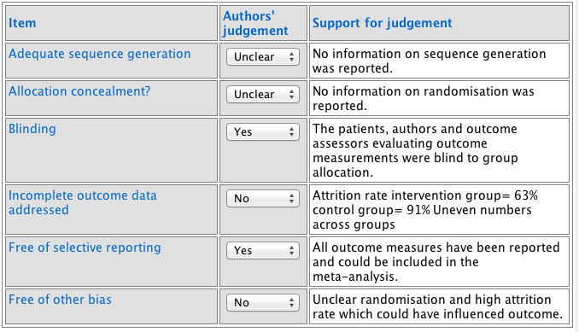

Bullock[13]
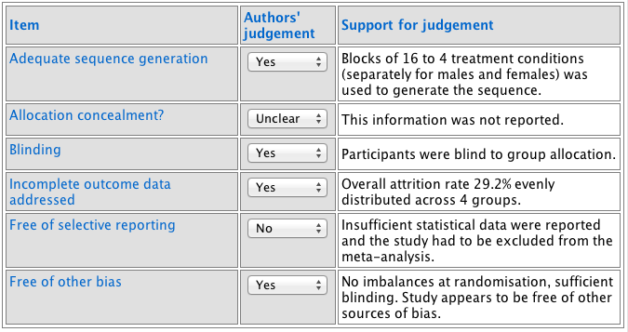

Karst[20]
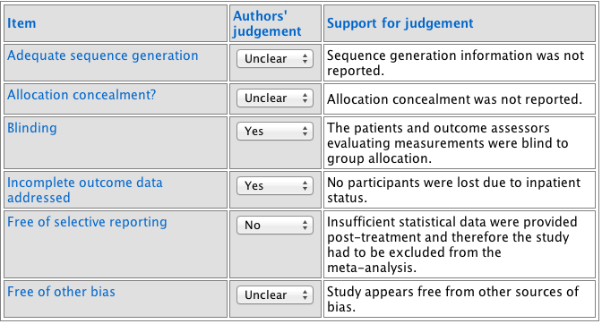

Kim[14]
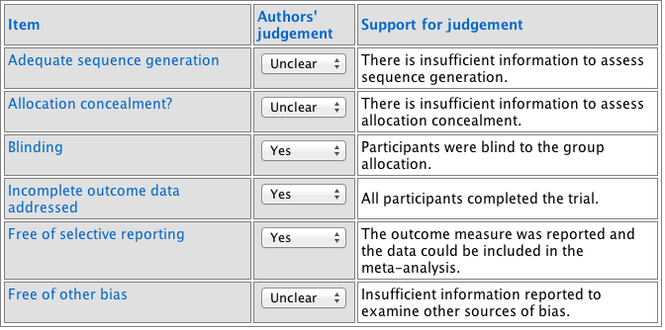

Kunz[19]
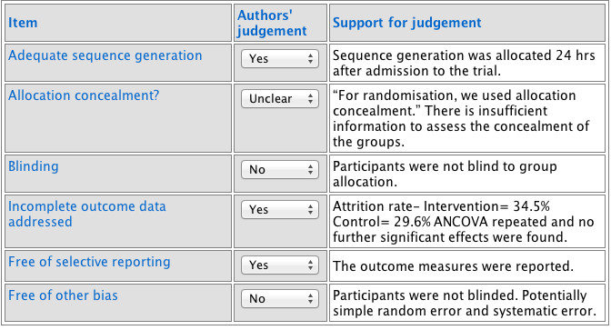

Lee[18]
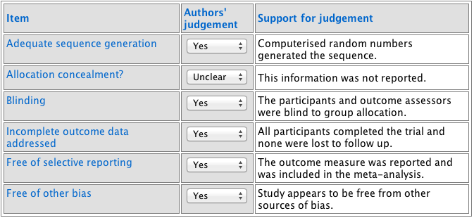

Li[24]
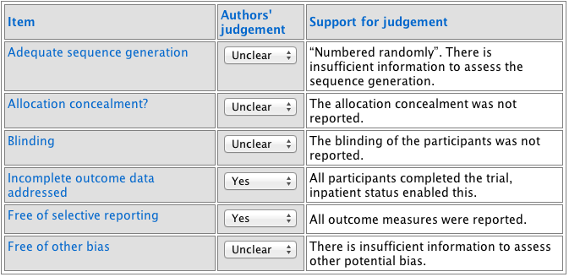

Rampes[10]
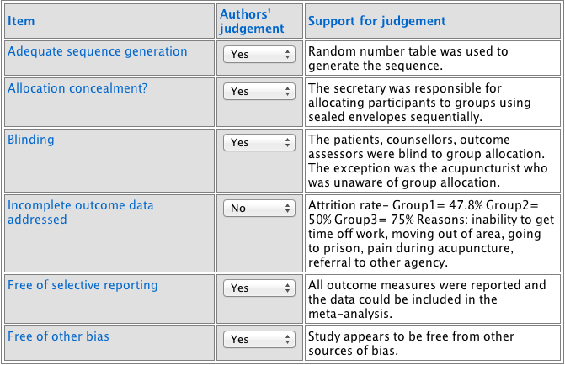

Sapir-Weise[16]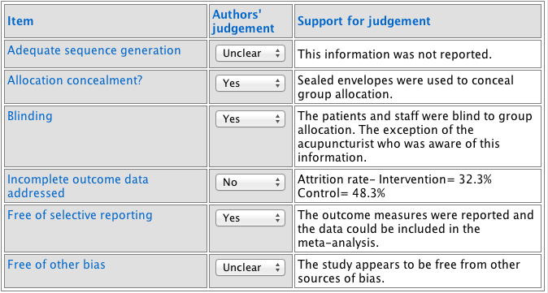

Tong[17]
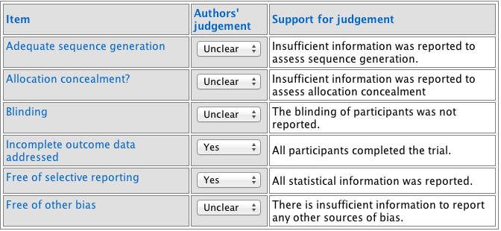

Toteva[15]
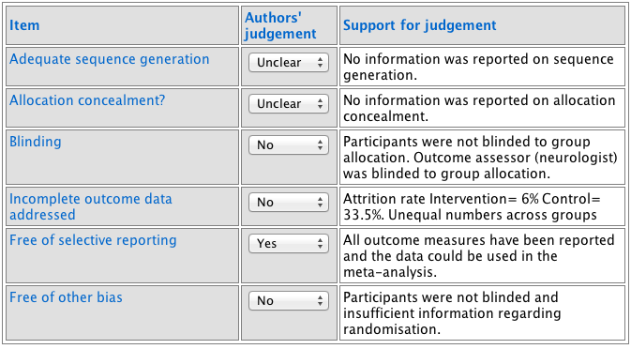

Trumpler[11]
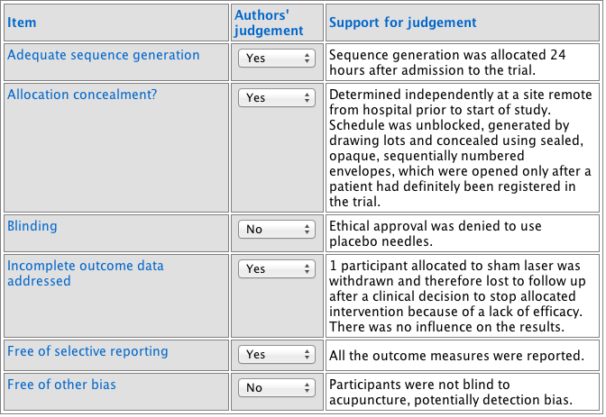

Worner[12]
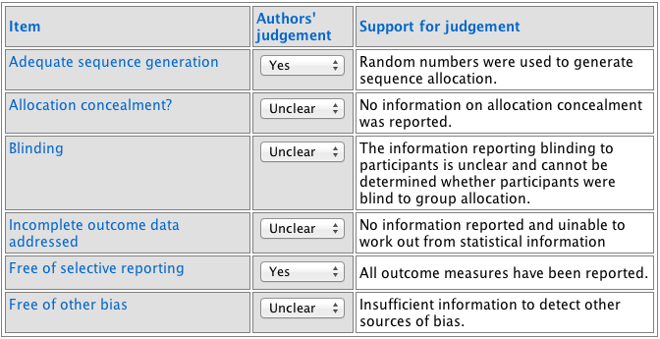

Yao[21]
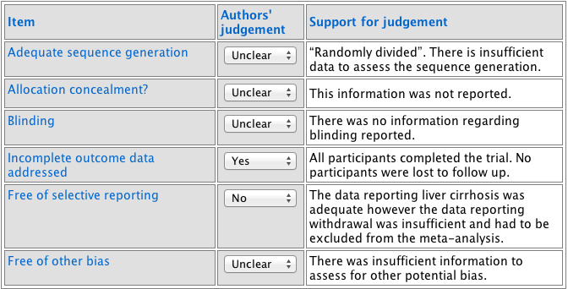

Zhang[22]
