Additional file 1:
Additional file 1: Table S1 The compositions of CQBP
NO. | Herbal drug | Local name | Collection place | Batch number
1 | Cortex phellodendri | Huangbai | Sichuan | 19072081
2 | Herba tuberculate speranskia | Tougucao | Jilin | 19072871

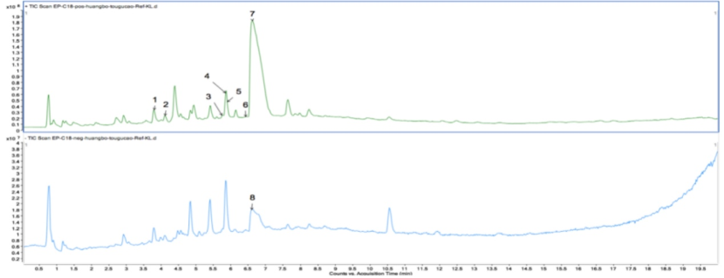
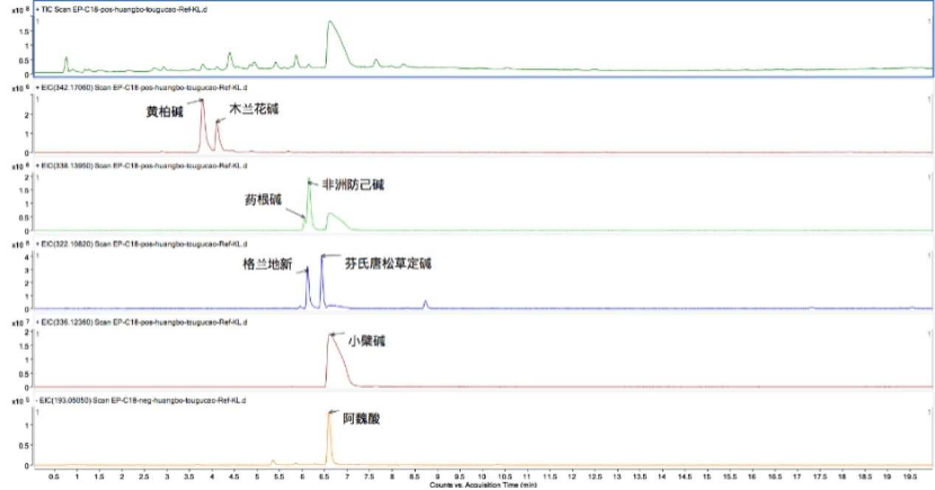
Additional file 1: Fig. S1. The fingerprints of CQBP. Peak number and identity, 1: phellodendrine; 2: magnoflorine; 3:jatrorrhizine; 4: tetrandrine; 5: columbamine; 6: phenanthrene herb and alkaloid; 7: berberine; 8: ferulic acid.

