Additional file 3.
GRADE assessment for combined CHM-WM vs WM alone treatment
Results on Efficacy
- Total effectiveness rate
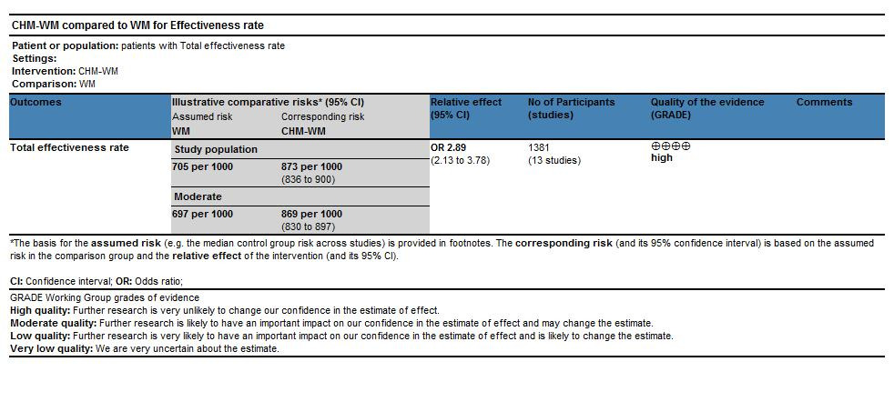
- Symptom improvement
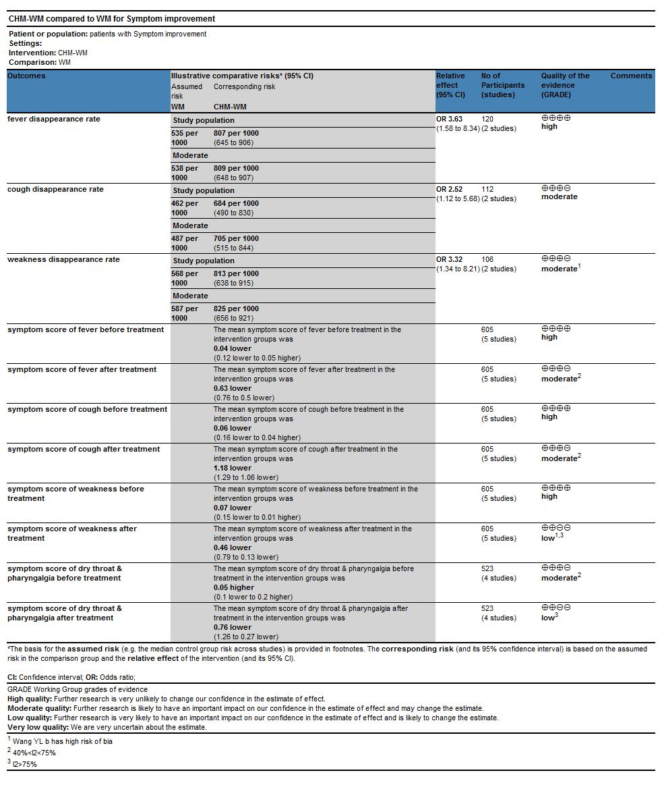

- Virological outcome
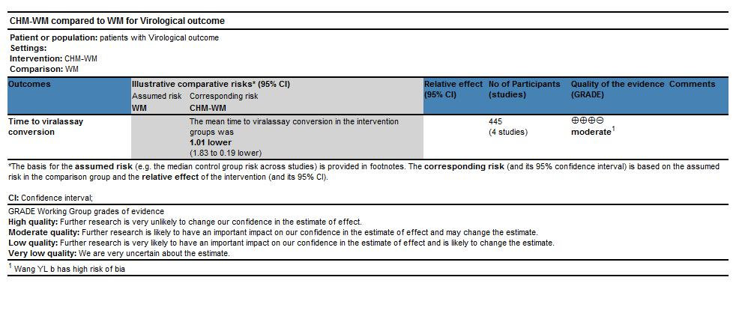

- CT image improvement rate
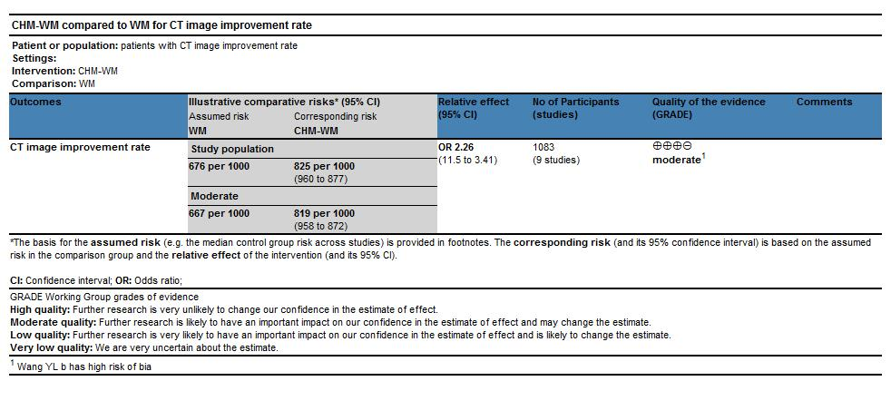
- Blood test improvement
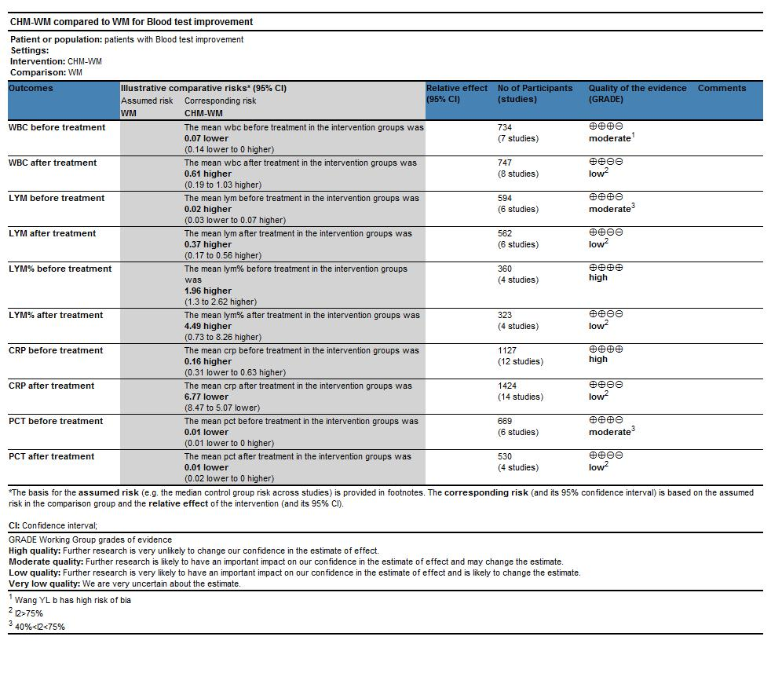
F. Results on Safety
