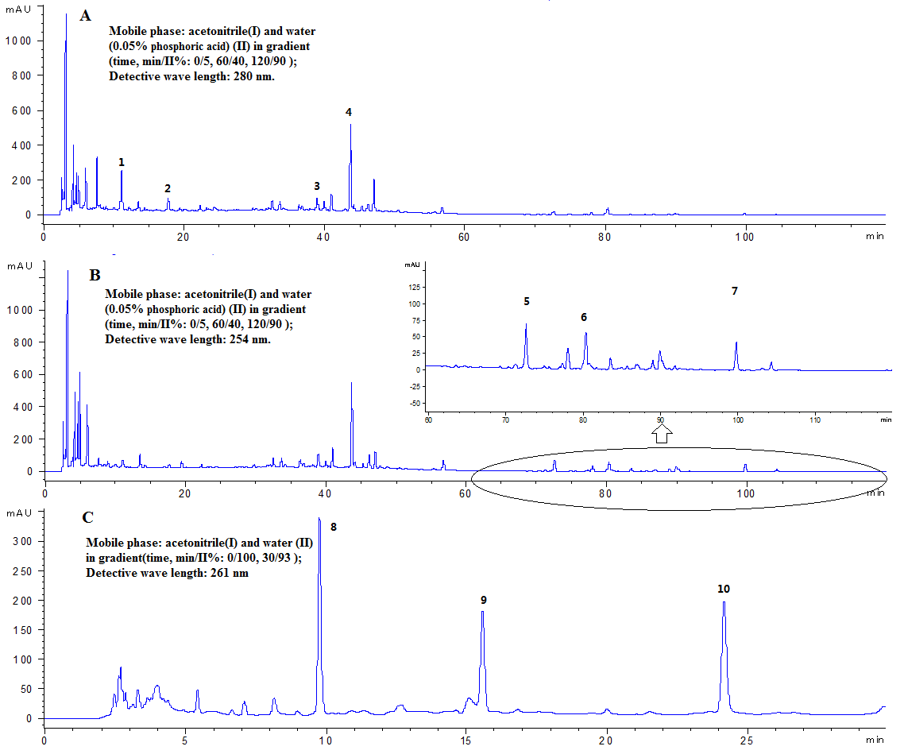
Figure Additional 1. The chromatographic proﬁle of FZHY extracts (Stationary phase: CNW Athena C18-WP (4.6mm×150mm, 3µm), ﬂow rate: 1 mL/min). Peak No.: 1. danshensu; 2. protocatechuic aldehyde; 3. rosmarinic acid; 4. salvianolic acid B; 5. schizandrol A; 6. schizandrol B; 7. schizandrin A; 8. uridine 9. guanosine; 10. adenosine.
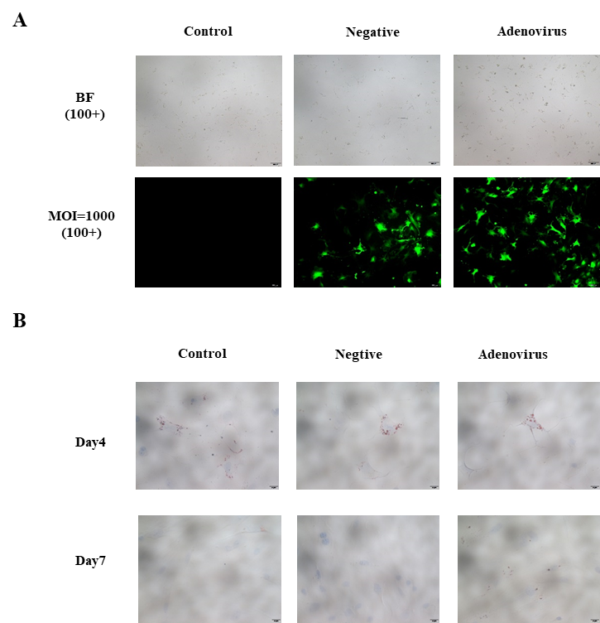
Figure Additional 2: HSCs were transfected with and without adenoviral vector for Cyp4a12a/b. (A) Adenovirus was used to transfect 1 day HSCs for 48h and transduc-tion at MOI 1000 was the best results. (B) Oil red staining in adenovirus-transfected HSCs was observed. Values represent means ± SD.

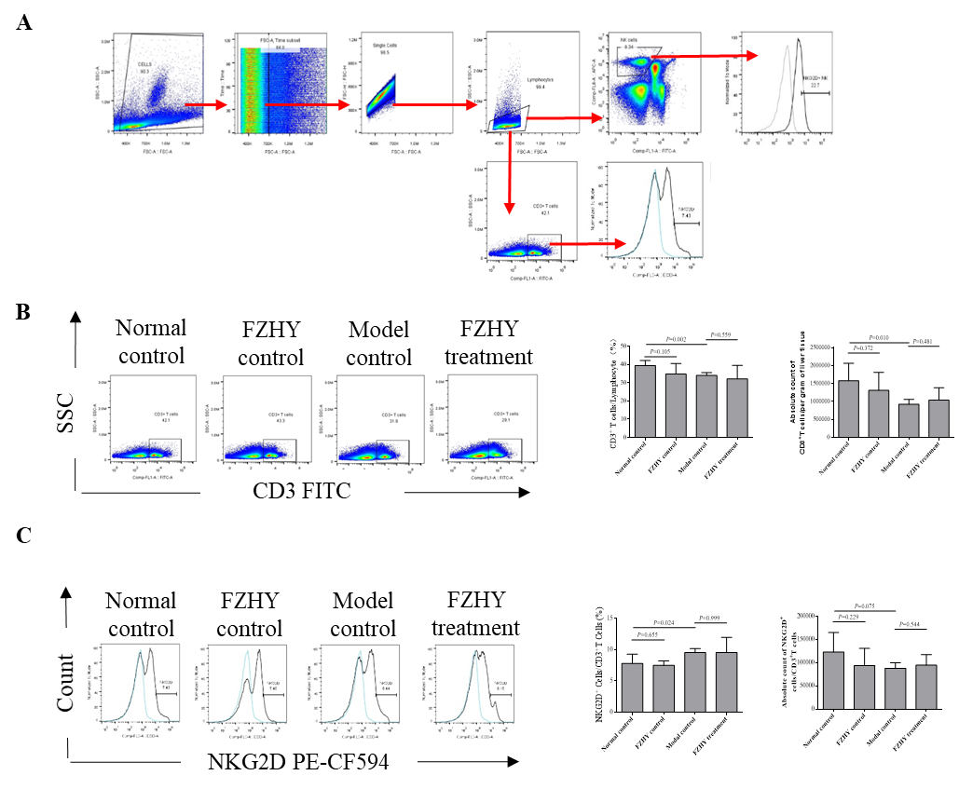
Figure Additional 3: The effects of FZHY on CD3⁺T cells expressed NKG2D. (A) Gating strategy for flow cytometry analysis. (B) Analysis of liver CD3⁺T-cells proportions and count. (C) Frequency and number of NKG2D⁺-cells in liver CD3⁺T-cells were counted. Values represent means ± SD.

