Additional file 13. Identification of Vitexin (Cas 3681-93-4, C₂₁H₂₀O₁₀, M.W. 432)

Standard
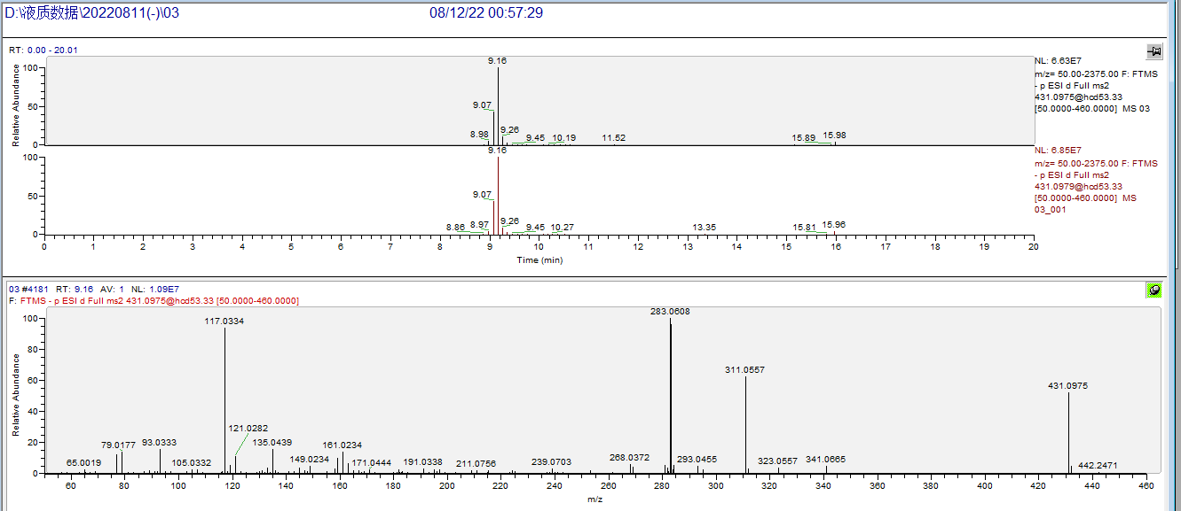

Sample
