Additional file 18. Identification of isoquercitrin (Cas 21637-25-2, C₂₁H₂₀O₁₂, M.W. 464.38)

Standard
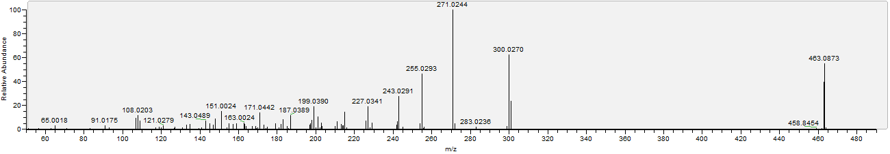

Sample
