Additional file 19. Identification of rutin (Cas 153-18-4, C₂₇H₃₀O₁₆, M.W. 610.52)

Standard
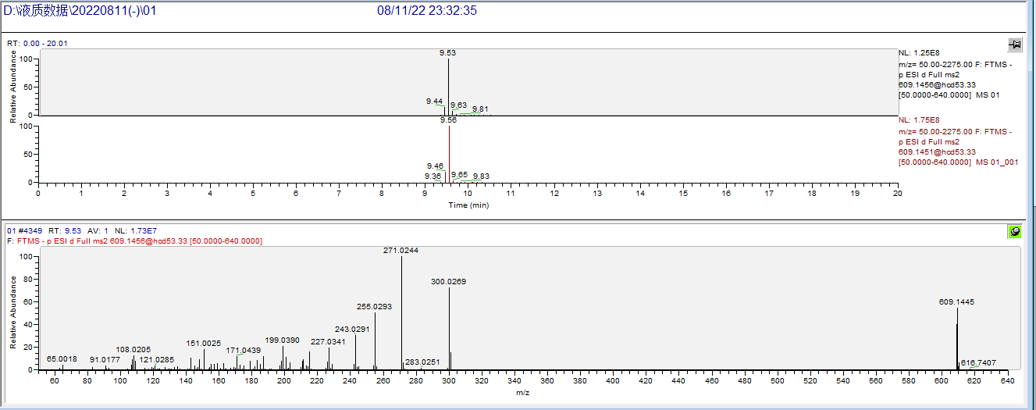

Sample
