Additional file 32. Identification of naringenin chalcone (Cas 73692-50-9, C₁₅H₁₂O₅, M.W. 272.25)

Standard
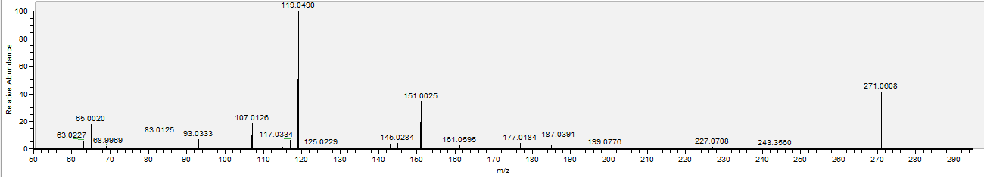

Sample
