Additional file 33. Identification of Luteolin (Cas 491-70-3, C₁₅H₁₀O₆, M.W.286.24)

Standard
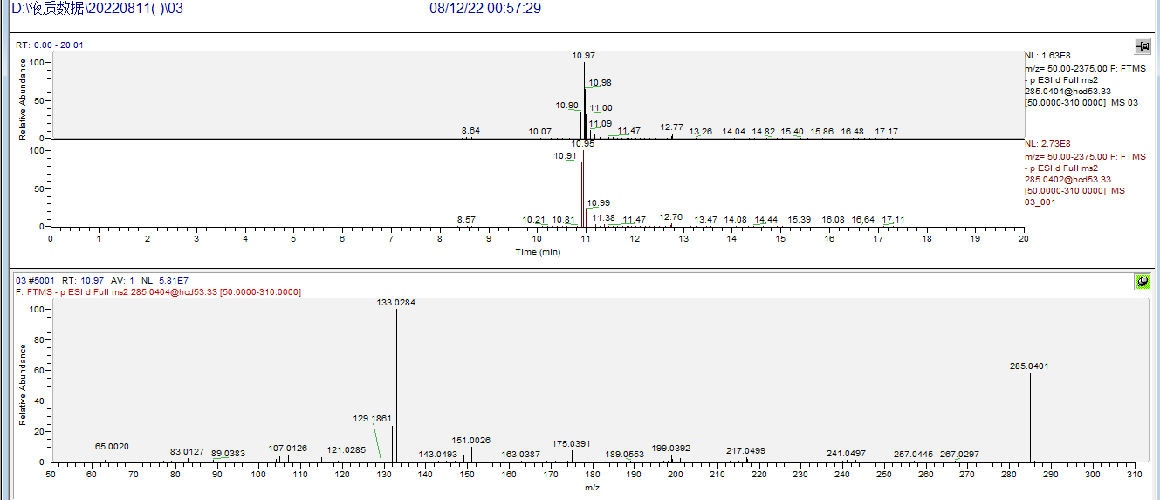

Sample
