Additional file 34. Identification of Hesperetin (Cas 520-33-2, C₁₆H₁₄O₆, M.W. 302.28)

Standard
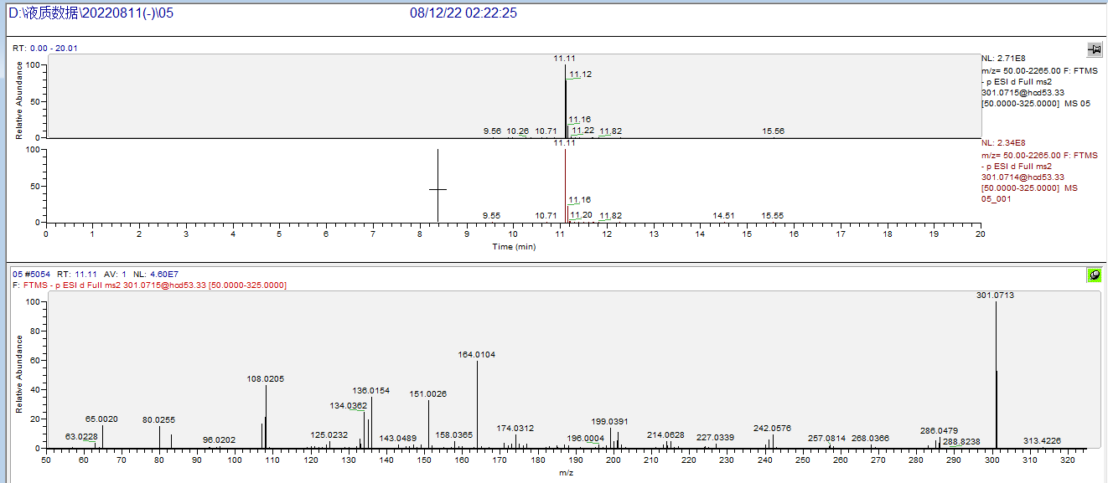

Sample
