Additional file 3. Identification of Gallic acid (Cas 149-91-7, C₇H₆O₅, M.W. 170.12)

Standard
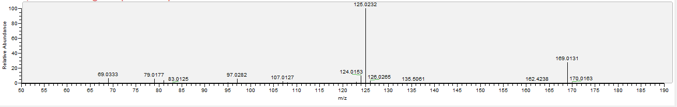
Sample
