Additional file 40. Identification of 3,5,6,7,8,3,4,-7-Methoxy-2-phenyl-4H-chromen-4-one (Cas 1178-24-1, C₂₂H₂₄O₉, M.W. 432.421)

Standard
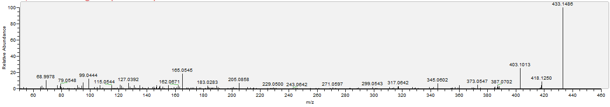

Sample
