Additional file 41. Identification of Licoricesaponin H2 (Cas 118441-85-3, C₄₂H₆₂O₁₆, M.W. 822.93)

Standard
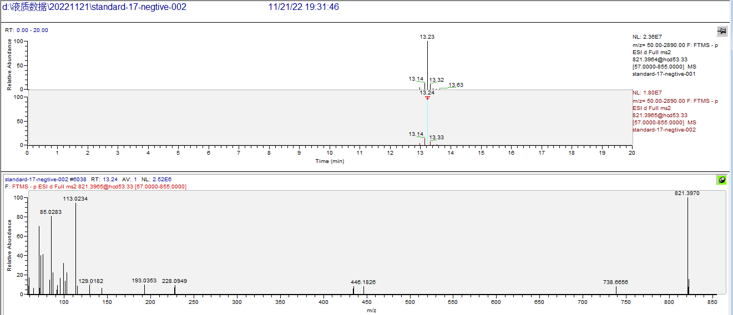

Sample
