Additional file 47. Identification of Oleic Acid (Cas 112-80-1, C₁₈H₃₄O₂, M.W. 282.468)

Standard
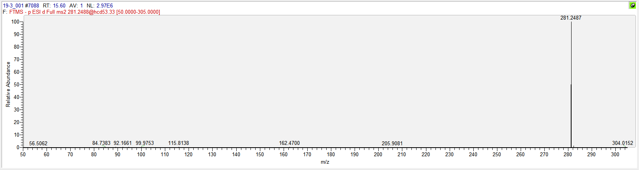

Sample
