Additional file 48. Identification of palmitic acid ethyl ester (Cas 628-97-7, C₁₈H₃₆O₂, M.W. 284.484)

Standard
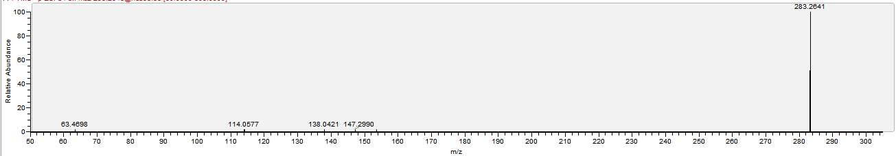

Sample
