Additional file 49. Identification of Ethyl Stearate (Cas 111-61-5, C₂₀H₄₀O₂, M.W. 312.53)

Standard
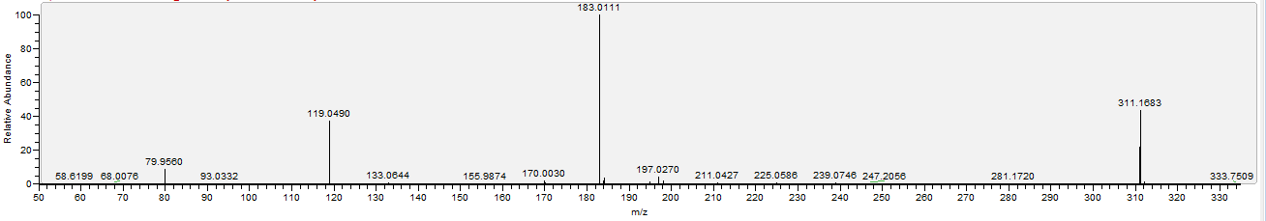

Sample
