Additional file 5. Identification of 5-Caffeoylquinic acid (Cas 906-33-2, C₁₆H₁₈O₉, M.W. 354.311)

Standard
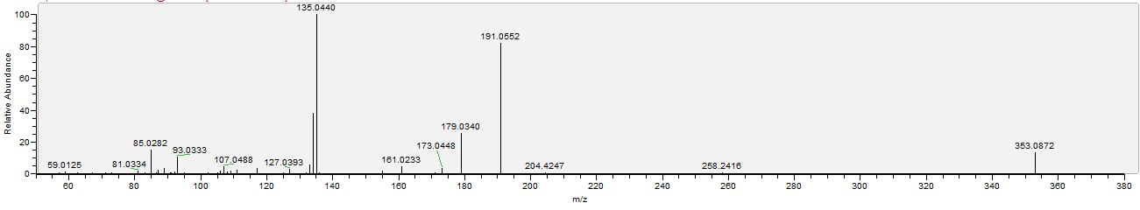

Sample
