Additional file 6. Identification of methyl gallate (Cas 99-24-1, C₈H₈O₅, M.W. 184.147)

Standard
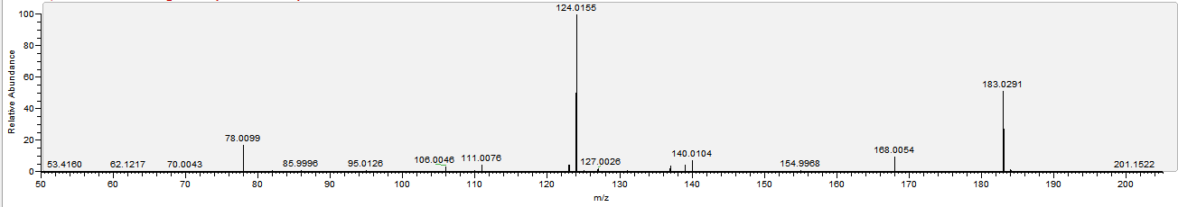

Sample
