Supporting information
Regulation of polysaccharide in Wu‐tou decoction on intestinal microflora and pharmacokinetics of small molecular compounds in AIA rats
Di Yang ^{a#}, Xiaoxu Cheng^{b#}, Meiling Fanª, Dong Xieª, Zhiqiang Liu^{c}, Fei Zhengª, Yulin Daiª, Zifeng Piª*, Hao Yueª*

a Changchun University of Chinese Medicine, No.1035 Boshuo Rd, Nanguan District, Changchun, 130117, China
b Jiangzhong Pharmaceutical Co, Ltd., Nanchang 330000, China
c National Center of Mass Spectrometry in Changchun and Jilin Provincal Key Laboratory of Chinese Medicine Chemistry and Mass Spectrometry, Changchun Institute of Applied Chemistry, Chinese Academy of Sciences, Changchun, 130022, China
#These two authors contributed equally to this paper.
*Corresponding authors:
Address: Changchun University of Chinese Medicine, No. 1035 Boshuo Rd, Nanguan District, Changchun, China.
Tel./Fax: +86 431 86172206 (Zifeng Pi), Tel./fax: +86 431 86172437 (Hao Yue).
E-mail addresses: 178521212@qq.com (Zifeng Pi), yuehao@ccucm.edu.cn (Hao Yue)

Chemical composition analysis
The analyzing methods of chemical composition were followed by the previous method. The phenol-sulfuric acid method[1] was applied to determine the total carbohydrate content with glucose as a standard. The yield of WTD (52.12%/ crude drug), SM (24.79%/ crude drug), and PS (22.55%/ crude drug) were evaluated. Polysaccharide content in WTD, SM, and PS were determined by phenol-sulfuric acid method (Table S1.)
Components analysis of SM and PS
74 chemical compounds had been found in WTD in previous studies[2], and the specific constituents were provided in Table S2. There were virtually no small molecule components in PS that were identical to SM (Figure 1S).

Table S1. WTD extractions yield and Polysaccharide content.
Table S2. Mass spectral data of compounds in SM and PS.
Figure S1. Mass spectra of WTD, SM, and PS. (A, C, D were positive spectra for WTD, SM, and PS. B, D, F were negative spectra for WTD, SM, and PS.)

Table S1. WTD extractions yield and Polysaccharide content
Fraction | Yield (%) | Polysaccharide (%)
Wu‐tou decoction (WTD) | 52.12 | 50.88±1.70
Small molecular compounds (SM) | 24.79 | 8.21±0.90
Polysaccharides (PS) | 22.55 | 78.89±0.89

Table S2. Mass spectral data of compounds in SM and PS.
Peak No. | Indentification | Measured Mass | Ionization mode | Molecular formula | Error (ppm) | Source | WTD | SM | PS
1 | Norephedrine or Norpseudoephedrine | 150.0906 | [M-H]⁻ | C₉H₁₃NO | -8.66 | MH | + | + | -
2 | Ephedrine | 164.1061 | [M-H]⁻ | C₁₀H₁₅NO | -8.53 | MH | + | + | -
3 | Gallic acid | 169.0128 | [M-H]⁻ | C₇H₆O₅ | -5.33 | BS | + | + | -
4 | Methylephedrine | 178.1235 | [M-H]⁻ | C₁₁H₁₇NO | 1.68 | MH | + | + | -
5 | Liquiritigenin | 255.0673 | [M-H]⁻ | C₁₅H₁₂O₄ | 6.27 | GC | + | + | -
6 | Isoliquiritigenin | 257.081 | [M-H]⁻ | C₁₅H₁₂O₄ | -1.56 | GC | + | + | -
7 | Formononetin | 267.0642 | [M-H]⁻ | C₁₆H₁₂O₄ | -5.62 | HQ | - | + | -
8 | Calycosin | 283.0629 | [M-H]⁻ | C₁₆H₁₂O₅ | 8.13 | HQ | + | + | +
9 | Songorine | 356.2213 | [M-H]⁻ | C₂₂H₃₁NO₃ | -3.65 | ZCW | + | + | -
10 | Chuanfumine | 392.2423 | [M-H]⁻ | C₂₂H₃₅NO₅ | -3.57 | ZCW | + | + | -
11 | Isotalatizidine | 408.2764 | [M+H]⁺ | C₂₃H₃₇NO₅ | 3.43 | ZCW | + | + | -
12 | Liquiritin | 417.1148 | [M-H]⁻ | C₂₁H₂₂O₉ | -9.11 | GC | + | + | +
13 | Senbusine B | 422.2565 | [M-H]⁻ | C₂₃H₃₇NO₆ | 5.21 | ZCW | + | + | -
14 | Talatizamine | 422.2876 | [M+H]⁺ | C₂₄H₃₉NO₅ | -7.10 | ZCW | + | - | -
15 | Senbusine A | 424.2665 | [M+H]⁺ | C₂₃H₃₇NO₆ | -8.01 | ZCW | + | + | -
16 | 5-OH liquiritin | 433.1147 | [M-H]⁻ | C₂₁H₂₂O₁₀ | 2.77 | GC | + | + | +
17 | Neoline or Bullatine B | 438.2864 | [M+H]⁺ | C₂₄H₃₉NO₆ | 1.83 | ZCW | + | - | -
18 | Calycosin-7-glucoside | 447.1265 | [M+H]⁺ | C₂₂H₂₂O₁₀ | -5.81 | HQ | + | + | -
19 | Chasmanine | 452.3001 | [M+H]⁺ | C₂₅H₄₁NO₆ | -2.43 | ZCW | + | + | -
20 | Fuziline | 454.2793 | [M+H]⁺ | C₂₄H₃₉NO₇ | -2.64 | ZCW | + | - | -
21 | Hypaconine | 470.2713 | [M+H]⁺ | C₂₄H₃₉NO₈ | -8.72 | ZCW | + | + | +
22 | Glycyrrhetinic acid | 471.3467 | [M-H]⁻ | C₃₀H₄₆O₄ | -1.49 | GC | + | + | -
23 | Paeoniflorin | 479.1522 | [M-H]⁻ | C₂₃H₂₈O₁₁ | -6.47 | BS | + | + | -
24 | Pseudaconine | 484.292 | [M+H]⁺ | C₂₅H₄₁NO₈ | 2.06 | ZCW | + | + | -
25 | Mesaconine | 486.2697 | [M+H]⁺ | C₂₄H₃₉NO₉ | -1.23 | ZCW | + | + | -
26 | Oxypaeoniflorin | 497.1644 | [M-H]⁻ | C₂₃H₂₈O₁₂ | -3.02 | BS | + | + | -
27 | Aconitine | 500.2851 | [M+H]⁺ | C₂₅H₄₁NO₉ | -1.80 | ZCW | + | + | -
28 | Paeoniflorin sulfonate | 543.1188 | [M-H]⁻ | C₂₃H₂₈O₁₃S | 2.95 | BS | - | + | -
29 | Liquiritin apioside | 549.1643 | [M-H]⁻ | C₂₆H₃₀O₁₃ | 6.37 | GC | - | + | +
30 | Pyrohypaconitine | 556.2959 | [M+H]⁺ | C₃₁H₄₁NO₈ | 8.81 | ZCW | + | - | -
31 | Benzoyl-3,13-deoxymesaconine | 558.3073 | [M+H]⁺ | C₃₁H₄₃NO₈ | 1.07 | ZCW | + | - | -
32 | Benzoyl-3,13-deoxyaconine | 558.3089 | [M+H]⁺ | C₃₁H₄₃NO₈ | 3.94 | ZCW | + | - | -
33 | Pyromesaconitine | 572.2814 | [M+H]⁺ | C₃₁H₄₁NO₉ | -8.04 | ZCW | + | + | -
34 | Benzoylhypaconine | 574.3034 | [M+H]⁺ | C₃₁H₄₃NO₉ | 3.13 | ZCW | + | + | -
35 | Benzoylpaeoniflorin | 585.1934 | [M+H]⁺ | C₃₀H₃₂O₁₂ | -6.49 | BS | + | + | -
36 | Pyroaconitine | 586.2995 | [M+H]⁺ | C₃₂H₄₃NO₉ | -3.58 | ZCW | + | + | -
37 | Benzoyldeoxyaconine | 588.3124 | [M+H]⁺ | C₃₂H₄₅NO₉ | -8.33 | ZCW | + | + | -
38 | Benzoylmesaconine | 590.2961 | [M+H]⁺ | C₃₁H₄₃NO₁₀ | -0.68 | ZCW | + | + | -
39 | Benzoylaconine | 604.3104 | [M+H]⁺ | C₃₂H₄₅NO₁₀ | -2.98 | ZCW | + | + | -
40 | 10-OH benzoylmesaconine | 606.2901 | [M+H]⁺ | C₃₁H₄₃NO₁₁ | -2.14 | ZCW | + | + | -
41 | Hypaconitine | 616.3131 | [M+H]⁺ | C₃₃H₄₅NO₁₀ | 1.46 | ZCW | + | - | -
42 | 10-OH Benzoylaconine | 620.3072 | [M+H]⁺ | C₃₂H₄₅NO₁₁ | 0.16 | ZCW | + | + | -
43 | Deoxyaconitine | 630.3294 | [M+H]⁺ | C₃₄H₄₇NO₁₀ | 2.54 | ZCW | + | + | -
44 | Galloylpaeoniflorin | 631.1665 | [M-H]⁻ | C₃₀H₃₂O₁₅ | 0.32 | BS | - | + | -
45 | Mesaconitine | 632.3044 | [M+H]⁺ | C₃₃H₄₅NO₁₁ | -4.27 | ZCW | + | - | -
46 | Benzoylpaeoniflorin sulfonate | 647.1456 | [M-H]⁻ | C₃₀H₃₂O₁₄S | 3.25 | BS | - | + | -
47 | 10-OH mesaconitine | 648.3058 | [M+H]⁺ | C₃₃H₄₅NO₁₂ | 5.86 | ZCW | + | + | -
48 | 10-OH aconitine | 662.3189 | [M+H]⁺ | C₃₄H₄₇NO₁₂ | 1.81 | ZCW | + | + | -
49 | Glucoliquiritin apioside | 711.2176 | [M-H]⁻ | C₃₂H₄₀O₁₈ | 5.62 | GC | - | + | -
50 | Astragaloside IV | 783.4532 | [M-H]⁻ | C₄₁H₆₈O₁₄ | 0.13 | HQ | + | + | -
51 | Licorice saponin B2 | 807.4134 | [M-H]⁻ | C₄₂H₆₄O₁₅ | -4.09 | GC | + | + | -
52 | Licorice saponin E2 | 819.3764 | [M-H]⁻ | C₄₂H₆₀O₁₆ | -4.76 | GC | + | + | -
53 | Glycyrrhizic acid or Licorice saponin H2 or K2 | 821.3919 | [M-H]⁻ | C₄₂H₆₂O₁₆ | -4.99 | GC | + | + | -
54 | Astragaloside II | 827.4735 | [M+H]⁺ | C₄₃H₇₀O₁₅ | -7.01 | HQ | + | - | -
55 | 24-OH licorice saponin E2 | 835.3759 | [M-H]⁻ | C₄₂H₆₀O₁₇ | 0.84 | GC | + | + | -
56 | Licorice saponin G2 | 837.3917 | [M-H]⁻ | C₄₂H₆₂O₁₇ | 0.96 | GC | + | + | -
57 | 22-Acetoxyl licorice saponin C2 | 863.40 | [M-H]⁻ | C₄₄H₆₄O₁₇ | -7.41 | GC | + | + | -
58 | 22-Acetoxyl glycyrrhizic acid | 879.40 | [M-H]⁻ | C₄₄H₆₄O₁₈ | 2.62 | GC | + | - | -
59 | 22-Acetoxyl licorice saponin J2 | 881.41 | [M-H]⁻ | C₄₄H₆₆O₁₈ | -2.61 | GC | + | + | -
60 | Licorice saponin A3 | 983.4456 | [M-H]⁻ | C₄₈H₇₂O₂₁ | -3.25 | GC | + | + | -
61 | Licorice saponin J2 | 823.4108 | [M-H]⁻ | C₄₂H₆₄O₁₆ | -0.97 | GC | + | + | -
62 | 24-OH licorice saponin A3 | 999.4435 | [M-H]⁻ | C₄₈H₇₂O₂₂ | -0.20 | GC | + | + | -

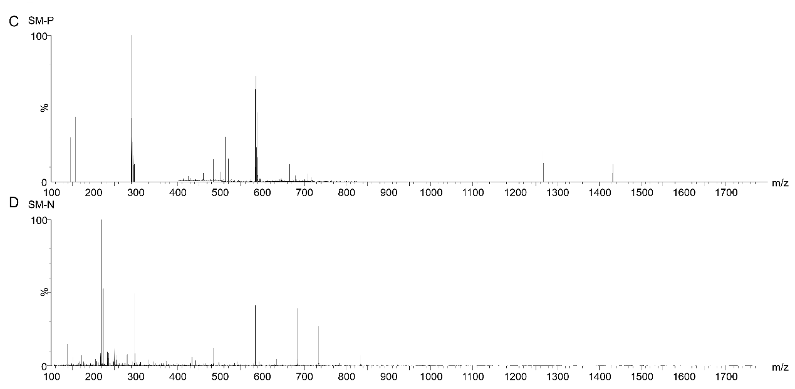
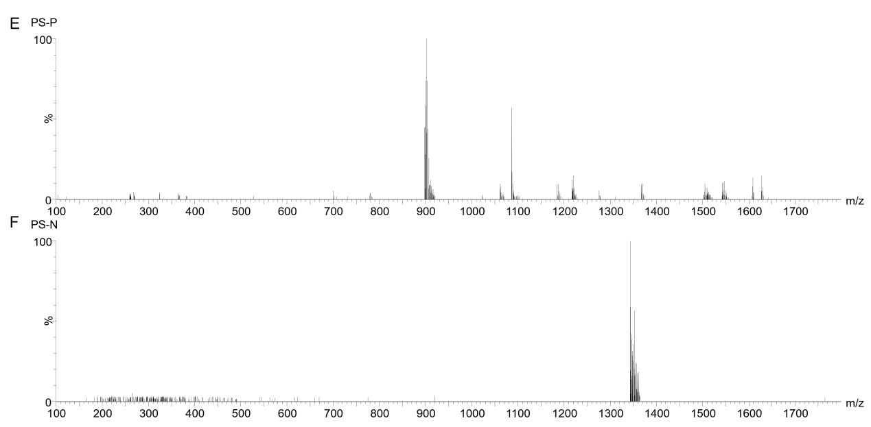
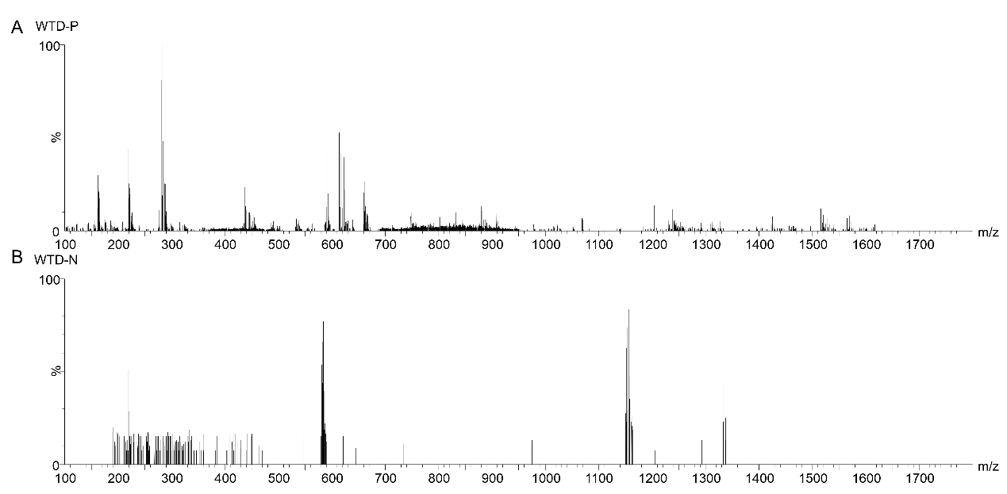
Figure S1. Mass spectra of WTD, SM, and PS. (A, C, D were positive spectra for WTD, SM, and PS. B, D, F were negative spectra for WTD, SM, and PS.)
- M. Dubois, K.A. Gilles, J.K. Hamilton, P.A. Rebers, F. Smith, Colorimetric method for determination of sugar and related substances, Anal Chem. 1956; 28: 350-356.
- Qi Y, Li S, Pi Z, Song F, Lin N, Liu S, Liu Z: Chemical profiling of Wu-tou decoction by UPLC-Q-TOF-MS. Talanta. 2014; 118:21-29.

