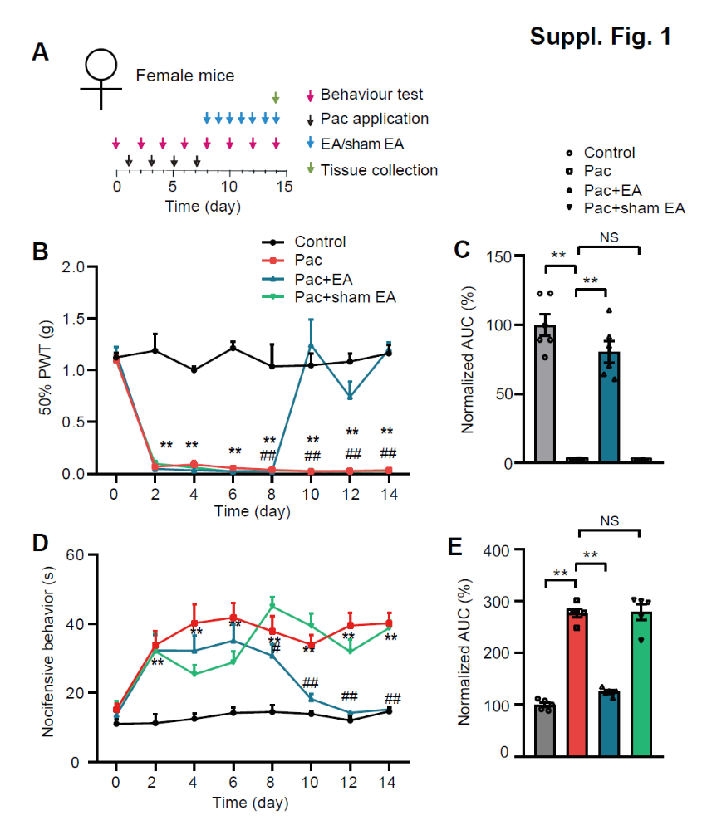
Fig. S1 EA intervention alleviates mechanical and cold allodynia of female PIPN model mice. (A) Experimental protocol indicating time points for the establishment of PIPN model in female mice, behavior test and EA/sham EA intervention. Please be noted that female mice were used for this experiment. (B) Effect of repeated 2 Hz EA on 50% PWT of control, Paclitaxel (Pac), Pac + EA and Pac + sham EA groups of female mice. **p<0.01 vs. control group. ##p<0.01 vs. Pac + sham EA group. (C) Normalized area under the curve (AUC) analysis of the curves shown in panel B. n = 6 mice/group. **p<0.01. (D) Effect of repeated 2 Hz EA intervention on nocifensive behaviors caused by acetone test of control, Pac, Pac + EA and Pac + sham EA groups of female mice. (E) AUC analysis of the curves shown in panel D. n = 5 mice/group.

