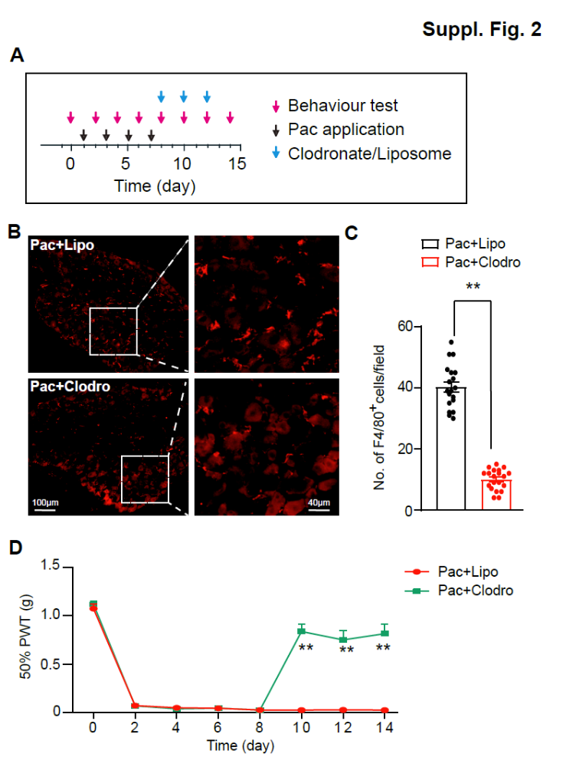
Fig. S2 Depleting macrophages ameliorates mechanical allodynia of PIPN model mice. (A) Experimental protocol. Clodronate (Clodro) was injected (i.v.) to deplete macrophages. Liposome was used as vehicle control. (B) Representative immunofluorescence images indicating macrophage antibody (F4/80) staining of DRG from the Pac+ Lipo, Pac+ Clodro group of mice. (C) Summary of the number of F4/80⁺ macrophages of the two groups as in panel B. 20 sections (pooled from 5 mice/group) were included in each group. (D) Effect of clodronate/liposome administration on 50% PWT of two groups of mice. **p<0.01. n = 5 mice/group. Scale bar indicates 100 μm.

