Supplemental information

In-depth characterization of minor 2-(2-phenylethyl)chromone oligomers from Chinese agarwood by integrating offline two-dimensional liquid chromatography and hybrid ion trap time-of-flight mass spectrometry

Huixia Huoª, Hang Zhang ^{a,b}, Huiting Liu ^{a,b}, Jiale Ma ^{a,b}, Qian Zhangª, Yunfang Zhaoª, Jiao Zhengª, Pengfei Tu ^{b}, Yuelin Song ^{a,}*, Jun Li ^{b,}*

Contents
Fig. S1 The chemical structures of eighteen 2-(2-phenylethyl)chromone dimers used as reference in this study.
Fig. S2 The ion nomenclature (A) and proposed mass fragmentation pathways of 2-(2-phenylethyl)chromone compounds (B: type I; C: type II; C: type III).
Fig. S3 The main structures of 2-(2-phenylethyl)chromone dimers (A-type, B-type, C-type, C-type, D-type, and F-type).
Fig. S4 The ion nomenclature (A), proposed mass fragmentation pathways(B), and the MS/MS of chemical reference standard(C) of aquisinenone I (representative E-type dimer).
Fig. S5 Selected HMBC (arrows point from protons to carbons) and ¹H−¹H COSY correlations of compounds I–V.
Fig. S6 Selected ROESY correlations of compounds I–V.
Fig. S7 Experimental and calculated ECD spectra of compounds I–V (in MeOH).
Table S1 Retention times, mass spectral data, molecular formulae, and plausible identities of detected compounds in Chinese agarwood using UHPLC-PDA-IT-TOF-MS.
Structural elucidation of PECs by LC/MS
Purification of new PEC dimers
Physicochemical Properties of New Compounds
MS, UV, IR, and NMR Spectra of New Compounds

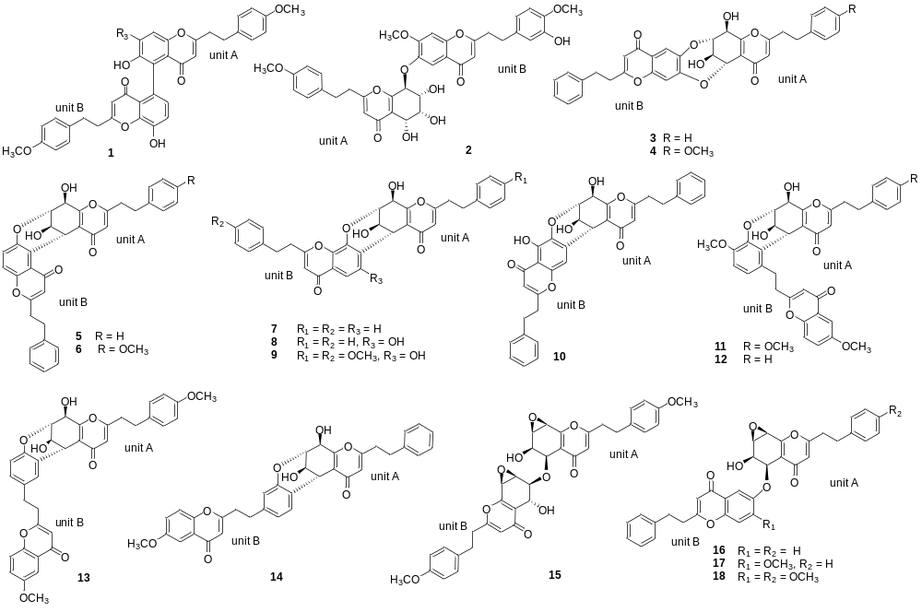Fig. S1 The chemical structures of eighteen 2-(2-phenylethyl)chromone dimers used as reference in this study.
crassin A (1), aquisinenone N (2), aquisinenone G (3), 4′-methoxy-aquisinenone G (4), aquisinenone A (5), 4′-methoxyaquisinenone A (6), aquisinenone B (7), 6′′-hydroxy- aquisinenone B (8), 6′′-hydroxy-4′,4′′′-dimethoxyaquisinenone B (9), aquisinenone C (10), aquisinenone D (11), 4′-demethoxyaquisinenone D (12), aquisinenone E (13), aquisinenone F (14), 4′,4‴-dimethoxyaquisinenone K (15), aquisinenone I (16), 7″-methoxyaquisinenone I (17), and 4′,7″-dimethoxyaquisinenone I (18).
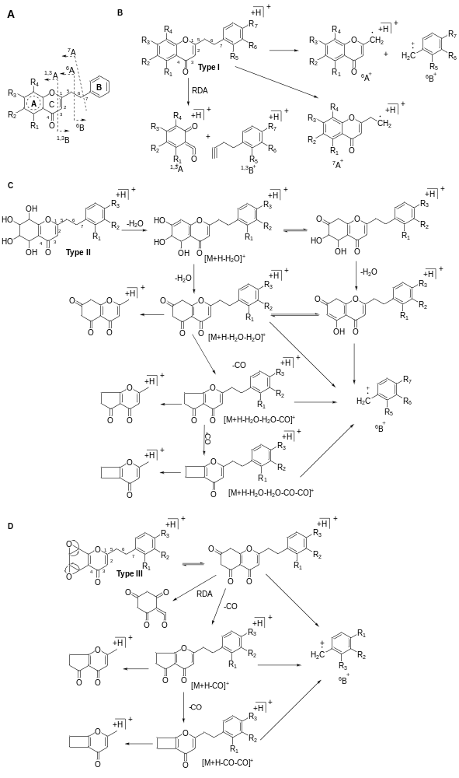
Fig. S2 The ion nomenclature (A) and proposed mass fragmentation pathways of 2-(2-phenylethyl)chromone compounds (B: type I; C: type II; D: type III).
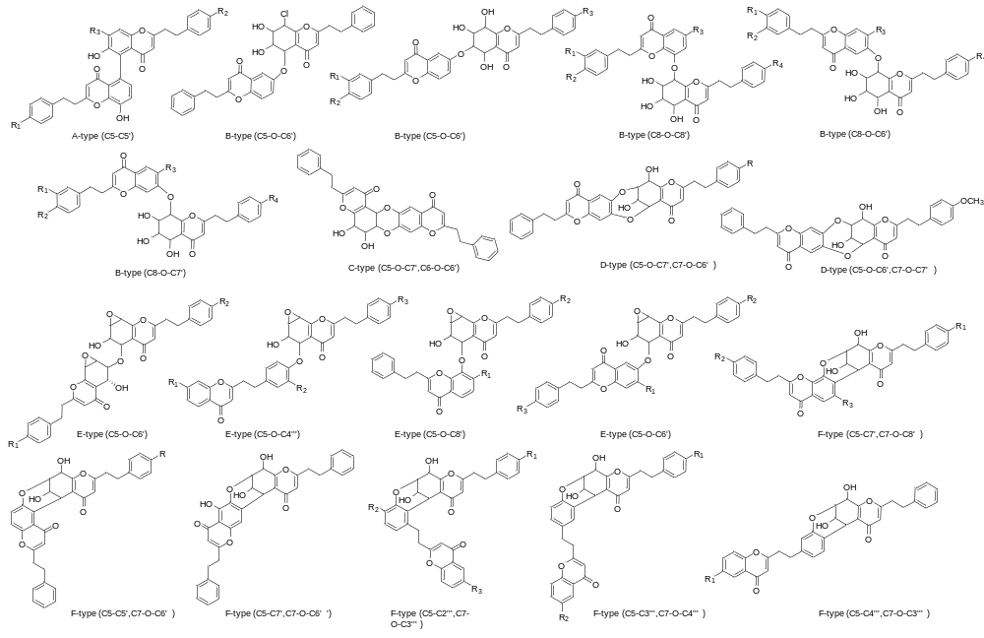
Fig. S3 The main structures of 2-(2-phenylethyl)chromone dimers (A-type, B-type, C-type, D-type, E-type, and F-type)

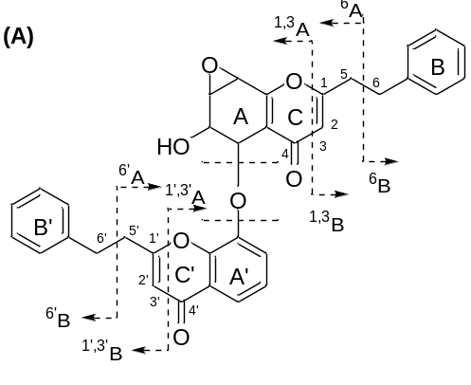
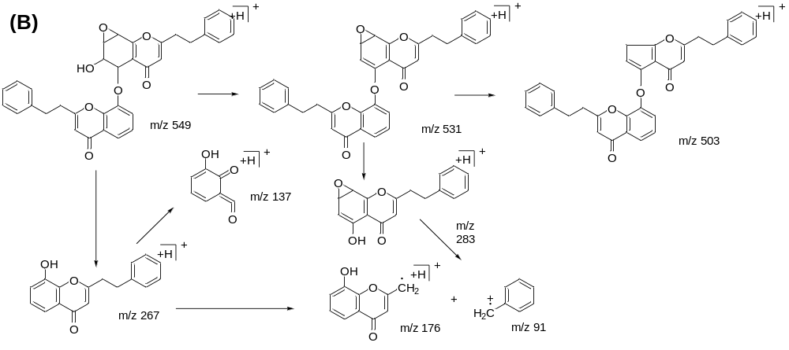
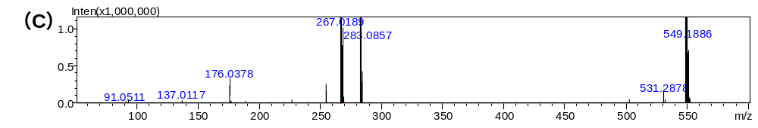
Fig. S4 The ion nomenclature (A), proposed mass fragmentation pathways(B), and the MS/MS of chemical reference standard(C) of aquisinenone I (representative E-type dimer)

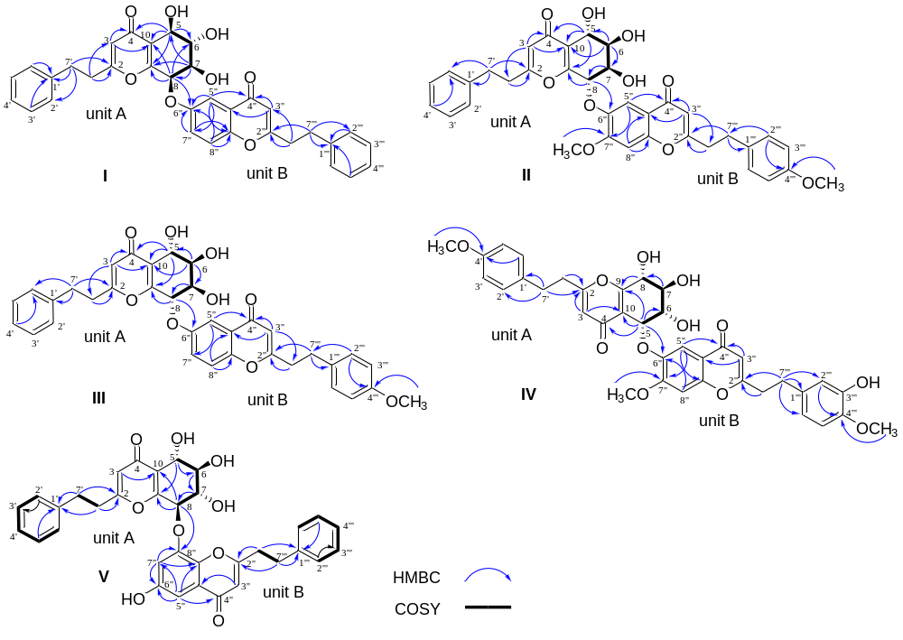
Fig. S5 Selected HMBC (arrows point from protons to carbons) and ¹H−¹H COSY correlations of compounds I–V.

Fig. S6 Selected ROESY correlations of compounds I–V.
Fig. S7 Experimental and calculated ECD spectra of compounds I–V (in MeOH).

Table S1. Retention Times, Mass Spectral Data, Molecular Formulae, and Plausible Identities of Detected Compounds in Chinese agarwood Using UHPLC-PDA-IT-TOF-MS
No. | t_{R}  (min) |  |  | [M + H]+ |  | Error  (ppm) |  | Molecular Formulae |  | MS/MS | Substituent |  |  | Plausible identity
 |  |  |  |  |  |  |  |  |  |  | Type | A-ring | B-ring | Plausible identity
Fr.A
1 |  | 4.480 |  | 319.1180 |  | 1.25 |  | C₁₇H₁₈O₆ |  | 301, 255, 227 | II | – | – | 5,6,7,8-tetrahydroxy-2-(2-phenylethyl)-5,6,7,8-tetrahydrochromone or isomer
2 |  | 5.838 |  | 319.1155 |  | –6.58 |  | C₁₇H₁₈O₆ |  | 301, 255, 227 | II | – | – | 5,6,7,8-tetrahydroxy-2-(2-phenylethyl)-5,6,7,8-tetrahydrochromone or isomer
3 |  | 5.870 |  | 301.1064 |  | –2.32 |  | C₁₇H₁₆O₅ |  | 283, 255, 227, 164 | IV | – | – | 5,6-epoxy-7,8-dihydroxy-2-(2-phenylethyl)-5,6,7,8-tetrahydrochromone or isomer
4 |  | 5.962 |  | 283.0975 |  | 3.53 |  | C₁₇H₁₄O₄ |  | 255, 227, 192, 164 | III | – | – | 5,6:7,8-diepoxy-2-(2-phenylethyl)-5,6,7,8-tetrahydrochromone or isomer
5 |  | 6.205 |  | 319.1151 |  | –7.83 |  | C₁₇H₁₈O₆ |  | 301, 283, 255, 173 | II | – | – | 5,6,7,8-tetrahydroxy-2-(2-phenylethyl)-5,6,7,8-tetrahydrochromone or isomer
6 |  | 7.122 |  | 349.1254 |  | –8.02 |  | C₁₈H₂₀O₇ |  | 331, 313, 285, 121 | II | – | OCH₃ | 5,6,7,8-tetrahydroxy-2-[2-(4′ methoxyphenyl)ethyl]-5,6,7,8-tetrahydrochromone or isomer
7 |  | 7.275 |  | 319.1146 |  | –9.40 |  | C₁₇H₁₈O₆ |  | 301, 283, 255, 227, 164 | II | – | – | 5,6,7,8-tetrahydroxy-2-(2-phenylethyl)-5,6,7,8-tetrahydrochromone or isomer
8 |  | 7.758 |  | 333.1277 |  | –16.81 |  | C₁₈H₂₀O₆ |  | 301, 283, 255 | II | OCH₃ |  | 5,6,7-trihydroxy-8-methoxy-5,6,7,8-tetrahydro-2-(2-phenylethyl)chromone or isomer
9 |  | 8.128 |  | 349.1282 |  | 0 |  | C₁₈H₂₀O₇ |  | 331, 313, 285, 121 | II | – | OCH₃ | 5,6,7,8-tetrahydroxy-2-[2-(4′ methoxyphenyl)ethyl]-5,6,7,8-tetrahydrochromone or isomer
10 |  | 8.602 |  | 331.1167 |  | –2.72 |  | C₁₈H₁₈O₆ |  | 313, 285, 121 | IV | – | OCH₃ | rel-(1aR,2R,3R,7bS)-1a,2,3,7b-tetrahydro-2,3-dihydroxy-5-[2-(4-methoxyphenyl)ethyl]-7H-oxireno[f][1]benzopyran-7-one or isomer
11 |  | 8.665 |  | 349.1227 |  | –15.75 |  | C₁₈H₂₀O₇ |  | 331, 313, 285, 121 | II | – | OCH₃ | 5,6,7,8-tetrahydroxy-2-[2-(4′ methoxyphenyl)ethyl]-5,6,7,8-tetrahydrochromone or isomer
12 |  | 8.918 |  | 285.1105 |  | –5.61 |  | C₁₇H₁₆O₄ |  | 267, 239, 148, | II | – | – | 5,6-dihydroxy-2-phenethyl-5,6-dihydro-4H-chromen-4-one or isomer
13 |  | 9.162 |  | 303.1207 |  | –6.60 |  | C₁₇H₁₈O₅ |  | 285, 267, 239 | II | – | – | 5,6,7-trihydroxy-2-(2-phenylethyl)-5,6,7,8-tetrahydrochromone or isomer
14 |  | 9.193 |  | 333.1309 |  | –7.20 |  | C₁₈H₂₀O₆ |  | 301, 283, 255 | II | OCH₃ |  | 5,6,7-trihydroxy-8-methoxy-5,6,7,8-tetrahydro-2-(2-phenylethyl)chromone or isomer
15 |  | 9.352 |  | 333.1370 |  | 11.11 |  | C₁₈H₂₀O₆ |  | 315, 297, 269, 121 | II | – | OCH₃ | 5,6,7-trihydroxy-2-[2-(4′-methoxyphenyl)ethyl]-5,6,7,8-tetrahydrochromone or isomer
16 |  | 9.70 |  | 333.1317 |  | –4.80 |  | C₁₈H₂₀O₆ |  | 301, 283, 255 | II | OCH₃ |  | 5,6,7-trihydroxy-8-methoxy-5,6,7,8-tetrahydro-2-(2-phenylethyl)chromone or isomer
17 |  | 9.922 |  | 333.1311 |  | –6.60 |  | C₁₈H₂₀O₆ |  | 315, 121 | II | – | OCH₃ | 5,6,7-trihydroxy-2-[2-(4′-methoxyphenyl)ethyl]-5,6,7,8-tetrahydrochromone or isomer
18 |  | 10.480 |  | 283.0960 |  | –1.77 |  | C₁₇H₁₄O₄ |  | 192, 153, 91 | I | OH, OH | – | 6,8-dihydroxy-2-(2-phenylethyl)chromone or isomer
19 |  | 10.522 |  | 303.1202 |  | –8.25 |  | C₁₇H₁₈O₅ |  | 285, 267, 239 | II | – | – | 5,6,7-trihydroxy-2-(2-phenylethyl)-5,6,7,8-tetrahydrochromone or isomer
20 |  | 10.710 |  | 267.1008 |  | –3.00 |  | C₁₇H₁₄O₃ |  | 176, 137,148, 110 | I | OH | – | 6-hydroxy-2-(2-phenylethyl)chromone or isomer
21 |  | 11.022 |  | 333.1291 |  | –12.61 |  | C₁₈H₂₀O₆ |  | 315, 283, 255, 227 | II | OCH₃ |  | 5,6,7-trihydroxy-8-methoxy-5,6,7,8-tetrahydro-2-(2-phenylethyl)chromone or isomer
22 |  | 11.053 |  | 303.1234 |  | 1.98 |  | C₁₇H₁₈O₅ |  | 285, 267, 239 | II | – | – | 5,6,7-trihydroxy-2-(2-phenylethyl)-5,6,7,8-tetrahydrochromone or isomer
23 |  | 11.537 |  | 333.1307 |  | –7.80 |  | C₁₈H₂₀O₆ |  | 315, 297, 121 | II | – | OCH₃ | 5,6,7-trihydroxy-2-[2-(4′-methoxyphenyl)ethyl]-5,6,7,8-tetrahydrochromone or isomer
24 |  | 11.662 |  | 287.1263 |  | –5.22 |  | C₁₇H₁₈O₄ |  | 269, 251, 160 | II | – | – | 6,7-cis-dihydroxy-2-(2-phenylethyl)-5,6,7,8-tetrahydrochromone or isomer
25 |  | 11.757 |  | 337.0832 |  | –1.48 |  | C₁₇H₁₇ClO₅ |  | 319, 301, 283, 273, 265, 255 | II | – | – | 8-chloro-5,6,7-trihydroxy-2-(2-phenylethyl)-5,6,7,8-tetrahydrochromone or isomer
26 |  | 12.032 |  | 347.1488 |  | –0.29 |  | C₁₉H₂₂O₆ |  | 315, 283, 255, 227 | II | OCH₃  OCH₃ |  | 6,7-dihydroxy-5,8-dimethoxy-5,6,7,8-tetrahydro-2-(2-phenylethyl)chromone or isomer
27 |  | 12.217 |  | 317.1339 |  | –14.19 |  | C₁₈H₂₀O₅ |  | 299, 281, 121 | II | – | OCH₃ | 6,7-cis-dihydroxy-5,6,7,8-tetrahydro-2-(2-(4-methoxyphenyl)ethyl)chromone or isomer
28 |  | 12.783 |  | 363.1407 |  | -8.54 |  | C₁₉H₂₂O₇ |  | 345, 313, 285, 121 | II | OCH₃ | OCH₃ | 5,6,7-trihydroxy-8-methoxy-5,6,7,8-tetrahydro-2-[2-(4′-methoxyphenyl)ethyl]chromone or isomer
29 |  | 12.847 |  | 337.0821 |  | –5.04 |  | C₁₇H₁₇ClO₅ |  | 319, 301, 283, 265, 255 | II | – | – | 8-chloro-5,6,7-trihydroxy-2-(2-phenylethyl)-5,6,7,8-tetrahydrochromone or isomer
30 |  | 13.227 |  | 287.1257 |  | –6.97 |  | C₁₇H₁₈O₄ |  | 269, 251, 160 | II | – | – | 6,7-cis-dihydroxy-2-(2-phenylethyl)-5,6,7,8-tetrahydrochromone or isomer
31 |  | 13.290 |  | 299.0894 |  | –6.69 |  | C₁₇H₁₄O₅ |  | 193, 107 | I | OH, OH | OH | 5,7-dihydroxy-2-[2-(4-hydroxyphenyl)ethyl]chromone or isomer
32 |  | 13.512 |  | 367.0948 |  | 1.36 |  | C₁₈H₁₉ClO₆ |  | 349, 331, 121 | II | – | OCH₃ | rel-(5R,6S,7S,8R)-8-Chloro-5,6,7,8-tetrahydro-5,6,7-trihydroxy-2-[2-(4-methoxyphenyl)ethyl]-4H-1-benzopyran-4-one or isomer
33 |  | 14.492 |  | 317.1403 |  | 5.99 |  | C₁₈H₂₀O₅ |  | 299, 281, 121 | II | – | OCH₃ | 6,7-cis-dihydroxy-5,6,7,8-tetrahydro-2-(2-(4-methoxyphenyl)ethyl)chromone or isomer
34 |  | 16.675 |  | 301.1056 |  | –4.98 |  | C₁₇H₁₆O₅ |  | 283, 255, 227, 164 | IV | – | – | 5,6-epoxy-7,8-dihydroxy-2-(2-phenylethyl)-5,6,7,8-tetrahydrochromone or isomer
35 |  | 19.650 |  | 613.2042 |  | –4.24 |  | C₃₅H₃₂O₁₀ |  | 595, 577, 441, 379, 313*, 283 | E |  |  | methoxy aquisinenone K or isomer
36 |  | 19.933 |  | 267.1019 |  | 1.12 |  | C₁₇H₁₄O₃ |  | 176, 137, 110, 91 | I | OH | – | 6-hydroxy-2-(2-phenylethyl)chromone or isomer
37 |  | 20.365 |  | 567.1918 |  | –16.75 |  | C₃₄H₃₀O₈ |  | 549, 531, 513, 357, 283, 267 | B |  |  | AH₁₃ or isomer
38 |  | 20.488 |  | 311.1252 |  | –8.63 |  | C₁₉H₁₈O₄ |  | 220, 205, 177 | I | OCH_{3,} OCH₃ | – | 6,7-dimethoxy-2-(2-phenylethyl)chromone or isomer
39 |  | 20.548 |  | 301.0604 |  | –7.31 |  | C₁₇H₁₃ClO₃ |  | 210, 182 | I | Cl, OH | – | 8-chloro-6-hydroxy-2-(2-phenylethyl)chromone or isomer
40 |  | 20.705 |  | 281.1147 |  | –8.89 |  | C₁₈H₁₆O₃ |  | 190, 151 | I | OCH_{3,} | – | 6-methoxy-2-(2-phenylethyl)chromone or isomer
Fr.B
41 |  |  | 2.263 |  | 365.1212 |  | –5.20 |  | C₁₈H₂₀O₈ | 347, 329, 301, 137 | II | – | OCH₃, OH | 5,6,7,8-tetrahydroxy-2-[2-(3′-hydroxy-4′-methoxyphenyl) ethyl]-5,6,7,8-tetrahydrochromone or isomer
42 |  |  | 2.422 |  | 335.1099 |  | –7.76 |  | C₁₇H₁₈O₇ | 317, 299, 271, 243 | II | – | OH | aquilarone F
43 |  |  | 3.392 |  | 319.1151 |  | –7.83 |  | C₁₇H₁₈O₆ | 301, 283, 255, 227, 164 | II | – | – | 5,6,7,8-tetrahydroxy-2-(2-phenylethyl)-5,6,7,8-tetrahydrochromone or isomer or isomer
44 |  |  | 4.143 |  | 319.1152 |  | –7.52 |  | C₁₇H₁₈O₆ | 301, 283, 255, 227, 164 | II | – | – | 5,6,7,8-tetrahydroxy-2-(2-phenylethyl)-5,6,7,8-tetrahydrochromone or isomer
45 |  |  | 4.585 |  | 303.1221 |  | –5.28 |  | C₁₇H₁₈O₅ | 285, 267, 239, 148, 91 | II | – | – | 5,6,7-trihydroxy-2-(2-phenylethyl)-5,6,7,8-tetrahydrochromone or isomer
46 |  |  | 4.870 |  | 349.1277 |  | –1.43 |  | C₁₈H₂₀O₇ | 331, 313, 285, 121 | II | – | OCH₃ | 5,6,7,8-tetrahydroxy-2-[2-(4′-methoxyphenyl)ethyl]-5,6,7,8-tetrahydrochromone or isomer
47 |  |  | 7.435 |  | 303.1199 |  | –9.24 |  | C₁₇H₁₈O₅ | 285, 267, 239 | II | – | – | 5,6,7-trihydroxy-2-(2-phenylethyl)-5,6,7,8-tetrahydrochromone or isomer
48 |  |  | 7.593 |  | 429.1536 |  | –1.86 |  | C₂₃H₂₄O₈ | 267, 176, 137, 91 | I | OH | – | 2-(2-phenylethyl)chromone-8-O-β-D-glucopyranoside or isomer
49 |  |  | 7.720 |  | 299.0930 |  | 5.35 |  | C₁₇H₁₄O₅ | 253, 209, 162, 123, 91 | III | – | R₄=OH | 5,6:7,8-diepoxy-2-[2-(7′-hydroxyphenyl)ethyl]-5,6,7,8-tetrahydrochromone or isomer
50 |  |  | 7.625 |  | 333.1340 |  | 2.10 |  | C₁₈H₂₀O₆ | 315, 287, 269, 121 | II | – | OCH₃ | 5,6,7-trihydroxy-2-[2-(4′-methoxyphenyl)ethyl]-5,6,7,8-tetrahydrochromone or isomer
51 |  |  | 8.587 |  | 459.1632 |  | –3.92 |  | C₂₄H₂₆O₉ | 297, 167 | I | OCH₃, OH | – | methoxy 2-(2-phenylethyl)chromone-8-O-β-D-glucopyranoside or isomer
52 |  |  | 8.998 |  | 331.1144 |  | –9.66 |  | C₁₈H₁₈O₆ | 313, 285, 121 | IV | – | OCH₃ | rel-(1aR,2R,3R,7bS)-1a,2,3,7b-tetrahydro-2,3-dihydroxy-5-[2-(4-methoxyphenyl)ethyl]-7H-oxireno[f][1]benzopyran-7-one or isomer
53 |  |  | 9.178 |  | 429.1581 |  | 8.62 |  | C₂₃H₂₄O₈ | 267, 176, 137 | I | OH | – | 2-(2-phenylethyl)chromone-8-O-β-D-glucopyranoside or isomer
54 |  |  | 9.210 |  | 317.1031 |  | 3.47 |  | C₁₇H₁₆O₆ | 285, 257, 227, 107 | IV | – | OH | 5,6-epoxy-7,8-dihydroxy-2-[2-(4′-hydroxyphenyl)ethyl]-5,6,7,8-tetrahydrochromone or isomer
55 |  |  | 9.557 |  | 459.1644 |  | –1.31 |  | C₂₄H₂₆O₉ | 297, 206, 167, 121 | I | OCH₃, OH | – | methoxy 2-(2-phenylethyl)chromone-8-O-β-D-glucopyranoside or isomer
56 |  |  | 9.683 |  | 583.2134 |  | 29.32 |  | C₃₁H₃₄O₁₁ | 547, 519, 371, 283 | B |  |  | AH₁₅ or isomer
57 |  |  | 10.408 |  | 285.1094 |  | –9.47 |  | C₁₇H₁₆O₄ | 267, 239, 176, 137 | II | – | – | 5,6-dihydroxy-2-phenethyl-5,6-dihydro-4H-chromen-4-one or isomer
58 |  |  | 10.933 |  | 313.1046 |  | –7.98 |  | C₁₈H₁₆O₅ | 192, 121 | I | OH, OH | OCH₃ | 6,7-dihydroxy-2-[2-(4′-methoxyphenyl)ethyl]chromone (isomer 1)
59 |  |  | 11.232 |  | 283.0907 |  | –20.49 |  | C₁₇H₁₄O₄ | 177,137, 107 | I | OH | OH | 6-hydroxy-2-[2-(4-hydroxyphenyl)ethyl]chromone or isomer
60 |  |  | 11.200 |  | 283.0943 |  | –7.77 |  | C₁₇H₁₄O₄ | 192, 153 | I | OH, OH | – | 6,8-dihydroxy-2-(2-phenylethyl)chromone or isomer
61 |  |  | 11.175 |  | 313.1053 |  | –5.75 |  | C₁₈H₁₆O₅ | 177, 137, 121 | I | OH | OH, OCH₃ | 6-hydroxy-2-[2-(4′-hydroxy-3′-methoxyphenyl)ethenyl]chromone or isomer
62 |  |  | 11.642 |  | 565.1944 |  | 15.39 |  | C₃₄H₂₈O₈ | 547, 529, 474, 283*, 192 | D |  |  | aquisinenone G or isomer
63 |  |  | 11.672 |  | 283.0924 |  | –14.48 |  | C₁₇H₁₄O₄ | 192, 153 | I | OH, OH | – | 5,8-dihydroxy-2-(2-phenylethyl)chromone or isomer
64 |  |  | 12.007 |  | 313.1075 |  | 1.28 |  | C₁₈H₁₆O₅ | 121 | I | OH, OH | OCH₃ | 6,7-dihydroxy-2-[2-(4′-methoxyphenyl)ethyl]chromone or isomer
65 |  |  | 12.353 |  | 327.1198 |  | –8.87 |  | C₁₉H₁₈O₅ | 221, 181, 205 | I | OCH₃, OCH₃ | OH | 6,7-dimethoxy-2-[2-(4-hydroxyphenyl)ethyl]chromone or isomer
66 |  |  | 12.918 |  | 357.1336 |  | 0.84 |  | C₂₀H₂₀O₆ | 220, 137, 122 | I | OCH₃, OCH₃ | OH, OCH₃ | 6,7-dimethoxy-2-[2-(3′-hydroxy-4′-methoxyphenyl)ethyl]chromone or isomer
67 |  |  | 12.950 |  | 583.1881 |  | –14.06 |  | C₃₄H₃₀O₉ | 565, 547, 519, 395, 327, 283 | B |  |  | AH₁₅ or isomer
68 |  |  | 13.073 |  | 297.1076 |  | –15.15 |  | C₁₈H₁₆O₄ | 206, 167 | I | OH, OCH₃ | – | 6-hydroxy-7-methoxy-2-(2-phenylethyl)chromone or isomer
69 |  |  | 13.137 |  | 267.1001 |  | –5.62 |  | C₁₇H₁₄O₃ | 176, 137, 91 | I | OH, | – | 6-hydroxy-2-(2-phenylethyl)chromone or isomer
70 |  |  | 13.163 |  | 625.2001 |  | –10.72 |  | C₃₆H₃₂O₁₀ | 607, 589, 343 | C |  |  | dimethoxy AH_{21、}or isomer
71 |  |  | 13.517 |  | 575.1976 |  | –15.30 |  | C₃₆H₃₀O₇ | 267, 176, 137 | A |  |  | dehydroxy-dimethoxy-AH₁₁
72 |  |  | 13.768 |  | 583.1897 |  | –11.32 |  | C₃₄H₃₀O₉ | 565, 547, 301, 283*, 192, 153 | E |  |  | aquisinenone K or isomer
73 |  |  | 13.800 |  | 613.2089 |  | 3.42 |  | C₃₅H₃₂O₁₀ | 595, 577, 475, 415, 313, 283, 121 | B |  |  | methoxy AH₁₅ or isomer
74 |  |  | 13.952 |  | 297.1111 |  | –3.37 |  | C₁₈H₁₆O₄ | 121 | I | OH | OCH₃ | 6-hydroxy-2-[2-(4′-methoxyphenyl)ethyl]chromone or isomer
75 |  |  | 14.298 |  | 613.2054 |  | –2.28 |  | C₃₅H₃₂O₁₀ | 595, 577, 313, 283, 121 | B |  |  | methoxy AH₁₅ or isomer
76 |  |  | 14.425 |  | 583.1913 |  | –8.57 |  | C₃₄H₃₀O₉ | 547, 519, 435, 283* | E |  |  | aquisinenone K or isomer
77 |  |  | 14.678 |  | 565.1816 |  | –7.25 |  | C₃₄H₂₈O₈ | 547.529, 373, 283*, 192 | D |  |  | aquisinenone G or isomer
78 |  |  | 14.805 |  | 567.1967 |  | –8.11 |  | C₃₄H₃₀O₈ | 549, 531, 375, 283 | B |  |  | AH₁₃ or isomer
79 |  |  | 16.163 |  | 311.1271 |  | –2.25 |  | C₁₉H₁₈O₄ | 220, 205 | I | OCH_{3，} OCH₃ |  | 6,7-dimethoxy-2-(2-phenylethyl)chromone or isomer
80 |  |  | 16.193 |  | 595.1940 |  | –3.86 |  | C₃₅H₃₀O₉ | 577, 503, 474*, 385, 283 | F |  |  | methoxy 6′′-hydroxy-aquisinenone B or isomer
81 |  |  | 16.960 |  | 595.1910 |  | –8.9 |  | C₃₅H₃₀O₉ | 577, 559, 549, 283, 192, | C |  |  | methoxy AH₂₁ or isomer
82 |  |  | 20.005 |  | 547.1693. |  | –10.60 |  | C₃₄H₂₆O₇ | 529, 456, 373, 282, 267, 176, 137 | A |  |  | hydroxy AH₁₁
Fr.C
83 |  |  | 1.038 |  | 301.1059 |  | –3.99 |  | C₁₇H₁₆O₅ | 283, 255, 227, 164 | IV | – | – | 5,6-epoxy-7,8-dihydroxy-2-(2-phenylethyl)-5,6,7,8-tetrahydrochromone or isomer
84 |  |  | 1.323 |  | 349.1280 |  | –0.57 |  | C₁₈H₂₀O₇ | 331, 313, 285, 121 | II | – | OCH₃ | 5,6,7,8-tetrahydroxy-2-[2-(4′-methoxyphenyl)ethyl]-5,6,7,8-tetrahydrochromone or isomer
85 |  |  | 2.463 |  | 337.0846 |  | 2.67 |  | C₁₇H₁₇O₅Cl | 319, 301, 265 | II | – | – | 8-chloro-5,6,7-trihydroxy-2-(2-phenylethyl)-5,6,7,8-tetrahydrochromone or isomer
86 |  |  | 2.527 |  | 319.1205 |  | 9.09 |  | C₁₇H₁₈O₆ | 301, 255 | II | – | – | 5,6,7,8-tetrahydroxy-2-(2-phenylethyl)-5,6,7,8-tetrahydrochromone or isomer
87 |  |  | 2.938 |  | 429.1504 |  | –9.32 |  | C₂₃H₂₄O₈ | 267, 176, 91 | I | OH | – | 2-(2-phenylethyl)chromone-8-O-β-D-glucopyranoside or isomer
88 |  |  | 3.128 |  | 459.1631 |  | –4.14 |  | C₂₄H₂₆O | 297, 206, 167 | I | OCH₃, OH | – | methoxy 2-(2-phenylethyl)chromone-8-O-β-D-glucopyranoside or isomer
89 |  |  | 3.160 |  | 429.1512 |  | –7.46 |  | C₂₃H₂₄O₈ | 267, 176, 137 | I | OH | – | 2-(2-phenylethyl)chromone-8-O-β-D-glucopyranoside or isomer
90 |  |  | 4.005 |  | 343.1177 |  | 0.29 |  | C₁₉H₁₈O₆ | 207, 137 | I | OCH₃, OH | OCH₃, OH | 7-hydroxy-6-methoxy-2-[2-(3′-hydroxy-4′-methoxyphenyl)ethyl]chromone or isomer
91 |  |  | 4.567 |  | 283.0941 |  | –8.48 |  | C₁₇H₁₄O₄ | 192, 153 | I | OH, OH | – | 5,8-dihydroxy-2-(2-phenylethyl)chromone or isomer
92 |  |  | 5.977 |  | 297.1135 |  | 4.71 |  | C₁₈H₁₆O₄ | 191, 176 | I | OCH₃, | OH | 4′-hydroxy-6-methoxy-2-(2-phenyl)ethylchromone or isomer
93 |  |  | 6.535 |  | 267.1000 |  | –5.99 |  | C₁₇H₁₄O₃ | 161, 107 | I | – | OH | 2-[2-(3-hydroxyphenyl)ethyl]chromone or isomer
94 |  |  | 6.567 |  | 327.1206 |  | –6.42 |  | C₁₉H₁₈O₅ | 191, 176 | I | OCH₃, | OCH₃, OH | 6-methoxy-2-[2-(3-methoxy-4-hydroxyphenyl)ethyl]chromone or isomer
95 |  |  | 7.463 |  | 583.1875 |  | –15.09 |  | C₃₄H₃₀O₉ | 565, 547, 519, 355,283 | B |  |  | AH₁₅ or isomer
96 |  |  | 7.495 |  | 267.1006 |  | –3.37 |  | C₁₇H₁₄O₃ | 176, 91 | I | OH | – | 6-hydroxy-2-(2-phenylethyl)chromone or isomer
97 |  |  | 7.558 |  | 297.1104 |  | –5.72 |  | C₁₈H₁₆O₄ | 282, 206, 167 | I | OH, OCH₃ | – | 6-hydroxy-7-methoxy-2-(2-phenylethyl)chromone or isomer
98 |  |  | 8.700 |  | 327.1200 |  | –7.95 |  | C₁₉H₁₈O₅ | 206, 121 | I | OH, OCH₃, | OCH₃ | 7-hydroxy-6-methoxy-2-[2-(4-methoxyphenyl)ethyl]-4H-1-benzopyran-4-one or isomer
99 |  |  | 9.855 |  | 565.1889 |  | 5.66 |  | C₃₄H₂₈O₈ | 547, 529, 474*, 373, 283，192 | F |  |  | 6′′-hydroxyaquisinenone B or isomer
100 |  |  | 10.077 |  | 565.1859 |  | 0.35 |  | C₃₄H₂₈O₈ | 547, 529, 435, 283*, 255 | D |  |  | aquisinenone G or isomer
101 |  |  | 10.362 |  | 595.1904 |  | –5.9 |  | C₃₅H₃₀O₉ | 577, 559, 489, 471, 368, 293, 297 | F |  |  | hydroxy and methoxy aquisinenone A or isomer
102 |  |  | 11.045 |  | 597.2092 |  | –4.52 |  | C₃₅H₃₂O₉ | 565, 547, 283, 192 | B |  |  | 5-methoxy-AH₁₃ isomer
103 |  |  | 11.108 |  | 595.1970 |  | 1.18 |  | C₃₅H₃₀O₉ | 577, 559, 283, 153 | C |  |  | methoxyAH₂₁ or isomer
104 |  |  | 12.577 |  | 311.1252 |  | –8.36 |  | C₁₉H₁₈O₄ | 220, 205, 181 | I | OCH₃, OCH₃ | – | 6,7-dimethoxy-2-(2-phenylethyl)chromone or isomer
105 |  |  | 12.952 |  | 565.1805 |  | –9.20 |  | C₃₄H₂₈O₈ | 529, 474, 283 | F |  |  | 6′′-hydroxyaquisinenone B or isomer
106 |  |  | 13.318 |  | 865.2855 |  | 0.81 |  | C₅₁H₄₄O₁₃ | 847, 829, 811, 565, 547, 529, 283 |  |  |  | tri-2-(2-phenylethyl)chromone or isomer
107 |  |  | 13.450 |  | 597.2087 |  | –5.19 |  | C₃₅H₃₂O₉ | 579, 561, 297 | B |  |  | AH₁₂ or isomer
108 |  |  | 13.543 |  | 567.1989 |  | –4.23 |  | C₃₄H₃₀O₈ | 549, 531, 283, 267, 176 | B |  |  | AH₁₃ or isomer
109 |  |  | 13.820 |  | 565.1812 |  | –7.96 |  | C₃₄H₂₈O₈ | 529, 474, 283 | F |  |  | 6′′-hydroxyaquisinenone B or isomer
110 |  |  | 14.038 |  | 595.1947 |  | –2.69 |  | C₃₅H₃₀O₉ | 577, 474*, 373, 283 | F |  |  | methoxy 6′′-hydroxyaquisinenone B or isomer
111 |  |  | 14.258 |  | 597.2080 |  | –6.53 |  | C₃₅H₃₂O₉ | 579, 561, 297 | B |  |  | AH₁₂ or isomer
112 |  |  | 14.955 |  | 565.1856 |  | –0.18 |  | C₃₄H₂₈O₈ | 547, 529, 474, 283, 192 | C |  |  | AH₂₁ or isomer
113 |  |  | 15.018 |  | 883.2913 |  | –5.32 |  | C₅₁H₄₆O₁₄ | 865, 847, 829, 811, 583, 565, 547, 519, 283, 192 |  |  |  | tri-2-(2-phenylethyl)chromone
114 |  |  | 15.570 |  | 865.2814 |  | –4.74 |  | C₅₁H₄₄O₁₃ | 847, 829, 811, 565, 501, 319, 267 |  |  |  | tri-2-(2-phenylethyl)chromone or isomer
115 |  |  | 15.887 |  | 565.1881 |  | 4.25 |  | C₃₄H₂₈O₈ | 547, 529, 438, 283, 192 | F |  |  | aquisinenone C or isomer
116 |  |  | 18.205 |  | 565.1891 |  | 6.02 |  | C₃₄H₂₈O₈ | 547, 474, 283*, 192 | D |  |  | aquisinenone G or isomer
117 |  |  | 19.607 |  | 579.2018 |  | 0.86 |  | C₃₄H₂₈O₈ | 561, 515, 487, 458, 394, 357, 303, 266 | F |  |  | 4′-methoxyaquisinenone A or isomer
Fr.D
118 |  |  | 1.105 |  | 319.1143 |  | –8.46 |  | C₁₇H₁₈O₆ | 301, 283, 255,164 | II | – | – | 5,6,7,8-tetrahydroxy-2-(2-phenylethyl)-5,6,7,8-tetrahydrochromone or isomer
119 |  |  | 1.422 |  | 349.1301 |  | 5.44 |  | C₁₈H₂₀O₇ | 331, 313, 285 | II | – | OCH₃ | 5,6,7,8-tetrahydroxy-2-[2-(4′-methoxyphenyl)ethyl] -5,6,7,8-tetrahydrochromone or isomer
120 |  |  | 2.688 |  | 337.0833 |  | –1.19 |  | C₁₇H₁₇O₅Cl | 319, 301, 283, 265 | II | – | – | 8-chloro-5,6,7-trihydroxy-2-(2-phenylethyl)-5,6,7,8-tetrahydrochromone or isomer
121 |  |  | 3.068 |  | 299.0921 |  | 2.34 |  | C₁₇H₁₄O₅ | 208, 169 | I | OH, OH, OH | – | trihydroxy-2-(2-phenylethyl)chromone
122 |  |  | 3.100 |  | 331.1184 |  | 2.42 |  | C₁₈H₁₈O₆ | 313, 285, 121 | IV | – | OCH₃ | rel-(1aR,2R,3R,7bS)-1a,2,3,7b-tetrahydro-2,3-dihydroxy-5-[2-(4-methoxyphenyl)ethyl]-7H-oxireno[f][1]benzopyran-7-one or isomer
123 |  |  | 3.163 |  | 301.1059 |  | –3.99 |  | C₁₇H₁₆O₅ | 283, 255, 227 | IV | – | – | rel-(1aR,2R,3R,7bS)-1a,2,3,7b-Tetrahydro-2,3-dihydroxy-5-(2-phenylethyl)-7H-oxireno[f][1]benzopyran-7-one or isomer
124 |  |  | 3.470 |  | 619.2215 |  | 6.62 |  | C₃₄H₃₄O₁₁ | 601, 301, 255, 227 | B |  |  | bi-phenylethylchromones I or isomer
125 |  |  | 3.787 |  | 343.1205 |  | 8.45 |  | C₁₉H₁₈O₆ | 207, 137 | I | OH, OCH₃ | OH, OCH₃ | 7-hydroxy-6-methoxy-2-[2-(3′-hydroxy-4′-methoxyphenyl)ethyl]chromone or isomer
126 |  |  | 4.420 |  | 283.0946 |  | –6.71 |  | C₁₇H₁₄O₄ | 255, 227, 192, 164 | III | – | – | 5,6:7,8-diepoxy-2-(2-phenylethyl)-5,6,7,8-tetrahydrochromone or isomer
127 |  |  | 4.547 |  | 327.1235 |  | 2.46 |  | C₁₉H₁₈O₅ | 221, 205 | I | OCH₃, OCH₃ | OH | 6,7-dimethoxy-2-[2-(4-hydroxyphenyl)ethyl]chromone or isomer
128 |  |  | 4.737 |  | 357.1327 |  | –1.68 |  | C₂₀H₂₀O₆ | 221, 205 | I | OCH₃, OCH₃ | OH, OCH₃ | 6,7-dimethoxy-2-[2-(4′-hydroxy-3′-methoxyphenyl) ethyl]chromone or isomer
129 |  |  | 6.460 |  | 601.2015 |  | –8.82 |  | C₃₄H₃₂O₁₀ | 583, 529, 301, 283, 227 | B |  |  | bi-phenylethylchromones II or isomer
130 |  |  | 6.723 |  | 583.1969 |  | 1.03 |  | C₃₄H₃₀O₉ | 565, 547, 519, 373, 355, 301, 283 | B |  |  | AH₁₅ or isomer
131 |  |  | 6.882 |  | 601.2027 |  | –6.82 |  | C₃₄H₃₂O₁₀ | 583, 301, 283, 255, 227 | B |  |  | bi-phenylethylchromones II or isomer
132 |  |  | 7.293 |  | 327.1236 |  | 2.75 |  | C₁₉H₁₈O₅ | 221, 205 | I | OCH₃, OCH₃ | OH, | 6,7-dimethoxy-2-[2-(4-hydroxyphenyl) ethyl]chromone or isomer
133 |  |  | 7.483 |  | 267.1016 |  | 0 |  | C₁₇H₁₄O₃ | 161, 107 | I | – | OH | 2-[2-(3-hydroxyphenyl)ethyl]chromone or isomer
134 |  |  | 7.725 |  | 297.1095 |  | –8.75 |  | C₁₈H₁₆O₄ | 206, 191, 167 | I | OH, OCH₃ | – | 6-hydroxy-7-methoxy-2-(2-phenylethyl)chromone or isomer
135 |  |  | 8.350 |  | 583.2065 |  | 9.09 |  | C₃₄H₃₀O₉ | 565, 547, 529, 301, 283*，255, 121 | E |  |  | Aquisinenone K or isomer
136 |  |  | 8.972 |  | 613.2118 |  | 8.15 |  | C₃₅H₃₂O₁₀ | 595, 576, 446, 313, 121 | B |  |  | methoxy AH₁₅ or isomer
137 |  |  | 9.225 |  | 311.1266 |  | –3.86 |  | C₁₉H₁₈O₄ | 151 | I | OCH₃ | OCH₃ | 6-methoxy-2-[2-(3-methoxyphenyl)ethyl]chromone
138 |  |  | 9.383 |  | 601.2153 |  | 14.14 |  | C₃₄H₃₂O₁₀ | 583, 565, 301, 283, 255, 227 | B |  |  | bi-phenylethylchromones II or isomer
139 |  |  | 9.792 |  | 297.1106 |  | –5.05 |  | C₁₈H₁₆O₄ | 121 | I | OH | OCH₃ | 6-hydroxy-2-[2-(4′-methoxyphenyl)ethyl]chromone or isomer
140 |  |  | 10.077 |  | 319.1192 |  | 5.01 |  | C₁₇H₁₈O₆ | 301, 283, 255, 227 | II | – | – | 5,6,7,8-tetrahydroxy-2-(2-phenylethyl)-5,6,7,8-tetrahydrochromone or isomer
141 |  |  | 10.140 |  | 583.1960 |  | –0.51 |  | C₃₄H₃₀O₉ | 565, 547, 283*, 255, 192, 91 | E |  |  | aquisinenone K or isomer
142 |  |  | 10.453 |  | 283.0939 |  | –9.18 |  | C₁₇H₁₄O₄ | 192, 153 | I | OH, OH | – | 6,8-dihydroxy-2-(2-phenylethyl)chromone or isomer
143 |  |  | 10.485 |  | 583.1923 |  | –6.86 |  | C₃₄H₃₀O₉ | 565, 547, 529, 474, 373, 283 | B |  |  | AH₁₅ or isomer
144 |  |  | 10.548 |  | 327.1224 |  | –0.92 |  | C₁₉H₁₈O₅ | 137 | I | OCH₃ | OH, OCH₃ | 6-methoxy-2-[2-(3-methoxy-4-hydroxyphenyl)ethyl]chromone or isomer
145 |  |  | 10.770 |  | 583.1931 |  | –5.49 |  | C₃₄H₃₀O₉ | 565, 547, 474, 373, 283 | B |  |  | AH₁₅ or isomer
146 |  |  | 10.897 |  | 643.2176 |  | 0.31 |  | C₃₆H₃₄O₁₁ | 607, 283*, 227 | E |  |  | 4′,4‴-dimethoxyaquisinenone K or isomer
147 |  |  | 10.897 |  | 311.1249 |  | –9.32 |  | C₁₉H₁₈O₄ | 220, 205, 181, 121, | I | OCH₃, OCH₃ | – | 6,7-dimethoxy-2-(2-(phenylethyl)chromone or isomer
148 |  |  | 11.352 |  | 341.1358 |  | –7.62 |  | C₂₀H₂₀O₅ | 220, 105, 181, 121 | I | OCH₃, OCH₃ | OCH₃ | 6,7-dimethoxy-2-[2-(4-methoxyphenyl)ethyl]chromone or isomer
149 |  |  | 11.623 |  | 565.1818 |  | –6.90 |  | C₃₄H₂₈O₈ | 547, 529, 458*, 368, 267 | F |  |  | hydroxy aquisinenone A or isomer
150 |  |  | 11.928 |  | 565.1830 |  | –4.78 |  | C₃₄H₂₈O₈ | 529, 474, 371, 283, 192 | F |  |  | 6′′-hydroxyaquisinenone B or isomer
151 |  |  | 12.080 |  | 595.1951 |  | –2.02 |  | C₃₅H₃₀O₉ | 577, 458*, 423, 293, 266 | F |  |  | hydroxy 4′-methoxyaquisinenone A or isomer
152 |  |  | 12.263 |  | 625.1993 |  | –12.00 |  | C₃₆H₃₂O₁₀ | 607, 487, 451, 423, 368, 332, 267 | F |  |  | methoxy and hydroxy 4′-methoxyaquisinenone A or isomer
153 |  |  | 12.295 |  | 595.1907 |  | –9.41 |  | C₃₅H₃₀O₉ | 577, 559, 458, 313, 283, 255, 121 | D |  |  | 4′-methoxy-aquisinenone G or isomer
154 |  |  | 12.358 |  | 565.1828 |  | –5.13 |  | C₃₄H₂₈O₈ | 547, 474, 283*, 107 | D |  |  | aquisinenone G or isomer
155 |  |  | 12.450 |  | 341.1371 |  | –3.81 |  | C₂₀H₂₀O₅ | 220, 121 | I | OCH₃, OCH₃ | OCH₃ | 6,7-dimethoxy-2-[2-(4-methoxyphenyl)ethyl]chromone or isomer
156 |  |  | 12.510 |  | 595.1920 |  | –7.22 |  | C₃₅H₃₀O₉ | 577, 487, 458, 423, 357, 279, 266 | F |  |  | hydroxy 4′-methoxyaquisinenone A or isomer
157 |  |  | 12.695 |  | 565.1774 |  | –14.69 |  | C₃₄H₂₈O₈ | 547, 529, 474, 373, 283*, 192 | D |  |  | aquisinenone G or isomer
158 |  |  | 13.020 |  | 549.1843 |  | –11.84 |  | C₃₄H₂₈O₇ | 531, 513, 458, 423, 357, 283, 267 | F |  |  | aquisinenone A or isomer
159 |  |  | 13.203 |  | 565.1846 |  | –1.96 |  | C₃₄H₂₈O₈ | 547, 529, 474, 438, 371, 283, 192 | F |  |  | 6′′-hydroxyaquisinenone B or isomer
160 |  |  | 13.293 |  | 619.1604 |  | 0.81 |  | C₃₆H₃₆O₁₀ | 601, 319, 283, 227 | B |  |  | bi-phenylethylchromones II or isomer
161 |  |  | 13.897 |  | 639.2311 |  | 13.45 |  | C₃₇H₃₄O₁₀ | 621, 593, 357*, 221, 137 | E |  |  | 6′′-methoxy-aquisinenone J or isomer
162 |  |  | 14.018 |  | 583.1971 |  | 1.54 |  | C₃₄H₃₀O₉ | 565, 547, 301, 283*, 192, | E |  |  | aquisinenone K or isomer
163 |  |  | 15.227 |  | 865.2700 |  | –17.91 |  | C₅₁H₄₄O₁₃ | 847, 829, 811, 565, 547, 474, 283 |  |  |  | tri-2-(2-phenylethyl)chromone or isomer
164 |  |  | 18.083 |  | 531.1730 |  | –13.55 |  | C₃₄H₂₆O₆ | 513, 453, 440, 401, 373, 267 | A |  |  | AH₁₁ or isomer
165 |  |  | 18.113 |  | 595.1894 |  | –11.59 |  | C₃₅H₃₀O₉ | 577, 313*, 283, 267, 121 | D |  |  | 4′-methoxy-aquisinenone G or isomer
166 |  |  | 18.143 |  | 565.1792 |  | –11.50 |  | C₃₄H₂₈O₈ | 547, 283*, 255, 192 | D |  |  | aquisinenone G or isomer
167 |  |  | 19.047 |  | 561.1908 |  | 0 |  | C₃₅H₂₈O₇ | 484, 470, 431, 303, 279 | A |  |  | methoxy AH₁₁ or isomer
168 |  |  | 20.203 |  | 865.2726 |  | –14.91 |  | C₅₁H₄₄O₁₃ | 848, 829, 584, 565, 529, 283, 255, 192 |  |  |  | tri-2-(2-phenylethyl)chromone or isomer
Fr.E
169 |  |  | 1.312 |  | 319.1160 |  | –5.01 |  | C₁₇H₁₈O₆ | 301, 283, 255, 227 | II | – | – | 5,6,7,8-tetrahydroxy-2-(2-phenylethyl)-5,6,7,8-tetrahydrochromone or isomer
170 |  |  | 1.342 |  | 349.1273 |  | –2.58 |  | C₁₈H₂₀O₇ | 331, 313, 285, 121 | II | – | OCH₃ | 5,6,7,8-tetrahydroxy-2-[2-(4′-methoxyphenyl)ethyl] -5,6,7,8-tetrahydrochromone or isomer
171 |  |  | 2.228 |  | 283.0956 |  | –3.18 |  | C₁₇H₁₄O₄ | 225, 227, 192 | III | – | – | 5,6:7,8-diepoxy-2-(2-phenylethyl)-5,6,7,8-tetrahydrochromone or isomer
172 |  |  | 2.387 |  | 337.0812 |  | –7.42 |  | C₁₇H₁₇O₅Cl | 319, 301, 265, 255, 237 | II | – | – | 8-chloro-5,6,7-trihydroxy-2-(2-phenylethyl)-5,6,7,8-tetrahydrochromone or isomer
173 |  |  | 6.807 |  | 327.1220 |  | –2.14 |  | C₁₉H₁₈O₅ | 221, 181, 205 | I | OCH₃, OCH₃ | OH | 6,7-dimethoxy-2-[2-(4-hydroxyphenyl)ethyl]chromone or isomer
174 |  |  | 7.370 |  | 583.2039 |  | 13.03 |  | C₃₄H₃₀O₉ | 565, 547, 415, 283, 192 | B |  |  | AH₁₅ or isomer
175 |  |  | 9.335 |  | 597.2094 |  | –4.19 |  | C₃₅H₃₂O₉ | 565, 547, 297, 283, 206, 91 | B |  |  | 5-methoxy-AH13 isomer
176 |  |  | 9.767 |  | 565.1850 |  | –1.24 |  | C₃₄H₂₈O₈ | 547, 459, 441, 368, 267 | F |  |  | hydroxy aquisinenone A or isomer
177 |  |  | 10.108 |  | 597.2119 |  | –3.01 |  | C₃₅H₃₂O₉ | 579, 561, 474, 297, 283, 206, 191 | B |  |  | AH₁₂ or isomer
178 |  |  | 10.500 |  | 595.1971 |  | 1.34 |  | C₃₅H₃₀O₉ | 577, 503, 474, 439, 373, 319, 283, | F |  |  | methoxy 6′′-hydroxyaquisinenone B or isomer
179 |  |  | 10.580 |  | 281.1151 |  | –7.47 |  | C₁₈H₁₆O₃ | 121 | I | – | OCH₃ | 2-(2-4′-methoxyphenylethyl)chromone or isomer
180 |  |  | 13.440 |  | 565.1768 |  | –15.75 |  | C₃₄H₂₈O₈ | 547, 529, 474, 439, 283, 193 | F |  |  | 6′′-hydroxyaquisinenone B or isomer
Fr.F
181 |  |  | 4.218 |  | 613.1964 |  | –16.96 |  | C₃₅H₃₂O₁₀ | 595, 577, 475, 313*, 283, 267 | E |  |  | methoxy aquisinenone K or isomer
182 |  |  | 4.313 |  | 583.1980 |  | 2.91 |  | C₃₄H₃₀O₉ | 565, 547, 301, 283*, 192 | E |  |  | aquisinenone K or isomer
183 |  |  | 6.822 |  | 311.1234 |  | –14.14 |  | C₁₉H₁₈O₄ | 220, 205, 91 | I | OCH₃, OCH₃ | – | 6,7-dimethoxy-2-(2-(phenylethyl)chromone or isomer
184 |  |  | 7.202 |  | 565.1945 |  | 15.57 |  | C₃₄H₂₈O₈ | 547, 474, 283, 192 | D |  |  | aquisinenone G or isomer
185 |  |  | 7.328 |  | 595.1993 |  | 5.04 |  | C₃₅H₃₀O₉ | 577, 559, 531, 435, 313, 121 | D |  |  | 4′-methoxy-aquisinenone G or isomer
186 |  |  | 7.863 |  | 565.1909 |  | 9.20 |  | C₃₄H₂₈O₈ | 547, 529, 474, 283,192 | C |  |  | AH₂₁ or isomer
187 |  |  | 8.763 |  | 579.1941 |  | –12.43 |  | C₃₅H₃₀O₈ | 561,543, 488, 453, 359, 266 | F |  |  | 6′′-methoxy-aquisinenone B or isomer
188 |  |  | 9.785 |  | 579.1957 |  | –9.67 |  | C₃₅H₃₀O₈ | 561, 543, 458, 357, 303, 266 | F |  |  | 4′-methoxy-aquisinenone A or isomer
189 |  |  | 10.615 |  | 549.1857 |  | –9.29 |  | C₃₄H₂₈O₇ | 531, 513, 458, 423, 329, 267 | F |  |  | aquisinenone A or isomer
190 |  |  | 12.485 |  | 301.1052 |  | –6.31 |  | C₁₇H₁₆O₅ | 283, 255, 227, 164 | IV | – | – | rel-(1aR,2R,3R,7bS)-1a,2,3,7b-Tetrahydro-2,3-dihydroxy-5-(2-phenylethyl)-7H-oxireno[f][1]benzopyran-7-one or isomer

Structural elucidation of PECs by LC/MS
Identification of FTPECs (I) in Agarwood
Compounds 18, 60, 63, 91, and 142 produced the same [M+H]⁺ ions at m/z 283, corresponding to the molecular formula of C₁₇H₁₄O₄, with 11 indices of hydrogen deficiency. They produced the same fragment ion at m/z192 [⁶A+OH×2]⁺ and m/z 153 [^{1,3}A+OH×2]⁺ , indicating that they contained two hydroxy groups in A ring. Thus, compounds 18, 60, 63, 91, and 142 were tentatively identified as 6,8-dihydroxy-2-(2-phenylethyl)chromone [1] or isomer. Compound 59 (C₁₇H₁₄O₄) generated the fragment ion at m/z 177 [⁶A+OH]⁺, m/z 107 [⁶B+OH]⁺, and m/z 137 [^{1,3}A+OH]⁺, revealing the distributions of one hydroxyl substitute at A- and B-ring, respectively; hence, 59 was plausibly identified as 6-hydroxy-2-[2-(4-hydroxyphenyl)ethyl]chromone[1]. In a similar manner, compounds 20, 36, 69, and 96 were tentatively identified as 6-hydroxy-2-(2-phenylethyl)chromone or isomer[2], compounds 93 and 133 were tentatively identified as 2-[2-(3-hydroxyphenyl)ethyl]chromone or isomer[2]. Compound 31 generated the protonated molecular ion at m/z 299 [M+H]⁺ and the fragment ion at m/z 193 [⁶A+OH×2]⁺ and m/z 107 [⁶B+OH]⁺, indicating the presence of two hydroxy substitutes at A-ring and one hydroxy group at B-ring; hence, 31 was plausibly identified as 5,7-dihydroxy-2-[2-(4-hydroxyphenyl)ethyl]chromone[3]. The molecular formula of compound 137 was predicted as C₁₉H₁₈O₄, the same as 38, 79, 104, 147, and 183. However, the fragment ion of 137 was observed at m/z 151 [^{1,3}A+ OCH₃]⁺, indicating a single methoxy substitution occurred at A-ring, whereas compounds 38, 79, 104, 147, and 183 exhibited fragment ions at m/z 220 [⁶A+OCH₃×2]⁺ and m/z 205 [⁶A+OCH₃×2–·CH₃]⁺. Thus, compound 137 was tentatively assigned as 6-methoxy-2-[2-(3-methoxyphenyl)ethyl]chromone[4], compounds 38, 79, 104, 147, and 183 were tentatively identified as 6,7-dimethoxy-2-(2-phenylethyl)chromone [4] or isomer. In the similar way, the structure of compound 40 was reasonably deduced as 6-methoxy-2-(2-phenylethyl)chromone[4], compound 179 was tentatively identified as 2-(2-4′-methoxyphenylethyl) chromone[5]. \. Analogous mass spectral profiles were exhibited for compounds 58 and 64, including the protonated molecular ion at m/z 313 ([M+H]⁺) and the product ions at m/z 192 [⁶A+OH×2]⁺ and m/z 121 [⁶B+OCH₃]⁺; hence, the structure of 58 and 64 were tentatively elucidated as 6,7-dihydroxy-2-[2-(4′- methoxyphenyl)ethyl]chromone[6]. In addition, the detection of the fragment ion at m/z 177 [⁶A+OH]⁺ and m/z 137 [⁶B+OCH₃+OH]⁺ for compound 61, the other isomer of 58, indicated that the structure of 61 should be 6,3′-dihydroxy-4′-methoxy-2-(2-phenylethyl)chromone[6]. The same molecular formula of compounds 65, 127, 132, 173, 94, 144, and 98 was determined as C₁₉H₁₈O₅, however, they exhibited different product ions. Compounds 65, 127, 132, and 173 produced the same fragment ion at m/z 221 [⁶A+OCH₃×2]⁺, indicating that they contained two methoxy substitutions in A ring. Thus, 65, 127, 132, and 173 were tentatively identified as 6,7-dimethoxy-2-[2-(4-hydroxyphenyl)ethyl]chromone[7] or isomer. The fragment ions at m/z 191 [⁶A+OCH₃]⁺ and m/z 176 [^{1,3}B+OCH₃+OH]⁺were observed for 94, and the fragment ion at m/z 137 [⁶B+OCH₃+OH]⁺ was observed for 144, indicating the distributions of one hydroxy and one methoxy substitutes at B-ring; hence, compounds 94 and 144 were tentatively identified as 6-methoxy-2-[2-(3-methoxy-4-hydroxyphenyl)ethyl]chromone[1] or isomer. Compound 98, with the fragment ions at m/z 206 [⁶A+OCH₃+OH]⁺ and m/z 121 [⁶B+OCH₃]⁺, was tentatively identified as 7-hydroxy-6-methoxy-2-[2-(4-methoxyphenyl)ethyl]-4H-1-benzopyran-4-one[8]. The molecular weight of both 66 and 128 was 356 Da, 30 Da (OCH₃) more than 65. Compound 66 yielded the fragment ions at m/z 221 [⁶A+OCH₃×2]⁺ and m/z 137 [⁶B+OCH₃+OH]⁺, indicating that two methoxy groups occurred in A-ring, one hydroxy and one methoxy group in B-ring, and it was tentatively identified as 6,7-dimethoxy-2-[2-(3′-hydroxy-4′-methoxyphenyl)ethyl]chromone[6]. Meanwhile, compound 128 was assigned as 6,7-dimethoxy-2-[2-(3′-hydroxy-4′-methoxyphenyl)ethyl]chromone isomer. Using similar strategies, compounds 74 and 139 were tentatively identified as 6-hydroxy-2-[2-(4′-methoxyphenyl)ethyl]chromone[9], compound 92 was assigned as 4′-hydroxy-6-methoxy-2-(2-phenyl)ethylchromone [10]. Meanwhile, compounds 68, 97 and 134 were tentatively identified as -hydroxy-7-methoxy-2-(2-phenylethyl)chromone [1] or isomer. The molecular weight of either 90 or 125 was 342 Da. Compound 90 generated fragment ions at m/z 207 [⁶A+OCH₃+OH]⁺ and m/z 137 [⁶B+OCH₃+OH]⁺, indicating that one hydroxy and one methoxy occurred in both A- and B-ring. This data led to the identification of the compound 90 as 7-hydroxy-6-methoxy-2-[2-(3′-hydroxy-4′-methoxyphenyl)ethyl]chromone, as the mass fragmentation pattern was consistent with the information in the literature [6]. Simultaneously, compound 125 was identified as 7-hydroxy-6-methoxy-2-[2-(3′-hydroxy-4′-methoxyphenyl)ethyl]chromone isomer. The fragment ions at m/z 220 [⁶A+OCH₃×2]⁺ and m/z 121 [⁶B+OCH₃]⁺ were observed for 148 and 155, respectively. In addition the fragment ion at m/z 181 [^{1,3}A+OCH₃×2]⁺ was observed for 148, indicating the distributions of one methoxy substitute at A-ring and two methoxy substitutes at B-ring; hence, compounds 148 and 155 were tentatively identified as 6,7-dimethoxy-2-[2-(4-methoxyphenyl) ethyl]chromone [11] or isomer. Detailed information can be found in Table S1.
Identification of THPECs (II) in Agarwood
Compounds 1, 2, 5, 7, 43, 44, 86, 118, 140, and 169 were classified into THPECs on the basis of their characteristic MS fragmentation behaviors. These compounds produced the same protonated molecular ion at m/z 319 ([M+H]⁺) and fragment ion at m/z 301 [M+H–H₂O]⁺ and m/z 255 [M+H–2H₂O–CO]⁺, suggesting that they were isomer and displayed the similar MS fragmentation behaviors as agarotetrol [12]. Thus, Compounds 1, 2, 5, 7, 43, 44, 86, 118, 140, and 169 were tentatively identified as 5,6,7,8-tetrahydroxy-2-[2-(4′methoxyphenyl)ethyl]-5,6,7,8-tetrahydrochromone or isomer. In the similar manner, the structure of compounds 6, 9, 11, 46, 84, 119, and 170 were plausibly established as the isomer of 5,6,7,8-tetrahydroxy-2-[2-(4′-methoxyphenyl)ethyl]-5,6,7,8-tetrahydrochromone. Compound 41, with a [M+H]⁺ ion at m/z 349 (C₁₈H₂₀O₈), was tentatively identified as 5,6,7,8-tetrahydroxy-2-[2-(3′-hydroxy-4′-methoxyphenyl)ethyl]-5,6,7,8-tetrahydrochromone according to its accurate masses and the reported data [10]. Compound 42 was identified as aquilarone F [10]. Compounds 8, 14, 21, and 28 exhibited comparable mass spectral patterns, featuring the neutral cleavages of MeOH and H₂O; hence, the structure of compounds 8, 14, and 21 were tentatively elucidated as 5,6,7-trihydroxy-8-methoxy-5,6,7,8-tetrahydro-2-(2-phenylethyl) chromone [13]. Conversely, the detection of the fragment ion at m/z 121 [⁶B+OCH₃]⁺ in the positive ionization mode for compound 28, indicated that the structure of 28 should be 5,6,7-trihydroxy-8-methoxy-5,6,7,8-tetrahydro-2-[2-(4′-methoxyphenyl)ethyl]chromone.
Compounds 25, 29, 85, 120, 172, and 32 were assigned to chlorinated THPECs, with their identity supported by the approximate 3:1 intensity ratio of the ions [M+H]⁺/[M+2H]⁺ and the neutral cleavages of HCl. The molecular formula of compounds 25, 85, 120, and 172 was predicted as C₁₇H₁₇ClO₅, and they exhibited similar fragmentation patterns, featuring the fragment ion at m/z 319 [M+H–H₂O]⁺, m/z 301 [M+H–2H₂O]⁺, and m/z 265 [M+H–2H₂O–HCl]⁺. Consequently, 25, 85, 120, and 172 were identified as 8-chloro-5,6,7-trihydroxy-2-(2-phenylethyl)-5,6,7,8-tetrahydrochromone isomers [14]. Given 30 Da greater than compound 25, compound 32 was tentatively assigned as rel-(5R,6S,7S,8R)-8-chloro-5,6,7,8-tetrahydro-5,6,7-trihydroxy-2-[2-(4-methoxyphenyl)ethyl]-4H-1-benzopyran-4-one[8].
The molecular formula of compounds 13, 19, 22, 45, and 47 was predicted as C₁₇H₁₈O₅, and they exhibited similar fragmentation patterns, featuring the fragment ion at m/z 285 and m/z 267 resulting from the successive neutral loss of two molecules of H₂O·and the m/z 239 corresponding to the subsequent CO neutral loss. Thus, compounds 13, 19, 22, 45, and 47 was tentatively identified as 5,6,7-trihydroxy-2-(2-phenylethyl)-5,6,7,8-tetrahydrochromone isomers, which has been isolated from Chinese agarwood [8]. Compounds 15, 17, 50, and 23 were tentatively identified as 5,6,7-trihydroxy-2-[2-(4′-methoxyphenyl)ethyl]-5,6,7,8-tetrahydrochromone isomers in a similar way. Compound 24 and 30 produced the protonated molecular ion at m/z 287 [M+H]⁺ and the fragment ion at m/z 269 [M+H–H₂O]⁺, m/z 251 [M+H–2H₂O]⁺, and m/z 160 [⁶A]⁺ suggesting the presence of two hydroxy group at A-ring; hence, compound 24 and 30 was plausibly identified as 6,7-cis-dihydroxy-2-(2-phenylethyl)-5,6,7,8-tetrahydrochromone isomers[14]. Compounds 27 and 33 were assigned as 6,7-cis-dihydroxy-5,6,7,8-tetrahydro-2-(2-(4-methoxyphenyl)ethyl)chromone [15] isomers owing to the signals at m/z 299 [M+H–H₂O]⁺, m/z 281 [M+H–2H₂O]⁺, and m/z 121 [⁶B+OCH₃]⁺ in their HR-MS/MS spectra.
Identification of B type PEC dimers in Agarwood
Compounds 37, 78, and 108 have the same molecular weight of 566 Da, with the molecular formula C₃₄H₃₀O₈. Compound 37 produced fragment ions at m/z 549 ([M+H–H₂O]⁺), 531 ([M+H–2H₂O]⁺), 513 ([M+H–2H₂O–CO]⁺), 283 ([M_{unit A}+H–2H₂O]⁺), and 267 ([M_{unit B}+H). These fragmentation patterns precisely aligned with the literature description, allowing for the identification of compound 37 as 2-phenethyl-6-(((5S,6R,7R,8S)-5,6,7-trihydroxy-4-oxo-2-phenethyl-5,6,7,8-tetrahydro-4H-chromen-8-yl)oxy)chromone (AH₁₃) [16]. Meanwhile, compounds 78 and 108 was assigned as AH₁₃ isomer. Compounds 107, 111, and, 177 were tentatively identified as AH₁₂[17] isomers in a similar way. The molecular formula of compound 102 was predicted as C₃₅H₃₂O₉, and the fragment ions at m/z 565 ([M+H–MeOH]⁺), 547 ([M+H–MeOH–H₂O]⁺), and 283 ([M_{unit A}+H–MeOH–H₂O]⁺) were observed for 102. Therefore, compound 102 was tentatively identified as 5-methoxy-AH₁₃ isomer. The molecular formula of compounds 56, 67, 95, 130, 143, 145, and 174 was predicted as C₃₄H₃₀O₉, all of which exhibited identical fragmentation pathways. Notably, the fragment ion at m/z 565, 547, and m/z 519 resulting from the successive neutral loss of two molecules of H₂O and one·molecule of CO, while the fragment ion at m/z 283 indicated the cleavage of carbon-carbon bonds linking the two constituent monomers. therefore, compounds 56, 67, 95, 130, 143, 145, and 174 was tentatively identified as AH₁₅ isomers. Similarly, three isomers, 73, 75, and 136 (C₃₅H₃₂O₁₀) were putatively assigned as methoxyAH₁₅. Moreover, compounds 129, 131, and 138 were also assigned as B type dimer comprising THPEC and a EPEC. Detailed information can be found in Table S1. It is worth mentioning that compounds 129, 131, and 138 were reported for the first time.
Identification of D type PEC dimers in Agarwood
The same molecular formula, C₃₄H₂₈O₈, was predicted for both compounds 77 and aquisinenone G [18], and they exhibited similar fragmentation pathways, including the fragment ion at m/z 547 ([M+H−H₂O]⁺) and m/z 529 ([M+H−2H₂O]⁺) and the MS² base peak ion at m/z 283 corresponding to the breakage of the carbon-carbon bonds between two monomers. The monomer-derived fragment ion (m/z 283) could also break the CH₂–CH₂ bond between chromone moiety and phenyl moiety to produce [M_{unit A}+H−⁶B]⁺ (m/z 192) ion. Therefore, compound 77 was tentatively identified as aquisinenone G isomers. Through the comprehensive analysis of MS/MS spectra, compounds 62, 116, 154, 157, 166, and 184 was also designated as aquisinenone G isomer. Detailed information was elaborated in Table S1.
Identification of E type PEC dimers in Agarwood
Compounds 72, 76, 135, 162, and 182 exhibited the molecular formula C₃₄H₃₀O₉ according to the protonated molecular ion at m/z 583 [M+H]⁺, suggesting 20 indices of hydrogen deficiency. A series of characteristic ions such as m/z 565 [M+H–H₂O]⁺, m/z 547 [M+H–2H₂O]⁺, m/z 519 [M+H–2H₂O–CO]⁺, and m/z 283 produced by breaking the ester bonds between two monomers were detected in the mass spectra of these compounds. Among them, fragment ion m/z 283 is the base peak in MS², and its cleavage pathway is the same as that of aquisinenone K. Therefore, compounds 72, 76, 135, 162, and 182 were identified as isomers of aquisinenone K [19]. Analogously, a pair of compounds, 35 and 181 (C₃₅H₃₂O₁₀) were tentatively classified as methoxy aquisinenone K. Furthermore, compound 146 was provisionally identified as 4′,4‴-dimethoxyaquisinenone K.
Identification of F type PEC dimers in Agarwood
Compounds 158 and 189 exhibited similar mass spectral profiles, featuring a precursor ion at m/z 549 ([M+H]⁺), and product ions at m/z 458 ([M+H–⁶B]⁺), m/z 531([M+H–H₂O]⁺), m/z 513([M+H–2H₂O]⁺), m/z 423 ([M+H–2H₂O–⁶B]⁺), m/z 267 ([M_{unit B}+H]⁺), and m/z 283 ([M_{unit A}+H–2H₂O]⁺); the structure of compounds 158 and 189 were tentatively elucidated as aquisinenone A [18]. Utilizing comparable methods, compounds 117 and 188 were assigned as 4′-methoxyaquisinenone A isomers. Compounds 149 and 176 (C₃₄H₂₈O₈) exhibited one more hydroxyl than aquisinenone A (C₃₄H₂₈O₇), and the fragment ions were observed at m/z 547 [M+H–H₂O]⁺, m/z 529 [M+H–2H₂O]⁺, 458 ([M+H–⁶B]⁺), and m/z 267 ions. The monomer-derived fragment ions at m/z 267 ([M_{unit B}+H]⁺) indicated the presence of an additional hydroxyl group at B-ring. Therefore, the structure of compounds 149 and 176 were tentatively elucidated as hydroxy aquisinenone A. Similarly, a pair of isomers, 151 and 156 (C₃₅H₃₀O₉) were tentatively characterized as hydroxy 4′-methoxyaquisinenone A, and compound 152 was putatively classied as methoxy and hydroxy 4′-methoxyaquisinenone A. Compounds 80, 110, and 178 had a molecular formula of C₃₅H₃₀O₉, the same as 151 and 156, and exhibited fragment ions at m/z 577 [M+H–H₂O]⁺, 474 ([M+H–⁶B]⁺), and m/z 283 ions. Thus, compounds 80, 110, and 178 were tentatively identified as methoxy 6′′-hydroxyaquisinenone B or isomer.
Compounds 99, 105, 109, 150, 159, and 180 exhibited the molecular formula C₃₄H₂₈O₈ according to the protonated molecular ion at m/z 565 [M+H]⁺, indicating 21 indices of hydrogen deficiency. A series of characteristic ions such as m/z 547 [M+H–H₂O]⁺, m/z 531 [M+H–2H₂O]⁺, m/z 474 [M+H–⁶B]⁺, and m/z 283 produced by the HRF-initiated synergetic cleavage of the linkages of units A and B were detected in the mass spectra of these compounds. Among them, fragment ion m/z 474 is the base peak in MS², and its cleavage pathway is the same as that of 6′′-hydroxyaquisinenone B. Therefore, compounds 99, 105, 109, 150, 159, and 180 were identified as isomers of 6′′-hydroxyaquisinenone B [18]. Similarly, compound 115 was preliminarily determined as aquisinenone C. And most remarkably, redshift (from to 250 nm) was observed in the UV spectrum of 99, 105, 109, 150, 159, 180, and 115 in comparison of the other dimers due to the presence of hydroxyl groups at C-6′′.
Purification of new PEC dimers
The dried Chinese agarwood sample (10.0 kg) was extracted with 95% EtOH (3 × 120 L, each 2.0 h) under reflux. Following the removal of the solvent under reduced pressure, the EtOH extract was suspended in 80% aqueous MeOH (1 L). Subsequently, petroleum ether (80.9 g) and EtOAc (1901.5 g) soluble extracts were obtained by successive extraction with petroleum ether and EtOAc. The EtOAc extract (1901.5 g) was applied to silica gel (200–300 mesh) vacuum liquid chromatography and eluted with CHCl₃-MeOH (1: 0–0:1) to provide 18 fractions (Fr.A−Fr.R). Subsequently, LC-MS-guided isolation and purification targeted the subfractions of Fr.M including compounds with m/z > 500. Therefore, Fr.M (8.9 g) was isolated on silica gel column eluting with CHCl₃-MeOH (1:0–0:1) to yield Fr.M1−Fr.M5. Fr.M3 (4.0 g) was subjected to an ODS gel column eluting with MeOH-H₂O (v/v, 40:60–100:0) to give Fr.M3-1−Fr.M3-8. Fr.M3-3 (110.0 mg) was separated by semipreparative HPLC eluted with an isocratic 23% aqueous ACN to produce compound VIII (t_{R} 12.5 min 4.2 mg) and compound VII (t_{R} 33.0 min; 6.0 mg). Fr.M3-5 (212.0 mg) was purified by semipreparative HPLC (ACN/H₂O, 25:75, 3 mL/min) to give compound V (t_{R} 66.0 min; 1.3 mg); Fr.M3-6 (1.44 g) was purified on Sephadex LH-20 gel column eluting with CHCl₃-MeOH (3:2) to give 5 fractions, namely Fr.M3-6-1−Fr.M3-6-5, Fr.M3-6-4 (937 mg) was followed by ODS gel column eluting with MeOH-H₂O (50:50–100:0) to give Fr.M3-6-4-1−M3-6-4-6. Fr.M3-6-4-1 (25.0 mg) was purified by semipreparative HPLC (ACN/H₂O, 25:75, 3.0 mL/min) to give compound IV (t_{R} 43.0 min; 1.6 mg), compound IV was further isolated using a chiral-phase HPLC (CHIRALPAKIBN-3 column) eluting with n-hexane−EtOH (60:40) to yield IVa (0.5 mg) and IVb (0.7 mg).; Fr.M3-6-4-4 (20 mg) was followed by semipreparative HPLC on an ODS column (ACN/H₂O, 45:55, 3 mL/min) to give compound II (t_{R} 20.5 min; 3.3 mg), compound I (t_{R} 30.0 min; 2.4 mg), and compound VI (t_{R} 32.5 min; 1.6 mg), compound II was further separated using a chiral-phase HPLC (CHIRALPAKIBN-3 column) eluting with n-hexane−EtOH (60:40) to yield IIa (1.0 mg) and IIb (1.3 mg). Fr.M3-5 (500 mg) was separated by ODS gel column with MeOH/H₂O (70:30–100:0) to afford 5 fractions (Fr.M3-5-1−M3-5-6). Fr.M3-5-5 (82.0 mg) was purified by semipreparative HPLC (ACN/H₂O, 65:35, 3 mL/min) to give compounds III (t_{R} 32.5 min; 2.6 mg), Furthermore, compound III was analysed using a chiral-phase HPLC (CHIRALPAKIBN-3 column) eluting with n-hexane−EtOH (20:80) to yield IIIa (1.0 mg) and IIIb (1.1 mg).
Thereafter, extensively assays were conducted for structural identification of those obtained components. Optical rotations were obtained on a Rudolph Autopol IV automatic polarimeter (NJ, USA). The HRESIMS were acquired through an LCMS-IT-TOF system, which was seamlessly integrated a Prominence UFLC system and an ESI interface (Shimadzu, Kyoto, Japan). UV spectra were recorded on a Hitachi UH-5300 spectrophotometer (Hitachi, Japan). ECD spectra were measured on a J-810 CD spectrophotometer (JASCO, Japan). IR spectra were obtained using a Thermo Nicolet iS50 FT-IR spectrophotometer (Nicolet Company, USA). NMR spectra were measured with a Bruker AVANCE NEO 400 spectrometer, operating at 600 MHz and 400 MHz for ¹H, 150 MHz and 100 MHz for ¹³C.

Physicochemical Properties of New Compounds

Aquisinenone P (I): colorless oil; [α]25 D–72 (c 0.1, MeOH); UV λMeOH max(log ε): 206 (4.17) nm; ECD (c 0.001, MeOH): 216 (Δε +14.20), 242 (Δε –24.44), 295 (Δε +2.28); IR (film) ν_{max}: 3344, 2967, 2926, 1656, 1632, 1602, 1478, 1453, 1375, 1286, 1190, 1076, 1044, 1007, 965, 748, 699, 556 cm⁻¹; positive-ion HRESIMS m/z 567.2023 [M + H]⁺ (calcd for C₃₄H₃₁O₈, 567.2013); ¹H and ¹³C NMR data see Table 2 in the main text.
Aquisinenone Q racemic mixture (II): white amorphous powder; [α]25 D–8 (c 0.1, MeOH); UV λMeOH max(log ε): 205 (4.30) nm; IR (film) ν_{max}: 3342, 2929, 1659, 1636, 1601, 1512, 1451, 1374, 1269, 1246, 1193, 1076, 1035, 849, and 700 cm⁻¹; negative-ion HRESIMS m/z 625.2093 [M – H]– (calcd for C₃₆H₃₃O₁₀, 625.2079); ¹H and ¹³C NMR data see Table 2 in the main text.
(+)-Aquisinenone Q (IIa): [α]25 D+32 (c 0.1, MeOH); ECD (c 0.001, MeOH): 246 (Δε –23.32), 289 (Δε +1.22), 317 (Δε –5.37)
(–)-Aquisinenone Q (IIb): [α]25 D–36 (c 0.1, MeOH); ECD (c 0.001, MeOH): 246 (Δε +23.01), 288 (Δε –1.21), 317 (Δε +5.32)
7′′-Demethoxyaquisinenone Q Scalemic Mixture (III): colorless oil; [α]25 D–8 (c 0.1, MeOH); UV λMeOH max(log ε): 209 (4.49) nm; IR (film) ν_{max}: 3342, 2968, 2929, 1657, 1633, 1608, 1512, 1478, 1452, 1375, 1245, 1190, 1041, 966, 824, 700 cm⁻¹; negative-ion HRESIMS m/z 595.1952 [M – H]– (calcd for C₃₅H₃₁O₉, 595.1974); ¹H and ¹³C NMR data see Table 2 in the main text.
(+)-7′′-Demethoxyaquisinenone Q (IIIa): [α]25 D+32 (c 0.1, MeOH); ECD (c 0.001, MeOH): 214 (Δε –1.46), 243 (Δε +3.28), 293 (Δε –0.24)
(–)-7′′-Demethoxyaquisinenone Q (IIIb): [α]25 D–36 (c 0.1, MeOH); ECD (c 0.001, MeOH): 214 (Δε +1.46), 243 (Δε –3.28), 293 (Δε +0.24)
(±)-Aquisinenone R racemic mixture (IV): white amorphous powder; [α]25 D0 (c 0.1, MeOH); UV λMeOH max(log ε): 207 (4.54), 230 (4.48) nm; IR (film) ν_{max}: 3323, 2967, 1659, 1633, 1594, 1512, 1451, 1377, 1272, 1245, 1209, 1190, 1129, 1080, 1031, 993 cm⁻¹; negative-ion HRESIMS m/z 671.2140 [M – H]– (calcd for C₃₇H₃₅O₁₂, 671.2134); ¹H and ¹³C NMR data see Table 2 in the main text.
(+)-Aquisinenone R (IVa): [α]25 D+12 (c 0.1, MeOH); ECD (c 0.001, MeOH): 238 (Δε +1.23), 263 (Δε –0.35), 299 (Δε +0.51)
(–)-Aquisinenone R (IVb): [α]25 D–12 (c 0.1, MeOH); ECD (c 0.001, MeOH): 238 (Δε –1.22), 264 (Δε +0.35), 297 (Δε –0.50)
Aquisinenone S (V): white amorphous powder; [α]25 D–12 (c 0.1, MeOH); UV λMeOH max(log ε): 206 (4.30), 243 (4.15) nm; ECD (c 0.001, MeOH): 220 (Δε +12.23), 244 (Δε –24.30), 275 (Δε +6.84); IR (film) ν_{max}: 3315, 2971, 2928, 1656, 1600, 1454, 1381, 1087, 1046, 879, 699 cm⁻¹; negative-ion HRESIMS m/z 581.1822 [M – H]– (calcd for C₃₄H₂₉O₉, 581.1817); ¹H and ¹³C NMR data see Table 2 in the main text.

MS, UV, IR, and NMR Spectra of New Compounds
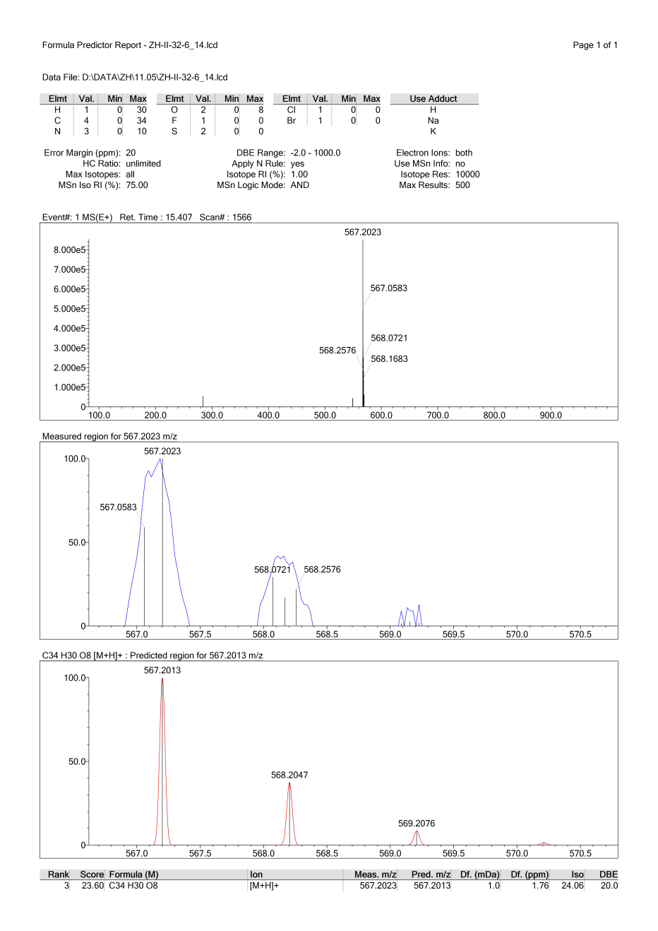
HRESIMS spectrum of compound I
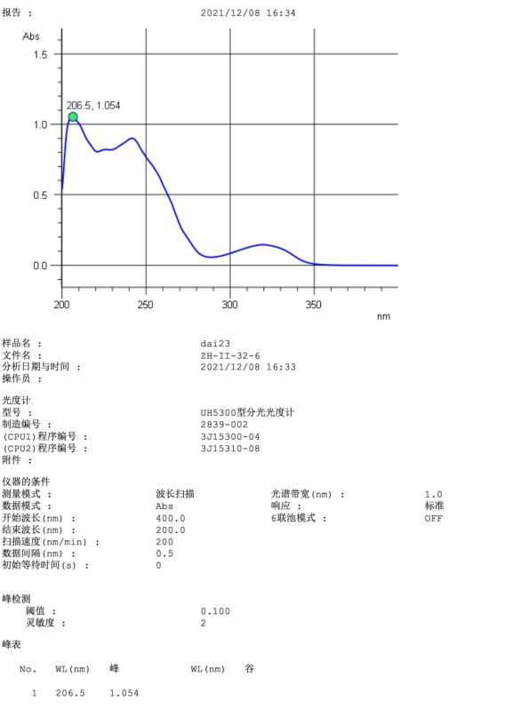
UV spectrum of compound I
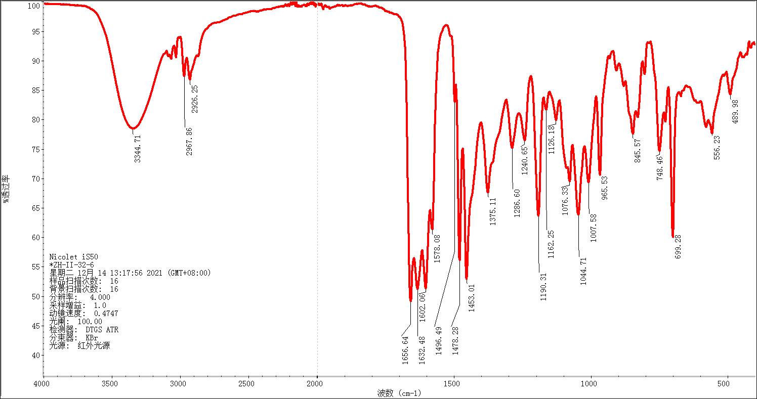
IR spectrum of compound I
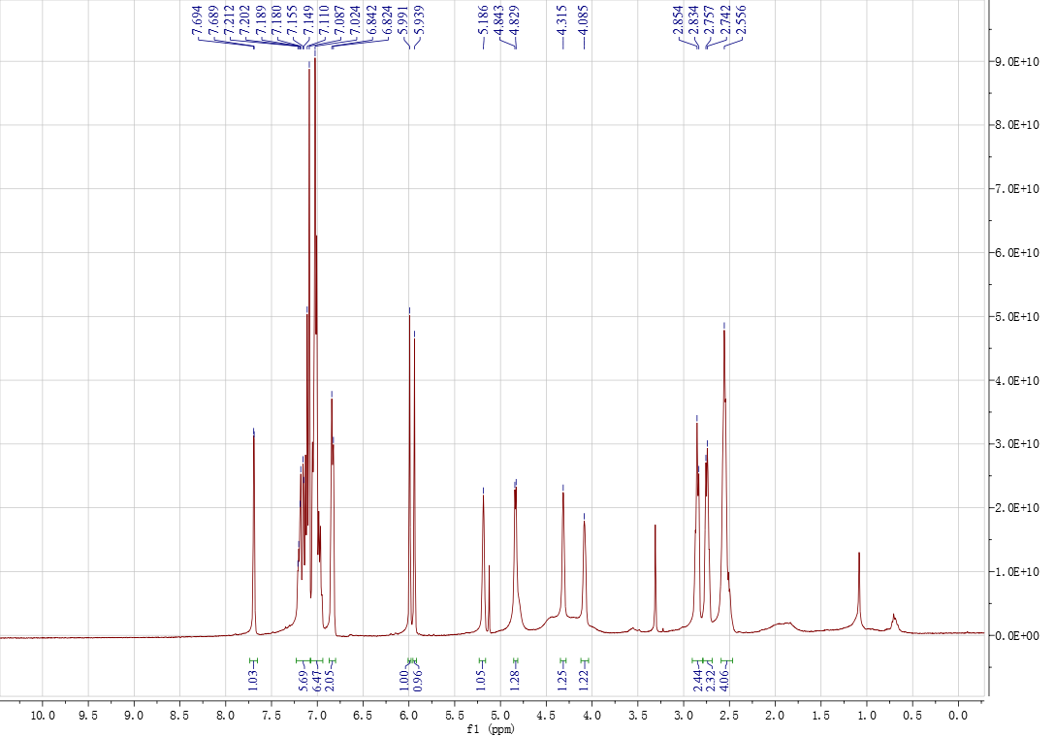
¹H NMR spectrum of compound I in CDCl₃
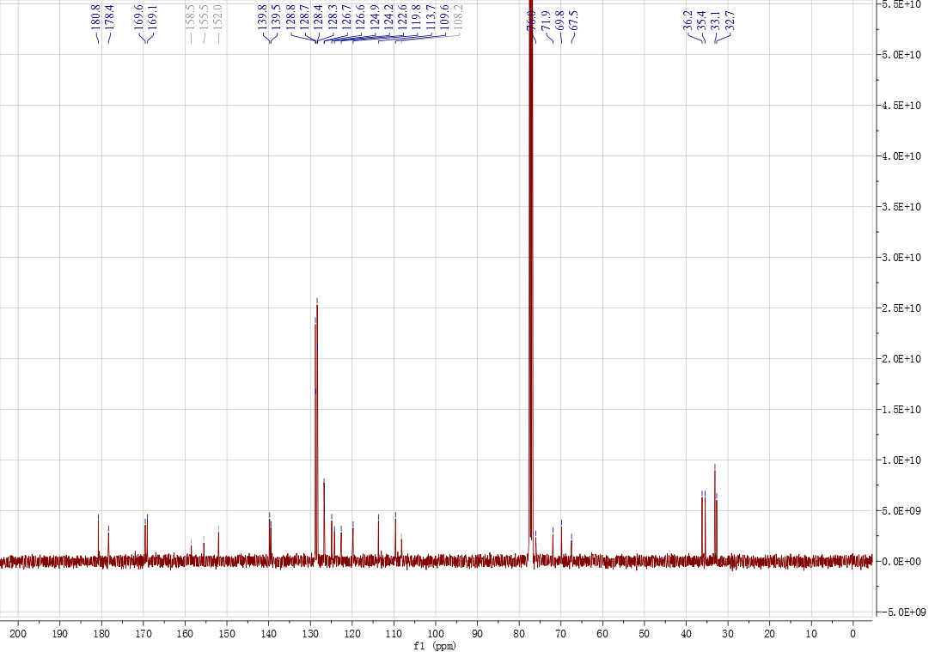
¹³C NMR spectrum of compound I in CDCl₃
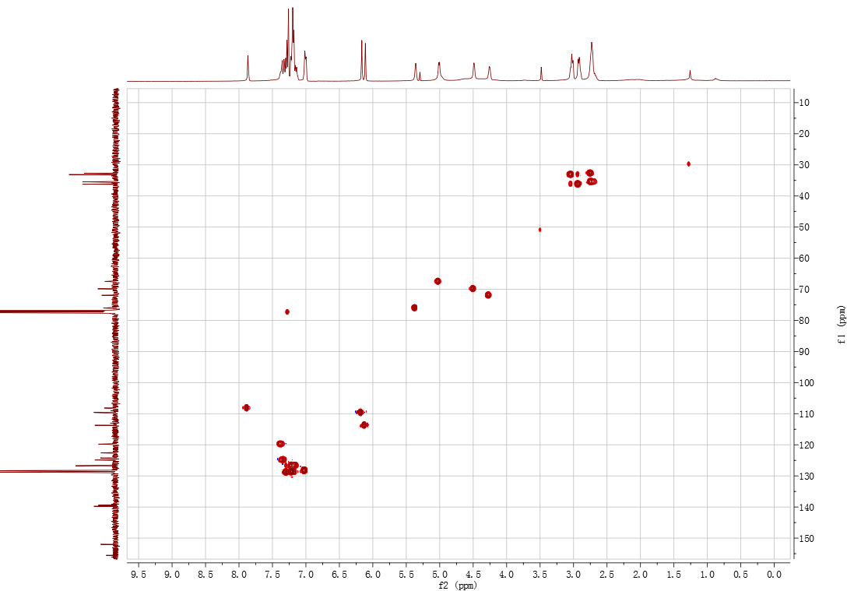
gHSQC spectrum of compound I in CDCl₃
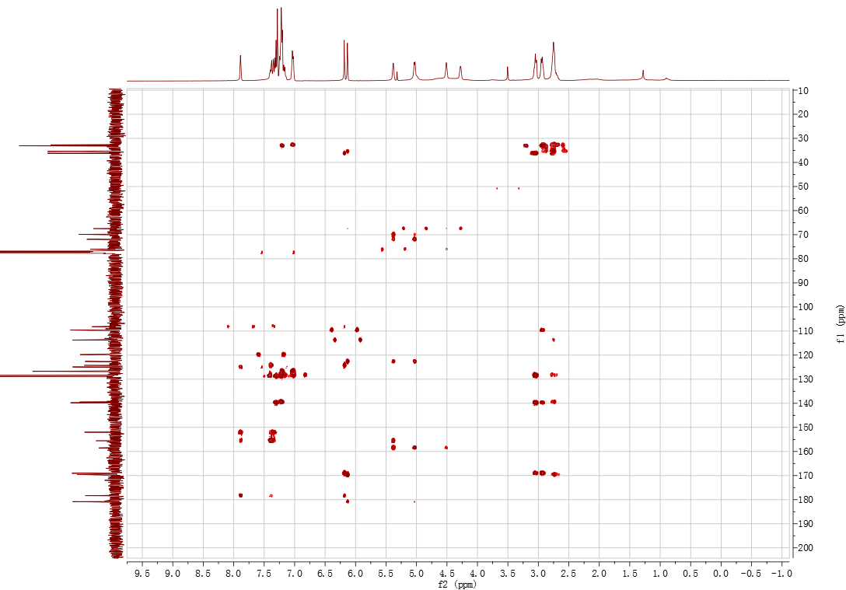
gHMBC spectrum of compound I in CDCl₃
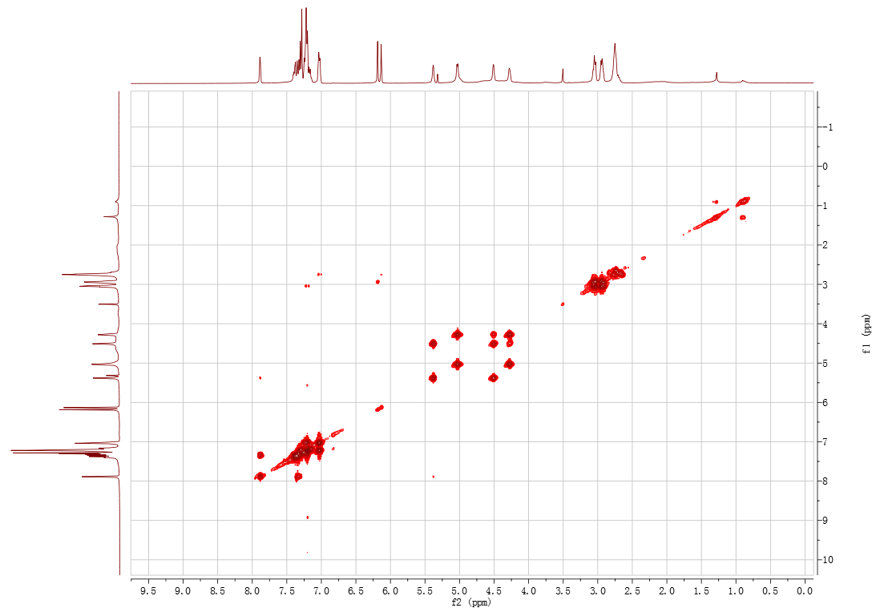
¹H-¹H COSY spectrum of compound I in CDCl₃
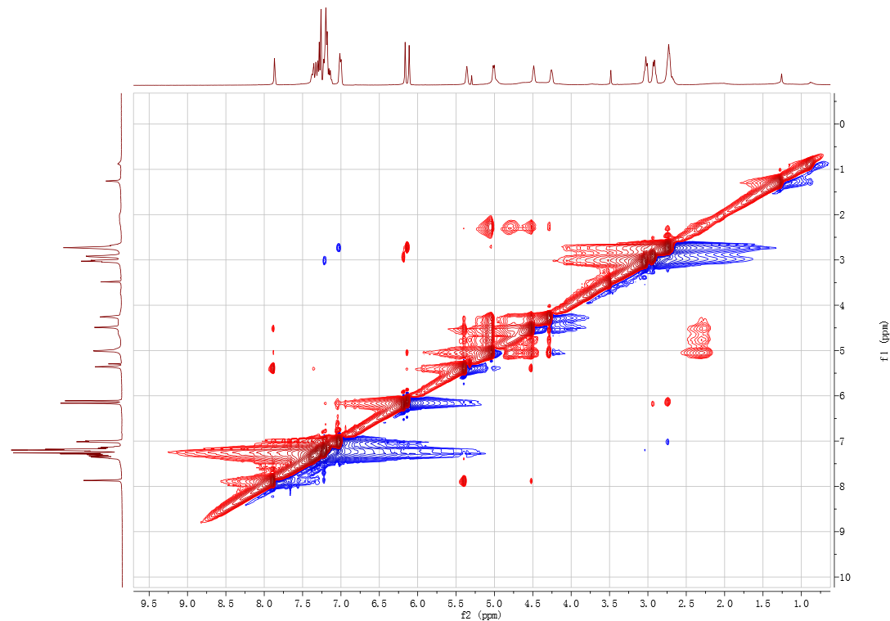
NOESY spectrum of compound I in CDCl₃
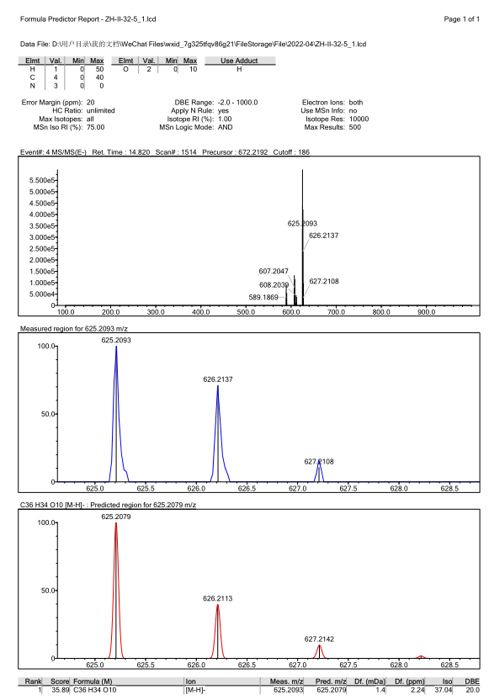
HRESIMS spectrum of compound II
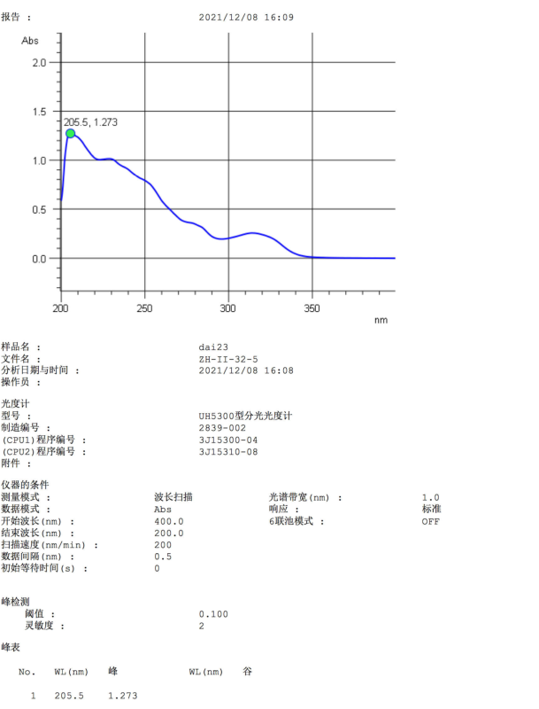
UV spectrum of compound II
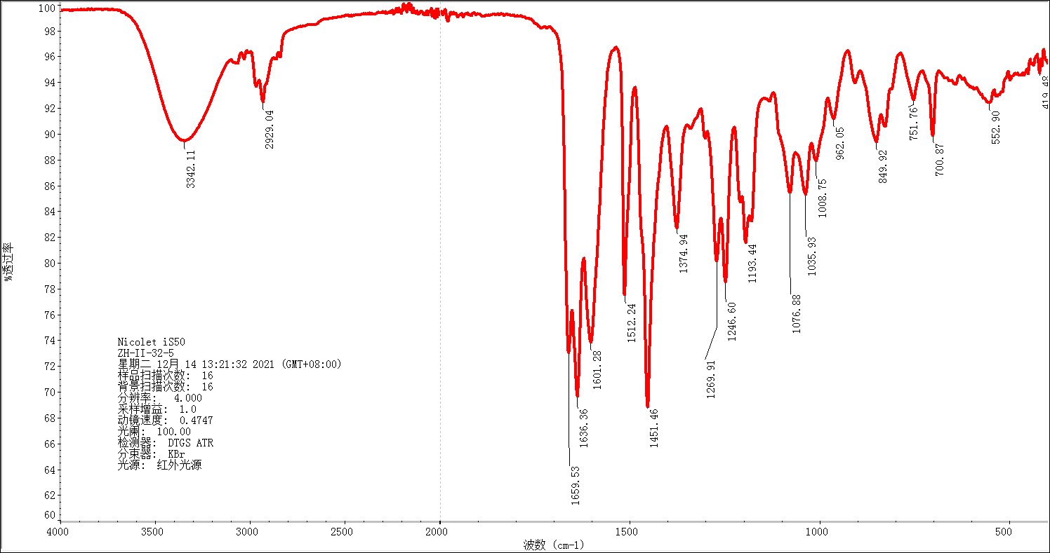
IR spectrum of compound II
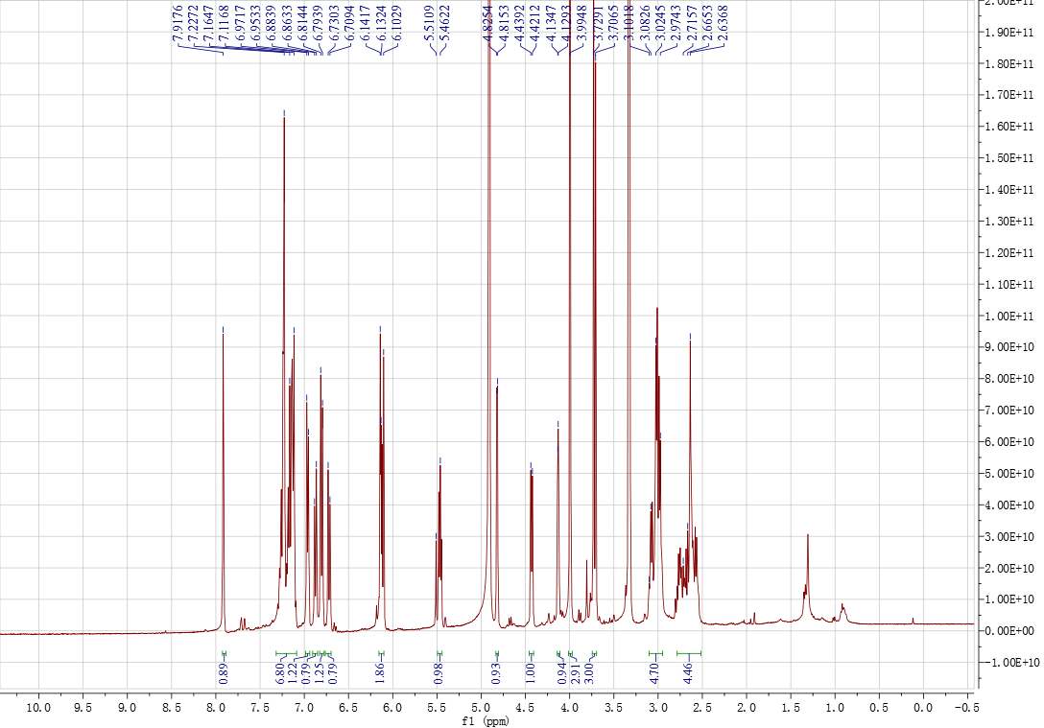
¹H NMR spectrum of compound II in methanol-d₄
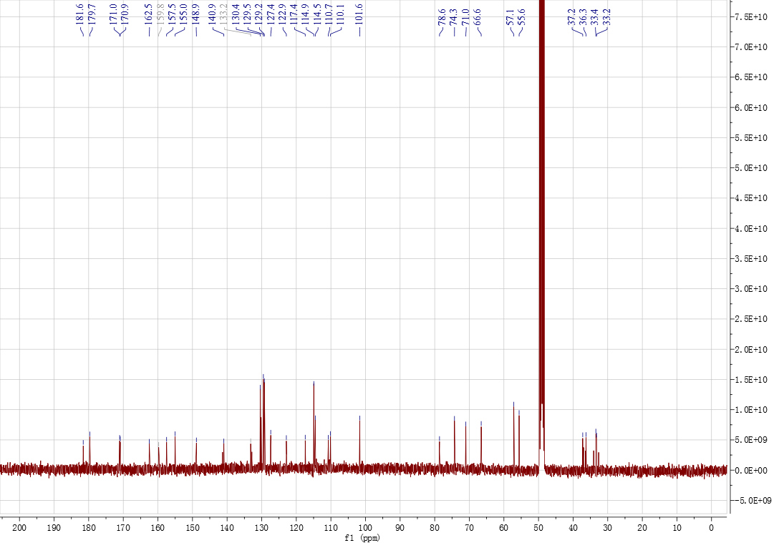
¹³C NMR spectrum of compound II in methanol-d₄
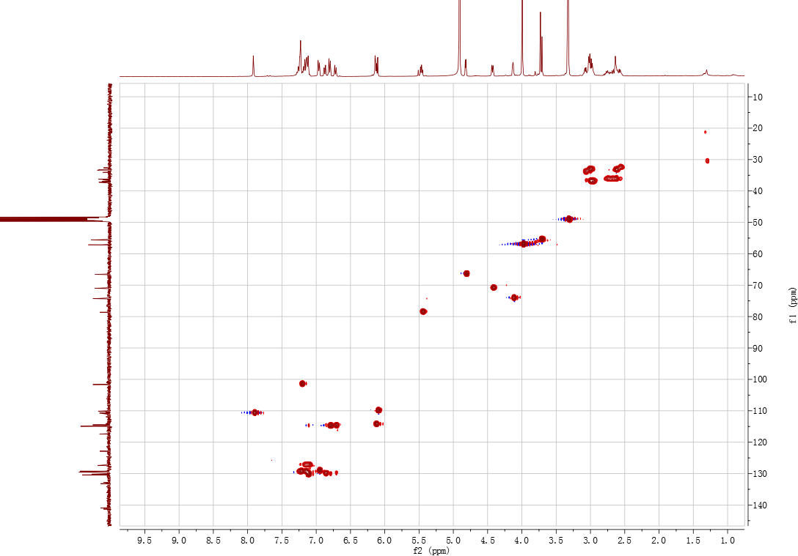
gHSQC spectrum of compound II in methanol-d₄
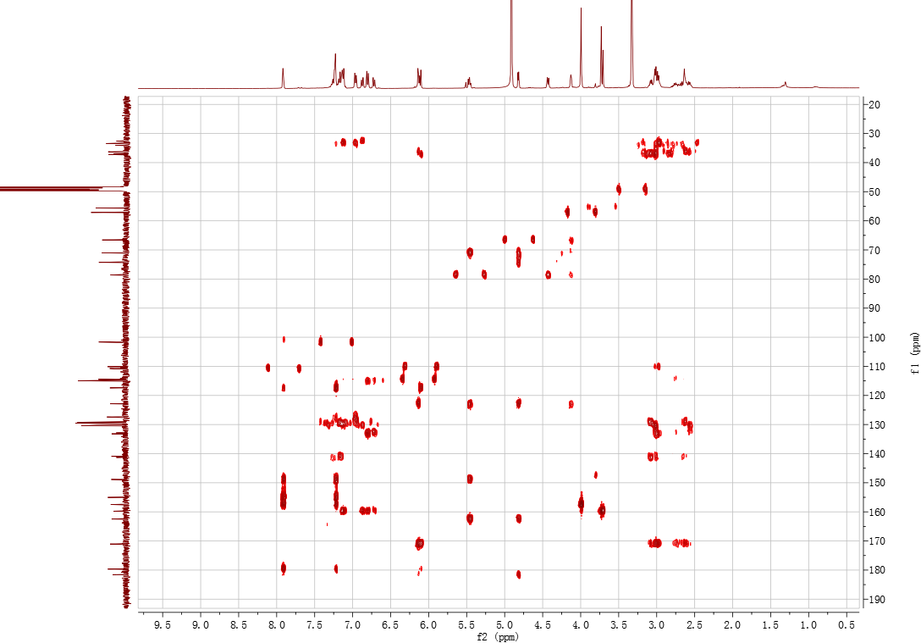
gHMBC spectrum of compound II in methanol-d₄
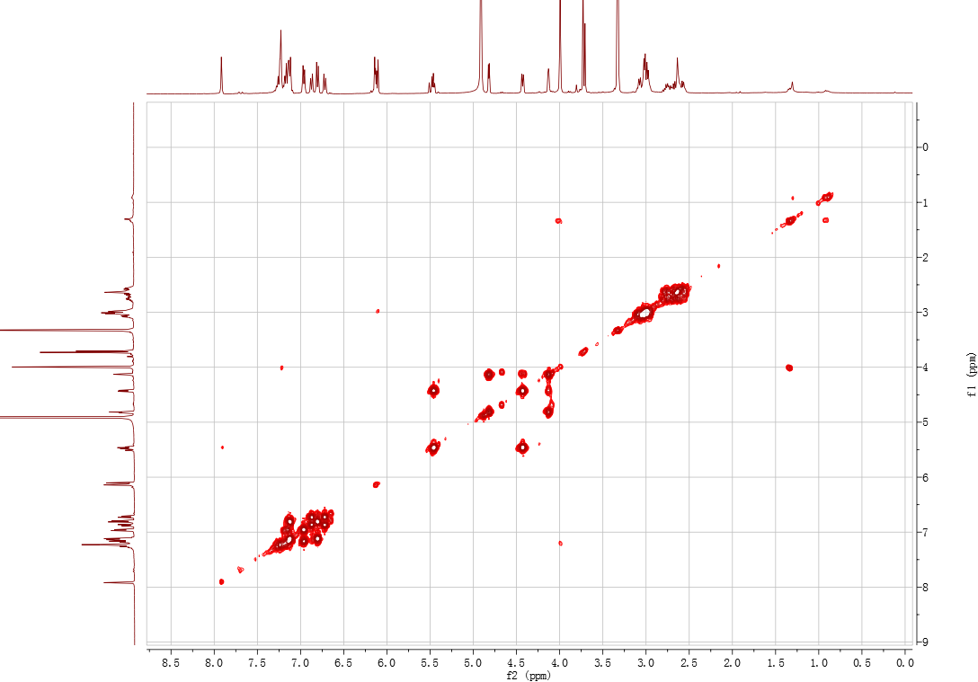
¹H-¹H COSY spectrum of compound II in methanol-d₄
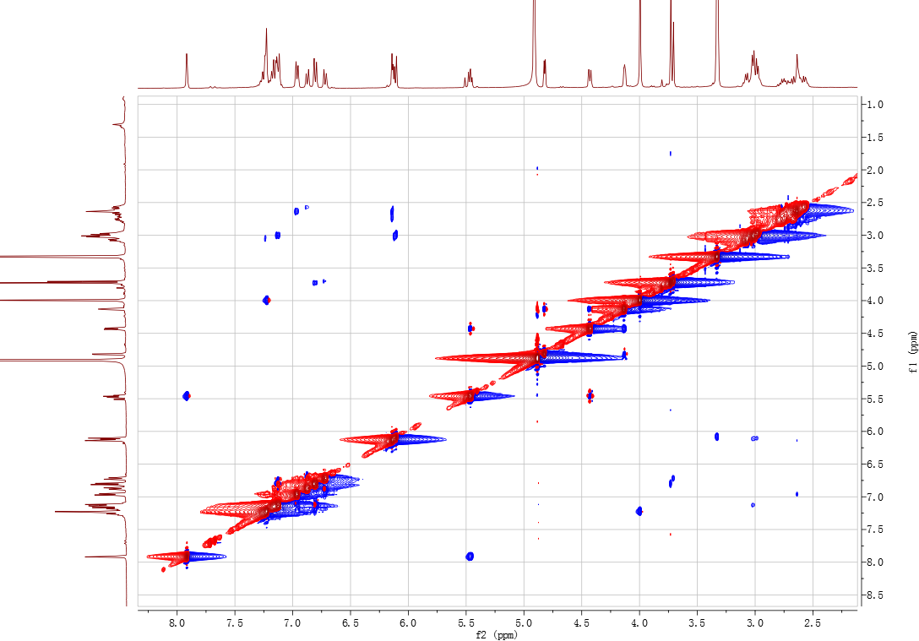
NOESY spectrum of compound II in methanol-d₄
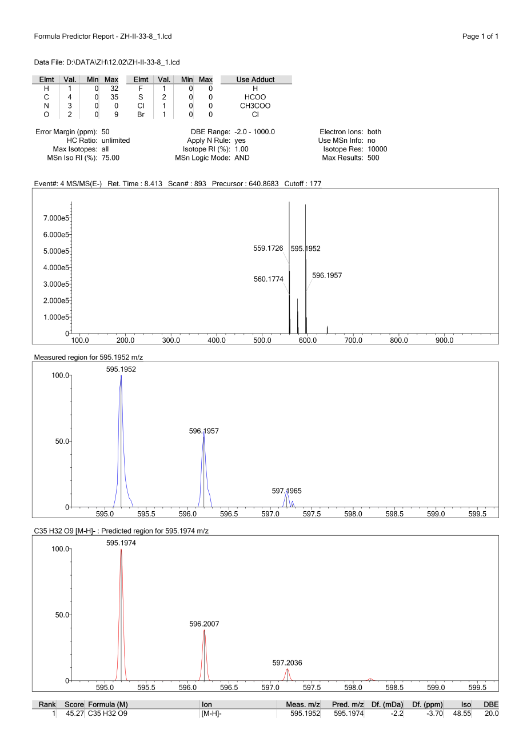
HRESIMS spectrum of compound III
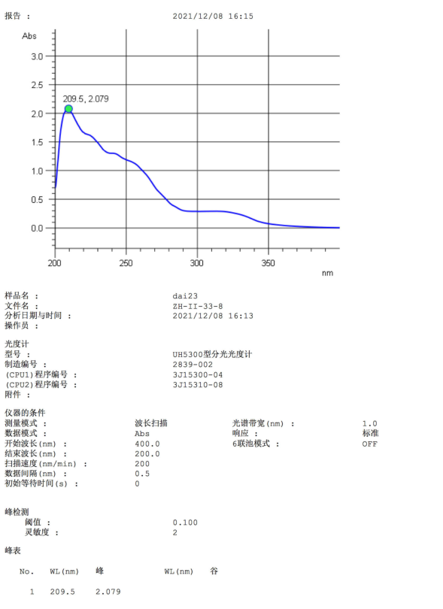
UV spectrum of compound III
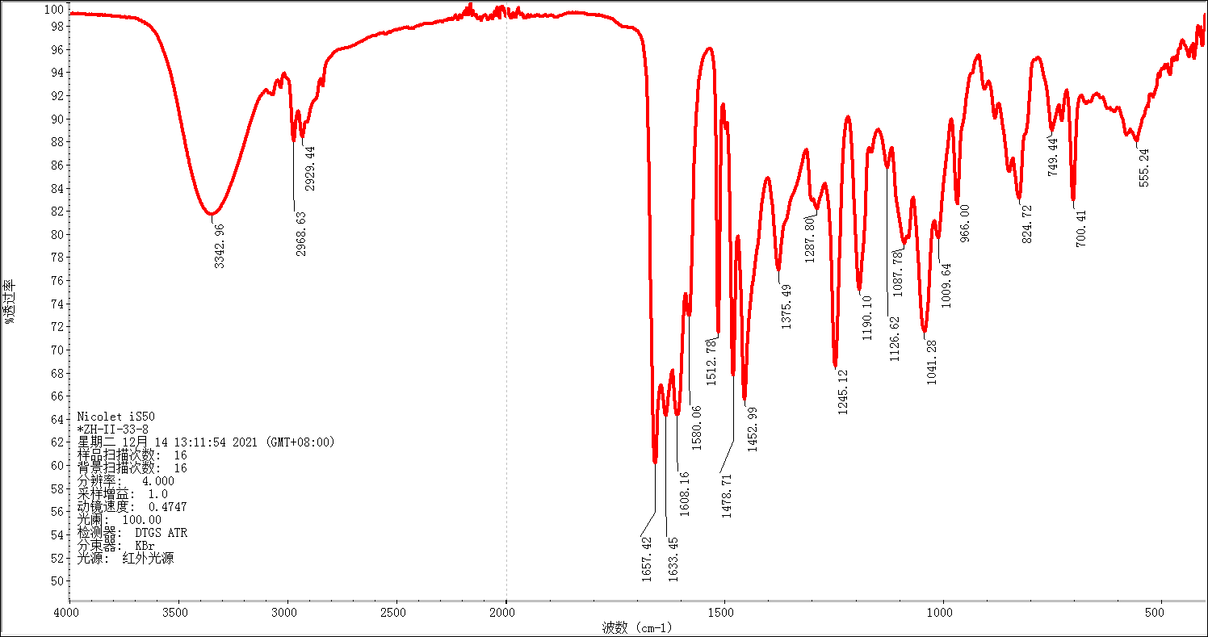
IR spectrum of compound III
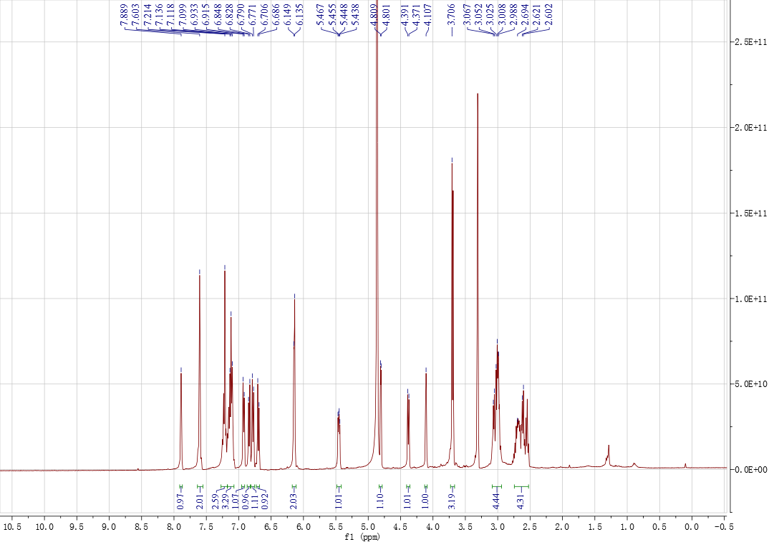
¹H NMR spectrum of compound III in methanol-d₄
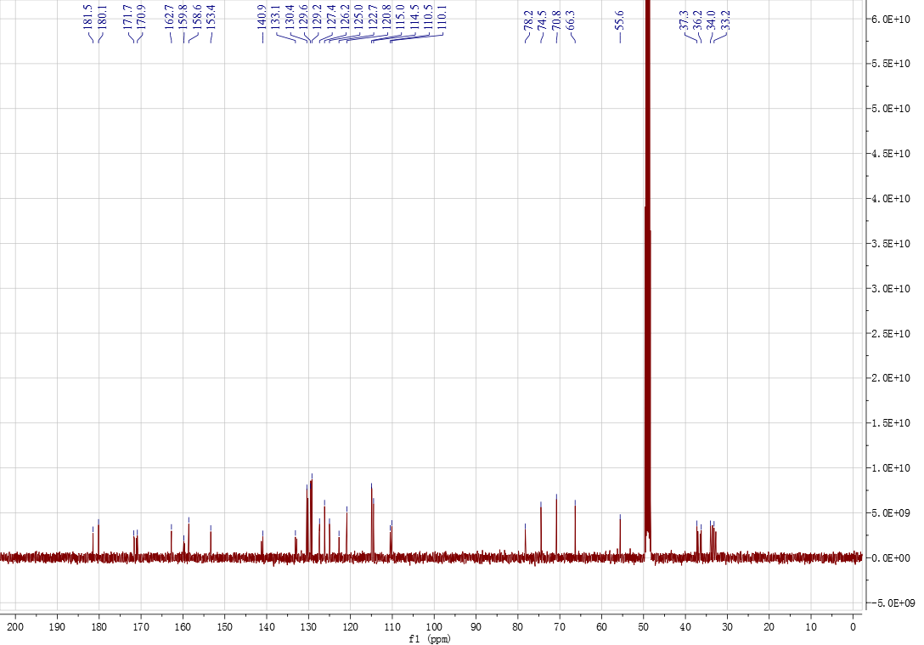
¹³C NMR spectrum of compound III in methanol-d₄
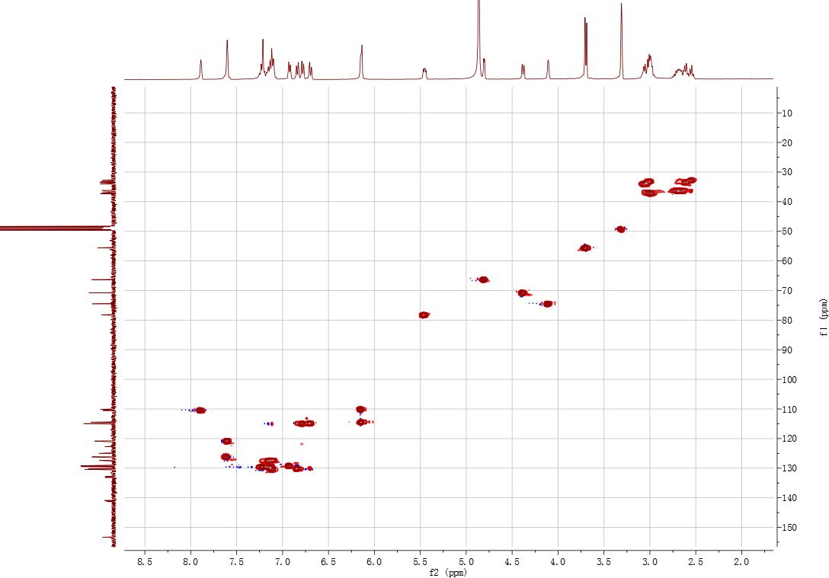
gHSQC spectrum of compound III in methanol-d₄
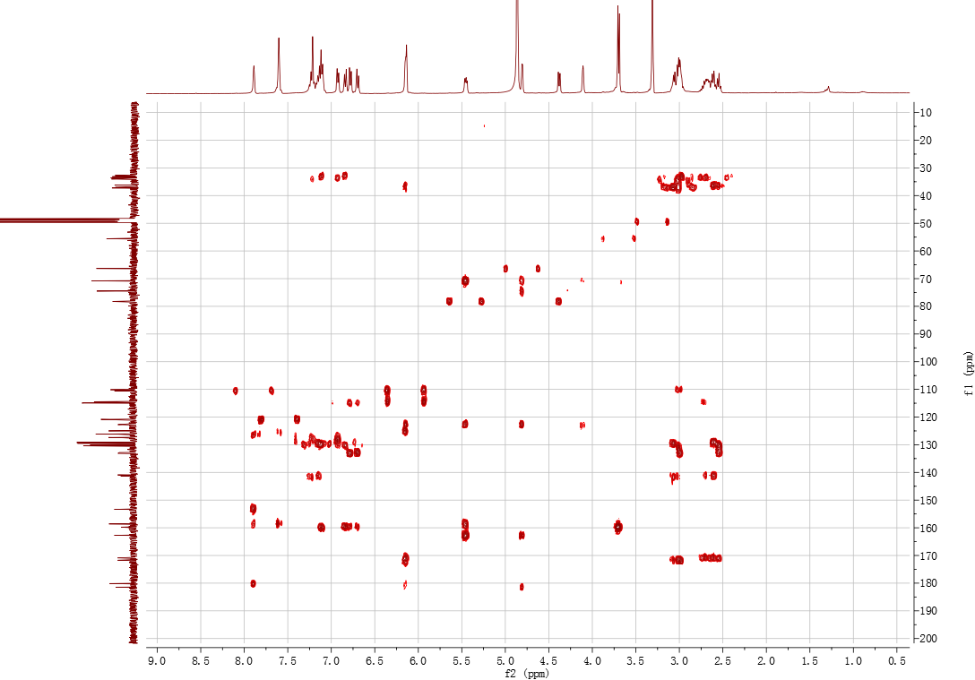
gHMBC spectrum of compound III in methanol-d₄
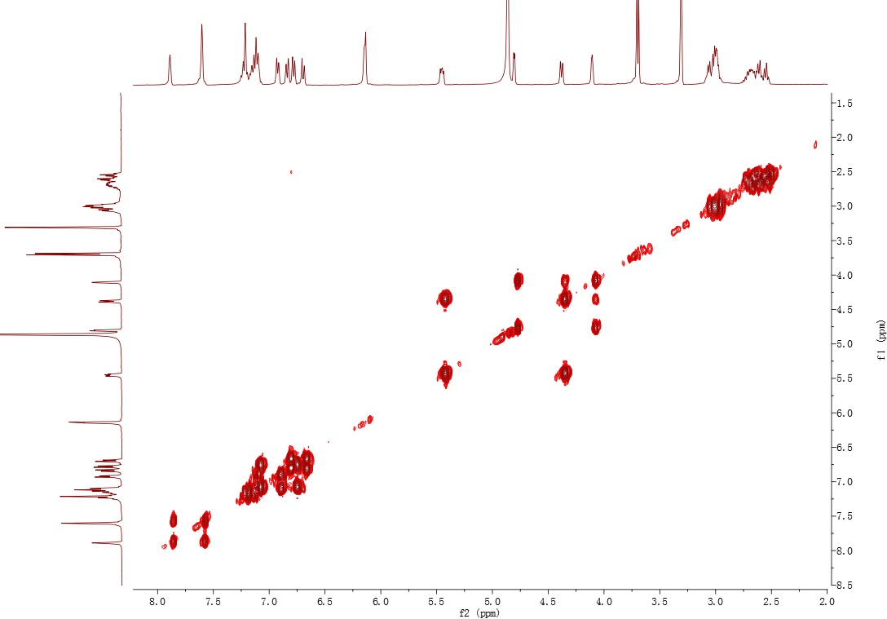
¹H-¹H COSY spectrum of compound III in methanol-d₄
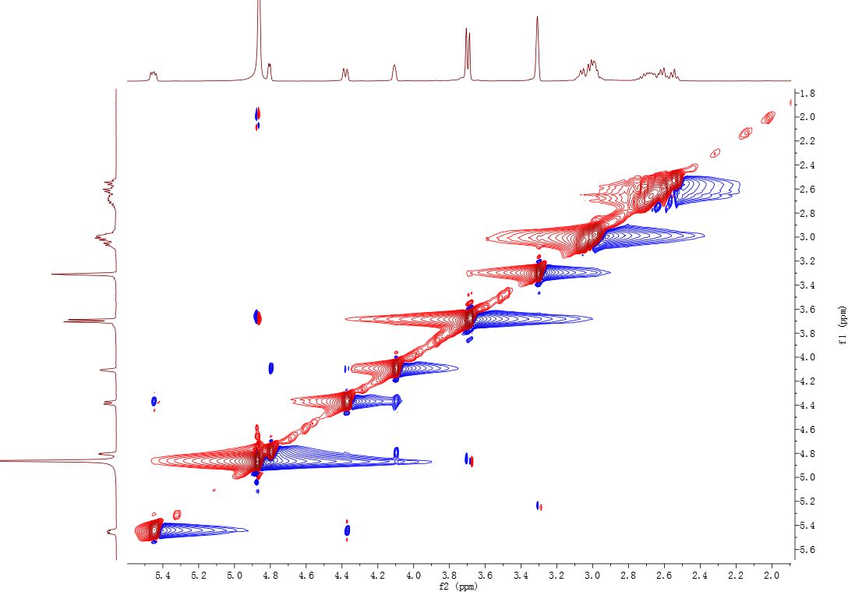
NOESY spectrum of compound III in methanol-d₄
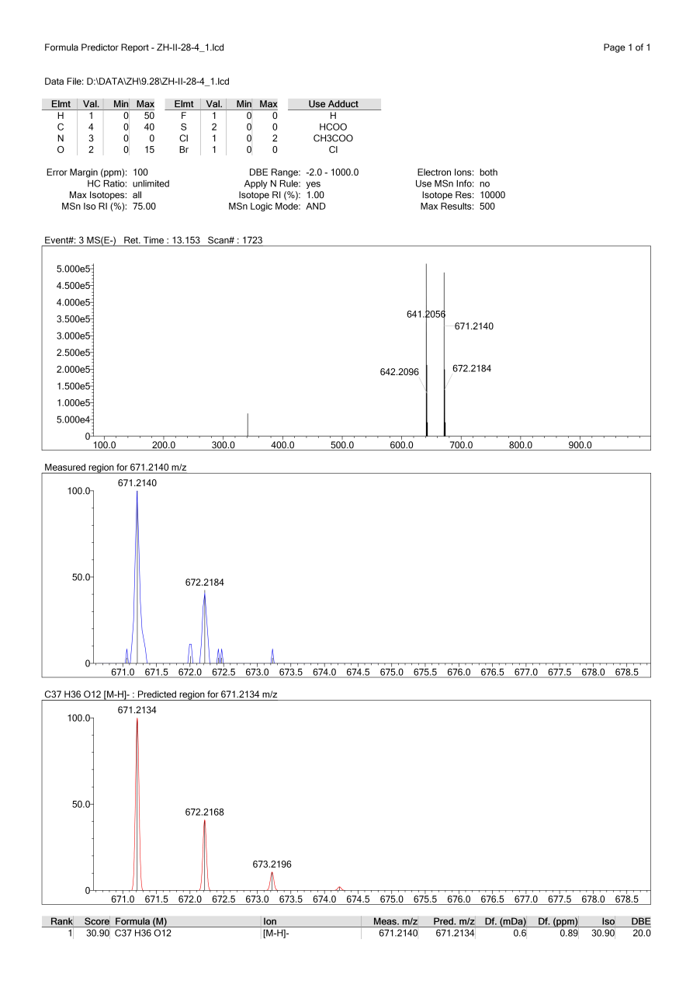
HRESIMS spectrum of compound IV
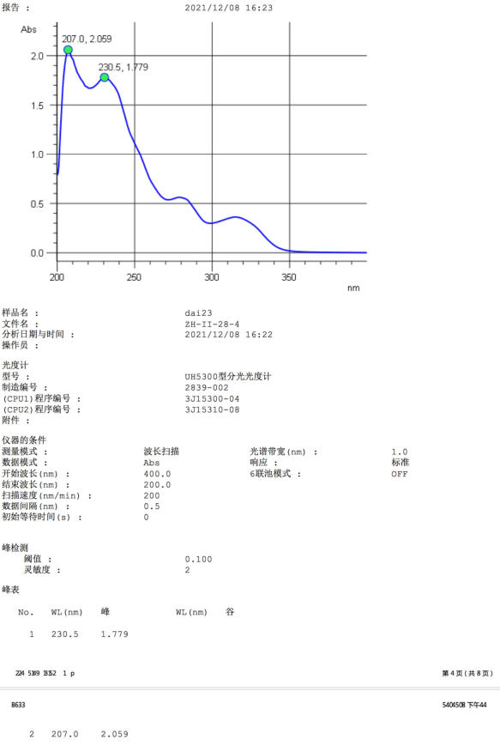
UV spectrum of compound IV
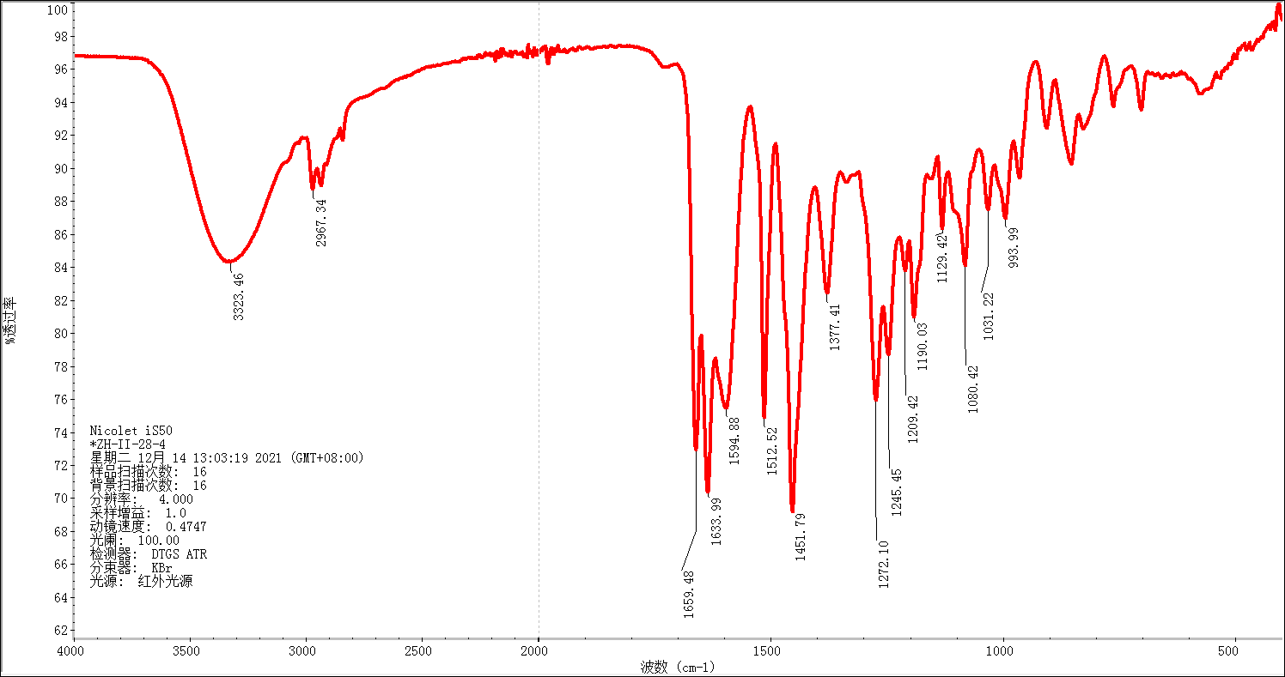
IR spectrum of compound IV
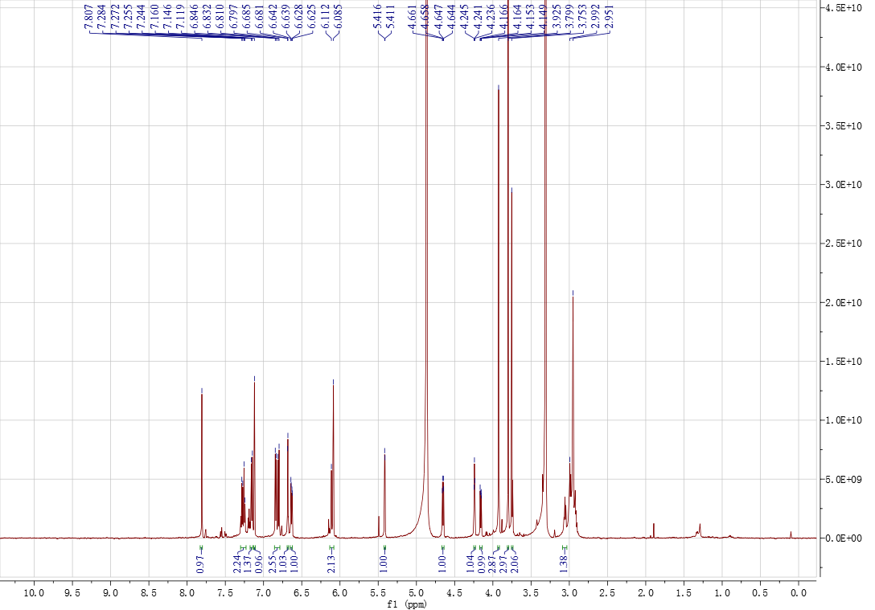
¹H NMR spectrum of compound IV in methanol-d₄
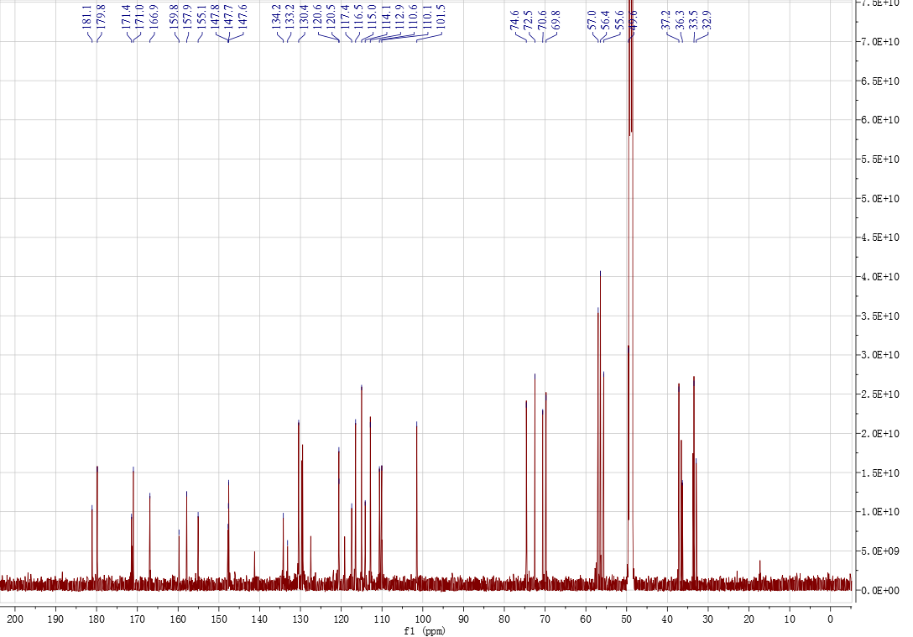
¹³C NMR spectrum of compound IV in methanol-d₄
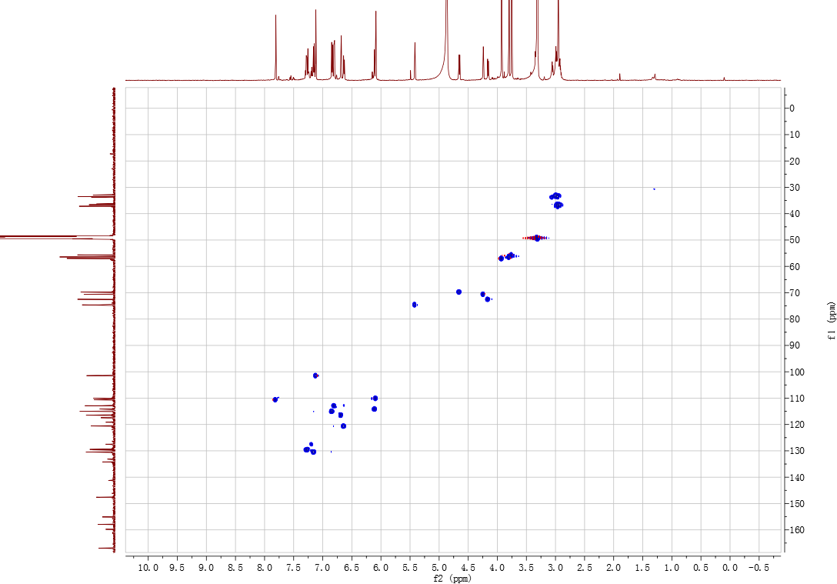
gHSQC spectrum of compound IV in methanol-d₄
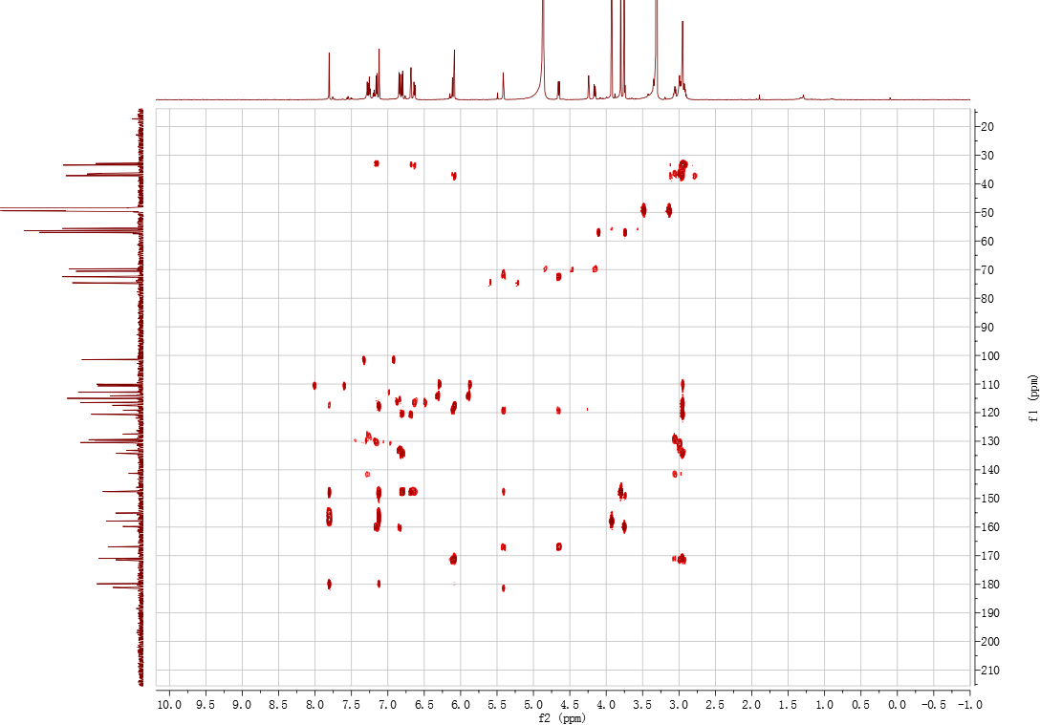
gHMBC spectrum of compound IV in methanol-d₄
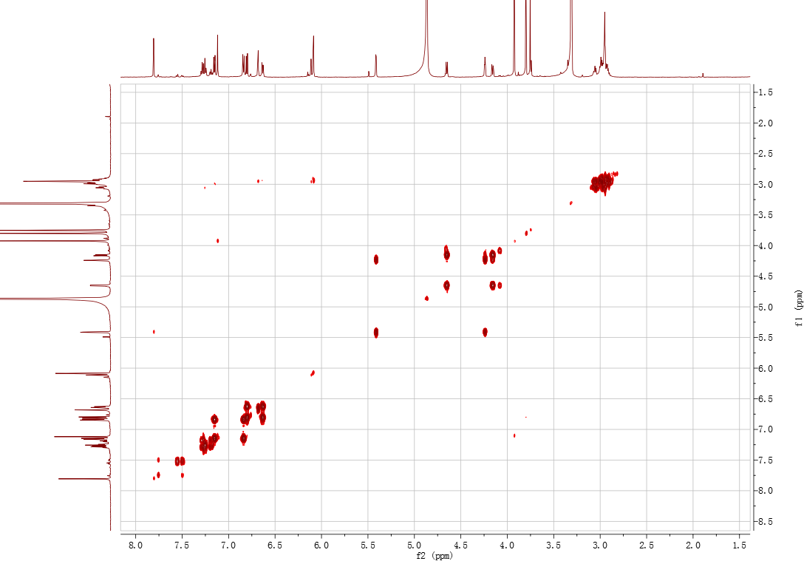
¹H-¹H COSY spectrum of compound IV in methanol-d₄
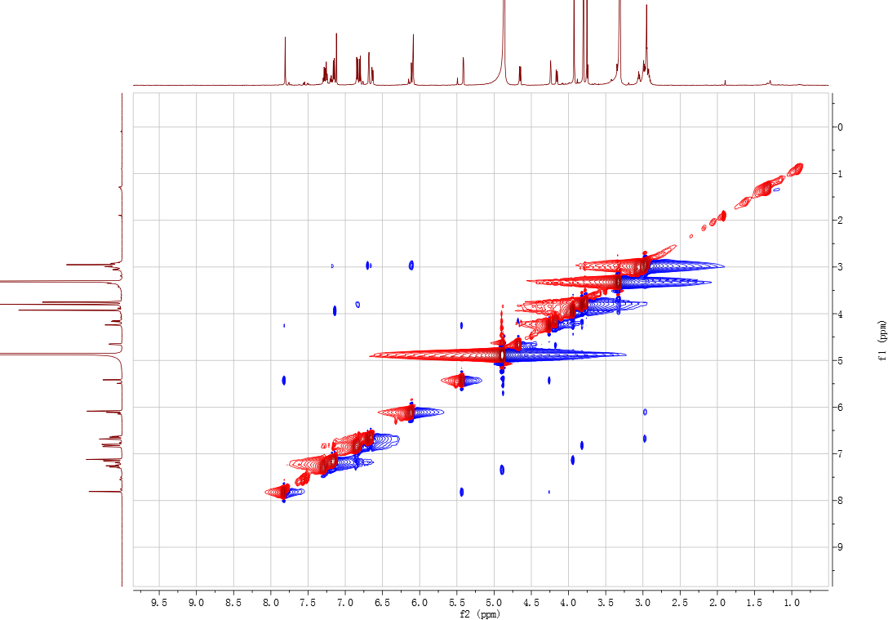
NOESY spectrum of compound IV in methanol-d₄
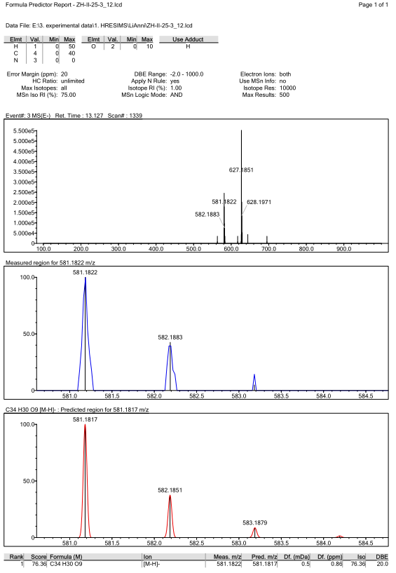
HRESIMS spectrum of compound V
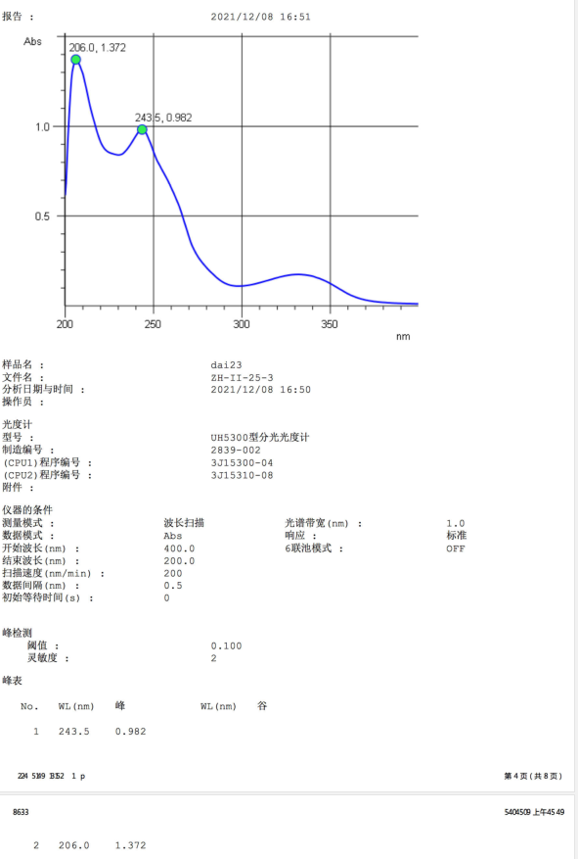
UV spectrum of compound V
IR spectrum of compound V
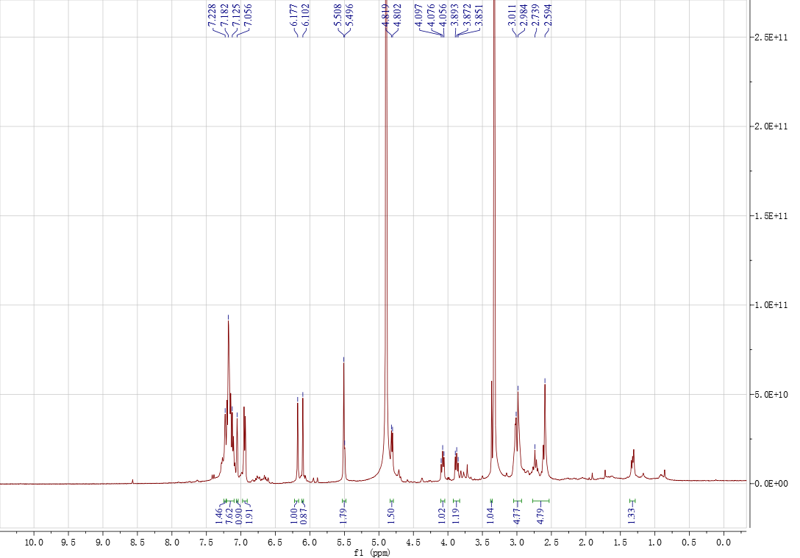
¹H NMR spectrum of compound V in methanol-d₄
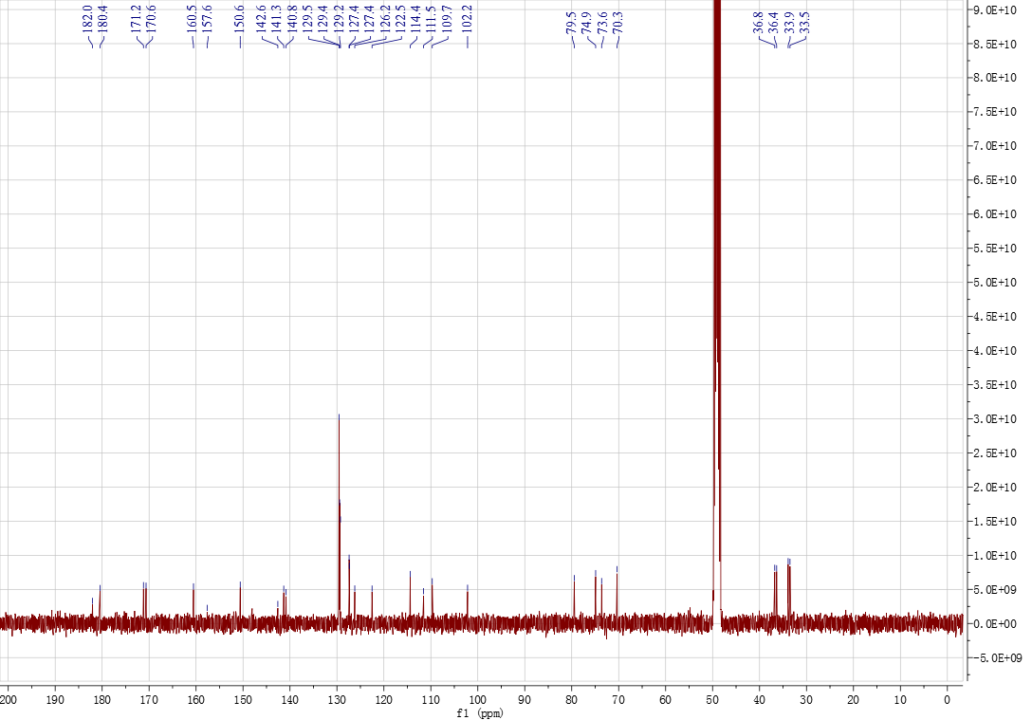
¹³C NMR spectrum of compound V in methanol-d₄
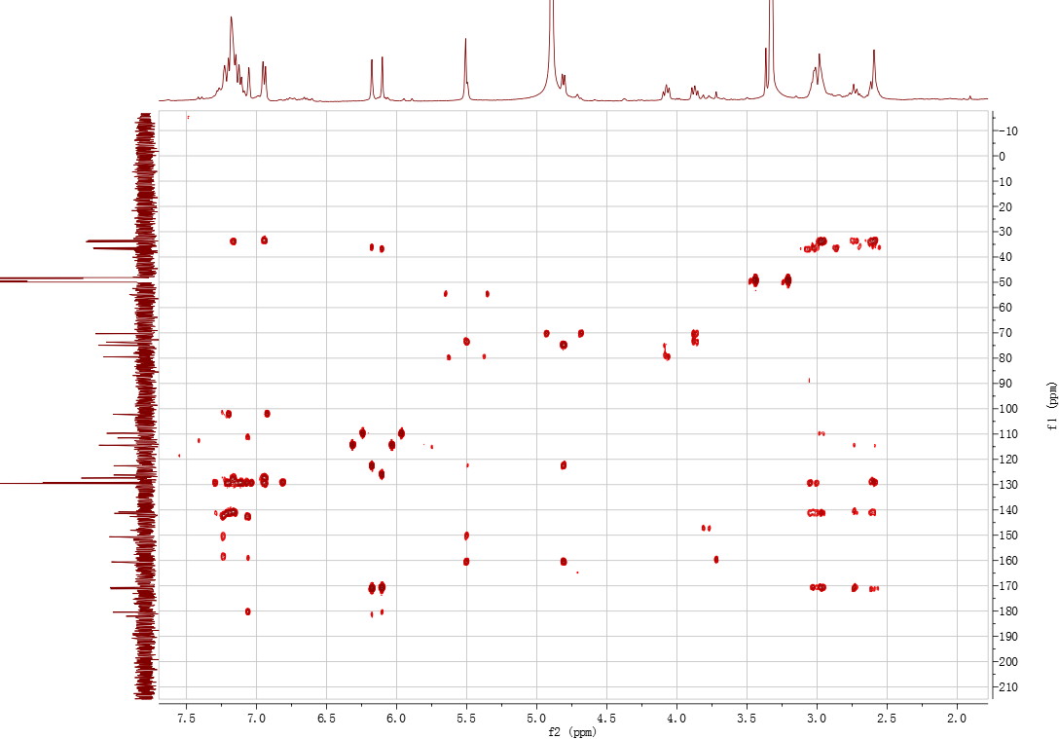
gHSQC spectrum of compound V in methanol-d₄
gHMBC spectrum of compound V in methanol-d₄
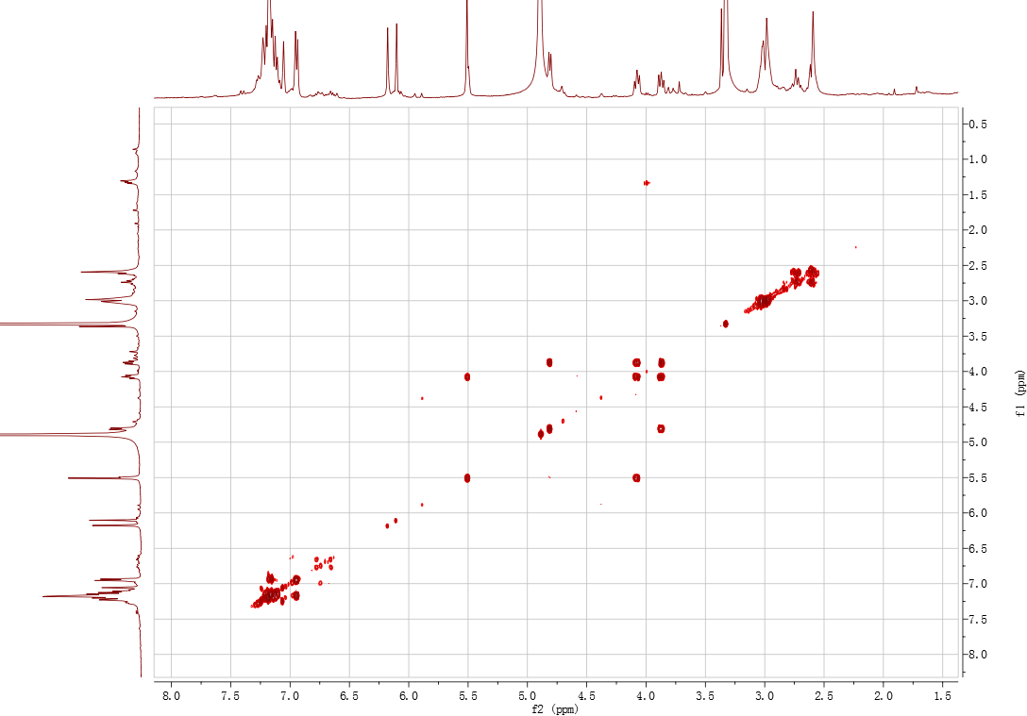
¹H-¹H COSY spectrum of compound V in methanol-d₄
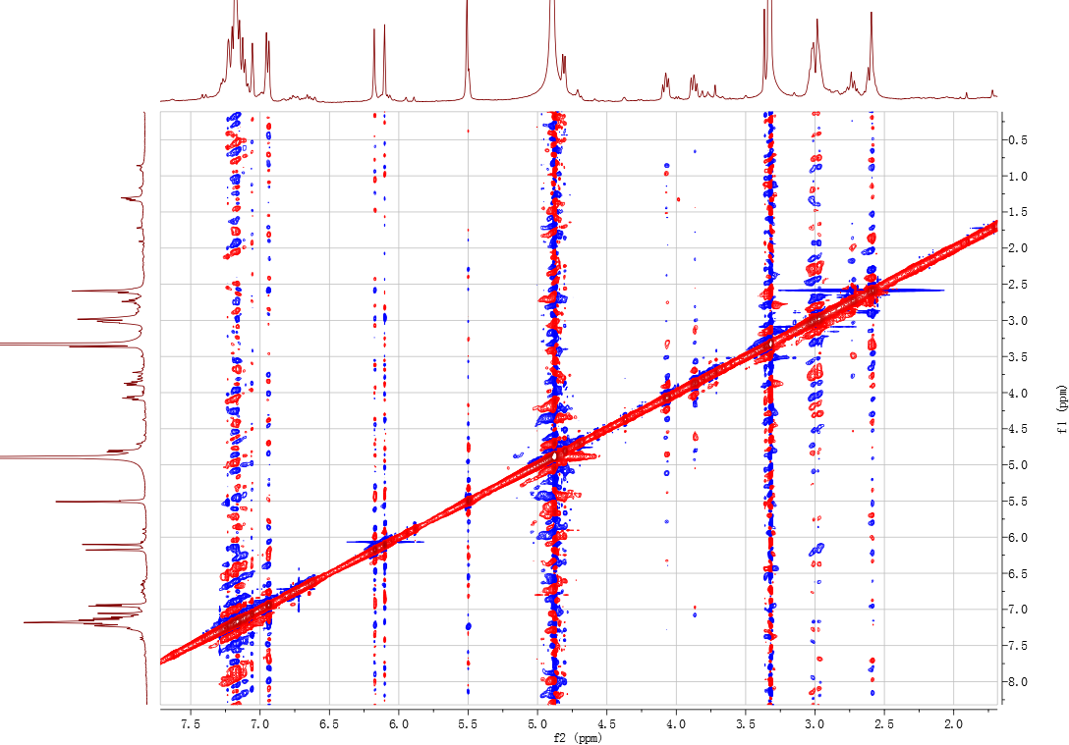
NOESY spectrum of compound V in methanol-d₄
References
- Konishi T, Konoshima T, Shimada Y, Kiyosawa S. Six new 2-(2-phenylethyl)chromones from agarwood. Chem Pharm Bull. 2002; 50: 419–422.
- Yang DL, Mei WL, Zeng YB, Guo ZK, Zhao YX, Wang H, Zuo WJ, Dong WH, Wang QH, Dai HF. 2-(2-Phenylethyl)chromone derivatives in Chinese agarwood “Qi-Nan” from Aquilaria sinensis. Planta Med. 2013; 79: 1329–1334.
- Ibrahim SRM. New 2-(2-phenylethyl)chromone derivatives from the seeds of Cucumis melo L var. reticulatus. Nat Prod Commun. 2010; 5: 403–406.
- Shimada Y, Tominaga T, Konishi T, Kiyosawa S. Studies on the agarwood (Jinko). I. Structures of 2-(2-phenylethyl)chromone derivatives. Chem Pharm Bull. 1982; 30: 3791–3795.
- Hashimoto K, Nakahara S, Inoue T, Sumida Y, Takahashi M, Masada Y. A new chromone from agarwood and pyrolysis products of chromone derivatives. Chem Pharm Bull. 1985; 33: 5088–5091.
- Yang L, Qiao L, Xie D, Yuan YH, Chen NH, Dai JG, Guo SX. 2-(2-Phenylethyl)chromones from Chinese eaglewood. Phytochemistry. 2012; 76: 92–97.
- Yang DL, Wang H, Guo ZK, Dong WH, Mei WL, Dai HF. A new 2-(2-phenylethyl)chromone derivative in Chinese Agarwood ′Qi-Nan′ from Aquilaria sinensis. J Asian Nat Prod Res. 2014; 16: 770–776.
- Wu B, Kwon SW, Hwang GS, Park JH. Eight new 2-(2-phenylethyl)chromone (=2-(2-phenylethyl)-4H-1-benzopyran-4-one) derivatives from Aquilaria malaccensis agarwood. Helv Chim Acta. 2012; 95: 1657–1665.
- Yang JS, Wang YL, Su YL. Studies on the chemical constituents of Aquilaria sinensis (Lour.) Gilg. IV. Isolation of 2(2-phenylethyl)chromone derivatives. Acta Pharm Sin. 1989; 24: 678–683.
- Chen D, Xu ZR, Chai XY, Zeng KW, Jia YX, Bi QD, Ma ZZ, Tu PF. Nine 2-(2-phenylethyl)chromone derivatives from the resinous wood of Aquilaria sinensis and their inhibition of LPS-induced NO production in RAW 264.7 cells. Eur J Org Chem. 2012; 27: 5389–5397.
- Iwagoe K, Konishi T, Kiyosawa S, Shimada Y, Miyahara K, Kawasaki T. Studies on the agalwood (Jinkō) VII. Structures of phenylethylchromone derivatives AH7, AH8 and AH9. Chem Pharm Bull. 1988; 36: 2417–2422.
- Shimada Y, Konishi T, Kiyosawa S, Nishi M, Miyahara K, Kawasaki T. Studies on the agarwood (Jinkō). IV. Structures of 2-(2-phenylethyl)chromone derivatives, agarotetrol and isoagarotetrol. Chem Pharm Bull. 1986; 34: 2766–2773.
- Konishi T, Iwagoe K, Sugimoto A, Kiyosawa S, Fujiwara Y, Shimada Y. Studies on agalwood Jinkō X. Structures of 2-(2-phenylethyl)chromone derivatives. Chem Pharm Bull. 1991; 39: 207–209.
- Yagura T, Ito M, Kiuchi F, Honda G, Shimada Y. Four new 2-(2-phenylethyl)chromone derivatives from withered wood of Aquilaria sinensis. Chem Pharm Bull. 2003; 51: 560–564.
- Zhao YM, Yang L, Kong FD, Dong WH, Li W, Chen HQ, Wang H, Cai CH, Gai CJ, Mei ML, Dai HF. Three new 5,6,7,8-tetrahydro-2-(2-phenylethyl)chromones and one new dimeric 2-(2-phenylethyl)chromone from agarwood of Aquilaria crassna pierre ex lecomte in laos. Nat Prod Res. 2021; 35: 2295–2302.
- Li Y, Sheng N, Wang L, Li S, Chen J, Lai X. Analysis of 2-(2-phenylethyl)chromones by UPLC-ESI-QTOF-MS and multivariate statistical methods in wild and cultivated agarwood. Int J Mol Sci. 2016; 17(5): 771.
- Iwagoe K, Kakae T, Konishi T, Kiyosawa S, Fujiwara Y, Shimada Y, Kawasaki T. Studies on the agalwood Jinkō VIII. structures of biphenylethylchromone derivatives. Chem Pharm Bull. 1989; 37: 124–128.
- Huo HX, Zhu ZX, Song YL, Shi SP, Sun J, Sun H, Zhao YF, Zheng J, Ferreira D, J Zjawiony K, Tu PF, Li J. Anti-inflammatory dimeric 2-(2-phenylethyl)chromones from the resinous wood of Aquilaria sinensis. J Nat Prod. 2018; 81: 543–553.
- Huo HX, Gu YF, Zhu ZX, Zhang YF, Chen XN, Guan PW, Shi SP, Song YL, Zhao YF, Tu PF, Li J. LC-MS-guided isolation of anti-inflamamtory 2-(2-phenylethyl)chromone dimers from Chinese agarwood (Aquilaria sinensis). Phytochemistry. 2019; 158: 46–55.

* Correspondence: Yuelin Song syltwc2005@163.com Jun Li drlj666@163.com ª Modern Research Center for Traditional Chinese Medicine, Beijing Research Institute of Chinese Medicine, Beijing University of Chinese Medicine, Beijing 100029, People’s Republic of China. ^{b} School of Chinese Materia Medica, Beijing University of Chinese Medicine, Beijing 100029, People’s Republic of China.

