Supplementary Materials
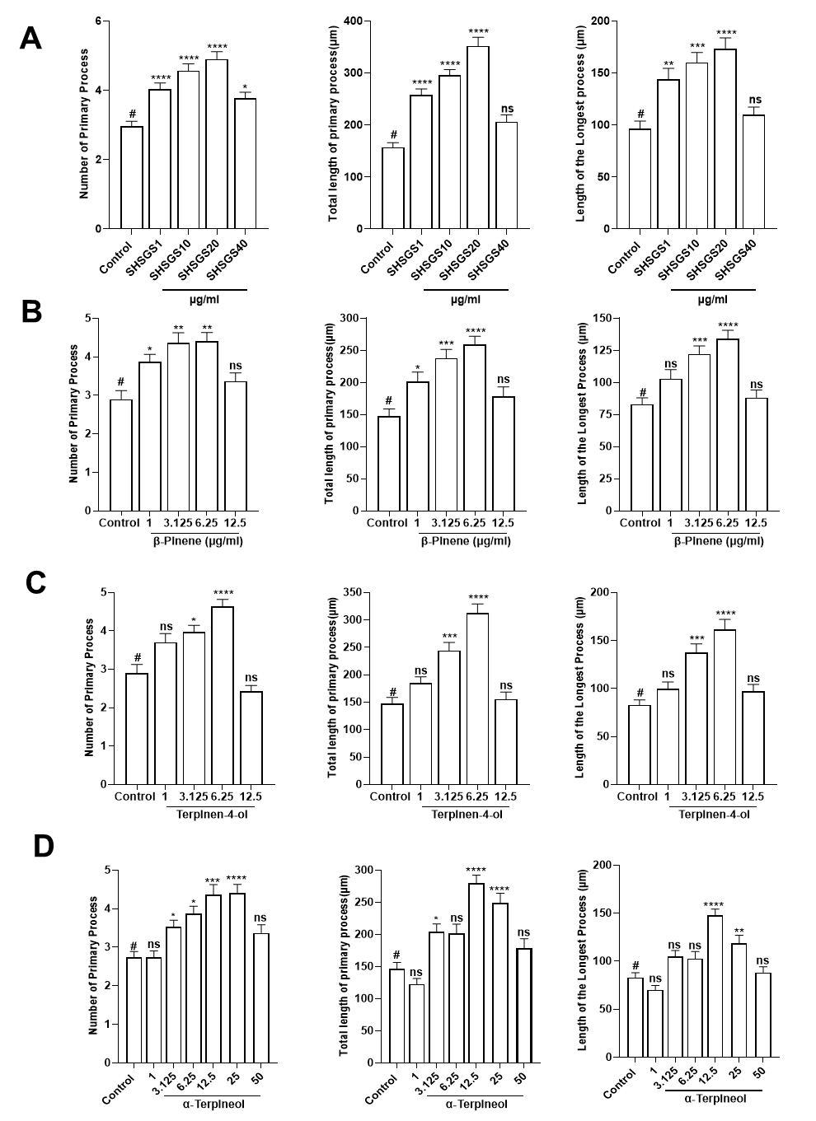
Supplementary Figure S1. Dose optimization of SHSGS, β-pinene, terpinen-4-ol, α-terpineol on neurite outgrowth. Neurite development of (A) SHSGS, (B) β-pinene, (C) terpinen-4-ol, and (D) α-terpineol via morphometric study describes the axon length, the number of primary processes, and their total length. The significance of the statistical test was obtained by one-way ANOVA analysis (*P < 0.05, **P < 0.01, ***P < 0.001, ****P < 0.0001) compared to vehicle followed by a Tukey post hoc test. data dots represent the mean ± S.E.M. (standard error of the mean). ​

Supplementary Table S1. Instrument conditions for GC-MS analysis.

Item | Condition
Detector | MSD
Column | DB-5MS (30 m x 250 μm, 0.25 μm thickness)
Oven temperature | 40°C (5 min) → 10°C/min, 280°C (10 min)
Helium gas flow (ml/min) | 1
Injection volume (μL) | 1
Split ratio | 1:20
Inlet / detector temperature (°C) | 250 / 280
Solvent delay (min) | 3
Scan mode (amu) | 50-500

Supplementary Table S2. Target genes of SHSGS compounds.
Target gene | Protein | Related compounds
ACHE | Acetylcholinesterase | α-Terpinene, γ-Terpinene, Caryophyllene oxide
ADH1A | Alcohol dehydrogenase 1A | Methylcyclopentane, γ-Terpinene
ADH1B | Alcohol dehydrogenase 1B | Methylcyclopentane, D-Limonene, γ-Terpinene, β-Selinene
ADH1B | Alpha-1B adrenergic receptor | Methylcyclopentane, D-Limonene, γ-Terpinene, (1R)-(+)-Nopinone, Caryophyllene oxide
ADH1C | Alcohol dehydrogenase 1C | β-Myrcene, α-Terpinene
ADRA1A | Alpha-1A adrenergic receptor | (-)-β-Pinene, α-Terpinene, α-Terpineol, β-Elemene, β-Chamigrene
ADRA1B | Alpha-1B adrenergic receptor | (-)-β-Pinene, Terpinen-4-ol, α-Terpineol, β-Chamigrene
ADRA1D | Alpha-1D adrenergic receptor | Terpinen-4-ol
ADRA2A | Alpha-2A adrenergic receptor | α-Terpinene
ADRA2C | Alpha-2C adrenergic receptor | (-)-β-Pinene, α-Terpinene
ADRB1 | Beta-1 adrenergic receptor | α-Terpinene, α-Terpineol
ADRB2 | Beta-2 adrenergic receptor | α-Terpinene, Terpinen-4-ol, α-Terpineol
AR | Androgen receptor | α-Terpinene
BCL2 | Apoptosis regulator Bcl-2 | β-Elemene
CALM1 | Calmodulin | Terpinen-4-ol
CCNB1 | G2/mitotic-specific cyclin-B1 | β-Elemene
CDC2 | Cell division control protein 2 homolog | β-Elemene
CDKN1A | Cyclin-dependent kinase inhibitor 1 | β-Elemene
CHRM1 | Muscarinic acetylcholine receptor M1 | (-)-β-Pinene, α-Terpinene, D-Limonene, Linalool, Terpinen-4-ol, α-Terpineol, β-Elemene, β-Selinene, β-Chamigrene, (+)-δ-Cadinene, Spathulenol, Caryophyllene oxide
CHRM2 | Muscarinic acetylcholine receptor M2 | β-Phellandrene, (-)-β-Pinene, α-Terpinene, D-Limonene, Linalool, Terpinen-4-ol, α-Terpineol, (-)-Verbenone, β-Elemene, β-Selinene, β-Chamigrene, Spathulenol, Caryophyllene oxide
CHRM3 | Muscarinic acetylcholine receptor M3 | β-Phellandrene, (-)-β-Pinene, Linalool, Terpinen-4-ol, α-Terpineol, (-)-Verbenone, β-Elemene, Cyperene, β-Selinene, β-Chamigrene, Spathulenol, Caryophyllene oxide
CHRNA2 | Neuronal acetylcholine receptor subunit alpha-2 | α-Pinene, β-Phellandrene, (-)-β-Pinene, Terpinen-4-ol, β-Chamigrene
CHRNA7 | Neuronal acetylcholine receptor protein, alpha-7 chain | β-Elemene, β-Chamigrene, α-Cyperone
CTRB1 | Chymotrypsinogen B | α-Terpinene
CYP101 | Cytochrome P450-cam | Methylcyclopentane, α-Pinene, (-)-β-Pinene, α-Terpinene, D-Limonene, γ-Terpinene, (1R)-(+)-Nopinone, Terpinen-4-ol, (-)-Verbenone, (+)-δ-Cadinene
DPP4 | Dipeptidyl peptidase IV | α-Terpinene, γ-Terpinene, Caryophyllene oxide
EIF6 | Eukaryotic translation initiation factor 6 | β-Elemene
F10 | Coagulation factor Xa | Terpinen-4-ol
F2 | Thrombin | α-Terpinene, Caryophyllene oxide
GABRA1 | Gamma-aminobutyric acid receptor subunit alpha-1 | α-Pinene, β-Phellandrene, (-)-β-Pinene, β-Myrcene, α-Terpinene, D-Limonene, γ-Terpinene, Linalool, Terpinen-4-ol, α-Terpineol, (-)-Verbenone, β-Elemene, Cyperene, β-Selinene, β-Chamigrene, (+)-δ-Cadinene, Spathulenol, Caryophyllene oxide, Sedanolide, (E)-Ligustilide, α-Cyperone
GABRA2 | Gamma-aminobutyric-acid receptor alpha-2 subunit | α-Pinene, (-)-β-Pinene, D-Limonene, Linalool, (1R)-(+)-Nopinone, Terpinen-4-ol, α-Terpineol, (-)-Verbenone, β-Elemene, β-Selinene, β-Chamigrene, Caryophyllene oxide, Sedanolide, α-Cyperone
GABRA3 | Gamma-aminobutyric-acid receptor alpha-3 subunit | (-)-β-Pinene, D-Limonene, Linalool, Terpinen-4-ol, α-Terpineol, β-Elemene, β-Selinene, β-Chamigrene, Sedanolide, α-Cyperone
GABRA4 | Gamma-aminobutyric-acid receptor subunit alpha-4 | β-Chamigrene
GABRA5 | Gamma-aminobutyric-acid receptor alpha-5 subunit | α-Pinene, (-)-β-Pinene, D-Limonene, Linalool, Terpinen-4-ol, α-Terpineol, (-)-Verbenone, β-Elemene, β-Chamigrene, Sedanolide
GABRA6 | Gamma-aminobutyric-acid receptor subunit alpha-6 | α-Pinene, (-)-β-Pinene, D-Limonene, Linalool, Terpinen-4-ol, α-Terpineol, β-Elemene, β-Selinene, β-Chamigrene, Caryophyllene oxide, Sedanolide
GRM2 | Glutamate receptor 2 | Sedanolide
HSP90AA1 | Heat shock protein HSP 90 | Terpinen-4-ol
HTR2A | 5-hydroxytryptamine 2A receptor | α-Terpineol
HTR3A | 5-hydroxytryptamine receptor 3A | Terpinen-4-ol
IGHG1 | Ig gamma-1 chain C region | D-Limonene, Terpinen-4-ol, α-Terpineol
KCNH2 | Potassium voltage-gated channel subfamily H member 2 | Terpinen-4-ol
LTA4H | Leukotriene A-4 hydrolase | α-Terpinene
LYZ | Lysozyme | Methylcyclopentane, (-)-β-Pinene, p-Cymene, (1R)-(+)-Nopinone
MAOA | Amine oxidase [flavin-containing] A | (-)-β-Pinene, α-Terpinene, α-Terpineol
MAOB | Amine oxidase [flavin-containing] B | α-Terpinene, α-Terpineol, β-Chamigrene, (+)-δ-Cadinene
NCOA1 | Nuclear receptor coactivator 1 | D-Limonene, Terpinen-4-ol
NCOA2 | Nuclear receptor coactivator 2 | (-)-β-Pinene, α-Terpinene, D-Limonene, Terpinen-4-ol, β-Elemene, Cyperene, β-Selinene, β-Chamigrene, (+)-δ-Cadinene
NR3C1 | Glucocorticoid receptor | α-Terpinene
NR3C2 | Mineralocorticoid receptor | Terpinen-4-ol, (-)-Verbenone
PDE3A | CGMP-inhibited 3',5'-cyclic phosphodiesterase A | Terpinen-4-ol, α-Terpineol
PGR | Progesterone receptor | Terpinen-4-ol, (-)-Verbenone
PRKACA | PKA Catalytic Subunit C-alpha | α-Pinene
PRSS3 | Trypsin-3 | Methylcyclopentane
PTGS1 | Prostaglandin G/H synthase 1 | (-)-β-Pinene, α-Terpinene, Terpinen-4-ol, β-Elemene, β-Selinene, β-Chamigrene, (+)-δ-Cadinene
PTGS2 | Prostaglandin G/H synthase 2 | α-Pinene, (-)-β-Pinene, α-Terpinene, D-Limonene, γ-Terpinene, Terpinen-4-ol, β-Elemene, Cyperene, β-Selinene, β-Chamigrene, (+)-δ-Cadinene, Caryophyllene oxide, Sedanolide, (E)-Ligustilide
RB1 | Retinoblastoma-associated protein | β-Elemene
RHOA | Transforming protein RhoA | β-Elemene
RUNX1T1 | Protein CBFA2T1 | β-Elemene
RXRA | Retinoic acid receptor RXR-alpha | (-)-β-Pinene, α-Terpinene, Terpinen-4-ol, α-Terpineol, β-Elemene, β-Selinene, β-Chamigrene, (+)-δ-Cadinene
SCN5A | Sodium channel protein type 5 subunit alpha | Terpinen-4-ol
SLC6A2 | Sodium-dependent noradrenaline transporter | (-)-β-Pinene, α-Terpinene, p-Cymene, Terpinen-4-ol, α-Terpineol, β-Elemene, β-Selinene, β-Chamigrene, (+)-δ-Cadinene, Sedanolide
SLC6A3 | Sodium-dependent dopamine transporter | (-)-β-Pinene, α-Terpinene, α-Terpineol
SLC6A4 | Sodium-dependent serotonin transporter | α-Terpineol
TEP1 | Telomerase protein component 1 | β-Elemene
TP53 | Cellular tumor antigen p53 | β-Elemene

Supplementary Table S3. KEGG enrichment analysis.
Pathway | Related genes
Neuroactive ligand-receptor interaction | ADRA1A, ADRA2A, ADRA2C, ADRB1, ADRB2, CHRM2, CHRM3, CHRNA2, GABRA1, GABRA3, GABRA6, GRM2, HTR2A, NR3C1
Serotonergic synapse | HTR2A, HTR3A, MAOA, MAOB, PTGS1, PTGS2, SCL6A4
Chemical carcinogenesis | ADRB1, ADRB2, AR, BCL2, HSP90AA1, PGR, PTGS2
Calcium signaling pathway | ADRA1A, ADRB1, ADRB2, CALM1, CHRM2, CHRM3, HTR2A
Taste transduction | CHRM3, GABRA1, GABRA3, GABRA6, HTR3A
cGMP-PKG signaling pathway | ADRA1A, ADRA2A, ADRA2C, ADRB1, ADRB2, CALM1
Salivary secretion | ADRA1A, ADRB1, ADRB2, CALM1, CHRM3
Cocaine addiction | GRM2, MAOA, MAOB, SCL6A3
Regulation of lipolysis in adipocytes | ADRB1, ADRB2, PTGS1, PTGS2
Adrenergic signaling in cardiomyocytes | ADRA1A, ADRB1, ADRB2, BCL2, CALM1
Amphetamine addiction | CALM1, MAOA, MAOB, SCL6A3
Prostate cancer | AR, BCL2, HSP90AA1, TP53
Pathways in cancer | AR, BCL2, CALM1, HSP90AA1, PTGS2, RUNX1T1, TP53
Tyrosine metabolism | ADH1B, MAOA, MAOB
Cholinergic synapse | ACHE, BCL2, CHRM2, CHRM3
Nicotine addiction | GABRA1, GABRA3, GABRA6
Parkinson disease | CALM1, MAOA, MAOB, SCL6A3, TP53
Dopaminergic synapse | CALM1, MAOA, MAOB, SCL6A3
Estrogen signaling pathway | BCL2, CALM1, HSP90AA1, PGR
Fluid shear stress and atherosclerosis | BCL2, CALM1, HSP90AA1, TP53

Supplementary Table S4. GO enrichment analysis.
Subgroup | GO term | Related genes
Biological process | Chemical Synaptic Transmission | CHRM2, CHRM3, CHRNA2, GABRA1, GABRA3, GABRA6, GRM2, HTR2A, HTR3A, SLC6A2
Biological process | Adenylate Cyclase-Activating Adrenergic Receptor Signaling Pathway | ADRA2A, ADRA2C, ADRB1, ADRB2
Biological process | Adrenergic Receptor Signaling Pathway | ADRA2A, ADRA2C, ADRB1, ADRB2
Biological process | Anterograde Trans-Synaptic Signaling | CHRM2, CHRM3, CHRNA2, GRM2, HTR2A, HTR3A, SLC6A2
Biological process | Monoamine Transport | SLC6A2, SLC6A3, SLC6A4
Biological process | Synaptic Transmission, GABAergic | GABRA1, GABRA3, GABRA6
Biological process | Gamma-Aminobutyric Acid Signaling Pathway | GABRA1, GABRA3, GABRA6
Biological process | Regulation Of Postsynaptic Membrane Potential | GABRA1, GABRA3, GABRA6
Biological process | Positive Regulation Of Signaling Receptor Activity | ADRA2A, ADRA2C, ADRB2
Biological process | Adenylate Cyclase-Activating G Protein-Coupled Receptor Signaling Pathway | ADRA2A, ADRA2C, ADRB1, ADRB2
Cellular component | Neuron Projection | CHRM2, CHRM3, CHRNA2, GABRA1, GABRA3, GABRA6, GRM2, HTR2A, HTR3A, PTGS1, PTGS2, SLC6A2, SLC6A3, SLC6A4
Cellular component | Dendrite | CHRM2, CHRM3, CHRNA2, GABRA1, GABRA3, GABRA6, HTR2A
Cellular component | Dendrite Membrane | GABRA1, GABRA3, GABRA6
Cellular component | Organelle Outer Membrane | BCL2, MAOA, MAOB, PTGS2
Cellular component | GABA-A Receptor Complex | GABRA3, GABRA6
Cellular component | Mitochondrial Outer Membrane | BCL2, MAOA, MAOB
Cellular component | Cation Channel Complex | CALM1, HTR3A
Cellular component | Neurotransmitter Receptor Complex | HTR3A
Cellular component | Flotillin Complex | SLC6A3
Cellular component | Astrocyte Projection | GRM2
Molecular function | Serotonin Receptor Activity | CHRM2, CHRM3, HTR2A, HTR3A
Molecular function | Estrogen Response Element Binding | NR3C1, NR3C2, PGR
Molecular function | Transmitter-Gated Monoatomic Ion Channel Activity | GABRA1, GABRA3, GABRA6, HTR3A
Molecular function | Monoamine Transmembrane Transporter Activity | SLC6A2, SLC6A3, SLC6A4
Molecular function | Sodium:Chloride Symporter Activity | SLC6A2, SLC6A3, SLC6A4
Molecular function | Ligand-Gated Monoatomic Anion Channel Activity | GABRA1, GABRA3, GABRA6
Molecular function | Acetylcholine Receptor Activity | CHRM2, CHRM3, CHRNA2
Molecular function | G Protein-Coupled Serotonin Receptor Activity | CHRM2, CHRM3, HTR2A
Molecular function | GABA Receptor Activity | GABRA1, GABRA3, GABRA6
Molecular function | G Protein-Coupled Amine Receptor Activity | CHRM2, CHRM3, HTR2A

