Supplementary materials
Targeted degradation of aberrant Tau for the discovery of Pulsatilla chinensis in Alzheimer's Disease
Lan Deng^{a,†}, Can Yin^{a,†}，Xiaogang Zhou^{a,†}, Chi Feng^{a,†}, Jianming Wuª, Xiaobing Anª,Jianing Mi^{c}, Lufen Huang^{d}, Dalian Qin^{a,}*, Lu Yu^{a,}*, Ting Chen^{b,}*, Anguo Wu^{a,}*
ªSichuan Key Medical Laboratory of New Drug Discovery and Drugability Evaluation, Department of Cardiology, the Affiliated Hospital of Southwest Medical University and Key Laboratory of Medical Electrophysiology, Southwest Medical University, School of Pharmacy, Luzhou, China, 646000. denglan910@163.com (Lan Deng); yincan200011@163.com (Can Yin); zxg@swmu.edu.cn (Xiaogang Zhou); fengafeng99@163.com (Chi Feng); jianmingwu@swmu.edu.cn (Jianming Wu); an3358825273@163.com(Xiaobing An); zxg@swmu.edu.cn (Xiaogang Zhou); dalianqin@swmu.edu.cn (Dalian Qin)；yulu863@swmu.edu.cn (Lu Yu); wuanguo@swmu.edu.cn (Anguo Wu).
^{b}School of Pharmaceutical Sciences, China-Pakistan International Science and Technology Innovation Cooperation Base for Ethnic Medicine Development in Huna Province, Hunan University of Medicine, Huaihua, China, 418000. chenting@hnmu.edu.cn (Ting Chen).
^{c}State Key Laboratory of Traditional Chinese Medicine Syndrome, The Second Affiliated Hospital of Guangzhou University of Chinese Medicine, Guangzhou, Guangdong, China, 510120. mjnrhw@hotmail.com (Jianing Mi).
^{d}Department of Pharmacy, Jining Medical University, Rizhao, Shandong, China, 276500. huanglufen0029@126.com (Lufen Huang).
*Corresponding authors: Lu Yu (E-mail: yulu863@swmu.edu.cn), Ting Chen (E-mail: chenting@hnmu.edu.cn), and Anguo Wu (Tel.: +86 17769617417; E-mail: wuanguo1114@swmu.edu.cn).
† Authors contribute to equal work.
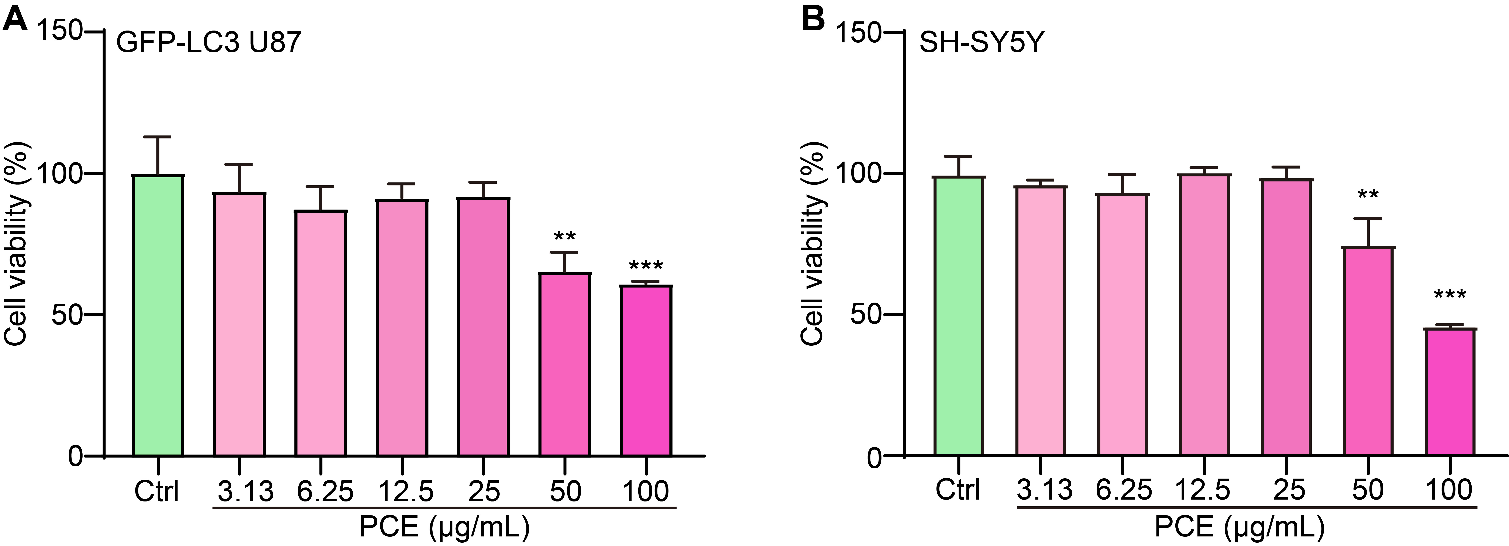
Figure S1. Dose-dependent effects of PCE on cell viability in SH-SY5Y and U87 cell lines. (A) Cell viability of SH-SY5Y cells treated with increasing concentrations of PCE (3.13–100 μg/mL). (B) Cell viability of GFP-LC3 U87 cells treated with increasing concentrations of PCE (3.13–100 μg/mL). Data are presented as mean ± SEM; **p < 0.01 and ***p < 0.001 compared to Ctrl.
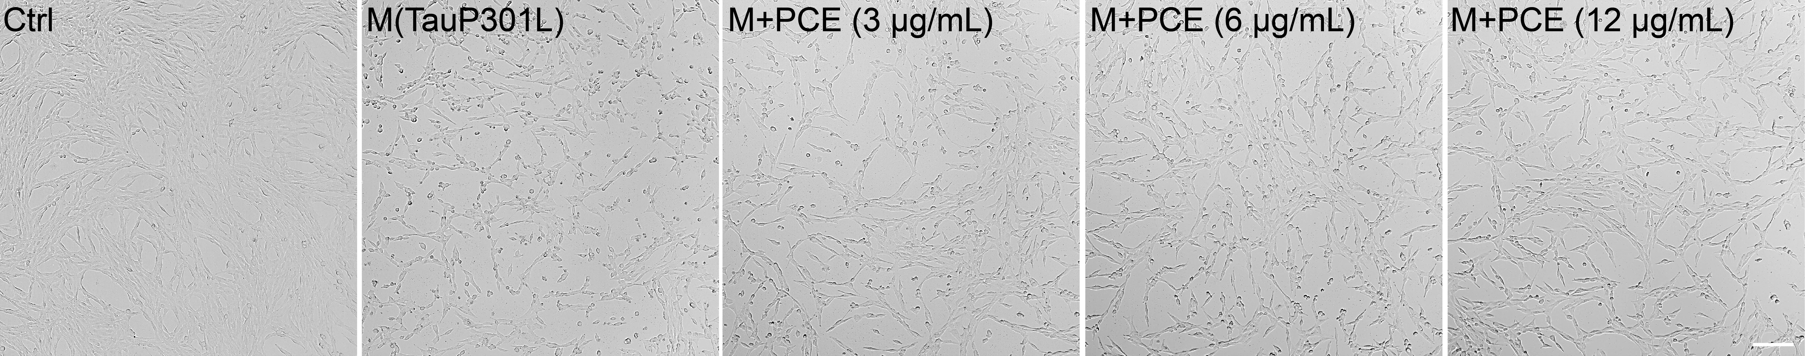
Figure S2. Morphological examination of SH-SY5Y cells expressing Tau P301L treated with PCE. Representative bright-field images of SH-SY5Y cells under Ctrl conditions, mock-transfected Tau P301L, and Tau P301L-expressing cells treated with increasing concentrations of PCE (3, 6, 12 µg/mL). Magnification: 10×, scale bar: 50 μm.
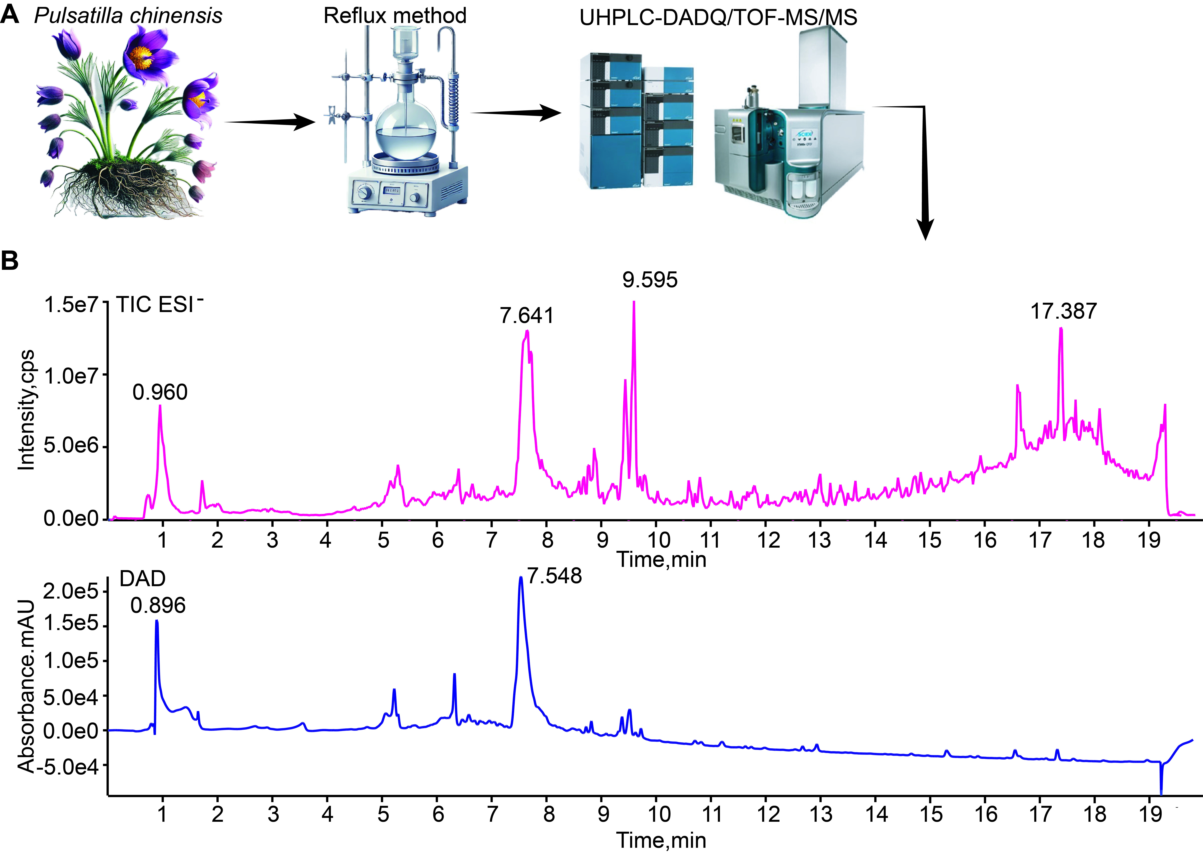
Figure S3. Characterization of PCE by UHPLC-DAD-Q/TOF-MS/MS. (A) Schematic representation of the extraction and analytical workflow. Pulsatilla chinensis plant material was processed using a reflux extraction method to obtain a crude extract. The resulting extract was subsequently analyzed by ultra-high-performance liquid chromatography coupled with diode array detection and quadrupole time-of-flight mass spectrometry/mass spectrometry (UHPLC-DAD-Q/TOF-MS/MS). (B) Representative total ion current (TIC) chromatogram recorded in negative ion mode (top) and a corresponding diode array detector (DAD) chromatogram (bottom) from the PCE.
Figure S4. The chemical names and molecular structures of identified compounds in PCE.

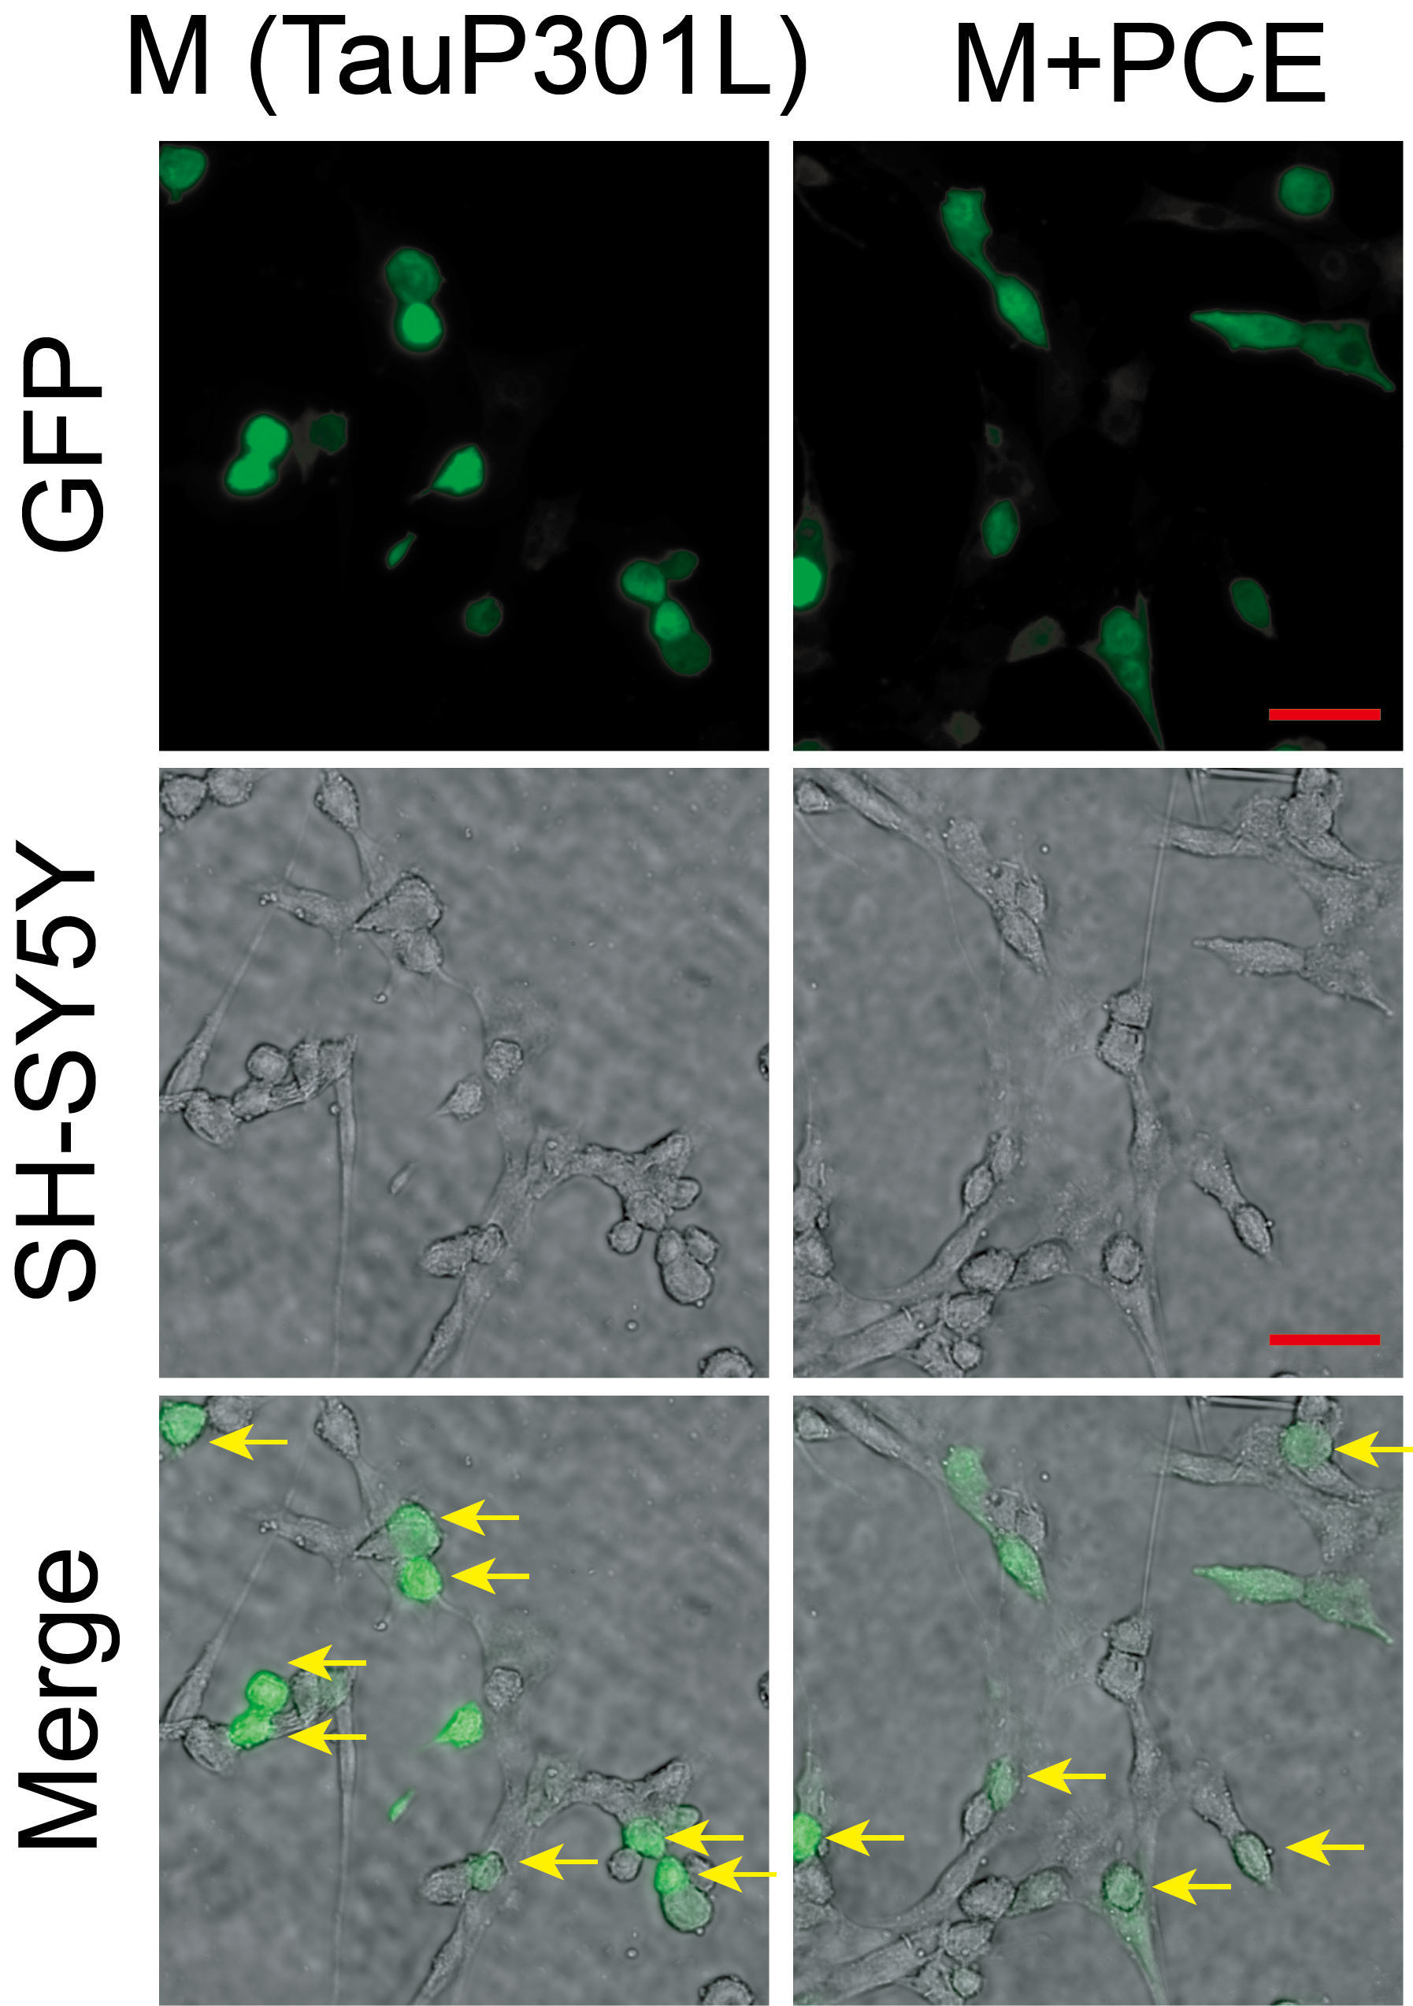
Figure S5. PCE inhibits Tau P301L-induced inclusion formation in SH-SY5Y cells. Representative fluorescence and bright-field merged images showing the effects of PCE on Tau inclusions in SH-SY5Y cells transfected with the Tau P301L plasmid. Yellow arrows indicate GFP-positive Tau inclusion, reflecting aberrant Tau aggregation within the cytoplasm. Magnification: 40×; scale bar = 50 μm.

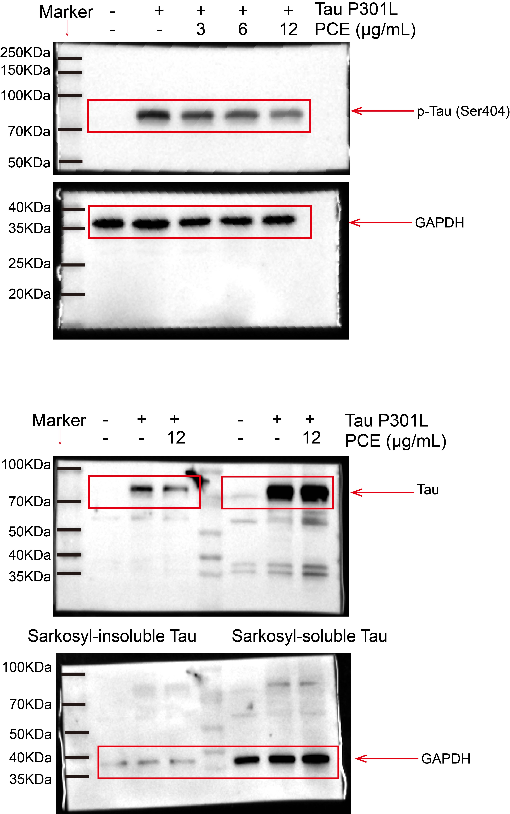
Figure S6. Full-length Western blotting images of Fig. 2A, B, I, and K
Figure S7. Full-length Western blotting images of Fig. 5A
Figure S8. Full-length Western blotting images of Fig. 7G
Figure S9. Full-length Western blotting images of Fig. 9G

Table S1. The retention time (RT), chemical name, chemical formula, molecular weight, and accurate mass of identified components in PCE.
No | RT (min) | Chemical name | Chemical formula | Molecular weight | [M-H]⁻
1 | 0.903 | Xanthotoxine | C₁₂H₈O₄ | 216.0422 | 215.035
2 | 0.954 | Anemonin | C₁₀H₈O₄ | 192.0422 | 191.035
3 | 5.266 | Caftaric acid | C₁₃H₁₂O₉ | 312.0481 | 311.0409
4 | 7.687 | Cichoric acid | C₂₂H₁₈O₁₂ | 474.0798 | 473.0725
5 | 8.96 | Anemoside B4 | C₅₉H₉₆O₂₆ | 1220.6189 | 1219.6117
6 | 9.45 | Beesioside Q | C₆₅H₁₀₆O₃₀ | 1366.6768 | 1365.6696
7 | 9.591 | Pulsatilloside E | C₆₅H₁₀₆O₃₁ | 1382.6718 | 1381.6645
8 | 9.719 | Cussosaponin C | C₅₉H₉₆O₂₅ | 1204.624 | 1203.6168
9 | 9.796 | Pulsatilloside D | C₅₉H₉₆O₂₇ | 1236.6139 | 1235.6066
10 | 10.825 | Pulchinenoside B | C₅₃H₈₆O₂₂ | 1074.541 | 1073.5538
11 | 11.028 | Pulsatilloside C | C₄₈H₇₈O₁₈ | 942.5188 | 941.5115
12 | 11.513 | Kalopanaxsaponin H | C₄₇H₇₆O₁₇ | 912.5082 | 911.501
13 | 11.713 | α-hederin | C₄₁H₆₆O₁₂ | 750.4554 | 749.4439
14 | 11.736 | Pulsatilloside A | C₃₅H₅₆O₈ | 603.3902 | 604.3975
15 | 12.069 | Anemoside A3 | C₄₁H₆₆O₁₂ | 750.4554 | 749.4482
16 | 12.758 | Betulinicacid3b-O-a-L-rhamnopyranosyl-(1→2)-[b-D-glucopyranosyl (1→4)]-a-L-arabinopyranoside | C₄₇H₇₆O₁₆ | 896.5133 | 895.5061
17 | 13.451 | Leontoside B | C₄₁H₆₆O₁₃ | 766.4503 | 765.4431
18 | 13.534 | Tauroside C | C₄₁H₆₆O₁₁ | 734.4605 | 733.4532
19 | 14.305 | 23-hydroxybetulinic acid | C₃₀H₄₈O₄ | 472.3552 | 471.348
20 | 14.424 | Pulsatillic acid | C₃₀H₄₆O₄ | 470.3396 | 469.3323
21 | 17.092 | Betulinic acid | C₃₀H₄₈O₃ | 456.3603 | 455.3517
22 | 17.14 | Ursolic acid | C₃₀H₄₈O₃ | 456.3603 | 455.3531

