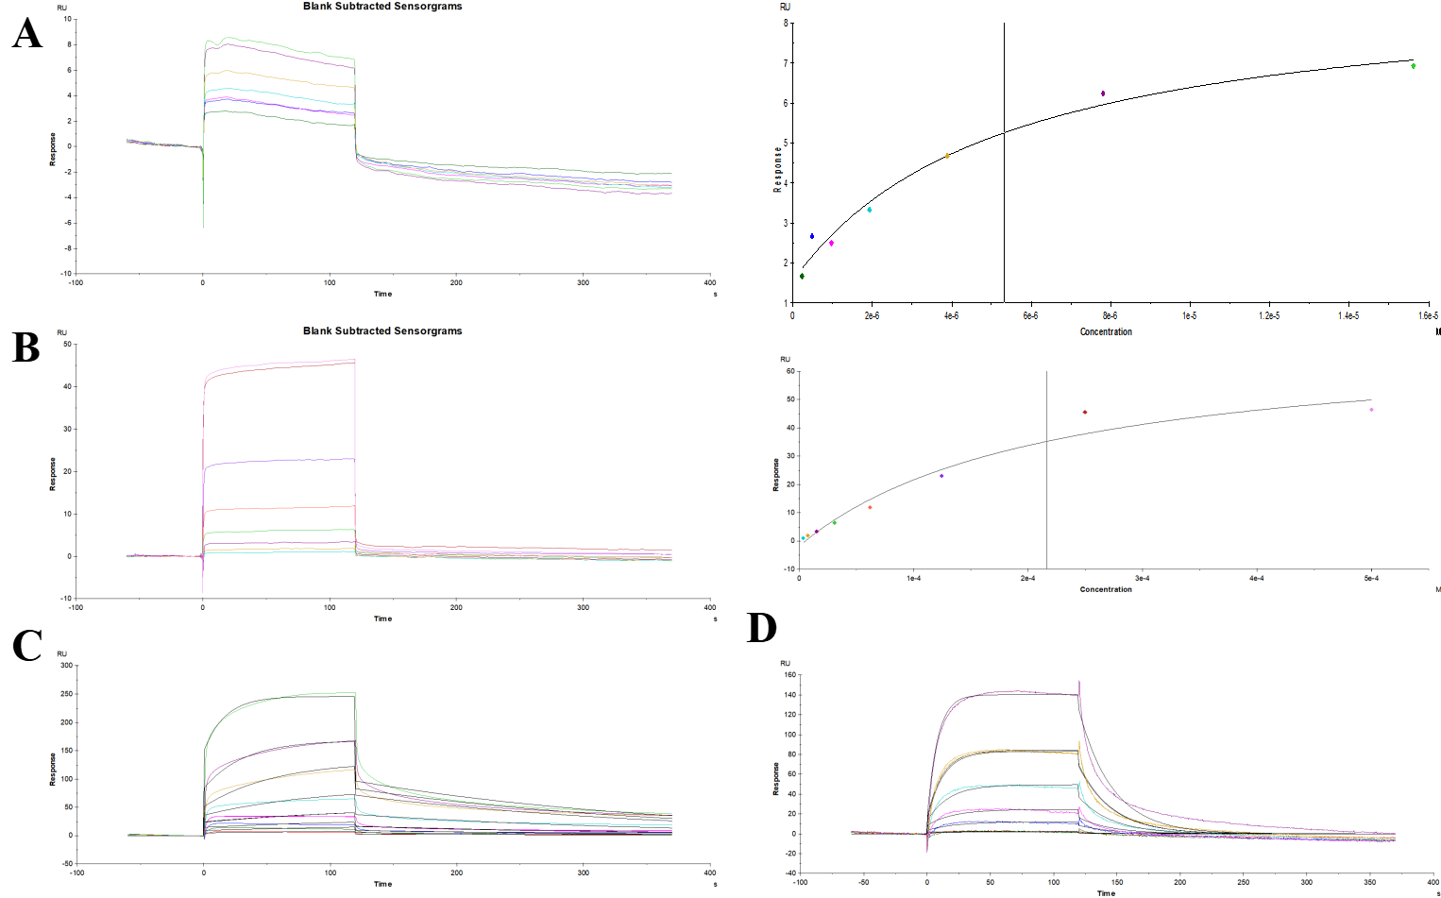
Fig. S2. (A) Sensorgram showing the interaction of AKT1 protein with Osthole, yielding Kd = 5.31 μM. (B) Sensorgram showing the interaction of IL17A protein with Resveratrol, yielding Kd = 217 μM. (C) Sensorgram showing the interaction of JAK2 protein with Quercetin, yielding Kd = 1.80 μM. (D) Sensorgram showing the interaction of PIK3CA protein with Kaempferol, yielding Kd = 3.43 μM.

