Homo- and hetero-dimeric sesquiterpenoids with unprecedented skeletons and their co-occurring monomers from Vernonia solanifolia with anti-liver steatotic potential
Yue Yang^{1†}, Fei Zhou^{2†}, Chang-Qiang Ke¹, Sheng Yao^{1,3}, Ligen Lin²*, Chunping Tang¹* and Yang Ye^{1,4}*
¹State Key Laboratory of Drug Research, and Natural Products Chemistry Department, Shanghai Institute of Materia Medica, Chinese Academy of Sciences, Shanghai 201203, China. ²State Key Laboratory of Mechanism and Quality of Chinese Medicine, Institute of Chinese Medical Sciences, University of Macau, Macau 999078, China. ³Zhongshan Institute for Drug Discovery, Shanghai Institute of Materia Medica, Chinese Academy of Sciences, Zhongshan 528400, China. ⁴China-Serbia “Belt and Road” Joint Laboratory for Natural Products and Drug Discovery, Shanghai Institute of Materia Medica, Chinese Academy of Sciences, Shanghai 201203, China.
†Yue Yang and Fei Zhou contributed equally to this work.
Correspondence:
Ligen Lin
ligenl@um.edu.mo
Chunping Tang
tangcp@simm.ac.cn
Yang Ye
yye@mail.shcnc.ac.cn
Table of contents
Fig. S1 ¹H–¹H COSY, and key HMBC correlations of compounds 2 and 4–5. 3
Fig. S2 Key NOESY correlations of compounds 4 and 5. 3
Fig. S3 Simplified structures of unit A of compounds 1–3 with their possible relative configurations. 3
Fig. S4 DP4+ probability statistical analysis result for the unit A of compound 1. 4
Fig. S5 DP4+ probability statistical analysis result for the unit A of compound 2. 4
Fig. S6 DP4+ probability statistical analysis result for the unit A of compound 3. 4
Fig. S7 The structures of B1–B4. 4
Fig. S8 DP4+ probability statistical analysis result for the B1–B4 of compound 1. 5
Fig.S9 DP4+ probability statistical analysis result for the B1–B4 of compound 2. 5
Fig. S10 DP4+ probability statistical analysis result for the B1–B4 of compound 4. 5
Fig. S11 The structures of C1–C4. 5
Fig. S12 DP4+ probability statistical analysis result for the C1–C4 of compound 3. 6
Fig. S13 Simplified structures of compounds 1 and 2 with their possible relative configurations. 6
Fig. S14 Simplified structures of compound 3 with their possible relative configurations. 6
Fig. S15 Simplified structures of compound 4 with their possible relative configurations. 7
Fig. S16 Experimental ECD spectra of compounds 5 and 8, and calculated ECD spectrum of 8. 7
Fig. S17 key 2D NMR correlations of compound 6. 7
Fig. S18 key 2D NMR correlations of compounds 7–9. 8
Fig. S19 Simplified structures of compounds 7 and 8 with their possible relative configurations. 8
Fig. S20 DP4+ probability statistical analysis result for compound 7. 9
Fig. S21 Experimental and calculated ECD spectra of compound 7. 9
Fig. S22 Simplified structures of compound 9 with their possible relative configurations. 9
Fig. S23 DP4+ probability statistical analysis result for compound 9. 10
Fig. S24 Experimental and calculated ECD spectra of compound 9. 10
Fig. S25 Cytotoxic effect of compounds 1‒9 on AML-12 hepatocytes. AML-12 cells were treated with different compounds at indicated concentrations for 24 h. Data are shown as mean ± S.D., n = 3. **P < 0.01 vs. DMSO. 11
Fig. S26–S31 The original Western blots. 12
Fig. S32−S40 MS, UV, IR, 1D and 2D NMR spectra of diversolanolide A (1). 15
Fig. S41−S49 MS, UV, IR, 1D and 2D NMR spectra of diversolanolide B (2). 19
Fig. S50−S58 MS, UV, IR, 1D and 2D NMR spectra of diversolanolide C (3). 24
Fig. S59−S67 MS, UV, IR, 1D and 2D NMR spectra of diversolanolide D (4). 28
Fig. S68−S76 MS, UV, IR, 1D and 2D NMR spectra of diversolanolide E (5). 33
Fig. S77−S85 MS, UV, IR, 1D and 2D NMR spectra of versolanolide A (6). 37
Fig. S86−S94 MS, UV, IR, 1D and 2D NMR spectra of versolanolide B (7). 42
Fig. S95−S103 MS, UV, IR, 1D and 2D NMR spectra of versolanolide C (8). 46
Fig. S104−S112 MS, UV, IR, 1D and 2D NMR spectra of versolanolide D (9). 51

Fig. S1 ¹H–¹H COSY, and key HMBC correlations of compounds 2 and 4–5.

Fig. S2 Key NOESY correlations of compounds 4 and 5.

Fig. S3 Simplified structures of unit A of compounds 1–3 with their possible relative configurations.

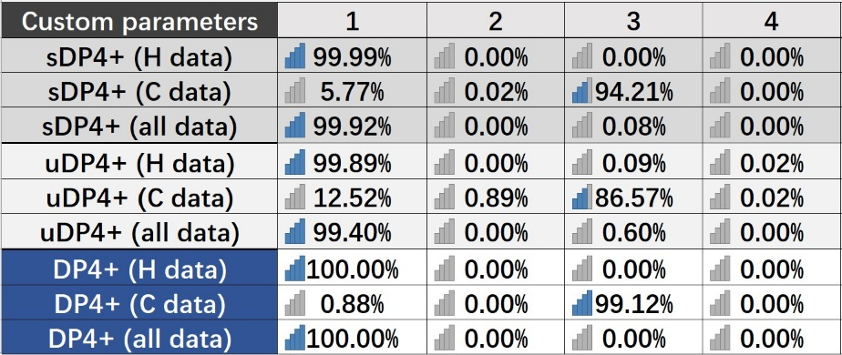
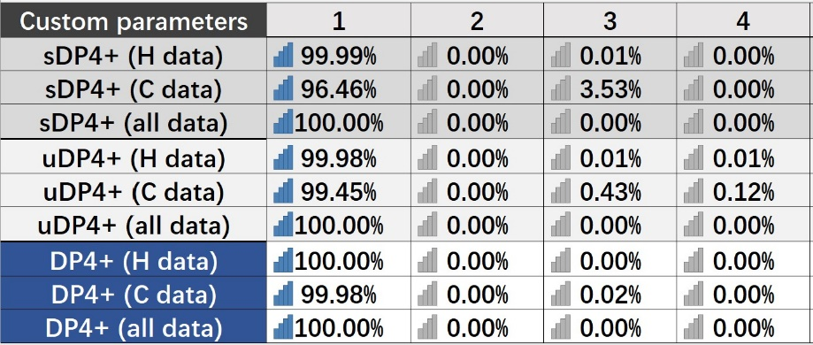
Fig. S4 DP4+ probability statistical analysis result for the unit A of compound 1.

Fig. S5 DP4+ probability statistical analysis result for the unit A of compound 2.

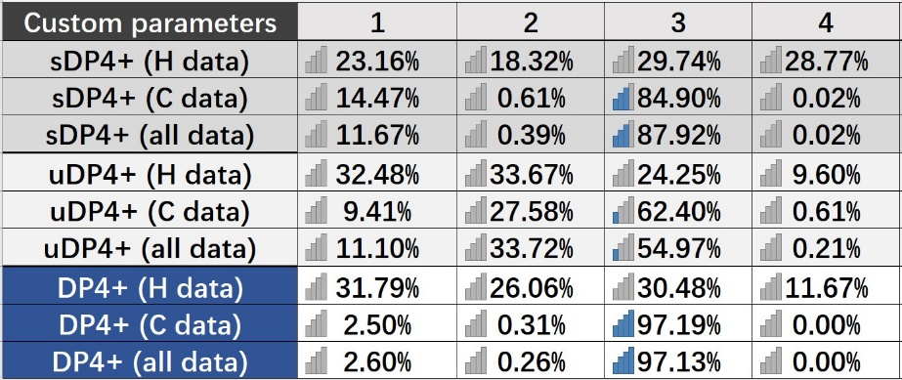
Fig. S6 DP4+ probability statistical analysis result for the unit A of compound 3.

Fig. S7 The structures of B1–B4.

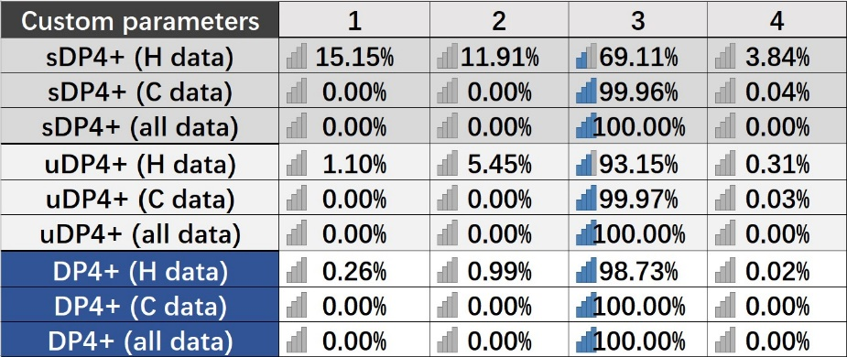
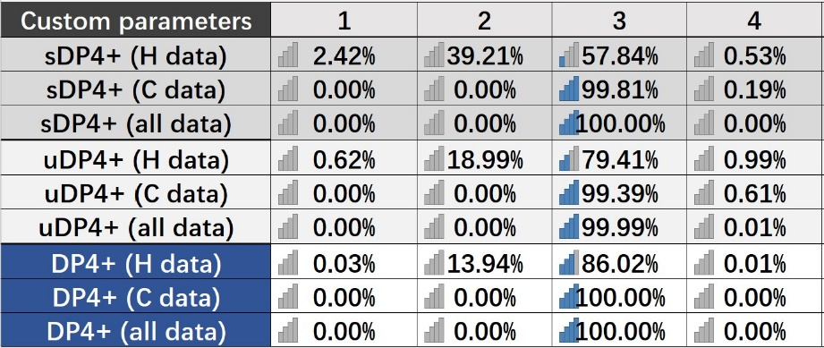
Fig. S8 DP4+ probability statistical analysis result for the B1–B4 of compound 1.

Fig. S9 DP4+ probability statistical analysis result for the B1–B4 of compound 2.

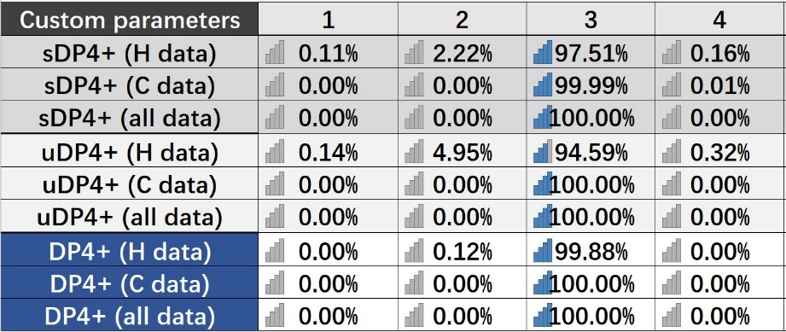
Fig. S10 DP4+ probability statistical analysis result for the B1–B4 of compound 4.

Fig. S11 The structures of C1–C4.

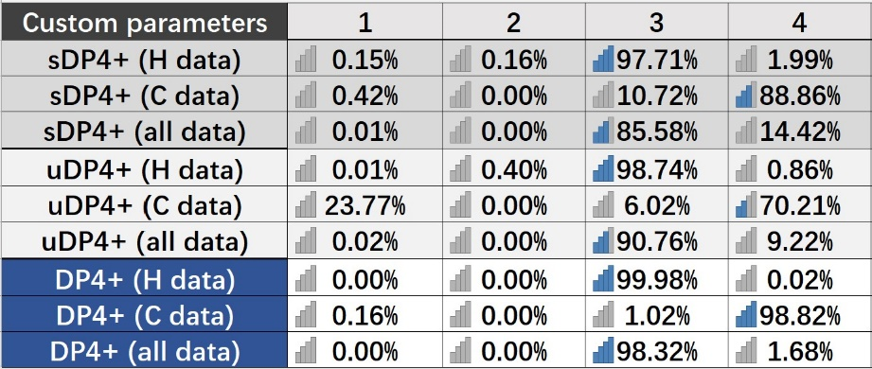
Fig. S12 DP4+ probability statistical analysis result for the C1–C4 of compound 3.

Fig. S13 Simplified structures of compounds 1 and 2 with their possible relative configurations.

Fig. S14 Simplified structures of compound 3 with their possible relative configurations.

Fig. S15 Simplified structures of compound 4 with their possible relative configurations.

Fig. S16 Experimental ECD spectra of compounds 5 and 8, and calculated ECD spectrum of 8.

Fig. S17 key 2D NMR correlations of compound 6.

Fig. S18 key 2D NMR correlations of compounds 7–9.

Fig. S19 Simplified structures of compounds 7 and 8 with their possible relative configurations.
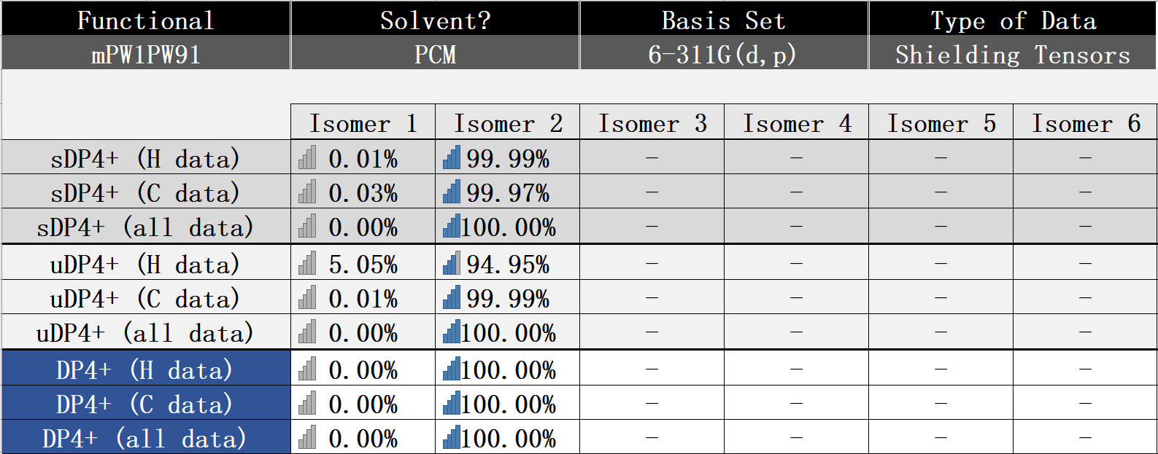

Fig. S20 DP4+ probability statistical analysis result for compound 7.

Fig. S21 Experimental and calculated ECD spectra of compound 7.

Fig. S22 Simplified structures of compound 9 with their possible relative configurations.

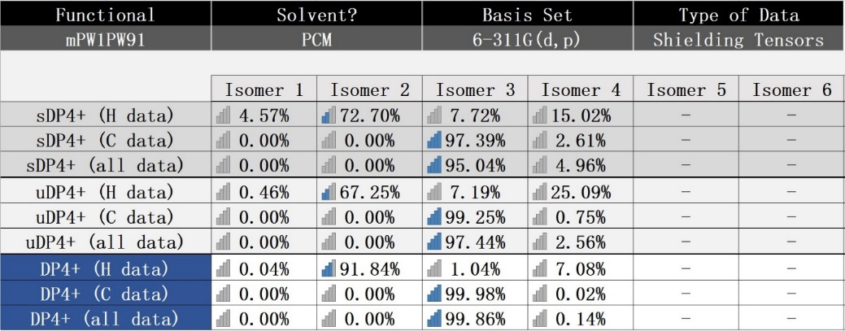

Fig. S23 DP4+ probability statistical analysis result for compound 9.

Fig. S24 Experimental and calculated ECD spectra of compound 9.

Fig. S25 Cytotoxic effect of compounds 1‒9 on AML-12 hepatocytes. AML-12 cells were treated with different compounds at indicated concentrations for 24 h. Data are shown as mean ± S.D., n = 3. **P < 0.01 vs. DMSO.

The original Western blots.

Fig. S26 The original Western blot of p-AMPK.
Fig. S27 The original Western blot of AMPK

Fig. S28 The original Western blot of p-ACC.
Fig. S29 The original Western blot of ACC

Fig. S30 The original Western blot of PGC-1α.
Fig. S31 The original Western blot of GAPDH.

Fig. S32−S40 MS, UV, IR, 1D and 2D NMR spectra of diversolanolide A (1).
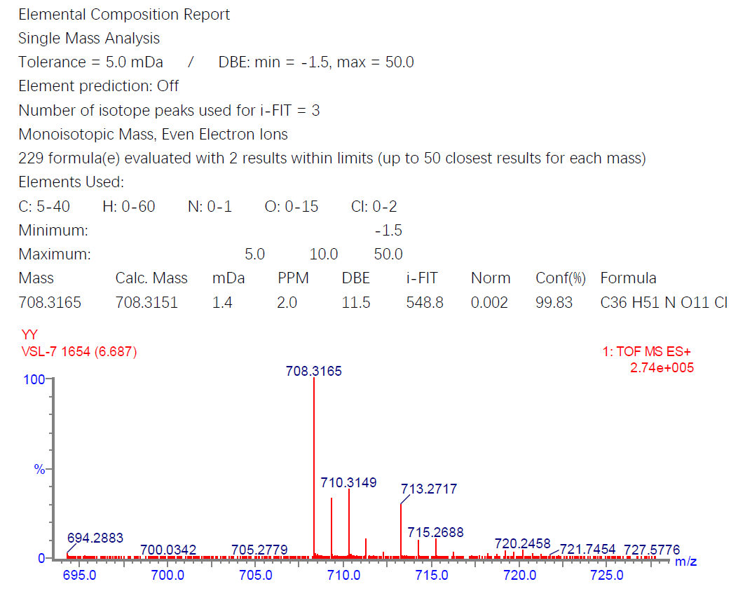

Fig. S32 HRESIMS spectrum of diversolanolide A (1).

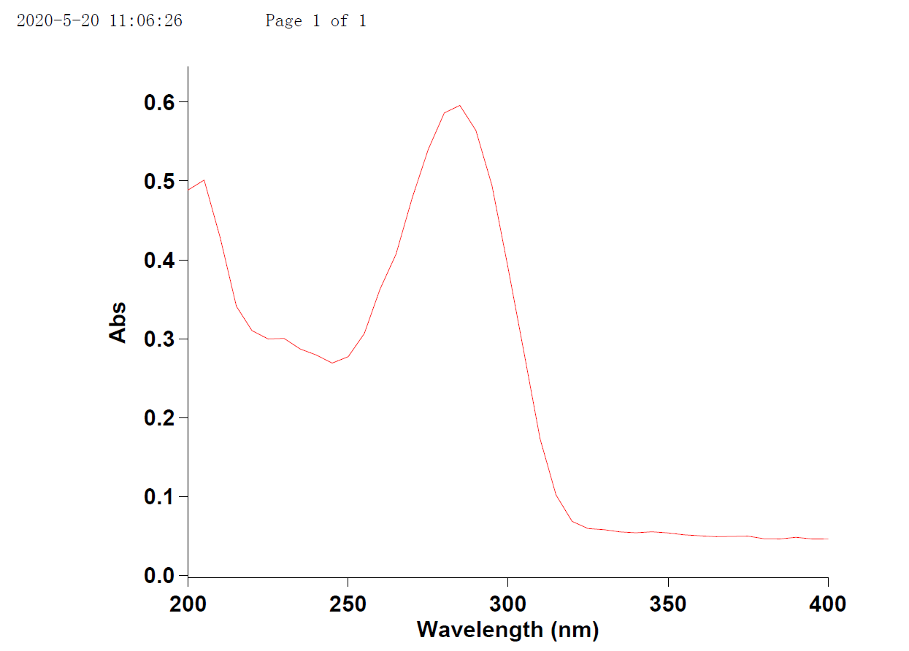

Fig. S33 UV spectrum of diversolanolide A (1).
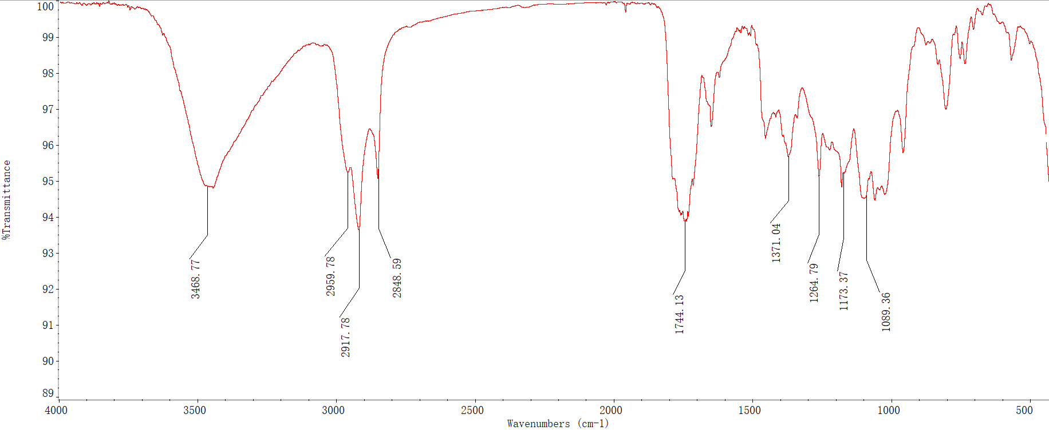
Fig. S34 IR spectrum of diversolanolide A (1).

Fig. 35 ¹H NMR (600 MHz) spectrum of diversolanolide A (1) in CDCl₃.

Fig. S36 ¹³C and DEPT-135 NMR (125 MHz) spectra of diversolanolide A (1) in CDCl₃.

Fig. S37 ¹H-¹H COSY spectrum of diversolanolide A (1) in CDCl₃.

Fig. S38 HSQC spectrum of diversolanolide A (1) in CDCl₃.

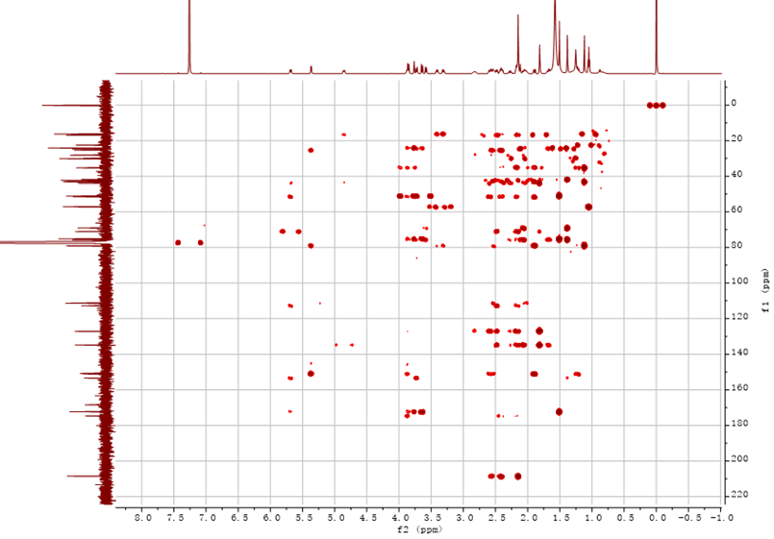

Fig. S39 HMBC spectrum of diversolanolide A (1) in CDCl₃.
Fig. S40 ROESY spectrum of diversolanolide A (1) in CDCl₃.

Figure S41.−Figure S49. MS, UV, IR, 1D and 2D NMR spectra of diversolanolide B (2).
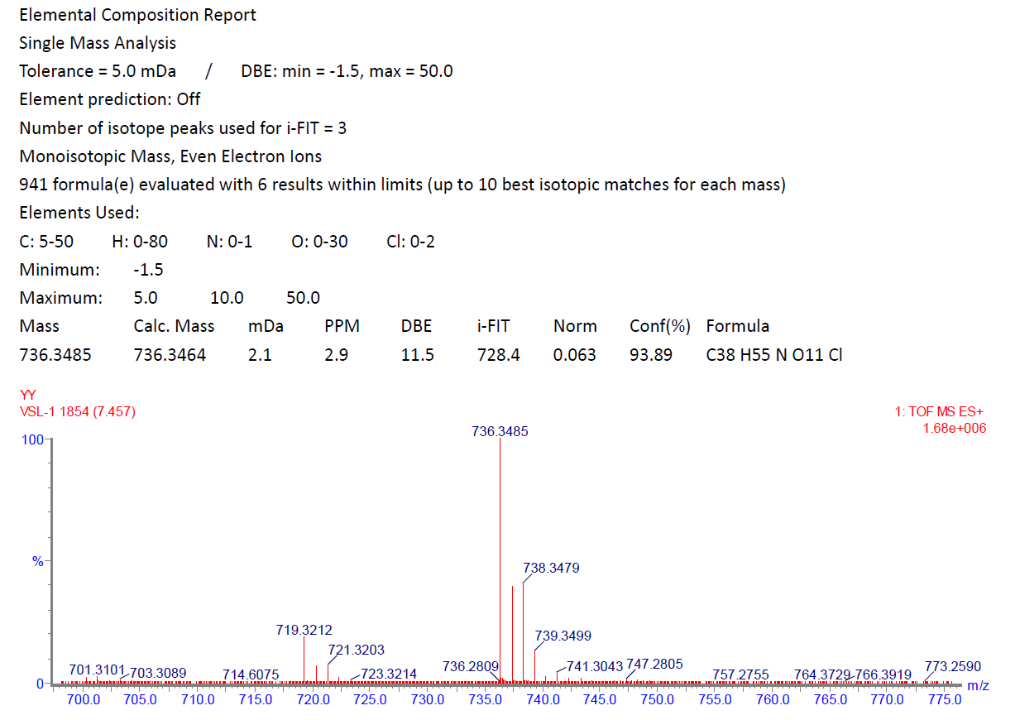
Fig. S41 HRESIMS spectrum of diversolanolide B (2).
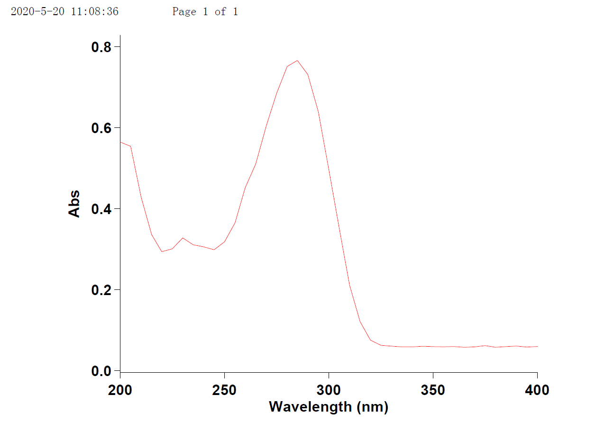
Fig. S42 UV spectrum of diversolanolide B (2).

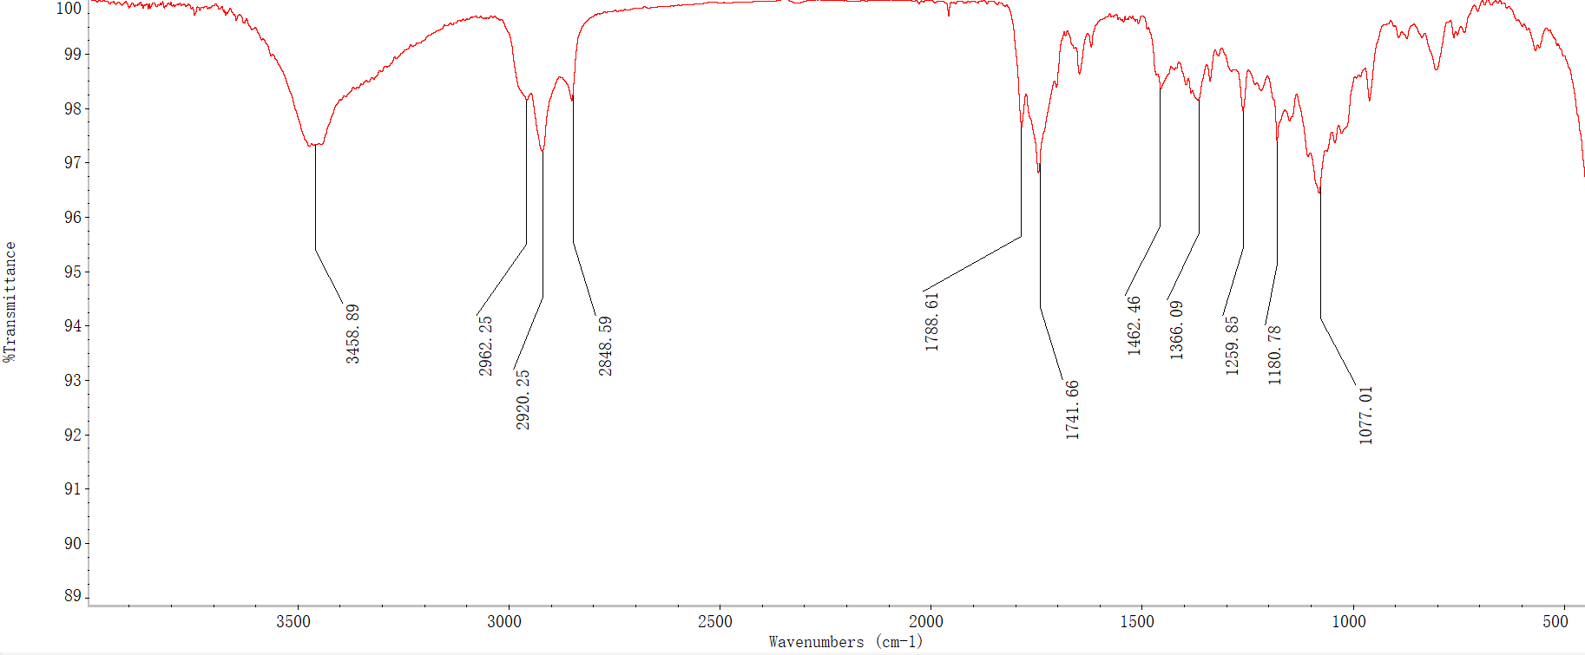

Fig. S43 IR spectrum of diversolanolide B (2).

Fig. S44 ¹H NMR (600 MHz) spectrum of diversolanolide B (2) in CDCl₃.

Fig. S45 ¹³C and DEPT-135 NMR (125 MHz) spectra of diversolanolide B (2) in CDCl₃.
Fig. S46 ¹H-¹H COSY spectrum of diversolanolide B (2) in CDCl₃.

Fig. S47 HSQC spectrum of diversolanolide B (2) in CDCl₃.
Fig. S48 HMBC spectrum of diversolanolide B (2) in CDCl₃.

Fig. S49 NOESY spectrum of diversolanolide B (2) in CDCl₃.

Fig. S50−58 MS, UV, IR, 1D and 2D NMR spectra of diversolanolide C (3).
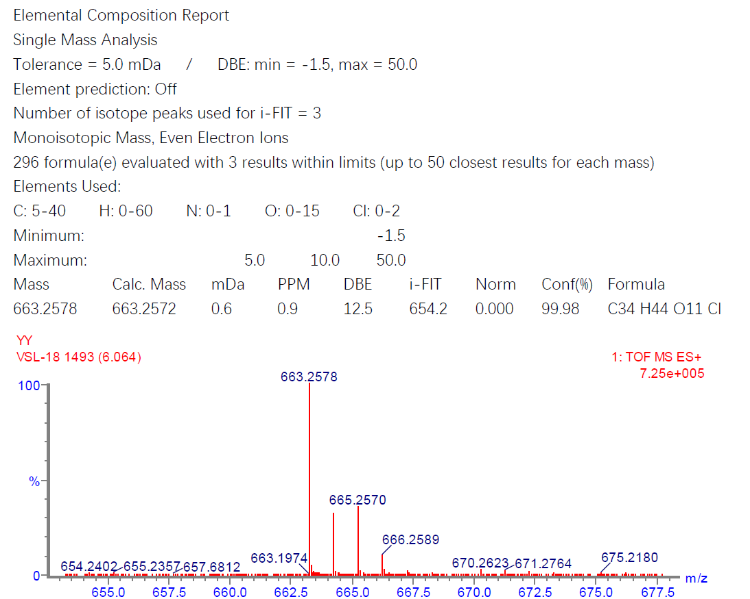
Fig. S50 HRESIMS spectrum of diversolanolide C (3).

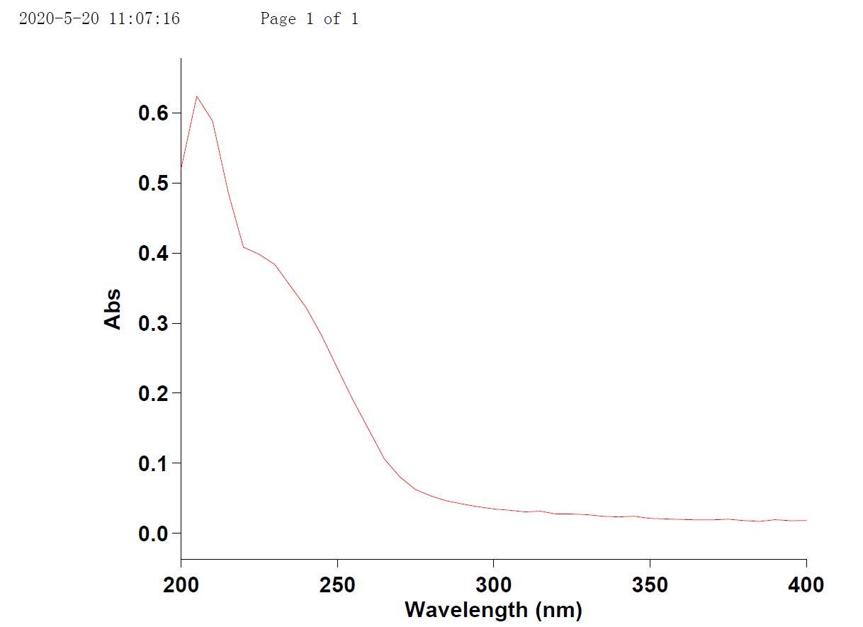
Fig. S51 UV spectrum of diversolanolide C (3).
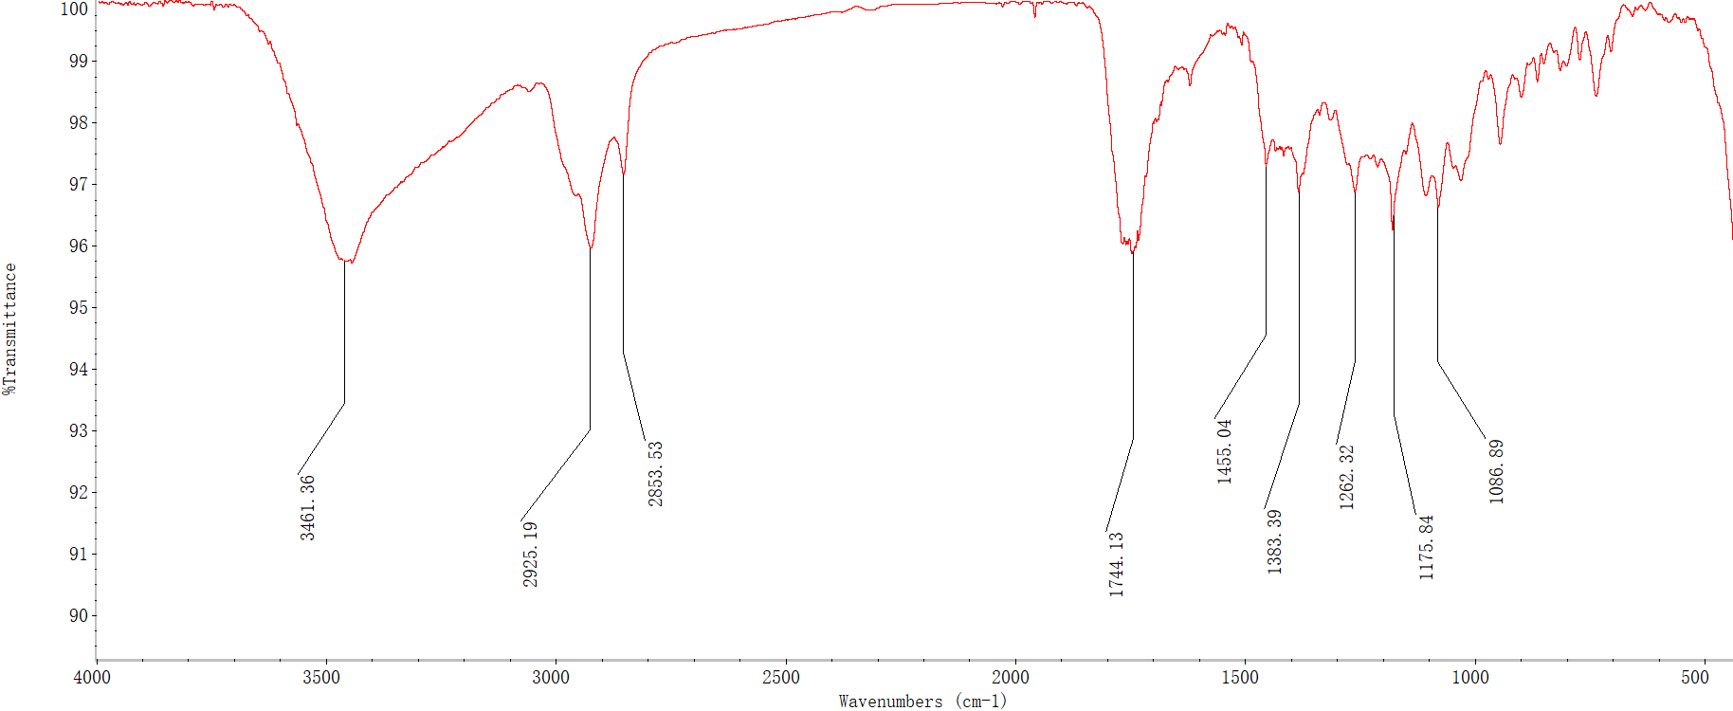
Fig. S52 IR spectrum of diversolanolide C (3).

Fig. S53 ¹H NMR (600 MHz) spectrum of diversolanolide C (3) in CDCl₃.
Fig. S54 ¹³C and DEPT-135 NMR (125 MHz) spectra of diversolanolide C (3) in CDCl₃.

Fig. S55 ¹H-¹H COSY spectrum of diversolanolide C (3) in CDCl₃.
Fig. S56 HSQC spectrum of diversolanolide C (3) in CDCl₃.

Fig. S57 HMBC spectrum of diversolanolide C (3) in CDCl₃.
Fig. S58 NOESY spectrum of diversolanolide C (3) in CDCl₃.

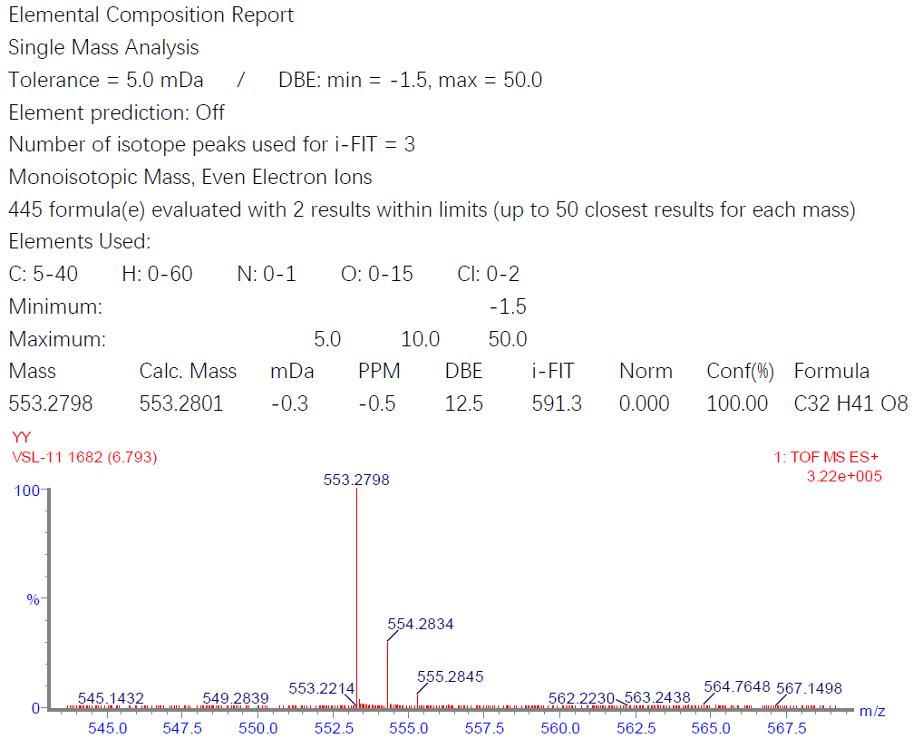
Fig. S59 HRESIMS spectrum of diversolanolide D (4).
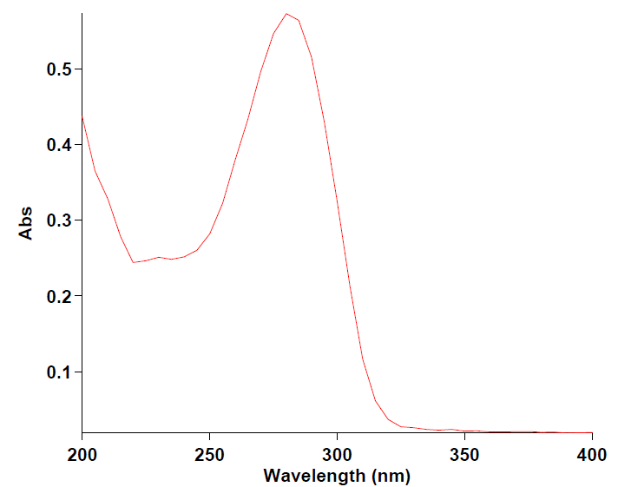
Fig. S60 UV spectrum of diversolanolide D (4).

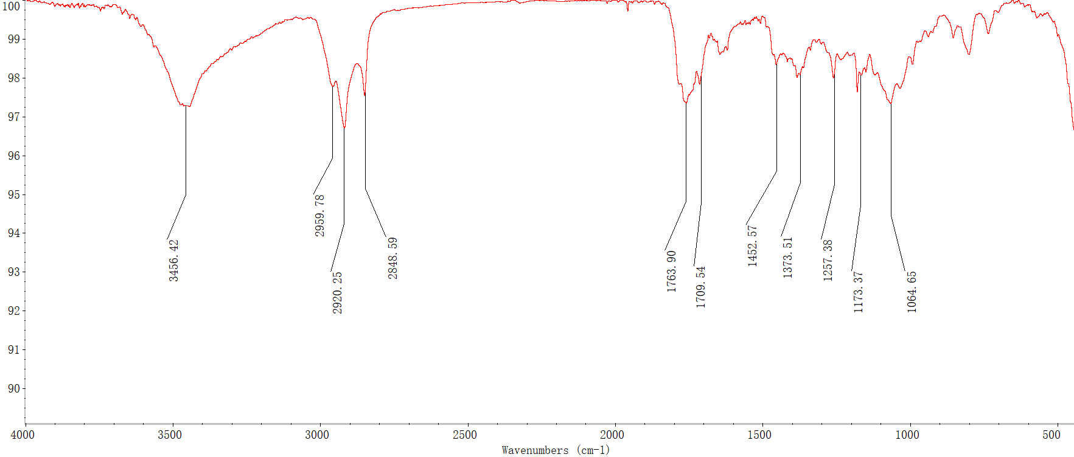
Fig. S61 IR Spectrum of diversolanolide D (4).
Fig. S62 ¹H NMR (600 MHz) spectrum of diversolanolide D (4) in CDCl₃.

Fig. S63 ¹³C and DEPT-135 NMR (125 MHz) spectra of diversolanolide D (4) in CDCl₃.

Fig. S64 ¹H-¹H COSY spectrum of diversolanolide D (4) in CDCl₃.

Fig. S65 HSQC spectrum of diversolanolide D (4) in CDCl₃.

Fig. S66 HMBC spectrum of diversolanolide D (4) in CDCl₃.

Fig. S67 NOESY spectrum of diversolanolide D (4) in CDCl₃.
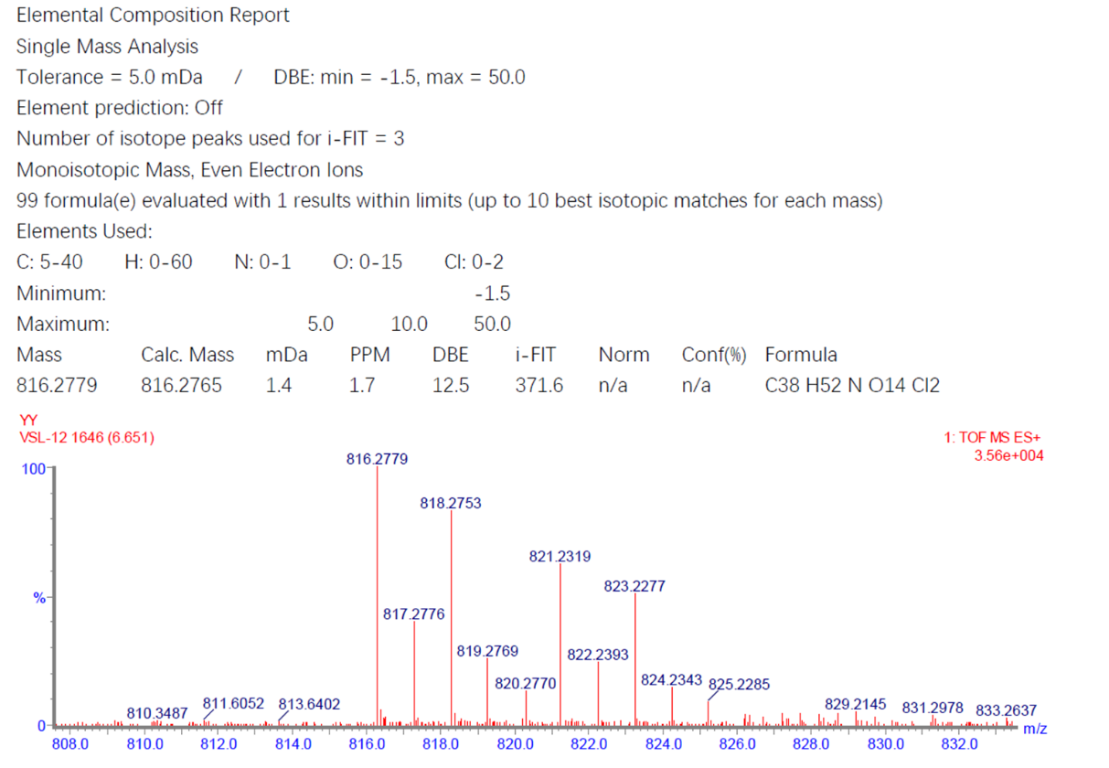
Fig. S68 HRESIMS spectrum of diversolanolide E (5).

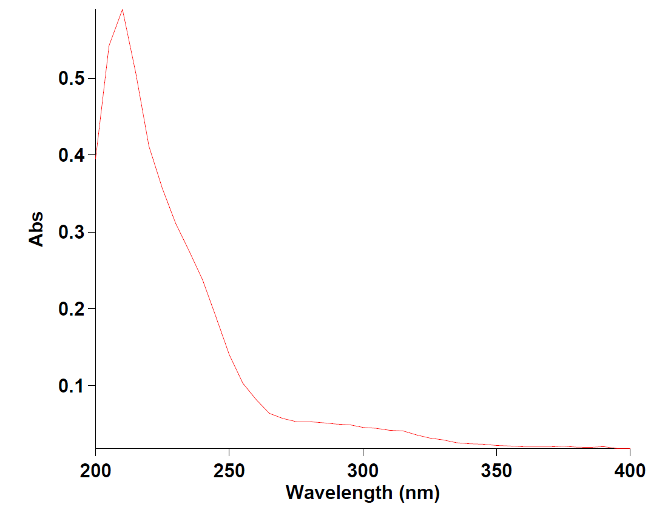
Fig. S69 UV spectrum of diversolanolide E (5).
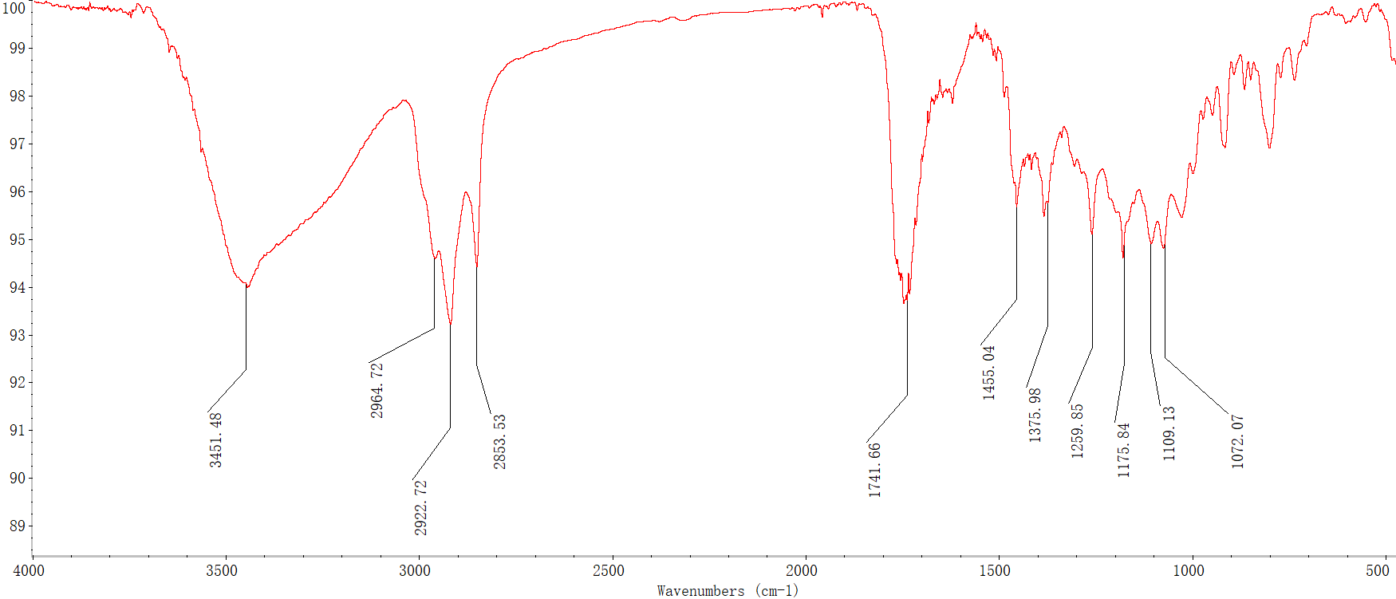
Fig. S70 IR spectrum of diversolanolide E (5).

Fig. S71 ¹H NMR (600 MHz) spectrum of diversolanolide E (5) in CDCl₃.
Fig. S72 ¹³C and DEPT-135 NMR (125 MHz) spectra of diversolanolide E (5) in CDCl₃.

Fig. S73 ¹H-¹H COSY spectrum of diversolanolide E (5) in CDCl₃.
Fig. S74 HSQC spectrum of diversolanolide E (5) in CDCl₃.

Fig. S75 HMBC spectrum of diversolanolide E (5) in CDCl₃.
Fig. S76 NOESY spectrum of diversolanolide E (5) in CDCl₃.

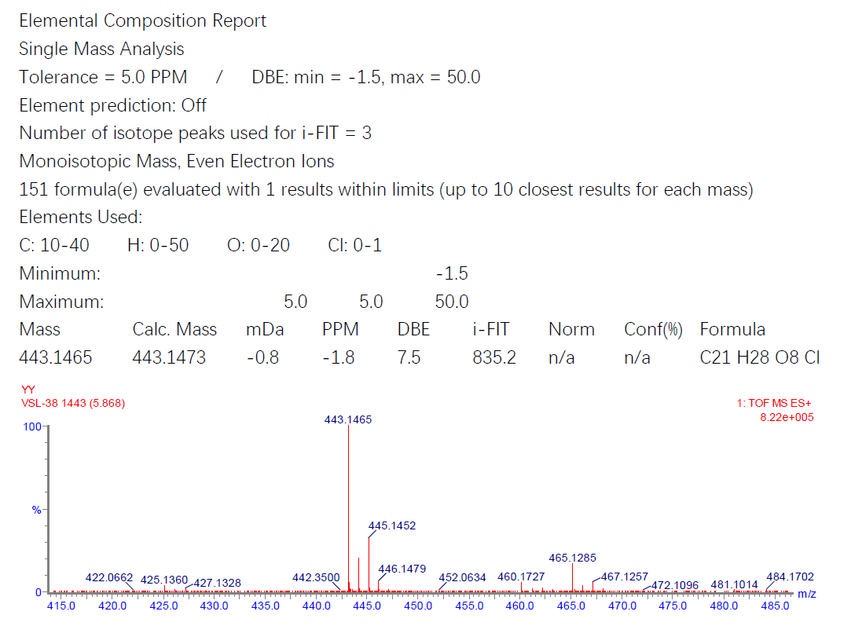
Fig. S77 HRESIMS spectrum of versolanolide A (6).
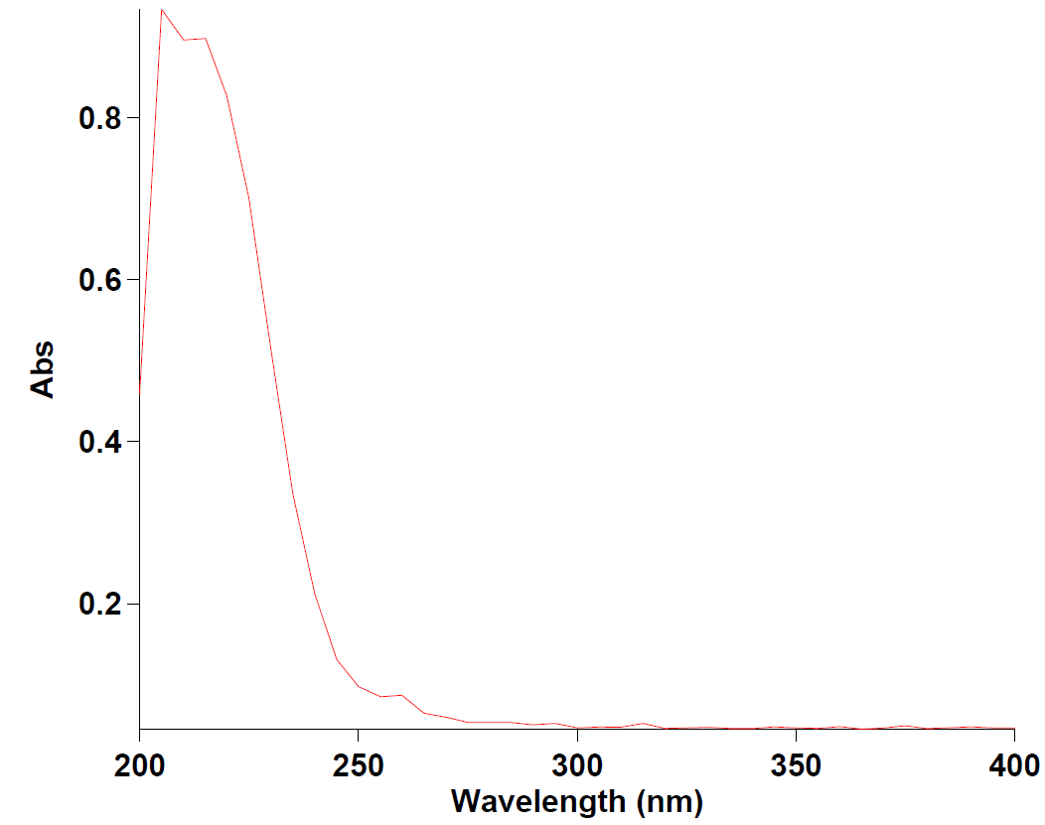
Fig. S78 UV spectrum of versolanolide A (6).

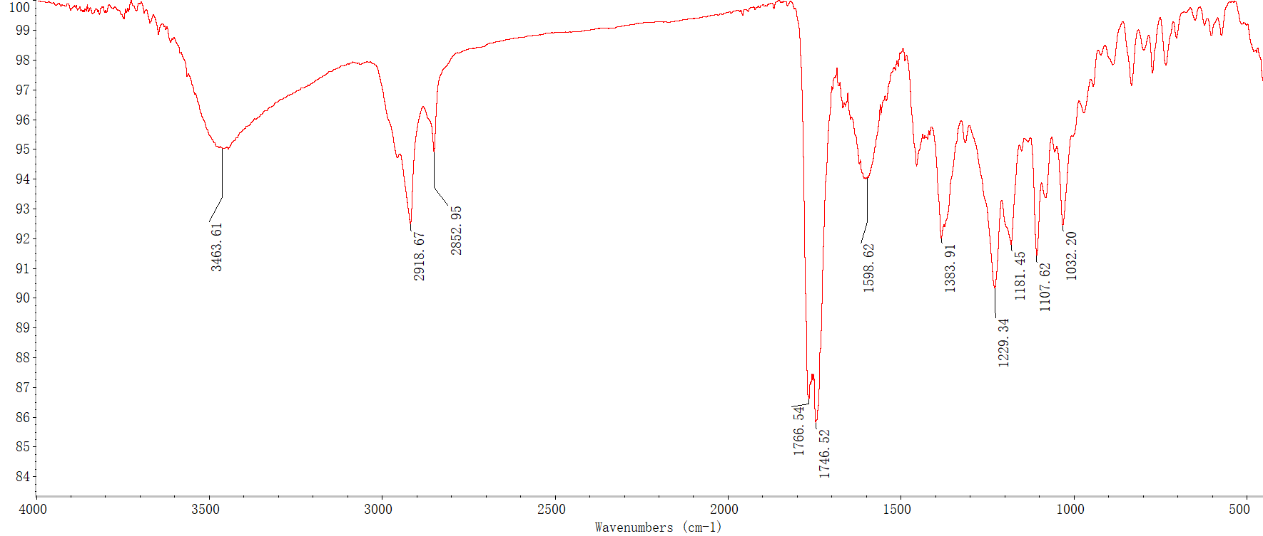
Fig. S79 IR spectrum of versolanolide A (6).

Fig. S80 ¹H NMR (600 MHz) spectrum of versolanolide A (6) in DMSO-d₆.

Fig. S81 ¹³C and DEPT-135 NMR (150 MHz) spectra of versolanolide A (6) in DMSO-d₆.
Fig. S82 ¹H-¹H COSY spectrum of versolanolide A (6) in DMSO-d₆.
Fig. S83 HSQC spectrum of versolanolide A (6) in DMSO-d₆.
Fig. S84 HMBC spectrum of versolanolide A (6) in DMSO-d₆.
Fig. S85 NOESY spectrum of versolanolide A (6) in DMSO-d₆.
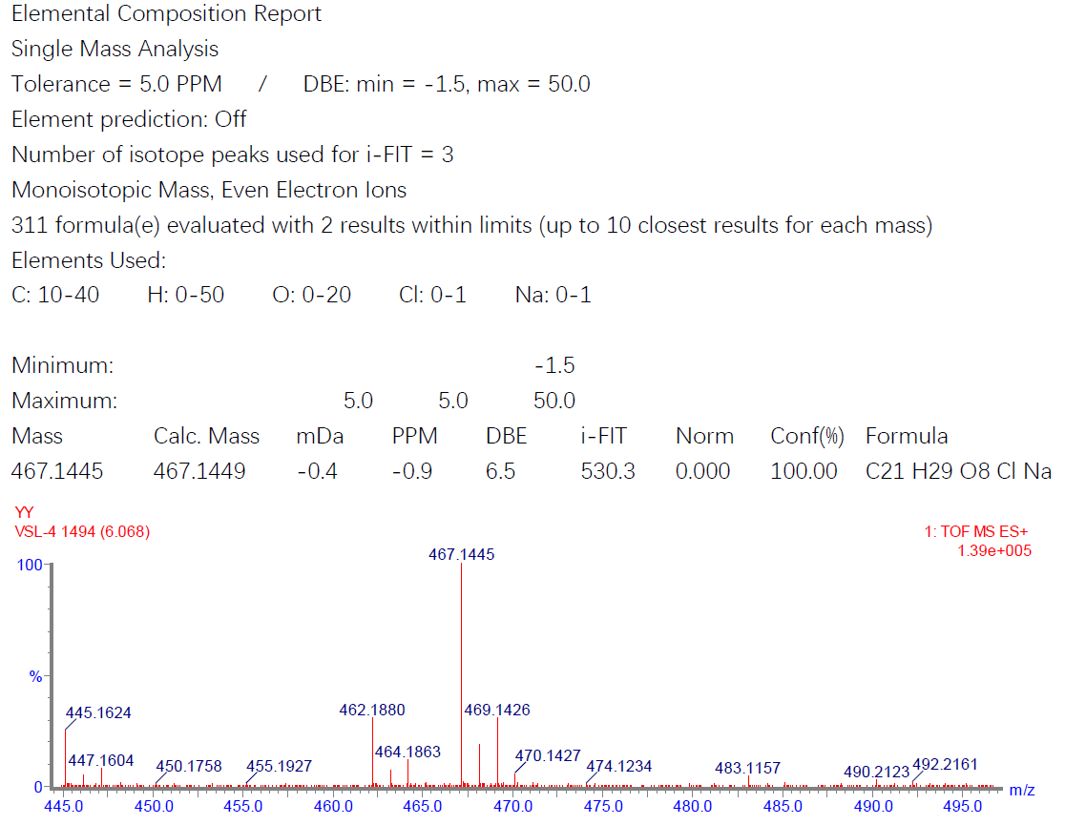
Fig. S86 HRESIMS spectrum of versolanolide B (7).

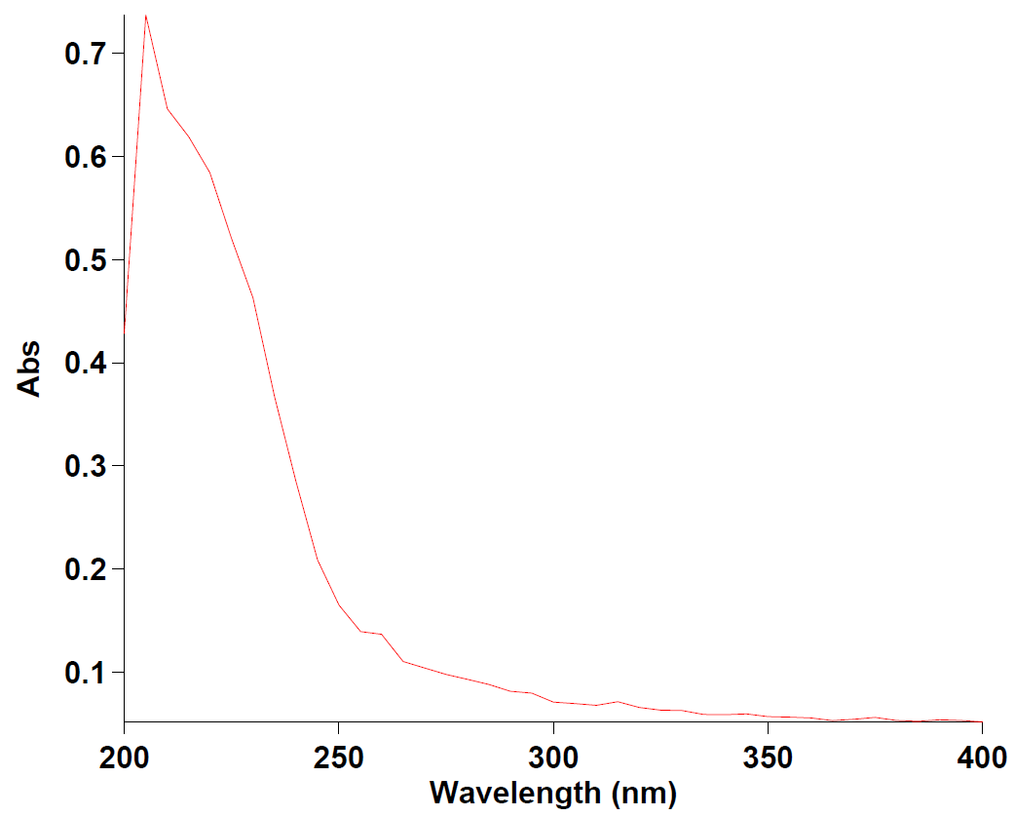
Fig. S87 UV spectrum of versolanolide B (7).

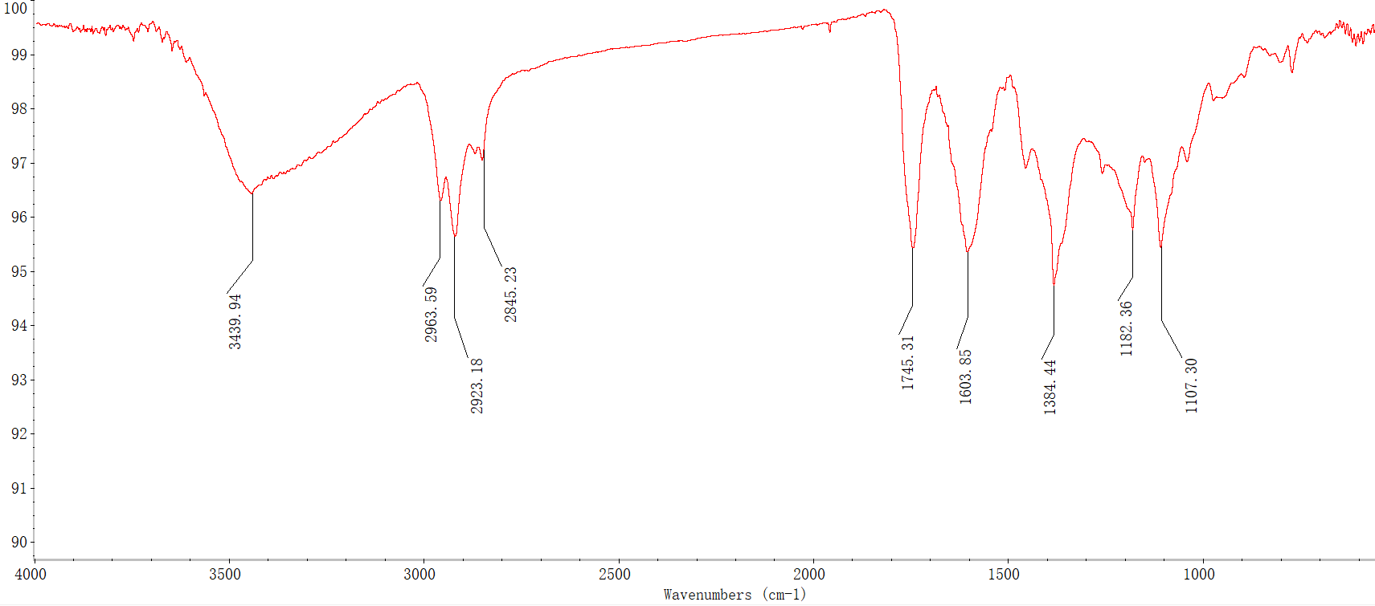
Fig. S88 IR spectrum of versolanolide B (7).

Fig. S89 ¹H NMR (600 MHz) spectrum of versolanolide B (7) in CDCl₃.

Fig. S90 ¹³C and DEPT-135 NMR (125 MHz) spectra of versolanolide B (7) in CDCl₃.

Fig. S91 ¹H-¹H COSY spectrum of versolanolide B (7) in CDCl₃.
Fig. S92 HSQC spectrum of versolanolide B (7) in CDCl₃.

Fig. S93 HMBC spectrum of versolanolide B (7) in CDCl₃.
Fig. S94 NOESY spectrum of versolanolide B (7) in CDCl₃.

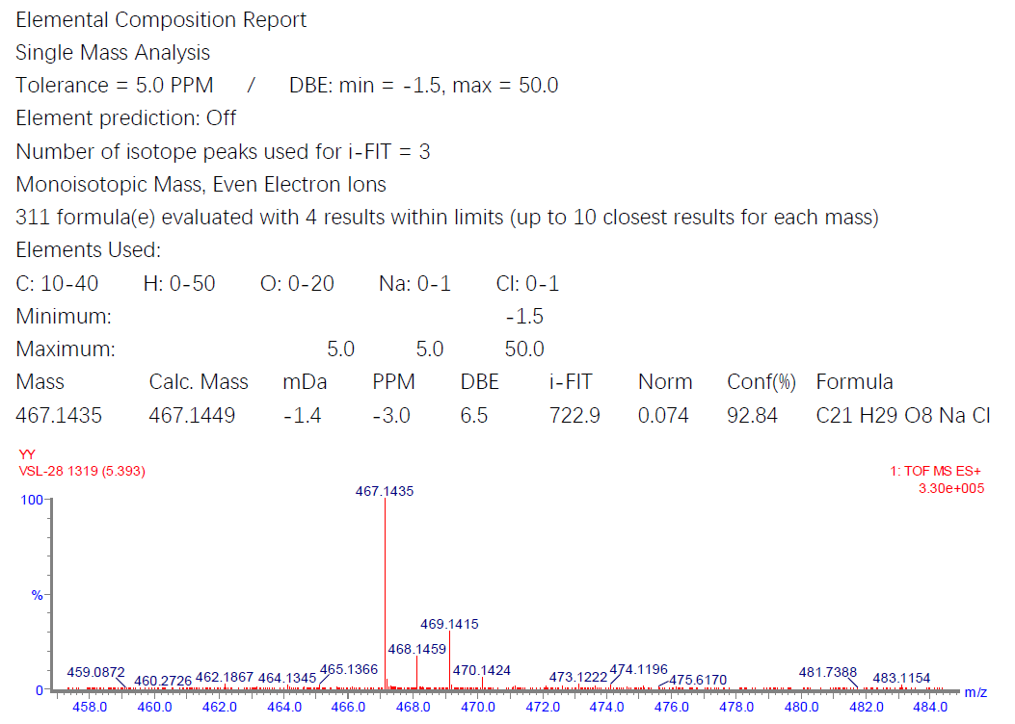
Fig. S95 HRESIMS spectrum of versolanolide C (8).

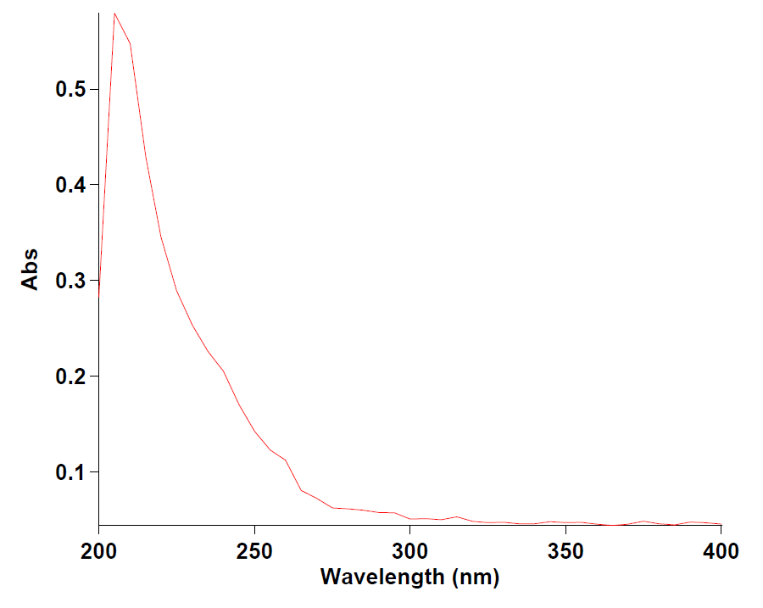
Fig. S96 UV spectrum of versolanolide C (8).

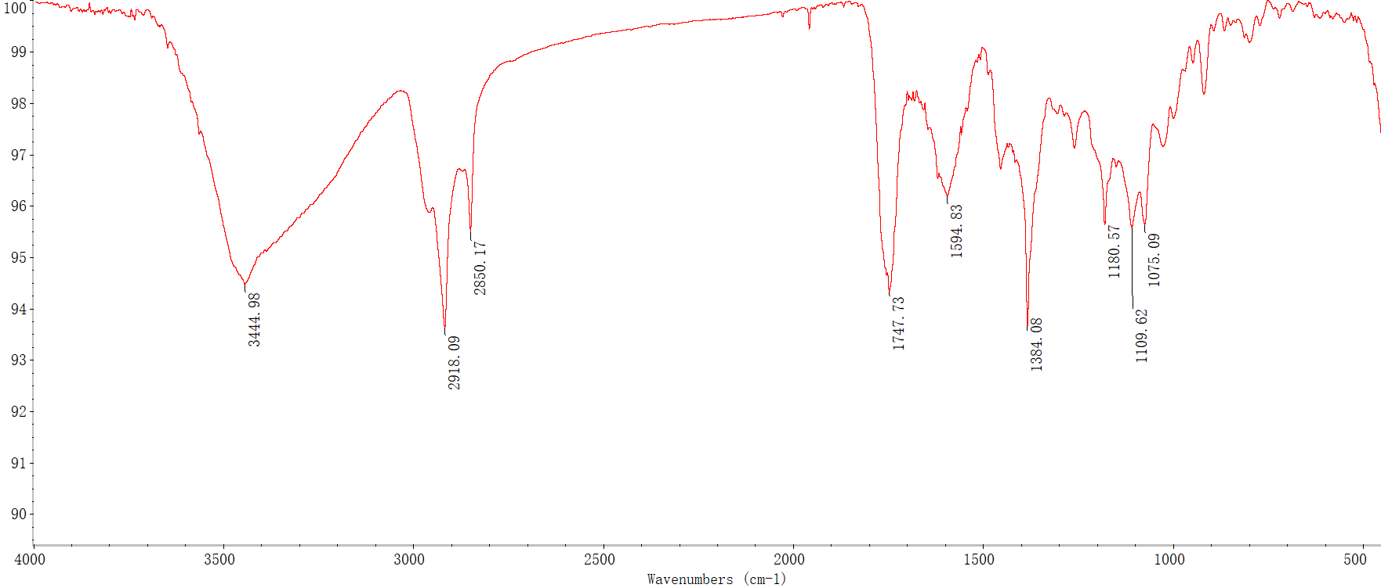
Fig. S97 IR spectrum of versolanolide C (8).

Fig. S98 ¹H NMR (600 MHz) spectrum of versolanolide C (8) in CDCl₃.

Fig. S99 ¹³C and DEPT-135 NMR (125 MHz) spectra of versolanolide C (8) in CDCl₃.
Fig. S100 ¹H-¹H COSY spectrum of versolanolide C (8) in CDCl₃.

Fig. S101 HSQC spectrum of versolanolide C (8) in CDCl₃.

Fig. S102 HMBC spectrum of versolanolide C (8) in CDCl₃.

Fig. S103 NOESY spectrum of versolanolide C (8) in CDCl₃.
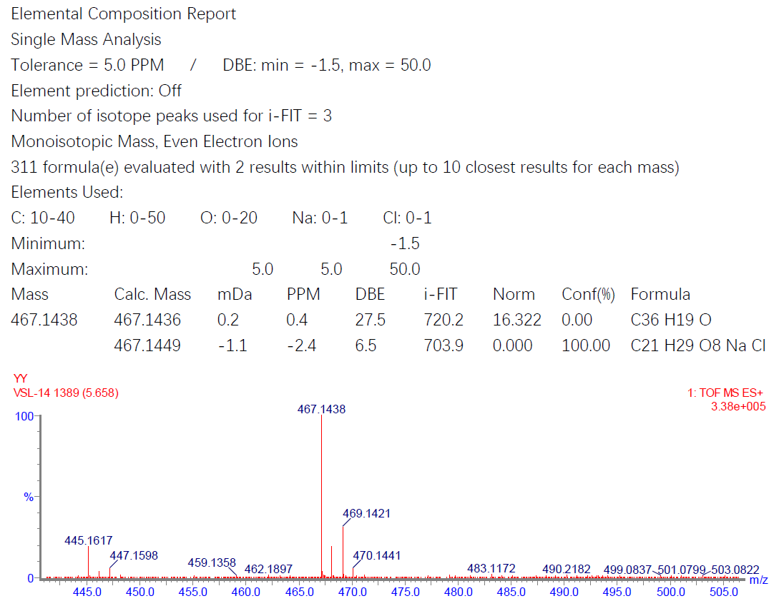
Fig. S104 HRESIMS spectrum of versolanolide D (9).

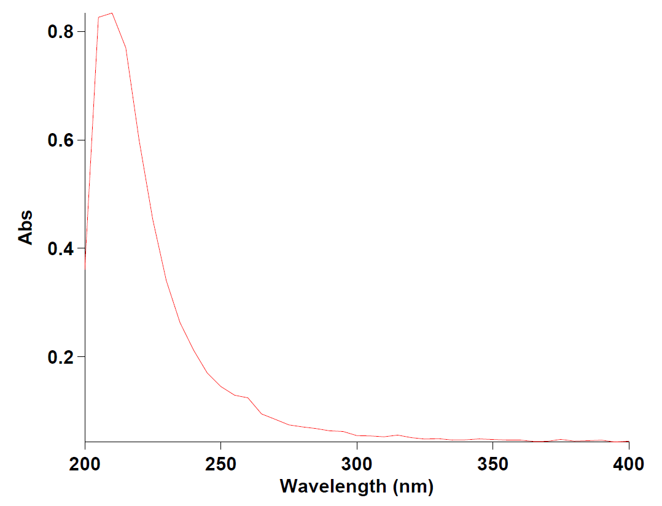
Fig. S105 UV spectrum of versolanolide D (9).

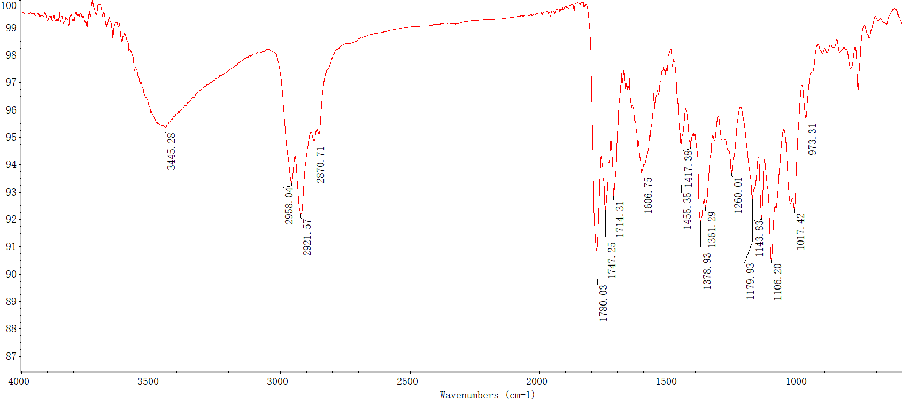
Fig. S106 IR spectrum of versolanolide D (9).

Fig. S107 ¹H NMR (600 MHz) spectrum of versolanolide D (9) in CDCl₃.

Fig. S108 ¹³C and DEPT-135 NMR (125 MHz) spectra of versolanolide D (9) in CDCl₃.
Fig. S109 ¹H-¹H COSY spectrum of versolanolide D (9) in CDCl₃.
Fig. S110 HSQC spectrum of versolanolide D (9) in CDCl₃.

Fig. S111 HMBC spectrum of versolanolide D (9) in CDCl₃.

Fig. S112 NOESY spectrum of versolanolide D (9) in CDCl₃.

