Additional Material

Table S1 Major agricultural regions in Europe (Olesen & Bindi, 2002).
Regions | Countries
Nordic | Norway, Sweden, and Finland
British Isles | Ireland, and United Kingdom
Western | Denmark, Germany, Netherlands, Belgium, Luxembourg, and France
Mediterranean | Portugal, Spain, Italy, Greece, Malta, and Cyprus
Alpine | Switzerland, and Austria
North eastern | Poland, Czech Republic, and Slovakia
South eastern | Hungary, Slovenia, Croatia, Romania, and Bulgaria
Eastern | Estonia, Latvia, and Lithuania

Table S2. Correlation between detrended annual NPP variation (NPP_{IAV}) and spring temperature variation (T_{springIAV}), and detrended NPP_{IAV} and summer soil moisture (average over 0-10cm in depth) variation (mc_{summerIAV}). In Europe, spring include March, April and May, and summer include June, July and August. The test statistic is based on Pearson's product moment correlation coefficient. Significant correlation with p value < 0.05 is annotated with *, and with p value < 0.01 is annotated with **.

 | Period | Europe | Nordic | British Isles | Western | Mediterranean | Alpine | North eastern | South eastern | Eastern
NPP_{IAV} vs. T_{springIAV} | Reference | 0.43* | 0.63** | 0.70** | 0.51** | -0.16 | 0.81** | 0.53** | 0.04 | 0.5**
NPP_{IAV} vs. T_{springIAV} | SWL1.5 | 0.52** | 0.64** | 0.60** | 0.55** | -0.48** | 0.53** | 0.68** | 0.14 | 0.78**
NPP_{IAV} vs. T_{springIAV} | SWL2 | 0.16 | 0.64** | 0.43* | 0.46* | -0.62** | 0.7** | 0.8** | -0.11 | 0.81**
NPP_{IAV} vs. T_{springIAV} | SWL3 | 0.17 | 0.46** | 0.57** | 0.51** | -0.51** | 0.61** | 0.76** | -0.28 | 0.56**
NPP_{IAV} vs. T_{springIAV} | SWL3.5 | -0.08 | 0.39* | 0.48** | -0.1 | -0.69** | 0.71** | 0.65** | -0.34 | 0.65**
NPP_{IAV} vs. mc_{summerIAV} | Reference | 0.58** | 0.00 | 0.72* | 0.68** | 0.87** | -0.44* | 0.43* | 0.94** | 0.72**
NPP_{IAV} vs. mc_{summerIAV} | SWL1.5 | 0.42* | -0.37* | -0.24 | 0.19 | 0.90** | -0.48** | 0.28 | 0.92** | -0.36
NPP_{IAV} vs. mc_{summerIAV} | SWL2 | 0.29 | -0.32 | -0.02 | 0.22 | 0.92** | -0.33 | 0.31 | 0.92** | -0.31
NPP_{IAV} vs. mc_{summerIAV} | SWL3 | 0.62** | -0.53** | -0.12 | 0.63** | 0.89** | -0.37* | -0.06 | 0.90** | -0.45*
NPP_{IAV} vs. mc_{summerIAV} | SWL3.5 | 0.66** | -0.68** | -0.36 | 0.8** | 0.92** | -0.53** | 0.27 | 0.91** | -0.36

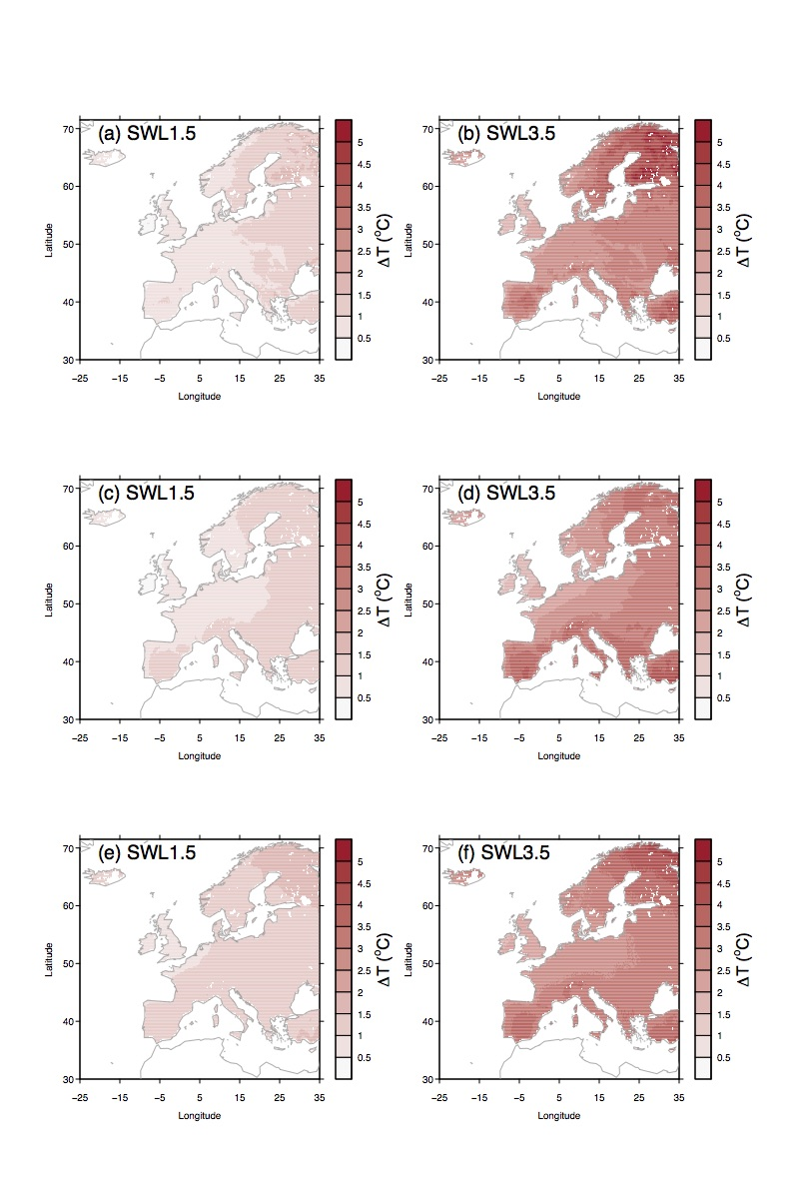
Figure S1. Simulated changes of annual mean temperature (ºC) for SWL of +1.5 ºC, and +3.5 ºC compared to 1981-2010 derived from bias-corrected bias-corrected REMO + ECHAM5 climate for SRES A1B scenario (a and b), from non bias-corrected REMO + ECHAM5 climate for SRES A1B scenario provided by the ENSEMBLE project (c and d), and from ensemble-mean of the RCM+GCM combinations for SRES A1B scenario provided by the ENSEMBLE project (e and f). Totally, 18 RCM+GCM combinations covering the period 1951-2100 were used for the ensemble-mean climate, which are available at: http://ensemblesrt3.dmi.dk/. They are (expressed as RCM+GCM) C4IRCA3+HadCM3Q16, CNRM-RM5.1+ARPEGE, HIRHAM5+ECHAM5, HIRHAM5+ECHAM5, HIRHAM5+BCM, CLM+HadCM3Q0, RACMO2+ECHAM5, HadRM3Q0+HadCM3Q0, HadRM3Q16+HadCM3Q16, HadRM3Q3+HadCM3Q3, REMO+ECHAM5, RCA+BCM, RCA+ECHAM5, RCA+HadCM3Q3, RACMO2+ECHAM5-r1, RACMO2+ECHAM5-r2, RACMO2+MIROC3.2, and RACMO2+ECHAM5-r3 (50km resolution).

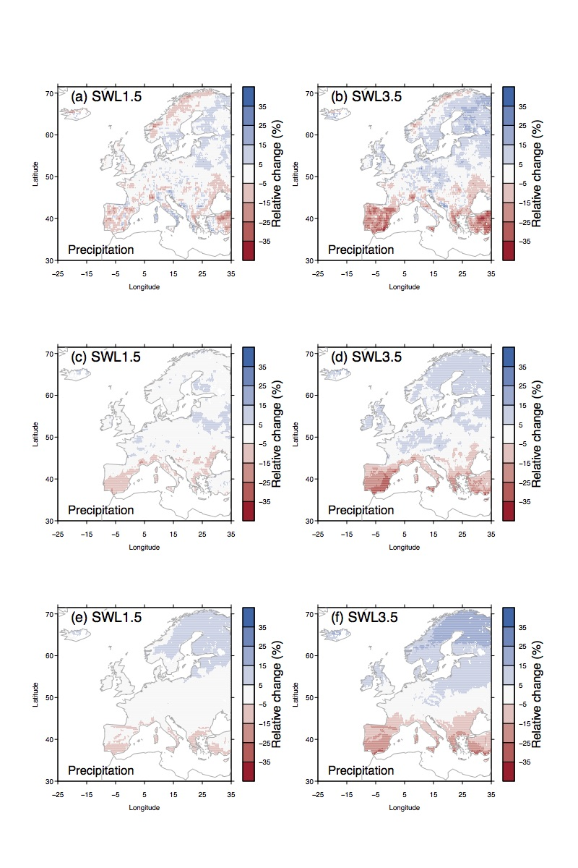
Figure S2. Simulated relative changes of total annual precipitation (%) for SWL of +1.5 ºC, and +3.5 ºC compared to 1981-2010 derived from bias-corrected bias-corrected REMO + ECHAM5 climate for SRES A1B scenario (a and b), from non bias-corrected REMO + ECHAM5 climate for SRES A1B scenario provided by the ENSEMBLE project (c and d), and from ensemble-mean of the RCM+GCM combinations for SRES A1B scenario provided by the ENSEMBLE project (e and f). Totally, 18 RCM+GCM combinations covering the period 1951-2100 were used for the ensemble-mean climate, which are available at: http://ensemblesrt3.dmi.dk/. They are (expressed as RCM+GCM) C4IRCA3+HadCM3Q16, CNRM-RM5.1+ARPEGE, HIRHAM5+ECHAM5, HIRHAM5+ECHAM5, HIRHAM5+BCM, CLM+HadCM3Q0, RACMO2+ECHAM5, HadRM3Q0+HadCM3Q0, HadRM3Q16+HadCM3Q16, HadRM3Q3+HadCM3Q3, REMO+ECHAM5, RCA+BCM, RCA+ECHAM5, RCA+HadCM3Q3, RACMO2+ECHAM5-r1, RACMO2+ECHAM5-r2, RACMO2+MIROC3.2, and RACMO2+ECHAM5-r3 (50km resolution).

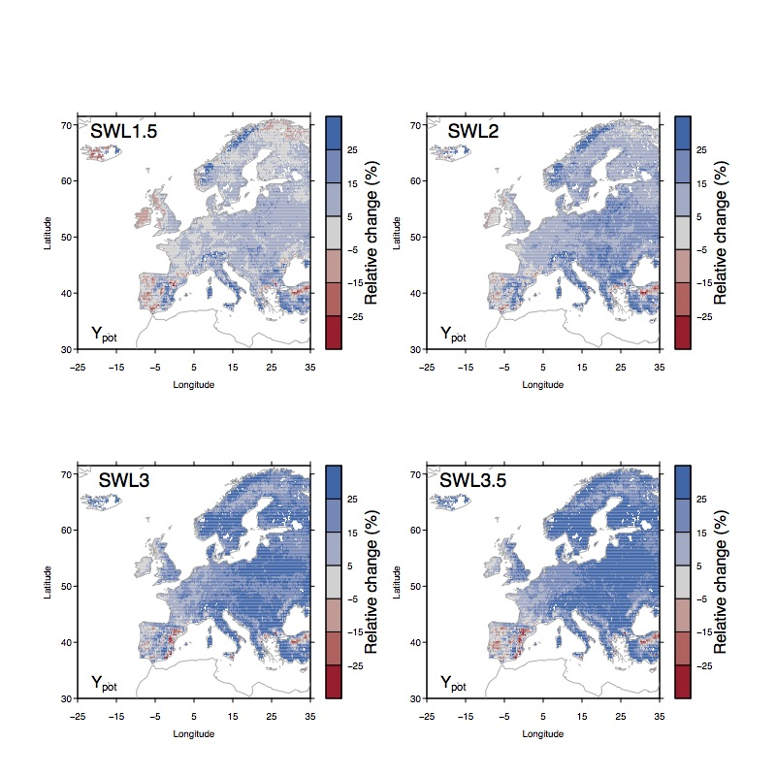
Figure S3. Simulated relative changes of biological potential productivity (Y_{pot}) from experiment E_{control}. The change of Y_{pot} is defined as the difference between Y_{pot} during 30 years in the future corresponding to each SWL minus Y_{pot} in reference historical period (1981-2010).
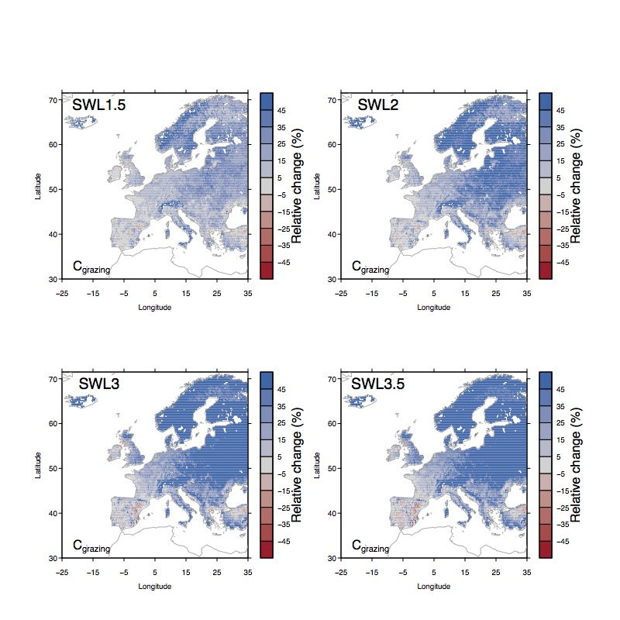
Figure S4. Simulated relative changes of annual grazing capacity (C_{grazing}) from experiment E_{control}. The change of C_{grazing} is defined as the difference between C_{grazing} during 30 years in the future corresponding to each SWL minus C_{grazing} in reference historical period (1981-2010).

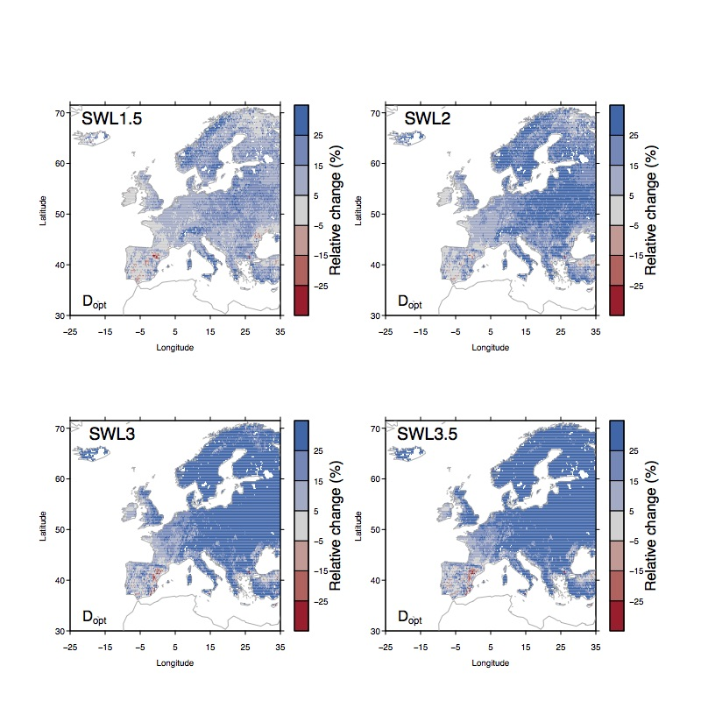
Figure S5. Simulated relative changes of optimal livestock density (D_{opt}) from experiment E_{control}. The change of D_{opt} is defined as the difference between D_{opt} during 30 years in the future corresponding to each SWL minus D_{opt} in reference historical period (1981-2010).

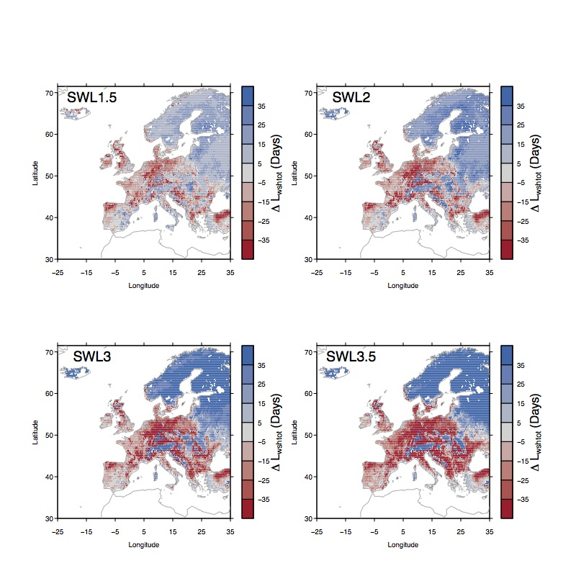
Figure S6. The contributions of the changes in the above-ground biomass availability to the changes in grazing season length (i.e., ∆L_{biomass}).
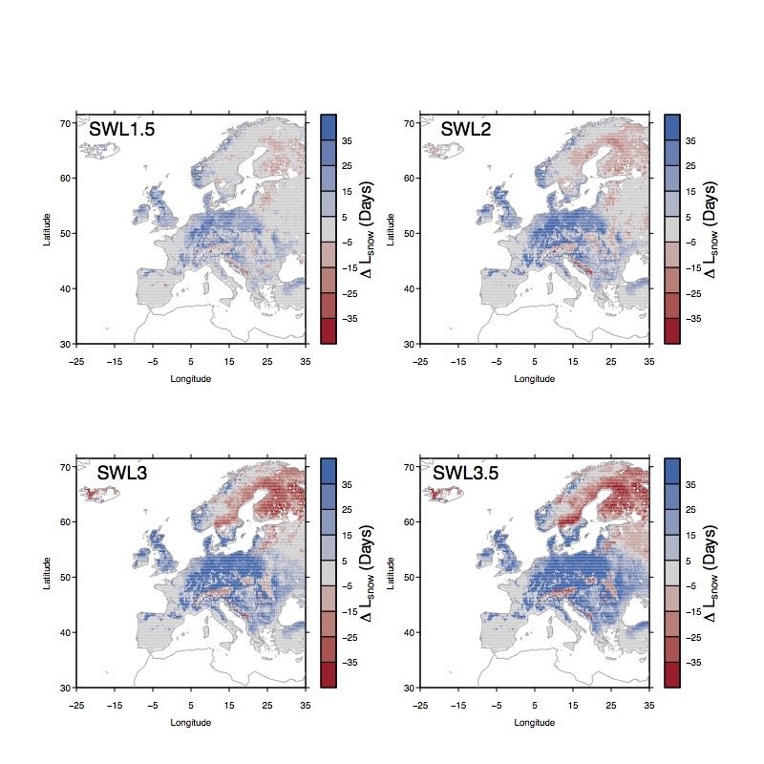
Figure S7. The contributions of the changes in the snow cover days to the changes in grazing season length (i.e., ∆L_{snow}).
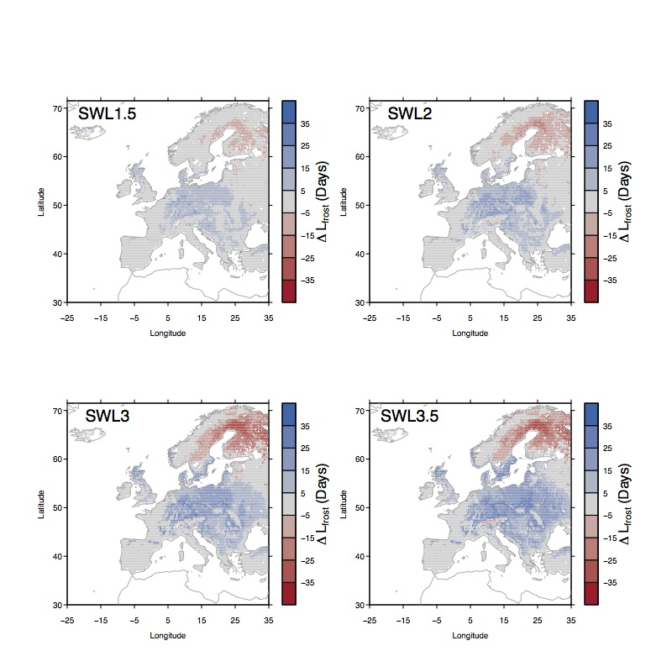
Figure S8. The contributions of the changes in the frost days (air temperature is below 0ºC) to the changes in grazing season length (i.e., ∆L_{frost}).
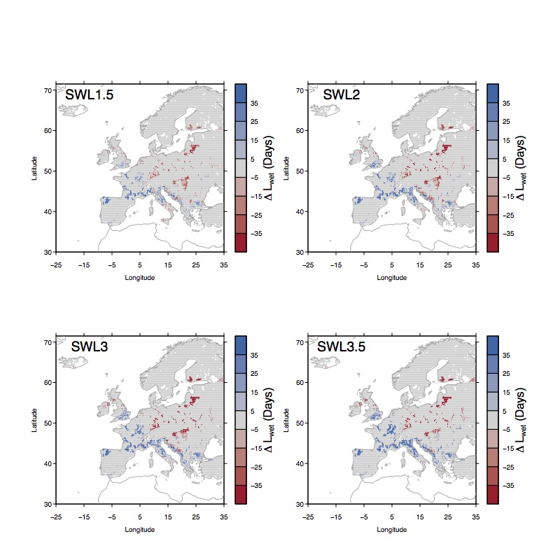
Figure S9. The contributions of the changes in the wet soil days to the changes in grazing season length (i.e., ∆L_{wet}).

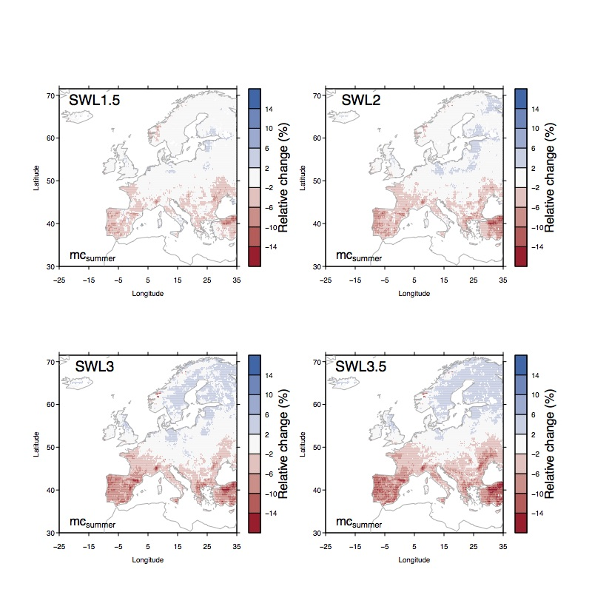
Figure S10. Simulated relative changes of summer mean soil moisture (mc_{summer}; average over 0-9 cm in depth) from experiment E_{control}. The change of summer mean soil moisture is defined as the difference between summer mean soil moisture during 30 years in the future corresponding to each SWL minus summer mean soil moisture in reference historical period (1981-2010).

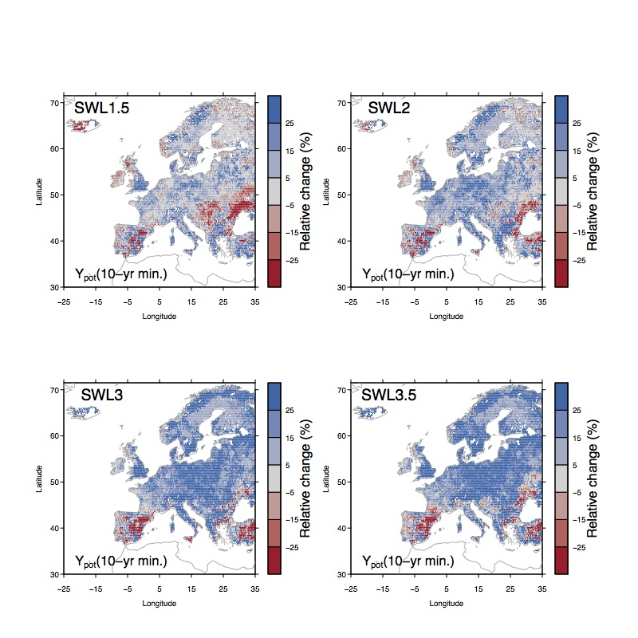
Figure S11. Simulated relative changes of 10-year minimum biological potential productivity (Y_{pot}) from experiment E_{control}. The 10-year minimum Y_{pot} is defined as minimum Y_{pot} in the past 10 years. The change of 10-year minimum Y_{pot} is defined as the the difference between 10-year minimum Y_{pot} during 30 years in the future corresponding to each SWL minus 10-year minimum Y_{pot} in reference historical period (1981-2010).

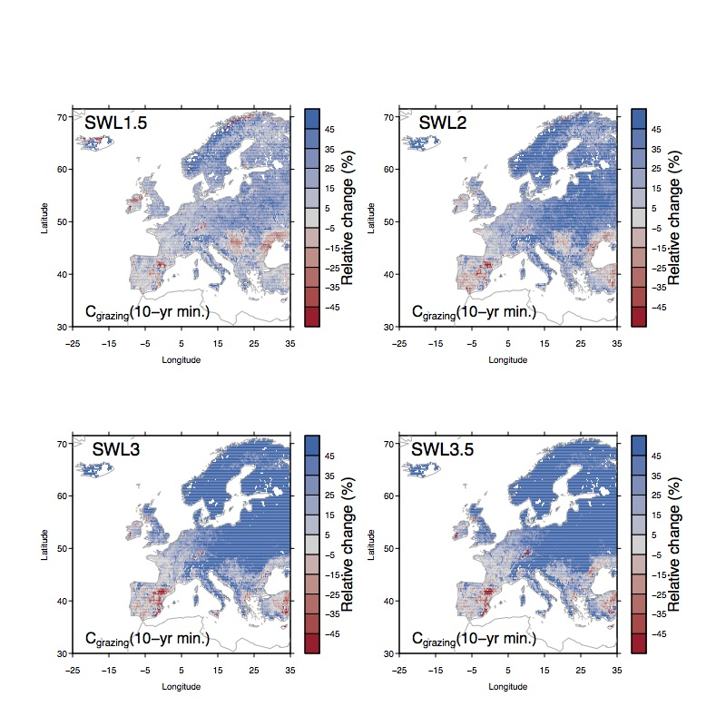
Figure S12. Simulated relative changes of 10-year minimum annual grazing capacity (C_{grazing}) from experiment E_{control}. The 10-year minimum C_{grazing} is defined as minimum C_{grazing} in the past 10 years. The change of 10-year minimum C_{grazing} is defined as the the difference between 10-year minimum C_{grazing} during 30 years in the future corresponding to each SWL minus 10-year minimum C_{grazing} in reference historical period (1981-2010).
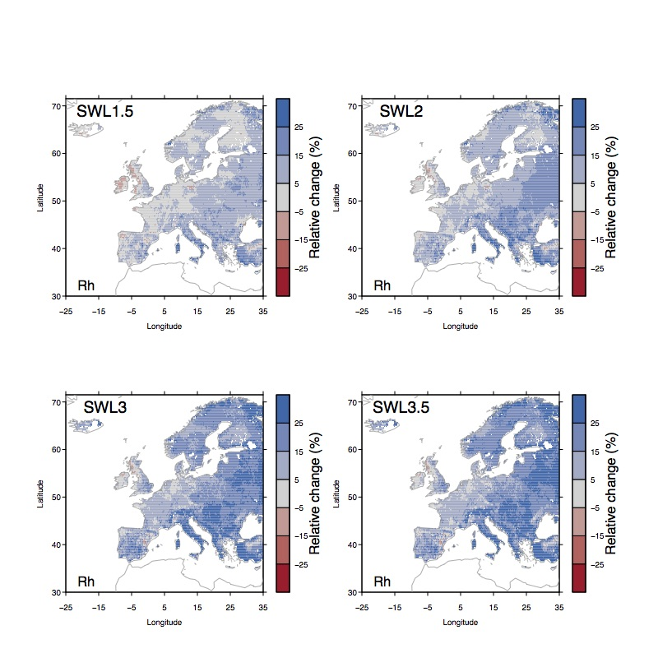
Figure S13. Simulated relative changes of heterotrophic respiration (Rh) from experiment E_{control}. The change of Rh is defined as the difference between Rh during 30 years in the future corresponding to each SWL minus Rh in reference historical period (1981-2010).

