Supplementary Information
Contribution of forest wood products to negative emissions: historical comparative analysis from 1960 to 2015 in Norway, Sweden and Finland
Cristina-Maria Iordan^{*1}, Xiangping Hu¹, Anders Arvesen¹, Pekka Kauppi², Francesco Cherubini¹
¹ Industrial Ecology Programme, Department of Energy and Process Engineering, Norwegian University of Science and Technology (NTNU), Trondheim, Norway
² Department of Environmental Sciences, University of Helsinki, Helsinki, Finland
* Email: cristina.m.iordan@ntnu.no, Phone: +4745238084
Table S1: References and assumptions for Norway’s data set (harvested amounts, HWP and bioenergy)
Category |  | Reference | Assumptions
Harvested Amounts |  | (Statistics Norway, 2016);  (Food and Agriculture Organization of the United Nations [FAO], 2015a) | 1960-1979 only total conifers (timber and wood for energy). We assume same ratio of pine and spruce within the total conifers as the average from 1980-1989. Wood for energy from FAO Dataset.
HWP | Timber | (Food and Agriculture Organization of the United Nations [FAO], 2015a) | We assume same production volumes in 1960 as in 1961.
HWP | Pulpwood | Norwegian Pulp and Paper Association - (TFB, 2015)
Bioenergy | District Heating | (Statistics Norway, 2017) | The value of TWh produced in 1983 is assumed to be fixed between 1960-1982
Bioenergy | Households and cabins | (Statistics Norway, 2017) | For 1960-1989 we assume the share of open fire from total households to be the same as the average from 1990 – 2015. We assume no new stoves until 1998.
Bioenergy | Industry | (Statistics Norway, 2017) | For the period 1960 – 1989 we assume same relative shares from the total consumption of fuel as for year 1990.
Bioenergy | Transport | (Statistics Norway, 2017) | Data available only after 2009.

Table S2: References and assumptions for Sweden’s data set (harvested amounts, HWP and bioenergy)
Category | Reference | Assumption
Harvested Amounts | (Swedish Forest Agency, 2015)
HWP | (Food and Agriculture Organization of the United Nations [FAO], 2015a) | We assume same production amounts in 1960 as in 1961.
Bioenergy | (Swedish Energy Agency, 2015) | For 1960-1989 we assume the ratio for each category from the total wood-based energy consumption equal to the category’s average ratio for the period 1990-1999.

Table S3: References and assumptions for Finland’s data set (harvested amounts, HWP and bioenergy)
Category | Reference | Assumption
Harvested Amounts | (LUKE, 2014)
HWP | (Food and Agriculture Organization of the United Nations [FAO], 2015a) | We assume same production amounts in 1960 as in 1961.
Bioenergy | (Natural Resources Institute Finland, 2016)

Table S4: End Products Categories and Lifetimes
Primary HWP | Finale HWP | Life time (years)
Wood for Energy | Bioenergy | 4
Graphic Paper, Tissue Paper | Paper | 4
Wrapping paper, Case Materials, Carton board | Packaging Items | 9
Mechanical, Chemical, Semi-chemical and Dissolving wood pulp | Pulp | 9
Particle board, plywood, veneer sheets, fibreboard | Furniture (and building maintenance) | 43
Sawnwood | Buildings | 140

Table S5: Densities for HWP
HWP | Density ( kg/ m³) | Reference
Particleboard | 650 | (Food and Agriculture Organization of the United Nations [FAO], 2015b)
Sawnwood ( conifers) | 440 | (UNECE, 2010)
Sawnwood ( non-conifers) | 550 | (UNECE, 2010)
Veneer sheets | 750 | (Food and Agriculture Organization of the United Nations [FAO], 2015b)
Plywood | 650 | (Food and Agriculture Organization of the United Nations [FAO], 2015b)
Fibreboard | 950 | (Food and Agriculture Organization of the United Nations [FAO], 2015b)
Fuelwood | 725 | (Food and Agriculture Organization of the United Nations [FAO], 2015b)
Table S6: Rotation periods
Tree Specie | Rotation Period (years)
Spruce | 100
Pine | 90
Birch | 60

Table S7: The estimated coefficients for the annual incremental rate and the standard deviation
Country | Coefficients for the annual incremental rate | Standard deviation
Norway | 0.029 | 0.009
Sweden | 0.477 | 0.047
Finland | 0.399 | 0.044

Table S8: Legend of the covariance coefficients (i) for the Tables S9 –S16
i =1 |  |  | self-correlation
0.7 | < i < | 0.99 | strongly positively correlated
0.4 | < i < | 0.7 | positively correlated
0.1 | < i < | 0.4 | slightly positively correlated
-0.1 | < i < | 0.1 | no correlation
-0.4 | < i < | -0.1 | slightly negatively correlated
-0.7 | < i < | -0.4 | negatively correlated
-1 | < i < | -0.7 | strongly negatively correlated

Table S9: Covariance coefficients of the historical trends of the total harvested volumes between each two countries.
 | Norway | Sweden | Finland
Norway | 1.00 | 0.33 | 0.38
Sweden |  | 1.00 | 0.72
Finland |  |  | 1.00

Table S10: Covariance coefficients of the historical trends of harvested volumes between each two countries with a breakdown on tree species
   | Norway
  Finland | Spruce | Pine | Birch
  Spruce | 0.23 | 0.23 | -0.05
  Pine | 0.41 | 0.50 | 0.40
  Birch | -0.11 | 0.15 | 0.51
   | Sweden
  Finland | Spruce | Pine | Birch
  Spruce | 0.64 | 0.66 | -0.64
  Pine | 0.69 | 0.79 | -0.31
  Birch | 0.14 | 0.21 | 0.31
   | Norway
  Sweden | Spruce | Pine | Birch
  Spruce | 0.18 | 0.40 | 0.20
  Pine | 0.21 | 0.45 | 0.29
  Birch | 0.27 | 0.31 | 0.41

Table S11: Covariance coefficients of the historical trends of harvested volumes between each tree species class in Norway, where the first capital letter indicates the tree species (S – Spruce, P-Pine, B -Birch) while the second letter indicates the wood class (s – saw logs, p – pulpwood, e – wood for energy).
Norway | Ss | Sp | Se | Ps | Pp | Pe | Bs | Bp | Be
Ss | 1.00 | 0.37 | -0.18 | 0.58 | 0.42 | -0.26 | -0.16 | 0.29 | -0.05
Sp |  | 1.00 | 0.02 | 0.65 | 0.78 | 0.04 | -0.23 | -0.14 | 0.25
Se |  |  | 1.00 | 0.16 | 0.12 | 0.99 | -0.34 | -0.33 | 0.88
Ps |  |  |  | 1.00 | 0.61 | 0.18 | -0.47 | -0.26 | 0.35
Pp |  |  |  |  | 1.00 | 0.12 | -0.14 | 0.11 | 0.33
Pe |  |  |  |  |  | 1.00 | -0.40 | -0.43 | 0.89
Bs |  |  |  |  |  |  | 1.00 | 0.81 | -0.56
Bp |  |  |  |  |  |  |  | 1.00 | -0.46
Be |  |  |  |  |  |  |  |  | 1.00

Table S12: Covariance coefficients of the historical trends of harvested volumes between each tree species class in Sweden, where the first capital letter indicates the tree species (S – Spruce, P-Pine, B -Birch) while the second letter indicates the wood class (s – saw logs, p – pulpwood, e – wood for energy).
Sweden | Ss | Sp | Se | Ps | Pp | Pe | Bs | Bp | Be
Ss | 1.00 | 0.53 | 0.57 | 0.95 | 0.57 | 0.57 | 0.35 | -0.44 | 0.07
Sp |  | 1.00 | 0.27 | 0.48 | 0.86 | 0.26 | -0.21 | 0.32 | 0.14
Se |  |  | 1.00 | 0.63 | 0.44 | 0.98 | 0.37 | -0.56 | 0.70
Ps |  |  |  | 1.00 | 0.69 | 0.69 | 0.34 | -0.41 | 0.18
Pp |  |  |  |  | 1.00 | 0.52 | -0.12 | 0.22 | 0.30
Pe |  |  |  |  |  | 1.00 | 0.35 | -0.52 | 0.69
Bs |  |  |  |  |  |  | 1.00 | -0.54 | 0.06
Bp |  |  |  |  |  |  |  | 1.00 | 0.03
Be |  |  |  |  |  |  |  |  | 1.00

Table S13: Covariance coefficients of the historical trends of harvested volumes between each tree species class in Finland, where the first capital letter indicates the tree species (S – Spruce, P-Pine, B -Birch) while the second letter indicates the wood class (s – saw logs, p – pulpwood, e – wood for energy).

Finland | Ss | Sp | Se | Ps | Pp | Pe | Bs | Bp | Be
Ss | 1.00 | 0.09 | 0.10 | 0.65 | 0.80 | 0.13 | -0.61 | 0.72 | -0.67
Sp |  | 1.00 | 0.03 | 0.34 | -0.04 | -0.09 | 0.39 | -0.15 | 0.30
Se |  |  | 1.00 | 0.11 | 0.40 | 0.95 | -0.38 | 0.15 | 0.49
Ps |  |  |  | 1.00 | 0.47 | 0.08 | -0.03 | 0.41 | -0.31
Pp |  |  |  |  | 1.00 | 0.49 | -0.65 | 0.88 | -0.46
Pe |  |  |  |  |  | 1.00 | -0.43 | 0.30 | 0.40
Bs |  |  |  |  |  |  | 1.00 | -0.50 | 0.42
Bp |  |  |  |  |  |  |  | 1.00 | -0.58
Be |  |  |  |  |  |  |  |  | 1.00

Table S14: Covariance coefficients of the historical trends of harvested volumes from Finland and Sweden with a breakdown on the tree species and class, where the first capital letter indicates the tree species (S – Spruce, P-Pine, B -Birch) while the second letter indicates the wood class (s – saw logs, p – pulpwood, e – wood for energy).
 | Sweden
Finland | Ss | Sp | Sf | Ps | Pp | Pf | Bs | Bp | Bf
Ss | 0.76 | 0.08 | 0.63 | 0.77 | 0.24 | 0.65 | 0.68 | -0.74 | 0.07
Sp | 0.00 | 0.10 | 0.16 | -0.01 | 0.05 | 0.14 | -0.02 | -0.17 | -0.07
Sf | 0.18 | 0.24 | 0.67 | 0.29 | 0.41 | 0.68 | -0.21 | -0.10 | 0.76
Ps | 0.47 | 0.01 | 0.41 | 0.54 | 0.23 | 0.46 | 0.24 | -0.45 | 0.06
Pp | 0.70 | 0.32 | 0.77 | 0.76 | 0.52 | 0.80 | 0.49 | -0.42 | 0.47
Pf | 0.22 | 0.28 | 0.64 | 0.33 | 0.46 | 0.67 | -0.16 | -0.01 | 0.80
Bs | -0.57 | -0.18 | -0.52 | -0.57 | -0.27 | -0.52 | -0.43 | 0.44 | -0.22
Bp | 0.67 | 0.31 | 0.59 | 0.72 | 0.47 | 0.62 | 0.54 | -0.29 | 0.36
Bf | -0.48 | 0.07 | -0.05 | -0.44 | 0.01 | -0.08 | -0.73 | 0.37 | 0.30

Table S15: Covariance coefficients of the historical trends of harvested volumes from Finland and Norway with a breakdown on the tree species and class, where the first capital letter indicates the tree species (S – Spruce, P-Pine, B -Birch) while the second letter indicates the wood class (s – saw logs, p – pulpwood, e – wood for energy).
 | Norway
Finland | Ss | Sp | Sf | Ps | Pp | Pf | Bs | Bp | Bf
Ss | 0.14 | 0.41 | 0.00 | 0.46 | 0.09 | 0.06 | -0.71 | -0.75 | 0.19
Sp | -0.18 | 0.00 | -0.07 | -0.14 | -0.22 | -0.07 | 0.33 | 0.02 | -0.20
Sf | -0.24 | 0.03 | 0.84 | 0.18 | 0.02 | 0.84 | -0.39 | -0.48 | 0.70
Ps | 0.21 | 0.01 | 0.09 | 0.25 | -0.16 | 0.12 | -0.44 | -0.43 | 0.16
Pp | 0.13 | 0.53 | 0.37 | 0.57 | 0.32 | 0.42 | -0.82 | -0.78 | 0.61
Pf | -0.09 | 0.15 | 0.79 | 0.32 | 0.17 | 0.78 | -0.47 | -0.47 | 0.74
Bs | 0.01 | -0.46 | -0.27 | -0.46 | -0.28 | -0.33 | 0.67 | 0.68 | -0.40
Bp | 0.21 | 0.53 | 0.17 | 0.56 | 0.40 | 0.24 | -0.76 | -0.62 | 0.51
Bf | -0.43 | -0.41 | 0.40 | -0.39 | -0.25 | 0.36 | 0.49 | 0.27 | 0.09

Table S16: Covariance coefficients of the historical trends of harvested volumes from Sweden and Norway with a breakdown on the tree species and class, where the first capital letter indicates the tree species (S – Spruce, P-Pine, B -Birch) while the second letter indicates the wood class (s – saw logs, p – pulpwood, e – wood for energy).
 | Norway
Sweden | Ss | Sp | Sf | Ps | Pp | Pf | Bs | Bp | Bf
Ss | 0.02 | 0.37 | 0.09 | 0.55 | 0.11 | 0.18 | -0.66 | -0.73 | 0.29
Sp | -0.19 | 0.24 | 0.25 | 0.29 | 0.15 | 0.33 | -0.22 | -0.32 | 0.39
Sf | -0.22 | 0.21 | 0.59 | 0.32 | 0.04 | 0.64 | -0.67 | -0.80 | 0.64
Ps | 0.06 | 0.30 | 0.20 | 0.57 | 0.12 | 0.28 | -0.75 | -0.79 | 0.38
Pp | -0.10 | 0.17 | 0.41 | 0.39 | 0.18 | 0.47 | -0.48 | -0.51 | 0.55
Pf | -0.17 | 0.19 | 0.60 | 0.36 | 0.06 | 0.65 | -0.72 | -0.82 | 0.65
Bs | 0.25 | 0.42 | -0.24 | 0.34 | 0.25 | -0.22 | -0.42 | -0.30 | -0.03
Bp | 0.19 | 0.01 | 0.03 | -0.03 | 0.32 | -0.01 | 0.42 | 0.63 | 0.05
Bf | -0.01 | 0.20 | 0.78 | 0.27 | 0.31 | 0.75 | -0.40 | -0.28 | 0.75

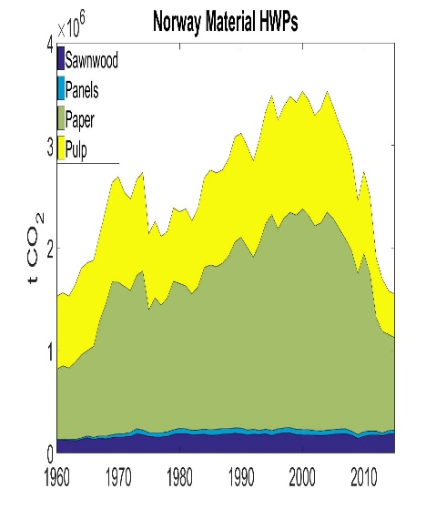 | 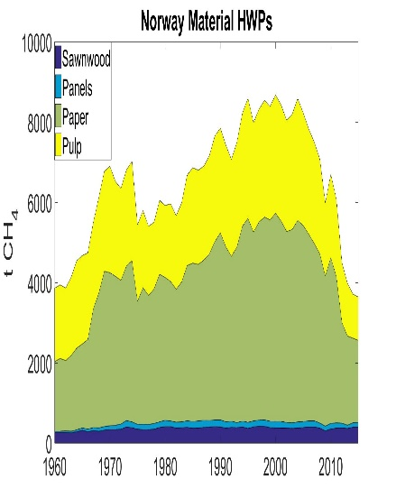 | 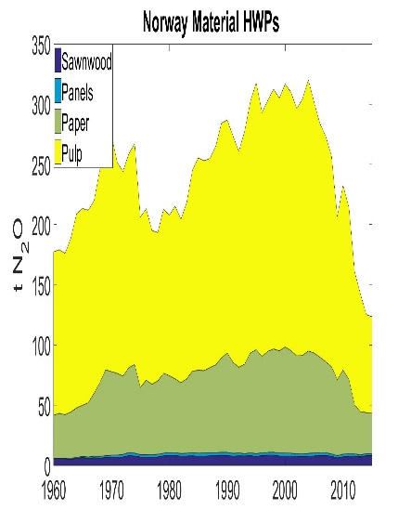
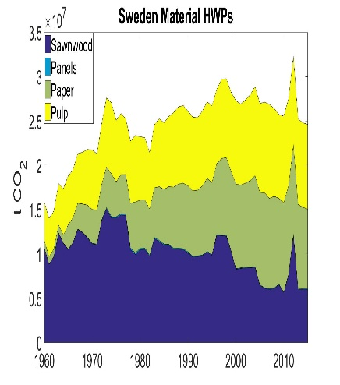 | 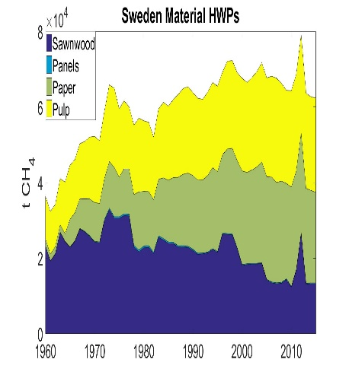 | 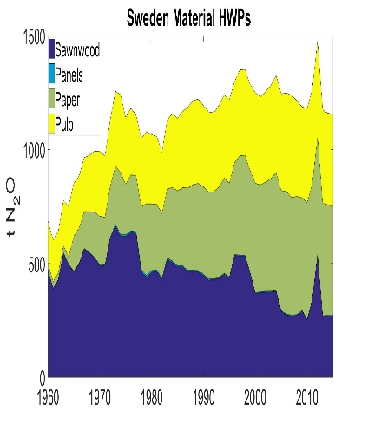
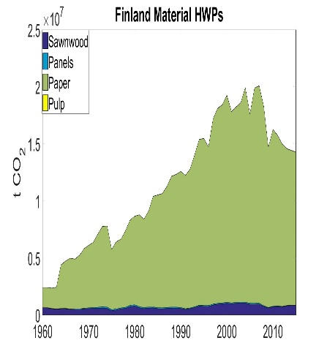 | 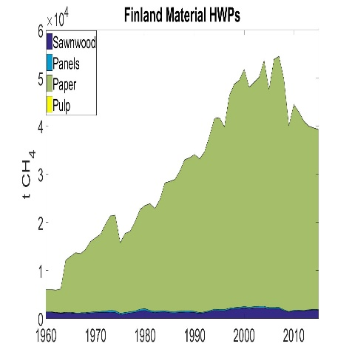 | 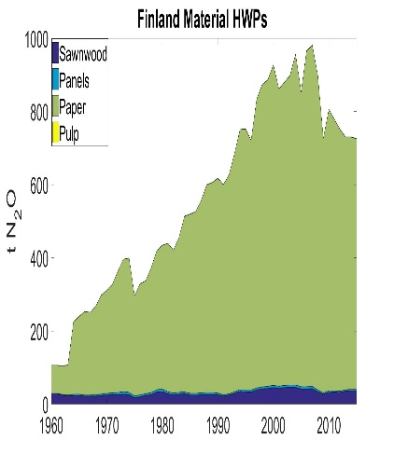
Figure S1: Historical emission inventories for CO₂ fossil, CH₄ fossil and N₂O due to material HWP in Norway, Sweden and Finland.
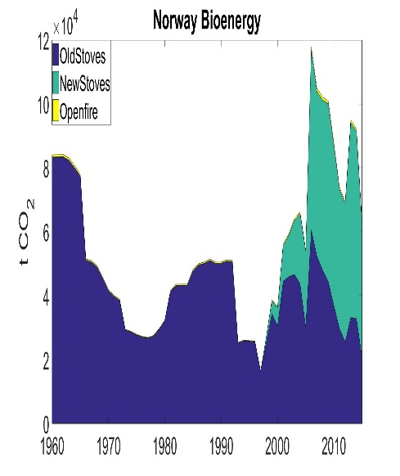 | 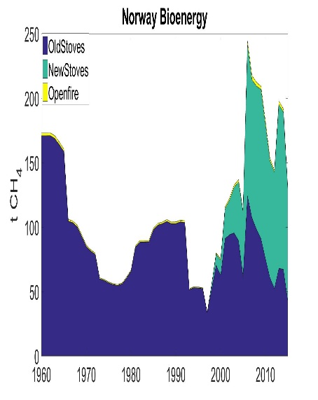 | 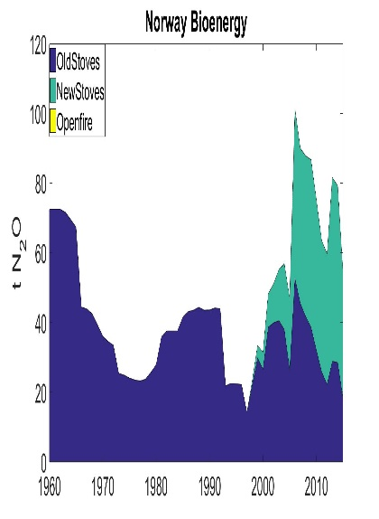
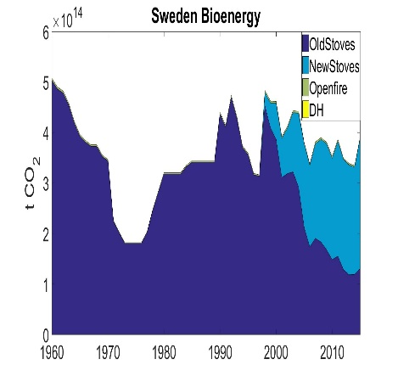 | 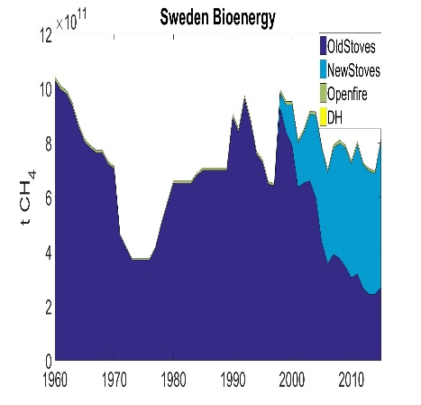 | 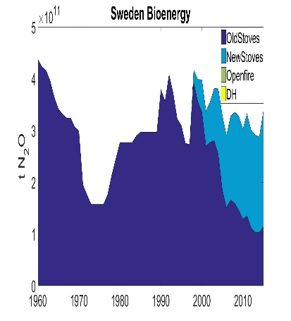
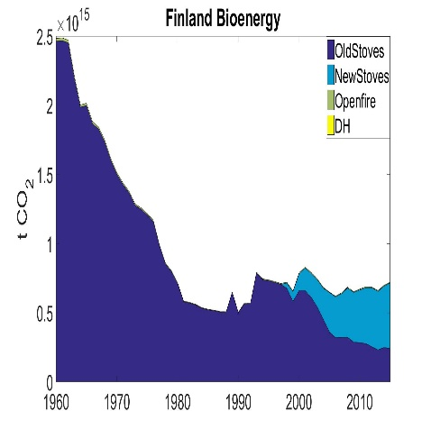 | 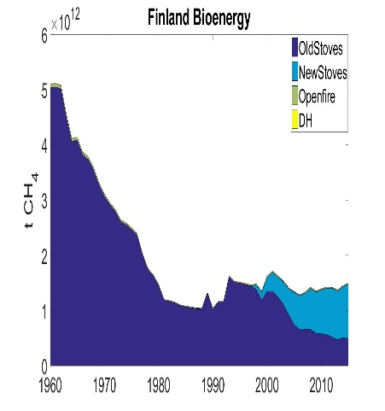 | 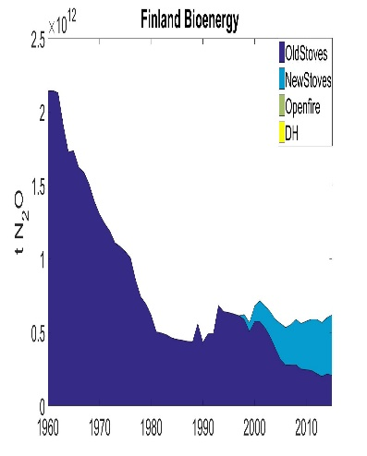
Figure S2: Historical emission inventories for CO₂ fossil, CH₄ fossil and N₂O due to wood-based energy in Norway, Sweden and Finland. In Norway, the figures do not include emissions from district heating (most of the inputs to DH in Norway are by-products of other wood industries). The trends in Norway are very dependent on the reported removals of wood for energy.
References:
Food and Agriculture Organization of the United Nations [FAO], (2015a) FAOSTAT. Forestry Production and Trade 1960 - 2015 http://www.fao.org/faostat/en/#data/FO.
Food and Agriculture Organization of the United Nations [FAO], (2015b) Global Forest Resources Assessment 2015: How are the world’s forests changeing? , Rome, Italy.
LUKE, (2014) Statistical Yearbook of Forestry 2014; Official statistics of Finland. Finnish Forest Research Institute.
Natural Resources Institute Finland, (2016) Wood in energy generation, http://stat.luke.fi/puun-energiakaytto.
Statistics Norway, (2016) The National Forest Inventory 2011-2015 - Commercial roundwood removals by species of tree, Oslo.
Statistics Norway, (2017) Energy and manufacturing: Energy 30.07.2017 ed, https://www.ssb.no/en/energi-og-industri/statistikker/fjernvarme.
Swedish Energy Agency (2015) Energy in Sweden 2015.
Swedish Forest Agency, (2015) Statistical Database on Forestry
TFB, (2015) Norwegian Pulp and Paper Association - Key Figures 2015 https://www.norskindustri.no/contentassets/10b0b5431ab24b46aa94602a71f6bd1d/nokkeltall-for-treforedlingsbransjen-2016.pdf.
UNECE, (2010) United Nations Economic Commision for Europe. Forest product conversion factors for the UNECE region https://www.unece.org/fileadmin/DAM/timber/publications/DP-49.pdf.

