Appendix Figures and Tables
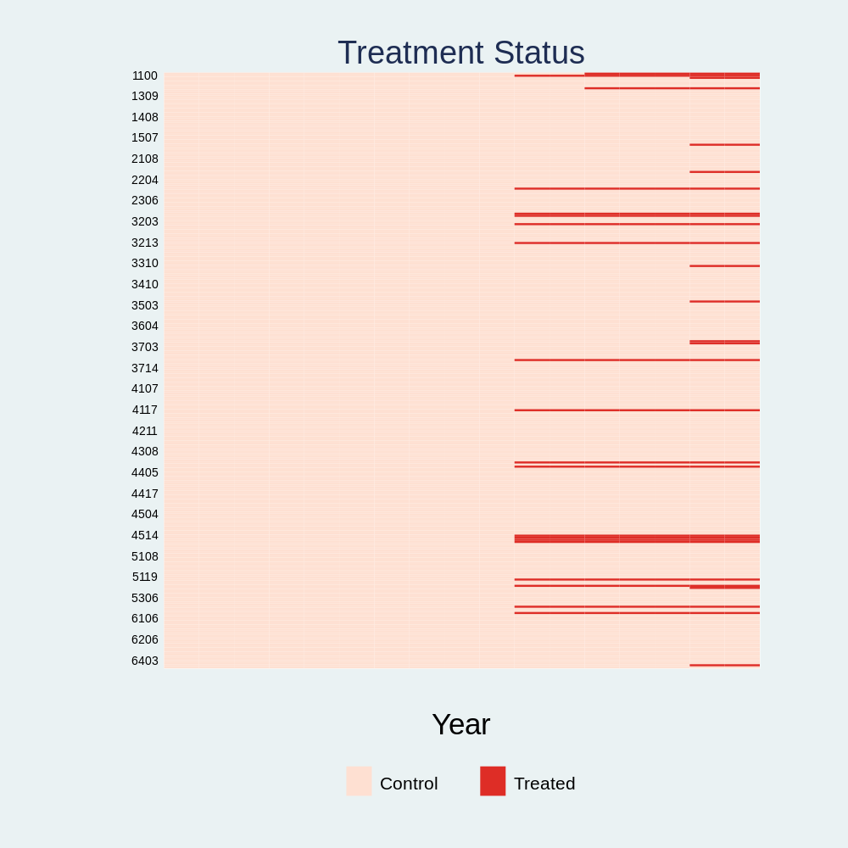
Figure A1 Treatment Status of the STIDPP (2006-2022)

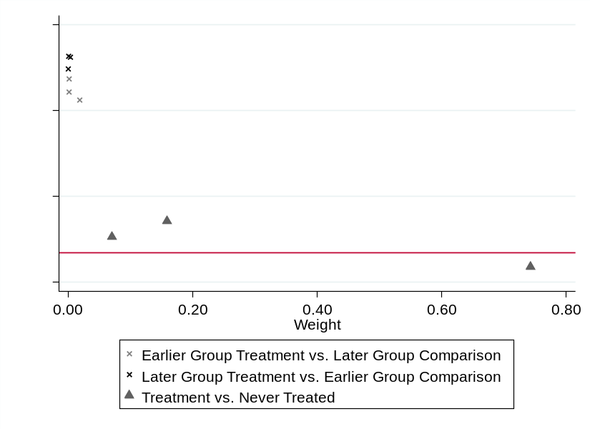
Figure A2 Bacon Decomposition Estimates
Notes: Following Goodman-Bacon (2021), we decompose the overall TWFE estimator into weighted averages of all possible two-group, two-period DID comparisons, allowing for an explicit evaluation of the identifying variation. The majority of the identifying weight (97.3%) comes from comparisons between treated and never-treated groups, which are generally considered the most reliable source of identification under standard DID assumptions. Only 0.5% of the total weight is assigned to comparisons between later-treated and early-treated groups, suggesting that bias from dynamic treatment timing is minimal. Figure A2 visualizes the Bacon decomposition results, showing that the estimated effects are predominantly driven by comparisons between treated and never-treated groups. The treatment effects from these comparisons are consistently negative, lending further support to the robustness of the baseline TWFE estimates. The weights for “Early treatment vs. Later treatment”, “Later treatment vs. Early treatment”, and “Time-varying treatment vs. Never-treated” are 0.022, 0.005, and 0.973, respectively.
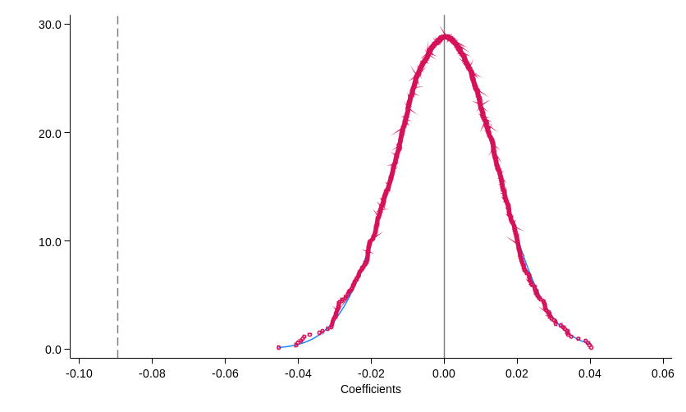
Figure A3 Placebo Test
Notes: To further corroborate the causal identification strategy, we perform a placebo test through the random assignment of treatment status and implementation year among cities. Specifically, we conduct 1000 iterations in which the treatment group and timing are reassigned at random. Figure A3 depicts the kernel density distribution of the placebo estimates. The distribution is tightly centered around zero, with no mass near the actual estimated effect of -0.089. Moreover, the vast majority of p-values exceed the 10% significance level, indicating that the observed carbon mitigation effect is unlikely to be attributable to spurious correlations or omitted confounding variables.

Table A1 Overview of STIDPP Pilot Cohorts and Rollout Schedule
Batch | Implementation year | Pilot cities
First | 2016.02 | Tianjin, Shanghai, Hainan, Shenzhen, Hangzhou, Wuhan, Guangzhou, Chengdu, Suzhou, Weihai, Harbin, Nanjing, Chongqing, Guiyang, Anshun, Xi’an, Xianyang
Second | 2018.06 | Beijing, Baoding
Third | 2020.08 | Dalian, Xiamen, Qingdao, Shijiazhuang, Changchun, Hefei, Jinan, Kunming, Urumqi

Table A2 Results Considering Time Trends, Lagged Effects, and Alternative Time Windows
Variables | lnCO2
Variables | (1) | (2) | (3) | (4) | (5) | (6)
DID | -0.089*** | -0.079*** | -0.075*** | -0.034** | -0.050*** | -0.069***
 | (0.021) | (0.020) | (0.019) | (0.016) | (0.017) | (0.018)
Observations | 4537 | 4261 | 4261 | 2409 | 2951 | 3503
Adjusted R² | 0.594 | 0.983 | 0.983 | 0.991 | 0.989 | 0.987
Notes: Column (1) includes both linear and nonlinear time trends to account for unobserved temporal dynamics. The coefficient associated with the policy variable persists in being statistically negative, demonstrating that the estimated effect is not attributable to long-term trends. In columns (2) and (3), we introduce one-period lags of the dependent variable and control variables, respectively, to capture potential persistence in emissions and delayed policy responses. The policy effect remains statistically significant and negative, suggesting robustness to intertemporal dynamics and autocorrelation. To investigate the sensitivity concerning the selection of the temporal window, we re-estimate Eq. (1) using balanced panels centered around the policy implementation year, with symmetric windows of ±4, ±5, and ±6 years. The estimated results are shown in columns (4) to (6), the statistically and significantly negative coefficients indicate that with the extension of the time window, the emission mitigation potential of the STIDPP becomes greater.

References
Goodman-Bacon, A. (2021). Difference-in-differences with variation in treatment timing. Journal of Econometrics, 225(2), 254–277.

