Supplementary material for
Leveraging meteorological legacy effects and machine learning to improve daily gap-free normalized difference vegetation index reconstruction: A critical basis for fine-scale carbon sink capacity monitoring
Huiwen Li^{1,*}, Yue Cao^{2,3}, Jingfeng Xiao⁴, Fei Yu¹, Rui Wang¹, Xinyi Hao¹, Zuoqiang Yuan^{1,#}
¹ Shaanxi Key Laboratory of Qinling Ecological Intelligent Monitoring and Protection, School of Life Science and Technology, Northwestern Polytechnical University, Xi’an, 710012, China
² Xi’an Institute for Innovative Earth Environment Research, Xi’an, Shaanxi Province, 710061, China
³ National Observation and Research Station of Regional Ecological Environment Change and Comprehensive Management in the Guanzhong Plain, Xi'an 710061, China
⁴ Earth Systems Research Center, Institute for the Study of Earth, Oceans, and Space, University of New Hampshire, Durham, NH 03824, USA
Corresponding authors: Huiwen Li *E-mail: lihuiwen@nwpu.edu.cn, Zuoqiang Yuan #E-mail: zqyuan@nwpu.edu.cn

Calculation of daily potential evapotranspiration
The FAO-recommended Penman-Monteith formula [1] was adopted to calculate daily potential evapotranspiration (PET), which has complete physical mechanisms and strong adaptability, and has been widely verified to be applicable in China. The formula is adjusted to the daily scale as follows:
$$\begin{aligned}PET\left(d\right)=\frac{0.408×Δ\left(d\right)×\left(R_{n}(d)-G(d)\right)+γ×\frac{900}{T_{2m}(d)+273}×U_{2m}\left(d\right)×VPD\left(d\right)}{Δ\left(d\right)+γ×\left(1+0.34×U_{2m}(d)\right)}\#\left(1\right)\end{aligned}$$
where $PET(d)$ is PET on day d (mm d⁻¹); $Δ(d)$ is the slope of the saturated vapor pressure curve (kPa ℃⁻¹) on day d, calculated based on the 2m daily average air temperature $T_{2m}(d)$ (℃) and saturated vapor pressure e_{s} (kPa):
$$\begin{aligned}Δ=\frac{4098×e_{s}}{{\left(T_{2m}+237.3\right)}^{2}}\#\left(2\right)\end{aligned}$$
$$\begin{aligned}e_{s}=6.112×f_{w}×e^{\frac{17.67T_{d}}{T_{a}+243.5}}\#\left(3\right)\end{aligned}$$
$$\begin{aligned}f_{w}=1+7×{10}^{-4}+3.46×{10}^{-6}P_{mst}\#\left(4\right)\end{aligned}$$
$$\begin{aligned}P_{mst}=P_{msl}{(\frac{T_{2m}+273.16}{T_{2m}+273.16+0.0065×Z})}^{5.625}\#\left(5\right)\end{aligned}$$
where T_{d} is the dew point temperature (°C), P_{mst} is the air pressure, and P_{msl} is the air pressure at mean sea level.
$R_{n}(d)$ is daily net radiation at the surface (MJ m⁻² d⁻¹) and is calculated as:
$$\begin{aligned}R_{n}=\left(1-α\right)×SSR-R_{nl}\#\left(6\right)\end{aligned}$$
where $α=0.23$, SSR is daily surface solar radiation (MJ m⁻² d⁻¹), R_{nl} is net longwave radiation (MJ m⁻² d⁻¹):
$$\begin{aligned}R_{nl}=4.903×{10}^{-9}×{\left(T_{2m}+273.15\right)}^{4}×\left(0.34-0.14×\sqrt{e_{a}}\right)×\left(1.35×\frac{SSR}{SSR_{0}}-0.35\right)\#\left(7\right)\end{aligned}$$
where e_{a} is the actual vapor pressure, calculated as shown in Equation (2) in the main text. $SSR_{0}$ is daily extraterrestrial solar radiation (MJ m⁻² d⁻¹), which can be calculated based on latitude and day of year (DOY):
$$\begin{aligned}SSR_{0}=\frac{24×3600}{π}×G_{sc}×d_{r}×\left[sinφsinδ+cosφcosδcosω_{s}\right]\#\left(8\right)\end{aligned}$$
where $G_{sc}$ is the solar constant. $d_{r}$ is the relative distance correction factor between the Earth and the Sun, calculated as follows:
$$\begin{aligned}d_{r}=1+0.033×cos\left(\frac{2π×DOY}{365}\right)\#\left(9\right)\end{aligned}$$
where φ is the geographical latitude of the observation site (rad). δ is the solar declination angle (rad) and is calculated as follows:
$$\begin{aligned}δ=0.4093×sin\left(\frac{2π×\left(DOY-80\right)}{365}\right)\#\left(10\right)\end{aligned}$$
ω_{s} is the sunset hour angle (rad) and is calculated as follows:
$$\begin{aligned}ω_{s}=arccos\left(-tanφ×tanδ\right)\#\left(11\right)\end{aligned}$$
G(d) is the daily soil heat flux (MJ m⁻² d⁻¹), which can be neglected in daily PET calculations. γ is psychrometric constant (kPa ℃⁻¹), adopted as a universal value (0.066 kPa ℃⁻¹) for near-surface air. VPD(d) is daily vapor pressure deficit (kPa), whose calculation method is shown in Equations (1)–(5) in the main text. U_{2m} is the 2m daily average wind speed (m s⁻¹).

Calculation of daily actual evapotranspiration
Daily actual evapotranspiration (ET) was calculated using the Priestley-Taylor Jet Propulsion Laboratory (PT-JPL) model [2], which is simple to operate, requires only AgERA5 variables and the reconstructed daily NDVI data, and can effectively reflect the ET of vegetation. The core formula is as follows:
$$\begin{aligned}ET\left(d\right)=T\left(d\right)+E_{i}\left(d\right)+E_{s}\left(d\right)\#\left(12\right)\end{aligned}$$
where $ET(d)$ is daily ET (mm d⁻¹) on day d. T(d) is daily vegetation transpiration (mm d⁻¹), $E_{i}(d)$ is daily canopy interception evaporation (mm d⁻¹), and $E_{s}(d)$ is daily soil evaporation (mm d⁻¹).
$$\begin{aligned}T=\left(1-F_{wet}\right)×F_{g}×F_{m}×α×\frac{Δ}{Δ+γ}×R_{nc}\#\left(13\right)\end{aligned}$$
$$\begin{aligned}E_{i}=F_{wet}×α×\frac{Δ}{Δ+γ}×R_{nc}\#\left(14\right)\end{aligned}$$
$$\begin{aligned}E_{s}=\left(1-F_{g}\right)×\left(1-F_{wet}\right)×α×\frac{Δ}{Δ+γ}×R_{ns}\#\left(15\right)\end{aligned}$$
where $F_{wet}$ is the 2m relative humidity. α is Priestley-Taylor constant (1.26). Δ and γ are consistent with the PET calculation. F_{g} is green canopy proportion, estimated directly from daily NDVI:
$$\begin{aligned}F_{g}=\frac{NDVI-NDVI_{min}}{NDVI_{max}-NDVI_{min}}\#\left(16\right)\end{aligned}$$
where $NDVI_{min}=0.05$, $NDVI_{max}=0.8$. $F_{m}$ is transpiration water limitation factor:
$$\begin{aligned}F_{m}=min\left(1 , \frac{PET(d)-0.5}{PET(d)}\right)\#\left(17\right)\end{aligned}$$
$R_{nc}$ and $R_{ns}$ are canopy-intercepted net radiation and soil surface net radiation (MJ m⁻² d⁻¹), respectively.
$$\begin{aligned}R_{nc}=F_{g}×R_{n}\#\left(18\right)\end{aligned}$$
$$\begin{aligned}R_{ns}=\left(1-F_{g}\right)×R_{n}\#\left(19\right)\end{aligned}$$
where $R_{n}$ is the same as that in PET calculation.

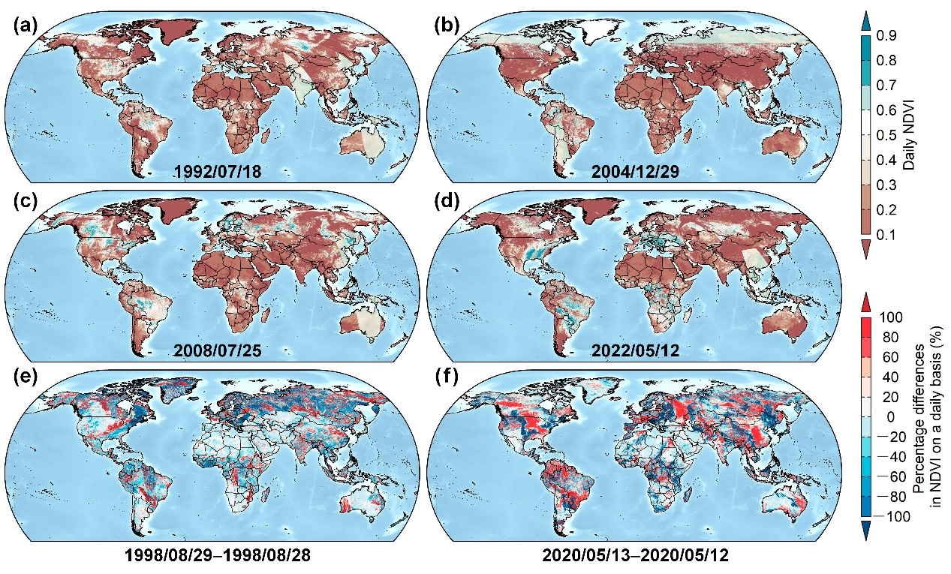
Fig. S1 Daily AVHRR/VIIRS NDVI maps of the NOAA CDR and the percentage differences in NDVI on a daily basis. (a)-(d) Spatial distribution of original NOAA CDR NDVI on different days. These dates were selected as representative examples of severe, widespread cloud-induced data gaps, covering different seasons and decades across the 1982–2023 time series, to demonstrate the persistent data quality issues in the original dataset. (e) and (f) The percentage differences in NDVI within two days. The greater the absolute percentage differences in NDVI within two days, the larger the impact of the noise (e.g., cloud). These maps indicate that gaps and noise data are still evident in the NOAA CDR NDVI dataset.

Table S1. Overview of mainstream long-term NDVI datasets for terrestrial vegetation monitoring.
Dataset | Spatial resolution | Temporal resolution | Temporal coverage | Data source | Gap-free status | Major limitations
NOAA CDR NDVI | 0.05° (~5 km) | Daily | 1981–present | NOAA AVHRR + VIIRS sensors | No | Severe data gaps caused by cloud cover, aerosols and atmospheric contamination; residual geometric and radiometric calibration errors; limited application for continuous daily vegetation analysis
GIMMS 3g | 0.083° (~8 km) | 15-day (bi-monthly) | 1981–2015 | NOAA AVHRR sensors | Partially filled | Coarse temporal resolution; cannot capture short-term daily vegetation dynamics; residual noise in cloudy and humid regions; time series ends in 2015
GIMMS-3G+ | 0.083° (~8 km) | 15-day (bi-monthly) | 1981–2022 | NOAA AVHRR sensors | Partially filled | Coarse temporal resolution; unable to reflect daily vegetation variations; residual atmospheric contamination effects in cloudy regions
PKU GIMMS NDVI | 0.083° (~8 km) | 15-day (bi-monthly) | 1982–2022 | GIMMS NDVI3g + MODIS NDVI + Landsat NDVI samples | Yes | Coarse temporal resolution; not suitable for daily-scale vegetation monitoring; uncertainties inherited from the original GIMMS NDVI3g product
SPOT NDVI (SPOT/VEGETATION) | 1 km | 10-day | 1998–2014 | SPOT VEGETATION sensor | Partially filled | Short time series; coarse temporal resolution; data acquisition channels are complex; no updates after 2014; unable to capture rapid vegetation changes
MODIS MOD13 | 250 m / 500 m / 1 km | 16-day | 2000–present | Terra/Aqua MODIS sensors | Partially filled | Short time series (only available since 2000); 16-day composite limits daily-scale research; residual cloud contamination in humid regions
Previous NDVIPF (this study) | 0.05° (~5 km) | Daily | 1982–2023 | NOAA CDR NDVI | Yes | Based on simple polynomial fitting; low reconstruction accuracy in complex terrain and cloudy/humid regions

Reference
[1] Allen RG, Pereira LS, Raes D, Smith M. FAO Irrigation and drainage paper No. 56. Rome: food and agriculture organization of the United Nations. 1998;56(97):e156.
[2] Fisher JB, Tu KP, Baldocchi DD. Global estimates of the land–atmosphere water flux based on monthly AVHRR and ISLSCP-II data, validated at 16 FLUXNET sites. Remote Sensing of Environment. 2008;112(3):901-19.

