Supplementary Materials：Drying crisis under greening: A study on the drought trigger thresholds of vegetation carbon fixation loss in karst areas

Supplementary Material 1: Detailed NPP calculation and inter-product agreement assessment.
The NPP data for 1982–2022 are derived from simulations of the Carnegie-Ames-Stanford Approach (CASA) model. This model determines NPP by integrating photosynthetic efficiency based on remotely sensed Normalized Difference Vegetation Index (NDVI) data. The continuity of GIMMS NDVI data is extended by utilizing overlapping years from two datasets spanning 2001 to 2022 (NDVI data sources are detailed in Table S1). The MOD 17 A3 NPP from the year 2001 is also used to validate the simulation results of the CASA model. The formulae are as follows:
$NPP\left(x,t\right)=APAR\left(x,t\right)×ε\left(x,t\right)$ (1)
where $NPP\left(x,t\right)$ is the net primary productivity of pixel $x$ in month $t$, and $APAR\left(x,t\right)$ and $ε\left(x,t\right)$ are the absorbed photosynthetic effective radiation ($MJ/m^{2}$) and the actual light energy utilization ($gC/MJ$), respectively.
Table S1. Detailed Information on NDVI Data Sources.
Data type | Name | Time span | Spatial resolution | Temporal resolution
NDVI dataset | GIMMS NDVI | 1982-2015 | 0.0833◦ | 15 days
NDVI dataset | MOD13C2 | 2001-2022 | 0.05◦ | monthly

A pixel-scale comparison was conducted between the CASA-simulated NPP and the MOD17A3 NPP product during their overlapping period from 2001 to 2022. The results showed a significant correlation and acceptable agreement between the two NPP products ($R^{2}=0.77$, RMSE = 118.64 g C m⁻², MAE = 94.97 g C m⁻², CCC = 0.83, $P<0.01$; Fig. S1). These results indicate that the CASA-simulated NPP can reasonably characterize the relative spatial variation of NPP in southern China. It should be noted that MOD17A3 is also a remote-sensing-based NPP product; therefore, this comparison primarily represents an assessment of inter-product consistency rather than an absolute validation against ground observations.
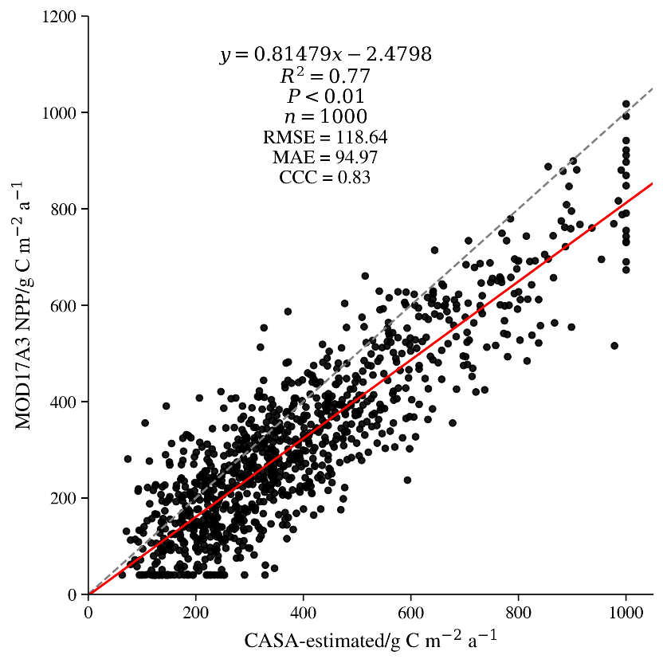
Fig.S1. Comparison between CASA-simulated NPP and MOD17A3 NPP during 2001–2022.

Supplementary Material 2: Sensitivity analysis of KA–NKA classification under different karst-area proportion criteria within 20-km grid cells.

Table S2. Sensitivity of KA–NKA comparisons to different karst-area proportion criteria
Karst-area criterion | KA grid cells (%) | NKA grid cells (%) | Mean (R_{max}) in KA | Mean (R_{max}) in NKA | KA–NKA difference in (R_{max}) | Dominant optimal response timescale in KA (months) | Dominant optimal response timescale in NKA (months) | Median trigger threshold in KA | Median trigger threshold in NKA | KA–NKA threshold difference
40% | 59.68 | 40.32 | 0.185 | 0.168 | 0.017 | 5–6 | 7–8 | −1.16 | −1.28 | 0.12
50% | 52.16 | 47.84 | 0.190 | 0.170 | 0.020 | 4–5 | 7–8 | −1.14 | −1.27 | 0.13
60% | 45.07 | 54.93 | 0.196 | 0.174 | 0.022 | 4–5 | 7–8 | −1.12 | −1.24 | 0.12
Note: Grid cells with karst-area proportions greater than the specified criterion were classified as KA, whereas the remaining grid cells were classified as NKA. The 50% criterion was adopted in the main analysis following the dominant-landscape principle. The percentages of KA and NKA refer to their proportions among grid cells with identifiable drought trigger thresholds under the NPP ≤ NPP50th early-warning state. The drought trigger thresholds also refer to the NPP ≤ NPP50th state. A positive KA–NKA threshold difference indicates that VCF in KA entered the early-warning low-value state under relatively weaker drought conditions than that in NKA.

Supplementary Material 3: Variance inflation factor (VIF) diagnostics of predictor variables in karst and non-karst areas.

Table S3. Variance inflation factors of the predictor variables in KA and NKA
Category | Predictor | VIF in KA | VIF in NKA
Meteorological factors | TEM | 7.42 | 7.11
Meteorological factors | PRE | 2.84 | 3.06
Meteorological factors | PET | 8.36 | 8.71
Meteorological factors | SR | 4.63 | 4.28
Meteorological factors | VPD | 7.95 | 7.62
Underlying surface factors | RFF | 2.57 | 2.89
Underlying surface factors | SWC1-2 | 5.41 | 5.86
Underlying surface factors | SWC3-4 | 5.08 | 5.32
Underlying surface factors | SOC | 2.16 | 2.48
Terrain factors | SP | 2.74 | 2.39
Terrain factors | ALT | 4.35 | 3.92
Terrain factors | AP | 1.29 | 1.36
Note: TEM, temperature; PRE, precipitation; PET, potential evapotranspiration; SR, solar radiation; VPD, vapor pressure deficit; RFF, surface runoff; SWC1-2, soil water content in the upper soil layers; SWC3-4, soil water content in the deeper soil layers; SOC, soil organic carbon; SP, slope; ALT, altitude; and AP, aspect. VIF values below 10 were considered to indicate an acceptable level of multicollinearity.

Supplementary Material 4: Validation of XGBoost models using five-fold spatial GroupKFold cross-validation.

Table S4. Performance of the XGBoost models based on five-fold spatial GroupKFold cross-validation
Validation strategy | Fold | KA (R²) | KA RMSE | KA MAE | NKA (R²) | NKA RMSE | NKA MAE
Random 8:2 split | — | 0.63 | 0.38 | 0.19 | 0.60 | 0.40 | 0.20
Spatial GroupKFold | Fold 1 | 0.58 | 0.41 | 0.22 | 0.55 | 0.43 | 0.24
Spatial GroupKFold | Fold 2 | 0.51 | 0.45 | 0.25 | 0.47 | 0.47 | 0.27
Spatial GroupKFold | Fold 3 | 0.56 | 0.42 | 0.23 | 0.53 | 0.44 | 0.25
Spatial GroupKFold | Fold 4 | 0.49 | 0.46 | 0.26 | 0.46 | 0.48 | 0.28
Spatial GroupKFold | Fold 5 | 0.55 | 0.43 | 0.24 | 0.52 | 0.45 | 0.26
Spatial GroupKFold | Mean ± SD | 0.54 ± 0.04 | 0.43 ± 0.02 | 0.24 ± 0.02 | 0.51 ± 0.04 | 0.45 ± 0.02 | 0.26 ± 0.02
Pooled out-of-fold predictions | All folds | 0.54 | 0.43 | 0.24 | 0.51 | 0.45 | 0.26
Note: The original random 8:2 split is presented only as a reference. For spatial validation, the study area was divided into 100 km × 100 km spatial blocks based on geographic coordinates, and all 20-km grid cells within the same spatial block were assigned to the same fold. In each iteration of the five-fold GroupKFold procedure, four folds were used for model training and parameter optimization, and the remaining fold was used for validation. Mean ± SD values were calculated from the five validation folds. Pooled out-of-fold performance was calculated by combining predictions for all held-out folds.

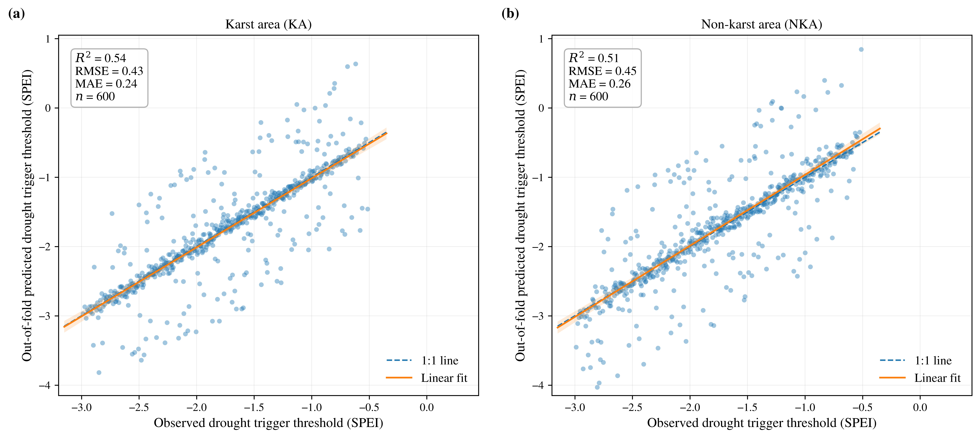
Fig. S2. Observed versus out-of-fold predicted drought trigger thresholds based on five-fold spatial GroupKFold cross-validation in (a) KA and (b) NKA. The dashed line represents the 1:1 reference line, the solid line represents the linear fit, and the shaded area indicates the 95% confidence interval.

Supplementary Material 5: Marginal distribution fitting, Copula model selection, and goodness-of-fit assessment.

Table S5. Selection and goodness-of-fit statistics of marginal distributions and Copula functions for the NPP–SPEI dependence
Region | Valid model fitting (%) | Median KS statistic (IQR) | Normal distribution for NPP (%) | GEV distribution for NPP (%) | Median RMSE (IQR) | Gaussian Copula (%) | t Copula (%) | Clayton Copula (%) | Gumbel Copula (%) | Frank Copula (%) | Median SED (IQR)
Entire study area | 95.8 | 0.071 (0.055–0.091) | 29.4 | 70.6 | 0.024 (0.018–0.031) | 6.9 | 11.2 | 24.8 | 13.5 | 43.6 | 0.0068 (0.0043–0.0096)
KA | 94.9 | 0.076 (0.059–0.097) | 25.8 | 74.2 | 0.026 (0.019–0.034) | 6.5 | 11.4 | 31.8 | 12.4 | 37.9 | 0.0074 (0.0048–0.0103)
NKA | 96.7 | 0.066 (0.051–0.085) | 33.1 | 66.9 | 0.022 (0.017–0.029) | 7.3 | 11.0 | 17.6 | 14.6 | 49.5 | 0.0062 (0.0040–0.0089)
Note: Normal and generalized extreme value（GEV）distributions were fitted as candidate marginal distributions for the monthly NPP series, whereas the Normal distribution was adopted for SPEI. The optimal NPP marginal distribution was selected using the Kolmogorov–Smirnov（KS）test and root mean square error（RMSE）. Gaussian, Student’s t, Clayton, Gumbel, and Frank Copulas were used as candidate dependence functions, and the Copula with the minimum squared Euclidean distance（SED）from the empirical Copula was selected as the optimal model. IQR represents the interquartile range. The proportions of the two NPP marginal distributions and the five Copula families sum to 100% separately within each region.

Supplementary Material 6: Sensitivity of drought trigger thresholds to different conditional probability criteria.

Table S6. Sensitivity of drought trigger thresholds to conditional probability criteria of 0.4, 0.5, and 0.6
VCF state | Conditional probability criterion | Median SPEI threshold | Grid cells with identifiable thresholds (%) | Median threshold in KA | Median threshold in NKA | KA–NKA difference | Spatial correlation with the baseline result
NPP ≤ NPP50th | 0.4 | −1.05 | 72.00 | −0.99 | −1.12 | 0.13 | 0.97
NPP ≤ NPP50th | 0.5 | −1.20 | 62.71 | −1.14 | −1.27 | 0.13 | 1.00
NPP ≤ NPP50th | 0.6 | −1.36 | 52.50 | −1.29 | −1.43 | 0.14 | 0.95
NPP ≤ NPP40th | 0.4 | −1.16 | 57.00 | −1.10 | −1.23 | 0.13 | 0.96
NPP ≤ NPP40th | 0.5 | −1.31 | 47.30 | −1.25 | −1.38 | 0.13 | 1.00
NPP ≤ NPP40th | 0.6 | −1.47 | 38.10 | −1.40 | −1.54 | 0.14 | 0.94
NPP ≤ NPP30th | 0.4 | −1.29 | 44.00 | −1.22 | −1.36 | 0.14 | 0.95
NPP ≤ NPP30th | 0.5 | −1.44 | 34.60 | −1.37 | −1.51 | 0.14 | 1.00
NPP ≤ NPP30th | 0.6 | −1.59 | 26.50 | −1.52 | −1.66 | 0.14 | 0.93
NPP ≤ NPP20th | 0.4 | −1.46 | 32.00 | −1.39 | −1.54 | 0.15 | 0.94
NPP ≤ NPP20th | 0.5 | −1.61 | 24.10 | −1.54 | −1.69 | 0.15 | 1.00
NPP ≤ NPP20th | 0.6 | −1.76 | 17.20 | −1.69 | −1.84 | 0.15 | 0.91
NPP ≤ NPP10th | 0.4 | −1.65 | 21.00 | −1.57 | −1.73 | 0.16 | 0.92
NPP ≤ NPP10th | 0.5 | −1.80 | 15.20 | −1.72 | −1.88 | 0.16 | 1.00
NPP ≤ NPP10th | 0.6 | −1.95 | 10.30 | −1.87 | −2.03 | 0.16 | 0.89
Note: NPP ≤ NPP50th represents an early-warning state associated with an elevated risk of mild VCF loss. NPP ≤ NPP40th, NPP ≤ NPP30th, NPP ≤ NPP20th, and NPP ≤ NPP10th represent mild, moderate, severe, and extreme relative VCF loss states, respectively. The conditional probability level of 0.5 was used as the baseline criterion. Spatial correlations were calculated using grid cells for which drought trigger thresholds could be identified under both the alternative probability criterion and the baseline criterion of 0.5. A positive KA–NKA difference indicates that the drought trigger threshold was higher in KA than in NKA.

Supplementary Material 7: Bootstrap uncertainty assessment of drought trigger thresholds across different percentile-based VCF states.

Table S7. Drought trigger thresholds and bootstrap-derived 95% confidence intervals across different percentile-based VCF states in the entire study area, KA, and NKA.
VCF state | Median SPEI threshold | Median lower bound of pixelwise 95% CIs | Median upper bound of pixelwise 95% CIs | Median CI width | Grid cells with valid Bootstrap CIs (%) | KA threshold and 95% CI | NKA threshold and 95% CI
NPP ≤ NPP50th | −1.20 | −1.31 | −1.09 | 0.22 | 96.4 | −1.14 [−1.25, −1.04] | −1.27 [−1.39, −1.16]
NPP ≤ NPP40th | −1.31 | −1.44 | −1.19 | 0.25 | 94.8 | −1.25 [−1.38, −1.13] | −1.38 [−1.51, −1.25]
NPP ≤ NPP30th | −1.44 | −1.59 | −1.30 | 0.29 | 92.1 | −1.37 [−1.52, −1.23] | −1.51 [−1.66, −1.37]
NPP ≤ NPP20th | −1.61 | −1.79 | −1.45 | 0.34 | 88.7 | −1.54 [−1.72, −1.38] | −1.69 [−1.87, −1.52]
NPP ≤ NPP10th | −1.80 | −2.02 | −1.60 | 0.42 | 81.5 | −1.72 [−1.94, −1.53] | −1.88 [−2.11, −1.68]
Note: Pixelwise 95% confidence intervals（CIs）were estimated using 500 circular moving-block Bootstrap replicates with a block length of 12 months. In each replicate, paired NPP–SPEI observations were jointly resampled, the candidate marginal distributions and Copula functions were refitted, and the drought trigger threshold was re-estimated. The 2.5th and 97.5th percentiles of the Bootstrap threshold distribution were used as the lower and upper confidence limits. CIs were reported only for grid cells in which a valid threshold was identified in at least 70% of the Bootstrap replicates. The regional CI limits shown in the table are the medians of the pixelwise lower and upper confidence limits.

