Additional file 1 for

Turning points of subtropical forest carbon sinks in southern China: Spatiotemporal dynamics and management insights

Contents of this file

Table S1 to S2 and Figure S1 to S3

Introduction
This supporting information provides the same figures as seen in the main article

Table S1 | Species Life history attribute data.
Species | Common name | LONG | SM | ED | MD | VP
 |  |  |  |  |  | probability | Min | Max
Species | Common name | [year] |  | [m] |  | [year]
Eucalyptus spp. | Eucalyptus | 300 | 15 | 60 | 160 | 0.4 | 10 | 80
Cupressus funebris | Chinese Weeping Cypress | 500 | 35 | 70 | 200 | 0.4 | 4 | 100
Pinus densiflora | Japanese Red Pine | 250 | 20 | 60 | 200 | 0.6 | 8 | 75
Baeckea frutescens | Shrubby baeckea | 200 | 15 | 30 | 100 | 0.2 | 3 | 40
Taxus | Chinese Yew | 350 | 25 | 80 | 250 | 0.7 | 10 | 90
Altingia gracilipes | Slender-stalked Altingia | 400 | 250 | 80 | 250 | 0.2 | 10 | 90
Eucalyptus grandis ×urophylla | Eucalyptus Grandi | 200 | 18 | 70 | 200 | 0.7 | 8 | 90
Diospyros morrisiana | Morris'  Persimmon | 250 | 20 | 40 | 200 | 0.5 | 15 | 75
Pinus massoniana | Masson pine | 200 | 10 | 200 | 500 | 0 | 0 | 0
Cunninghamia lanceolata | Chinese fir | 200 | 10 | 200 | 500 | 0.6 | 1 | 80
Metasequoia glyptostroboides | Dawn Redwood | 150 | 10 | 40 | 150 | 0.4 | 5 | 60
Rhodomyrtus tomentosa | Downy Rosemyrtle | 300 | 15 | 50 | 150 | 0.4 | 10 | 60
Castanopsis eyrei | Eyre's Evergreen chinkapin | 300 | 20 | 50 | 200 | 0.5 | 10 | 80
Pinus  kwangtungensis | Guangdong White Pine | 150 | 12 | 50 | 180 | 0.3 | 6 | 70
Keteleeria fortunei​​ | Fortune's Keteleeria | 250 | 20 | 60 | 150 | 0.4 | 8 | 80
Taxus cuspidata | Japanese Yew | 300 | 20 | 70 | 300 | 0.5 | 15 | 100

Note. LONG, longevity; SM, the age of sexual maturity; ED, effective seeding distance; MD, maximum seeding distance; VP, vegetative reproduction probability; MINVP, minimum age of vegetative reproduction; MAXVP, maximum age of vegetative reproduction.

Table S2 | Statistical analysis of forest AGB slope distribution among classification areas under various climate scenarios.
Climate scenario | SE |  | TP |  | ED
Climate scenario | Number of Pixels | Percentage  [%] | Number of Pixels | Percentage  [%] | Number of Pixels | Percentage  [%]
CC | 19,644 | 90.62 | 98 | 0.45 | 1,939 | 8.94
SSP1-2.6 | 20,858 | 96.22 | 55 | 0.25 | 766 | 3.53
SSP2-4.5 | 20,824 | 96.06 | 106 | 0.49 | 750 | 3.46
SSP3-7.0 | 19,650 | 90.64 | 46 | 0.21 | 1,982 | 9.14
SSP5-8.5 | 19,302 | 89.04 | 33 | 0.15 | 2,343 | 10.81

Note. SE, stable enhancement zone; TP, turning point risk zone; ED, ecologically degraded zone. Percentage, percentage of study area.

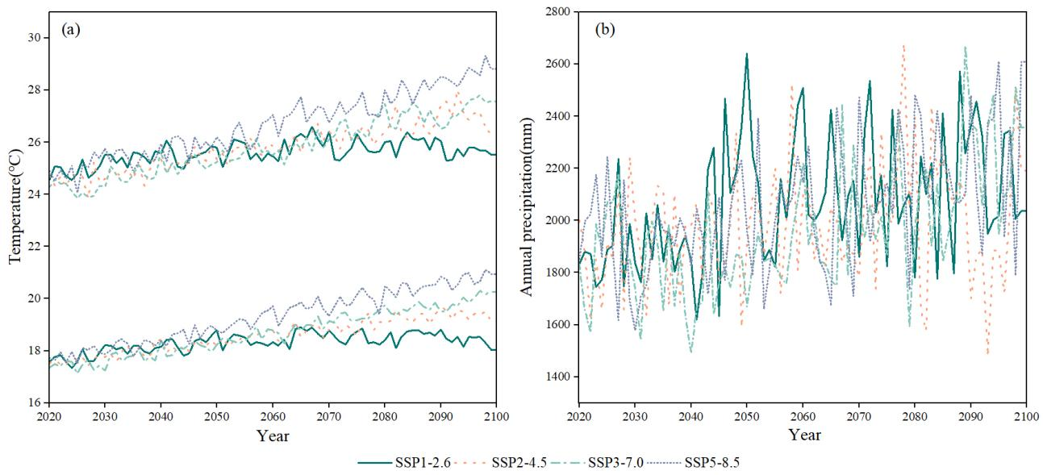
Figure S1. Meteorological data of GBA under different climate scenarios from 2020 to 2100. (a) Trends of maximum and minimum temperatures. (b) Trends of annual average precipitation.

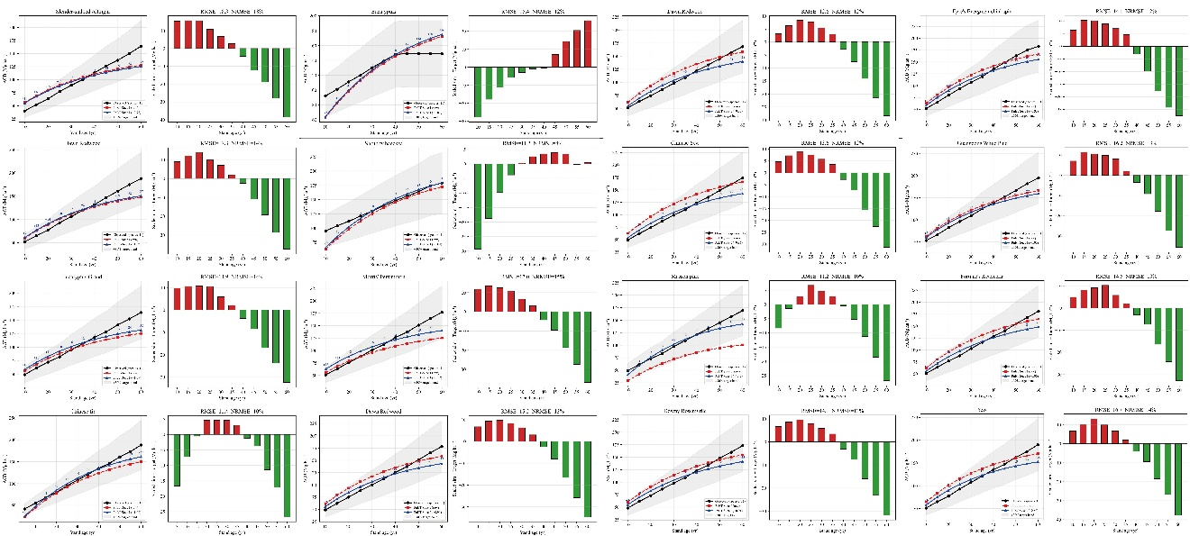

Figure S2. Calibration and validation results for 16 tree species parameters. Each panel shows the simulated vs. observed scatter plot with 1:1 line, regression fit, and residual bias distribution. The close alignment along the 1:1 line and narrow residual ranges indicate successful parameter calibration across all evaluated species.

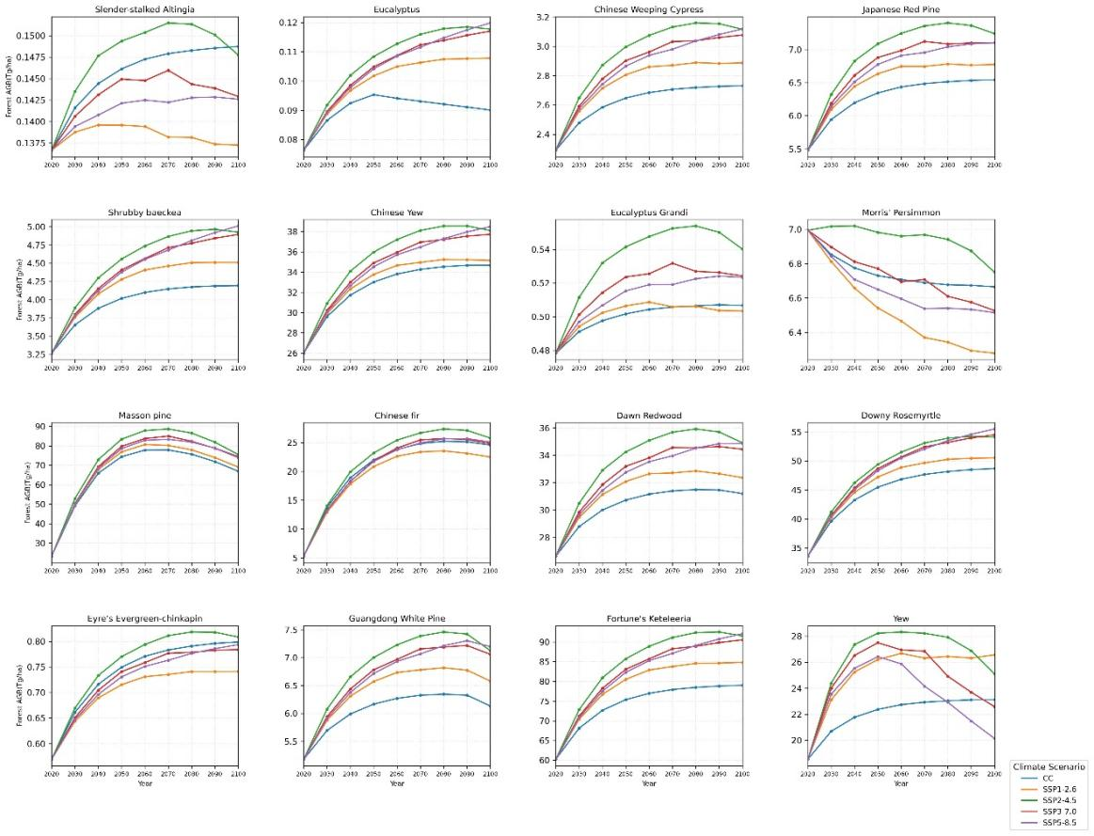

Figure S3. Forest aboveground biomass for single tree species under different climate scenarios during 2020 to 2100.

