Appendix B – Self-/ Proxy- Reported Instruments used in the survey

Likert scale on threat to life caused by the rare condition, score range 0 – 10
(the example below was used in the survey targeting patients)

“Compared with someone of the same age and gender as you but WITHOUT your condition, how much is your life in danger because of your condition?”

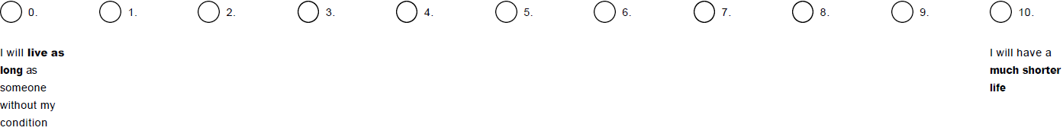

Likert scale on impairment level, score range 0 – 10
(the example below was used in the survey targeting patients)

“What is the level of impairment induced by your condition?”

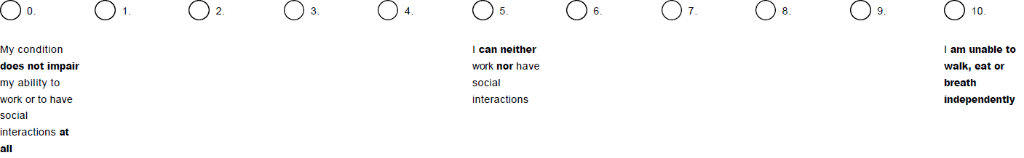

World Health Organization Disability Assessment Schedule 2.0 (WHODAS 2.0), score range 0 – 48

WHODAS 2.0 is a generic health and disability assessment tool designed according to the International Classification of Functioning, Disability, and Health (ICF) framework. It describes effects of disease on six domains: cognition, mobility, self-care, getting along, life activities, and participation in society. In each questionnaire item, individuals have to assess the magnitude of disability over the previous 30 days using a five-point scale (none = 0, mild = 1, moderate = 2, severe = 3, extreme/cannot do = 4). In the 12 item version of the WHODAS 2.0, total score is computed as the sum of the 12 items (range 0 – 48), with higher scores reflecting greater disability. WHODAS 2.0 has been tested for its psychometric properties in a number of studies across different population samples and health conditions [1-6]. Administration time is less than 5 min.

