

Additional file 1
Examination protocol
Prevalence study of dentinogenesis imperfecta (DGI)

Patient name and personal identity number:

Address:

Phone number:

Consent obtained from Guardian Patient

Date of examination:

QUESTIONS FOR THE PATIENT OR THE GUARDIAN

Do you (does your child) bruise easily? Yes No

Do you experience that you have (your child has) prolonged bleeding? Yes No

Do you (does your child) sprain easily? Yes No

Have you (has your child) had any bone fractures? Yes No

If you have (your child has) had a bone fracture, how many times?
……………..times.

What bones have you (has your child) broken and how?

……………………………………………………………………………………

Do you (does your child) have a hearing impairment? Yes No

Do you have a family history of osteoporosis? Yes No

Does anyone in the family have osteogenesis imperfecta (OI)?
Yes No

If yes, what is their name and how are you related?.........………………....

………………………………………………………………………………………

Does anyone in the family have brittle teeth (DGI)?
Yes No

Name of the treating physician/medical center/hospital:

CLINICAL ASSESSMENTS

Does the patient exhibit joint hypermobility? Yes No

If yes, which joints are affected? Specify whether on the right or left side
……………………………………………………………………………………………………………………………………………………………………………...
Does the patient have characteristic changes in the color of the whites of the eyes (the sclerae)? Yes No

How tall is the patient? …………………

Does the patient have tooth agenesis?
Yes No
If yes, which teeth are missing? …………………
Does the patient have retained second molars? Yes No

Does the patient have other retained teeth? Yes No

If yes, which teeth are retained? …………………

Does the patient have unusually large pulp chambers? Yes No

Does the patient have obliterated pulps? Yes No

Does the patient exhibit any malocclusion? Yes No

If yes, what type?
……………………..……………………………………………………………….

Does the patient exhibit any other dental anomalies? Yes No

If yes, which ones?
…….………………………………………………………………………………..
………………………………………………………………………………………

Examining dentist (name, clinic, and phone number):

Assessment of the sclerae
Patients with osteogenesis imperfecta sometimes exhibit a discoloration of the whites of the eyes (sclerae). The discoloration is often blue and is caused by an altered translucency due to the collagen defect. It is thus important to assess any tinge of discoloration of the sclera. Please record your findings in the examination protocol.
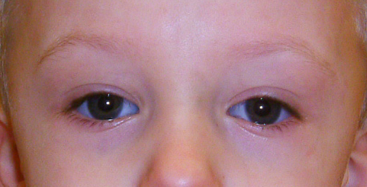

Assessment of joint hypermobility
This assessment is based on the Beighton scale. Please note which joints are affected. Nine points are possible. A detailed description of the maneuvers is shown below.

1) Passive dorsiflexion of the little fingers beyond 90 degrees (1 point per little finger)
2) Passive apposition of the thumbs to the flexor aspects of the forearms (1 point per thumb)
3) Hyperextension of the elbows more than 10 degrees (1 point per elbow)
4) Hyperextension of the knees more than 10 degrees (1 point per knee)
5) Forward flexion of the trunk, with knees straight, so that the palms of the hands rest easily on the floor (1 point)

