Fig. S1 Mean change from baseline (SEM) in NIS (a) and NIS+7 (b) scores from the all-treated population over 24 months. Error bars represent the SEM. NIS, Neuropathy Impairment Score; NIS+7, Neuropathy Impairment Score +7; SEM, standard error of the mean
a
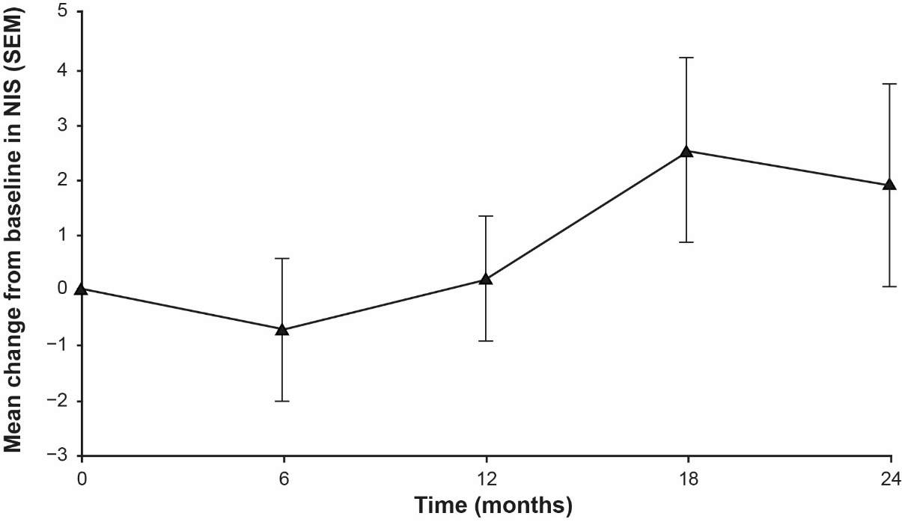
b
