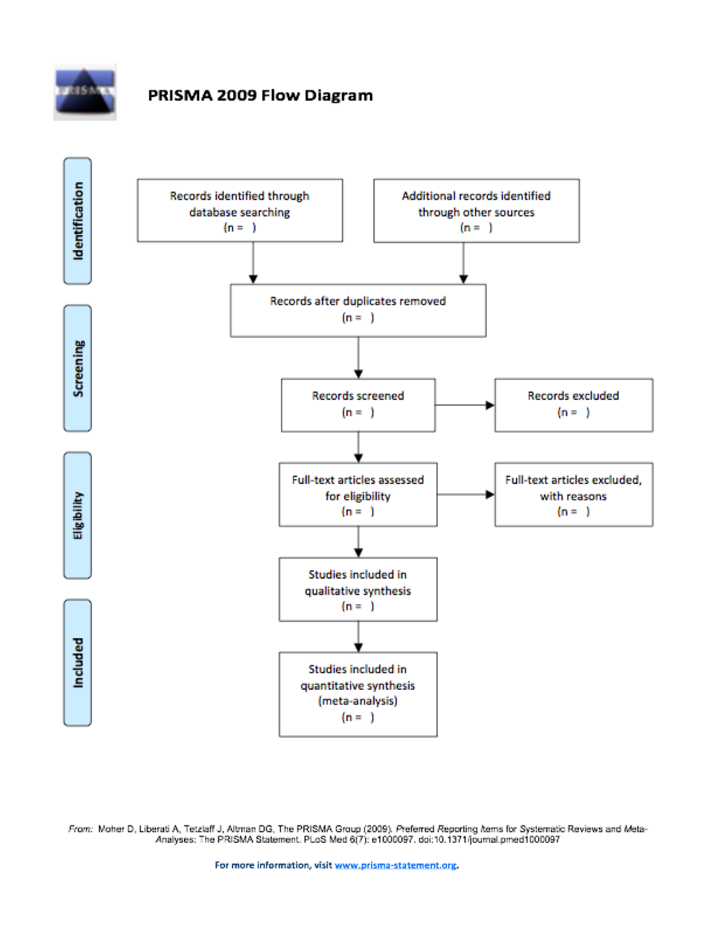

TABLE OF CONTENTS

SUBJECT | PAGE
Abstract | 2
Background | 3
Aims | 5
Methods | 6
Systematic Review Protocol | 6
Systematic Review Research Question | 6
Search Strategy | 7
Data Capture | 8
Data Extraction | 9
Data Synthesis | 11
Discussion | 12
Conclusions | 12
List of Abbreviations | 13
Acknowledgments | 14
Funding | 14
Competing Interests | 14
Authors’ Contributions | 14
Availability of Data and Materials | 14
Ethicals approval and consent to participate | 15
Consent for publication | 15
Bibliography | 16
Figure 1 – The Treatabolome Overview | 18
Figure 2 – The Treatabolome is a precision medicine project | 19
Figure 3 – The Treatabolome Systematic Review Checklist | 20
Figure 3 – Systematic Review Phases | 21
Table I - codebook specifying data capture form spreadsheet headings | 22
Table II - codebook specifying summary table column headings (variable names) | 23
Annex I - Systematic Review Protocol | 24
Annex II - Search Log | 29
Annex III - Data Capture Form | 31
Annex IV - PRISMA Flow Diagram | 33

